**EC2 -- Elastic compute cloud**

Amazon Elastic Compute Cloud (Amazon EC2) provides scalable computing capacity in the Amazon Web Services (AWS) cloud. Using Amazon EC2 eliminates your need to invest in hardware up front, so you can develop and deploy applications faster.

Synonyms

Computer, machine, box, PC, Server = As per AWS terminology - **Instance**

Ex 1: Launch windows instance

Step 1: Login to AWS

Step 2: Choose region which is near? ( Asia pacific - Mumbai )

Step 3: Services -- EC2

( If any keypairs -- delete )

( If any security groups - delete, except default )

Services -- EC2 --- Launch an instance

**Name and tags**

MyWindows

**Amazon Machine Image**

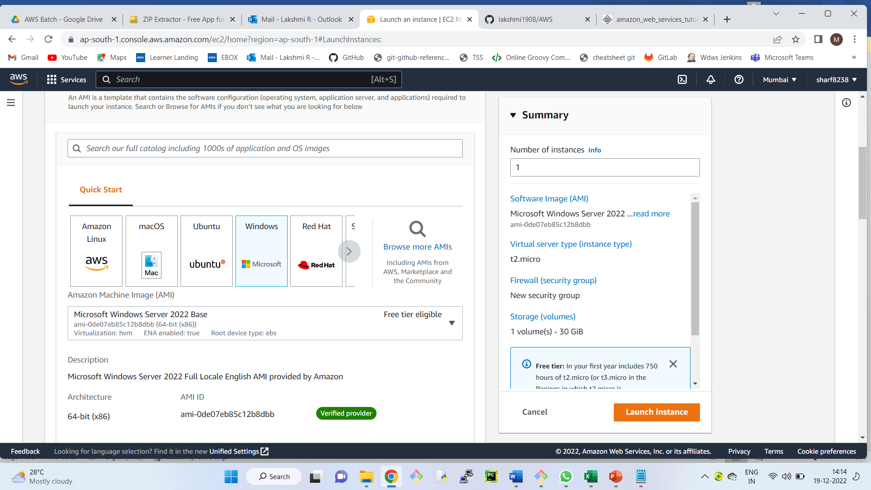

**Instance type ---** t2.micro

**Key pair (login)**

Create new keypair – MyWindowsKP

**Network settings – edit**

Security group name *– required --- MyWindowsGP*

**Inbound security groups rules** ( It deals with ports )

We have 0 to 65535 ports

Every port is dedicated to special purpose

RDP -- 3389

SSH -- 22

HTTP -- 80

HTTPS - 443

For windows machine, we need to open RDP port (Remote Desktop Protocol)

He by default, we have RDP

**Configure storage -- 30**

Number of instance – 1

Storage (volumes)

1 volume(s) - 30 GiB

**Launch instance**

We get the instance ID ([i-0bb3b70e747e31e5d](https://ap-south-1.console.aws.amazon.com/ec2/home?region=ap-south-1#Instances:instanceId=i-0bb3b70e747e31e5d)) View all Instances

Now, the new windows machines, is having its own DNS Name, Username and password

We need to provide all the above 3 details in our laptop, so that we can connect.

We use an application called Remote Desktop Connection

AWS, gives us DNS name , username, it does not give the password.

Instead of password , AWS has given us pem file.

But, to connect to Window, we need password

AWS gives an option to convert .pem to password

How to connect .pem to password

Connect to instance – RDP Get password -- upload pem file -- Decrypt

Open Remote Desktop

Computer - Provide public DNS -- ec2-65-2-190-2.ap-south-1.compute.amazonaws.com

User name -- Administrator

password -- Uc%=c)?KIYBq8Yh!@UDtZf6LkD%Ms?=X

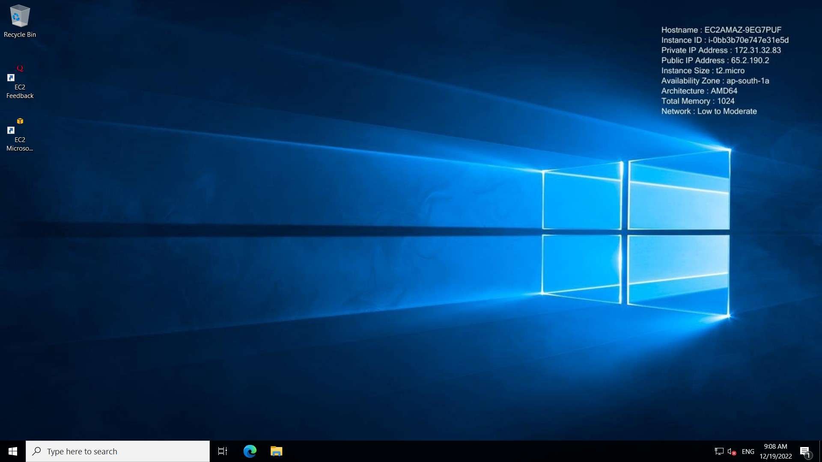

Hurray!!

We are connected.

Let’s check the hardware configuration

Check hard disk

Check Ram

You can copy paste file from laptop to win server!!

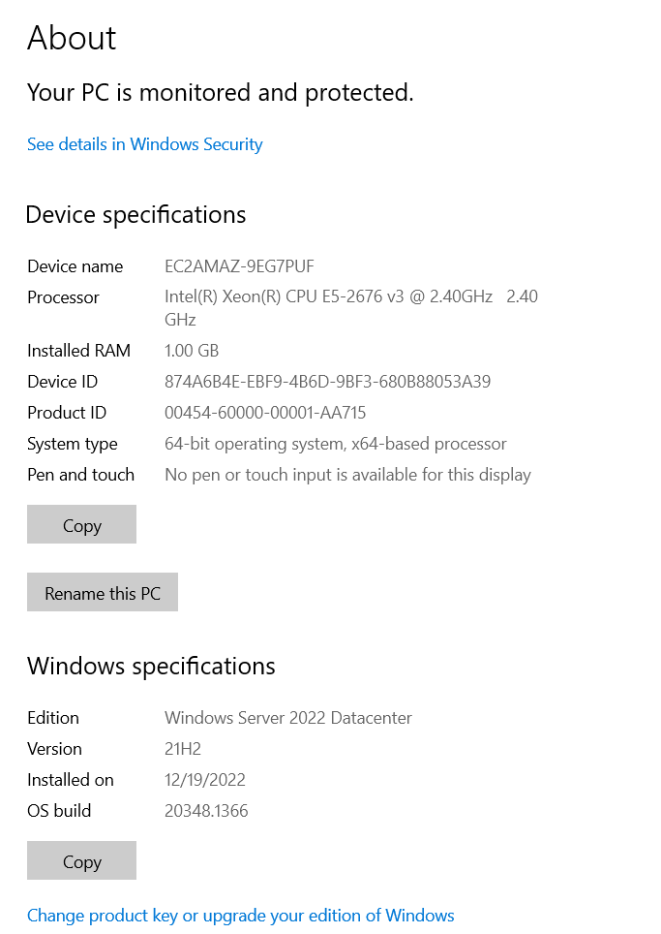

To disconnect, just close the remote desktop window.

Explain about Stop and reboot and terminate

++++++++++++++++END++++++++++++++++++++++++++++++++