**Update & Upgrade:**

sudo apt update; sudo apt upgrade

sudo apt install build-essential dkms linux-headers-$(uname -r)

**# for Putty to start ssh server**

sudo apt install openssh-server

sudo systemctl status ssh

sudo systemctl enable --now ssh

##

java -version

sudo apt install openjdk-11-jre

## Jenkins installation

$ java -version

openjdk version "11.0.12" 2021-07-20

OpenJDK Runtime Environment (build 11.0.12+7-post-Debian-2)

OpenJDK 64-Bit Server VM (build 11.0.12+7-post-Debian-2, mixed mode, sharing)

sudo apt install curl

curl -fsSL https://pkg.jenkins.io/debian-stable/jenkins.io.key | sudo tee \

/usr/share/keyrings/jenkins-keyring.asc > /dev/null

echo deb [signed-by=/usr/share/keyrings/jenkins-keyring.asc] \

https://pkg.jenkins.io/debian-stable binary/ | sudo tee \

/etc/apt/sources.list.d/jenkins.list > /dev/null

sudo apt-get update

sudo apt-get install jenkins

You can enable the Jenkins service to start at boot with the command:

sudo systemctl enable jenkins

You can start the Jenkins service with the command:

sudo systemctl start jenkins

You can check the status of the Jenkins service using the command:

sudo systemctl status Jenkins

**How to Install Apache Maven on Ubuntu 22.04**

[Apache Maven](https://maven.apache.org/) is an open-source utility that enables you to automate the development procedure of Java projects. It can also be utilized for Ruby, C#, and other programming languages. In Linux-based systems such as Ubuntu 22.04, Apache Maven is a well-known tool for developing projects related to Java. It is hosted by the maven project.

## **Method 1: Installing Apache Maven on Ubuntu 22.04 using apt**

**Step 1: Update system repositories**

open up the terminal by hitting “**CTRL+ALT+T**” in Ubuntu 22.04 and write out the below-given commands for updating the system repositories:

$ sudo apt update

$ sudo apt upgrade

**Step 2: Apache Maven Installation on Ubuntu 22.04**

$ sudo apt install maven -y

**Step 3: Check Apache Maven version**

$ mvn -version

## **Method 2: Installing Apache Maven on Ubuntu 22.04 using Manual method**

**Step 1: Install Java**

$ sudo apt install default-jdk -y

**Step 2: Download Apache Maven latest version**

$ wget https://downloads.apache.org/maven/maven-3/3.6.3/binaries/apache-maven-3.6.3-bin.tar.gz -P /tmp

**Step 3: Extract downloaded Apache Maven package**

$ cd /tmp

$ tar -xvzf apache-maven-3.6.3-bin.tar.gz

After extracting the required package, copy it to the “**/opt/**” directory:

$ sudo cp -r apache-maven-3.6.3 /opt/maven

**Step 4: Set up environment variables**

**set up**the **environment variables**by creating a maven script file “**maven.sh**” inside the “**/etc.profile.d**” directory:

$ sudo nano /etc/profile.d/maven.sh

In the opened “**maven.sh**” file, paste the follow code and press “**CTRL+O**” to save it:

export JAVA_HOME=/usr/lib/jvm/default-java  
export M2_HOME=/opt/maven  
export MAVEN_HOME=/opt/maven  
export PATH=${M2_HOME}/bin:${PATH}

Next, write out the following command for **enabling**the **executable permission**of the created **Apache Maven script**:

$ sudo chmod +x /etc/profile.d/maven.sh

**load**the **environment variables**with the help of the following “**source**” command:

$ source /etc/profile.d/maven.sh

**Step 5: Check Apache Maven version**

$ mvn -version

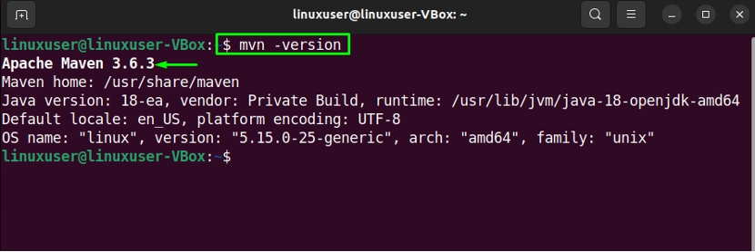

## **How to uninstall Apache Maven from Ubuntu 22.04**

$ sudo apt remove maven

## **Conclusion**

For Apache Maven installation, you can either utilize “**apt**” or the **manual installation**method. In order to use “**apt**”, open your Ubuntu **22.04** terminal and execute the “**$ sudo apt install maven -y**” command. While in the manual installation, you have to **download**the **archive**file from the official[website](https://maven.apache.org/download.cgi), **extract**it, and **set**the **environment**variables accordingly. This write-up discussed two methods for the **installation**of **Apache Maven**on Ubuntu **22.04**.