1. Downloaded file from LMS and uploaded file in HDFS using HUE

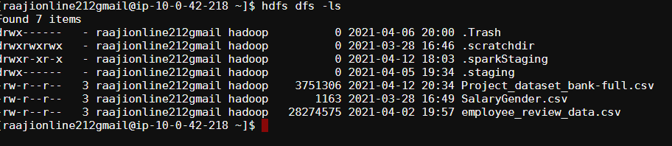

1. Connected to spark using spark-shell

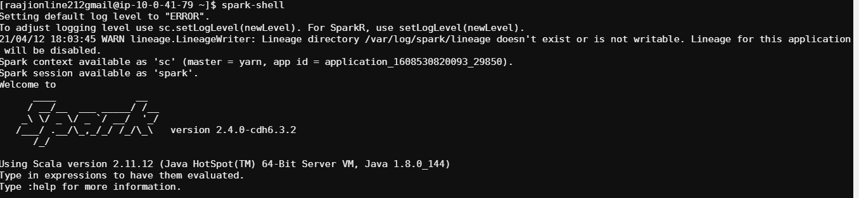

1. Uploaded the file using spark

val sqlContext = new org.apache.spark.sql.SQLContext(sc)

val df = sqlContext.read.format("com.databricks.spark.csv").option("header","true").option("inferSchema","true").option("delimiter", ";").load("/user/raajionline212gmail/Project_dataset_bank-full.csv");

1. Displayed the uploaded data using the command

Df.show();

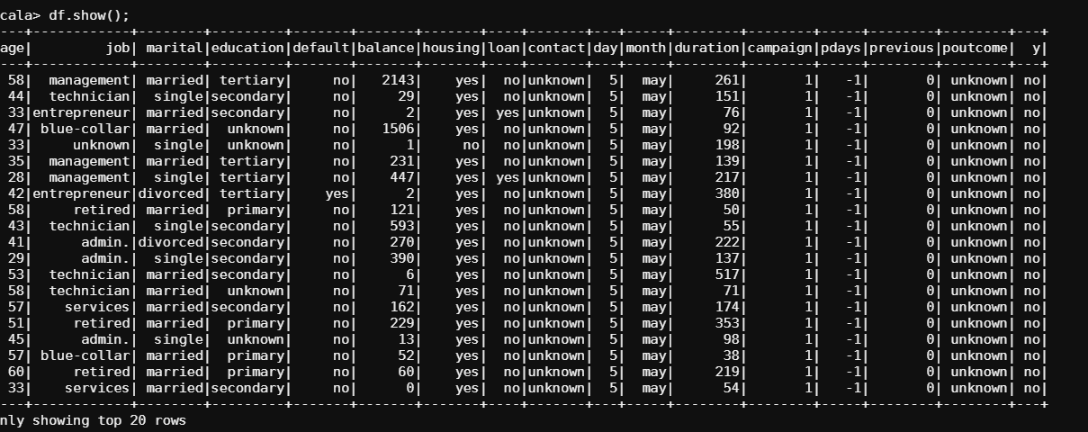

1. Record count of uploaded data.

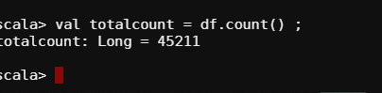

1. Give marketing success rate

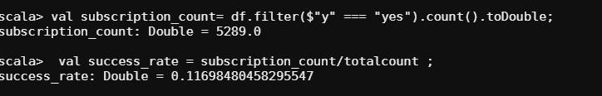

1. Give Failure rate Count

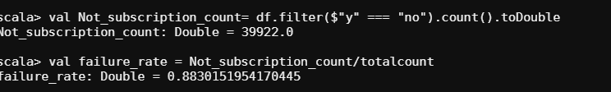

1. Give the maximum, mean, and minimum age of the average targeted customer

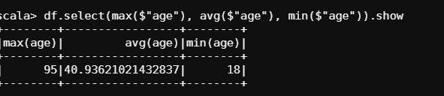

1. Check the quality of customers by checking average balance, median balance of customers

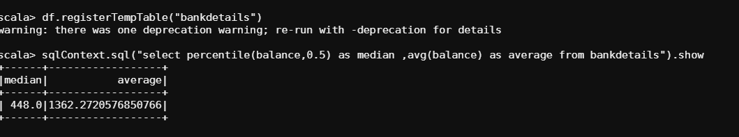

1. Check if age matters in marketing subscription for deposit

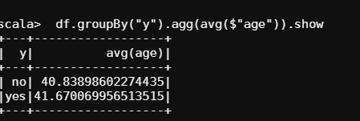

1. Check if marital status mattered for a subscription to deposit

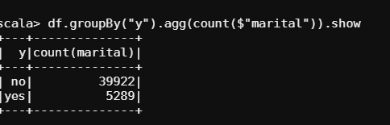

1. Check if age and marital status together mattered for a subscription to deposit scheme

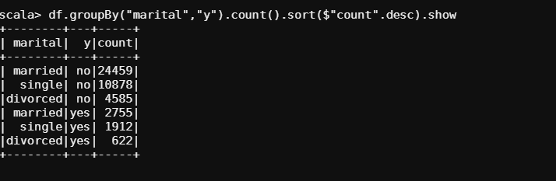

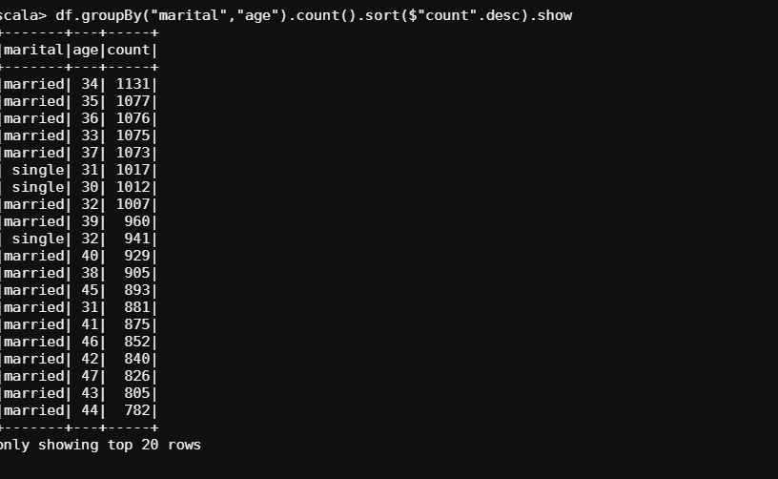

1. Do feature engineering for the bank and find the right age effect on the campaign.

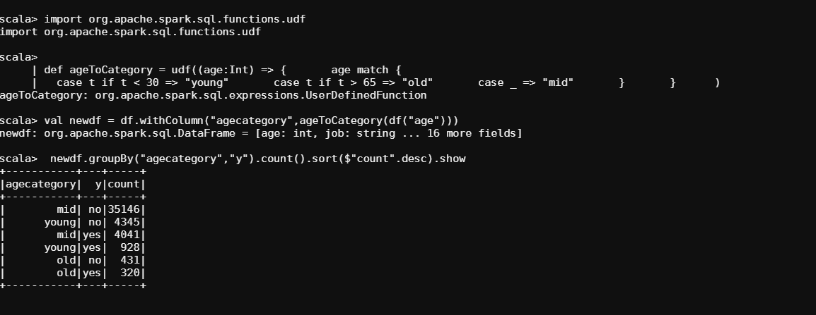

As per the analysis MID age is right age effect on the campaign.