Kavach — Hackathon MVP Plan
Oct 3, 2026 · @Lakshmi

1. One-line pitch
Kavach gives families a verified pause before panic becomes payment.
Track: Personal AI. Also eligible for: Grand Prize, Best Use of Tavily, Most Valuable Feedback. Deadline: Fri 30 Oct 2026, 10:00 AM PT (10:30 PM IST).

2. What makes Kavach unique
Kavach is not a scam classifier; it is a family protocol that inserts a verified pause between a pressure message and a payment.
- Out-of-band family verification. When someone claims to be family from an unknown number, Kavach does not guess. It asks the real relative or guardian, through the Telegram account they were bound to at setup, to confirm or reject. No static safe word.
- Family Circuit-Breaker. In high-risk cases the parent sees "Pause. Do not pay.", hears a parent-approved recorded message from a trusted child (never an AI voice clone), and gets a one-tap call to a number the contact shared themselves. The guardian is escalated according to rules the family set.
- Policy decides, models explain. Deterministic code controls every guardian alert and trusted-contact action. Models only extract risk signals and write explanations, so a scam message cannot talk its way into a "Verified" result.
- Three outcomes only. Identity route verified, Pause and verify, Likely scam. Verified means we confirmed who answered, never that a money request is safe. Kavach never says "Safe".
- Evidence, not opinion. When an applicable official advisory is found, Kavach cites it with its date. Otherwise it states that identity verification is still required.
- Fits the Personal AI track. Persistent memory is the guardian-approved trusted-contact vault; reusable skills are verify-contact, circuit-breaker and recovery-checklist; the family controls what is stored.

3. Exact MVP scope
The MVP is nine pieces and three scenarios, all on synthetic data, built on Telegram with a channel-agnostic core.
# | In scope | Done when
1 | Inputs: text, screenshot, one uploaded recorded voice or video sample | All three reach the pipeline through the Telegram bot
2 | Service-side redaction (before model and Tavily calls) of OTPs, account-like numbers, passwords, personal identifiers | Redacted text is what every model and Tavily call receives; the demo shows before and after
3 | Risk-signal extraction: urgency, secrecy, authority impersonation, unknown contact, payment pressure | Signals come back as validated JSON
4 | Trusted-contact verification through the contact's bound Telegram account | The expected verifier confirms or rejects from their bound Telegram account; parent sees the result
5 | Official-source evidence via Tavily | One dated advisory from an allowlisted domain, cited when an applicable one is found
6 | Replies in Telugu, Hindi and English | Safety-critical lines come from fixed, reviewed templates; explanations from Super
7 | Circuit-Breaker and guardian escalation | "Pause. Do not pay." screen, recorded message, one-tap call, escalation rule fires
8 | Small dashboard and audit trail | One Mini App page: verification history, alerts, routing, latency, cost
9 | Small held-out synthetic benchmark | Generic analysis vs. Kavach, reported in the README
Channels. Telegram carries demo input, guardian confirmation requests and alerts. A mobile Kavach Mini App (Telegram Web App) carries trusted-contact setup, the Circuit-Breaker screen, consent controls and verification history. The core sits behind a MessagingChannel interface (section 6), so WhatsApp can be added later without touching the policy, vault, model pipeline or audit trail.
Demo scenarios. (1) Fake "digital arrest" recorded video call. (2) "Mom, it's Ravi, I changed my number." (3) A genuine new-number message that the real contact confirms through their bound account, to show Kavach does not cry wolf.
Not in the MVP: everything listed in sections 10 and 11.

4. User flow
The parent forwards one thing and gets one of three outcomes; the family is pulled in only when policy says so.

Setup (guardian, once, in the Mini App)
- Guardian adds trusted contacts: name and relationship. Each one starts the Kavach bot and is bound to their Telegram user ID. A phone number is optional, collected only when the contact shares it themselves, and used only for the parent's one-tap callback, never to match senders.
- Guardian records a short Circuit-Breaker message; the parent approves it before it is used.
- Family sets the language (Telugu, Hindi or English) and the escalation rule, e.g. alert the guardian on every Likely scam, and on a Pause with no guardian answer.
- Parent gives consent; Kavach shows what it stores and what it never stores.

Check (parent, any time, in Telegram)
- Parent forwards a text, screenshot, or recorded voice/video sample.
- Kavach redacts sensitive numbers in the Kavach service before any model or Tavily call (Telegram still holds the original) and shows the parent a short "protected" note.
- Signals are extracted; policy decides the outcome:
  - Identity route verified: the pre-enrolled verifier confirmed through their bound Telegram account. It never means a money request is safe.
  - Pause and verify: an unknown contact claims to be family, or signals are mixed.
  - Likely scam: payment pressure + secrecy + urgency (or authority impersonation + payment pressure). This outranks every other rule, even a confirmed verifier.
- Reply arrives in the parent's language with 2–3 plain reasons and, when an applicable official advisory is found, its citation; otherwise a note that identity verification is still required.

Family claim from an unknown number
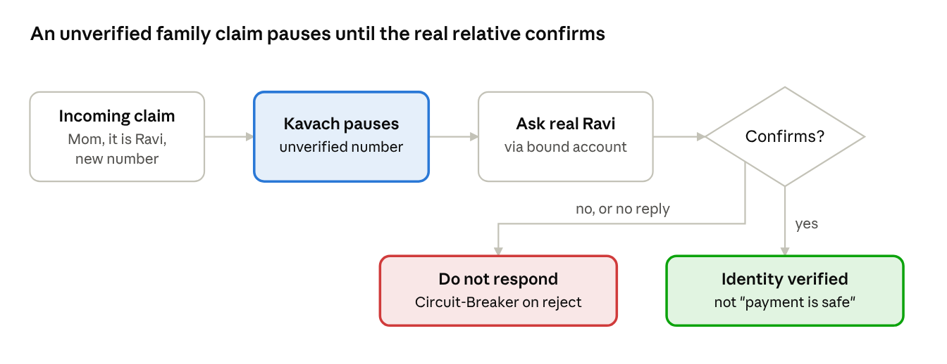
Trusted-contact verification · 1 decision, 2 outcomes
The guardian receives "Someone claiming to be Ravi asked Amma for money from a new number. Is this you?" with Confirm / Reject buttons. Only the expected verifier's bound account can answer; the request is single-use, carries a nonce and expires after 10 minutes. No answer keeps the parent on Pause.

High risk: Circuit-Breaker
- Telegram sends an "Open Circuit-Breaker" button; the parent taps it to open the Mini App showing "Pause. Do not pay."
- The guardian's approved recorded message plays.
- One-tap call to a number the contact shared themselves.
- Guardian escalation fires; every step goes into the audit trail.

If money may already have been sent
Kavach shows an urgent checklist for a human to act on: call your bank now using the number on your card or the bank's official website (never a number from the message), call the 1930 cybercrime helpline, keep screenshots and transaction IDs, and do not send more money. Kavach does not file reports itself.

5. Safety and privacy design
Every rule below is enforced in code and shown in the demo or README; none depends on a model behaving well.
Rule | How it is enforced
No end-to-end privacy claim | Telegram servers see raw messages. The README says so plainly and documents redaction and retention boundaries.
Synthetic data only | All demo contacts, numbers, messages and media are invented; the repo ships them as fixtures.
Service-side redaction first | Regex and checksum rules mask OTPs, card and account-like numbers, passwords, UPI IDs, phone numbers and names in the Kavach service before any model or Tavily call. Transcripts of voice/video are redacted the same way. Telegram still receives the original message; redaction protects what Kavach sends onward.
Minimal storage | Only guardian-approved trusted contacts (name, relationship, bound Telegram ID, and an optional self-shared phone for the parent's callback), consent settings, the recorded message and a redacted audit trail. No live location, routines, bank details or family profiling.
Retention | Raw uploads are deleted after processing; redacted audit entries are kept for a fixed period set in config and can be wiped from the Mini App.
Tavily isolation | Tavily receives only a sanitized, generic claim (e.g. "CBI digital arrest video call payment") restricted to allowlisted official domains. Never raw messages or personal data.
Untrusted input | Uploads, scam text and web results are passed to models as quoted data, never as instructions. Model output is schema-validated; invalid output becomes Pause.
Policy controls actions | Deterministic code alone decides guardian alerts, verification requests, adding or changing trusted contacts, and the Verified outcome. Models cannot trigger them.
Verified means who answered | Only a pre-enrolled verifier confirming through their bound Telegram account produces Identity route verified, and it never makes a money request safe. A saved contact does not either.
Recorded voice only | The Circuit-Breaker plays a parent-approved human recording. No AI voice cloning anywhere.
No over-promising | No live-call interception, deepfake detection, automated complaint filing, legal conclusions or guaranteed detection. Replies say "likely", never "certain".
Recovery is human-led | If money may have been sent, Kavach shows an urgent checklist (bank, 1930 helpline, preserve evidence); a person acts on it.
Audit trail | Each decision logs time, keyed (HMAC) digest of the redacted input, signals, rule fired, models called, latency, cost and guardian action.

6. Technical architecture and model routing
One small Python service runs a five-step pipeline; three Nemotron models do language work, and deterministic policy code owns every action.
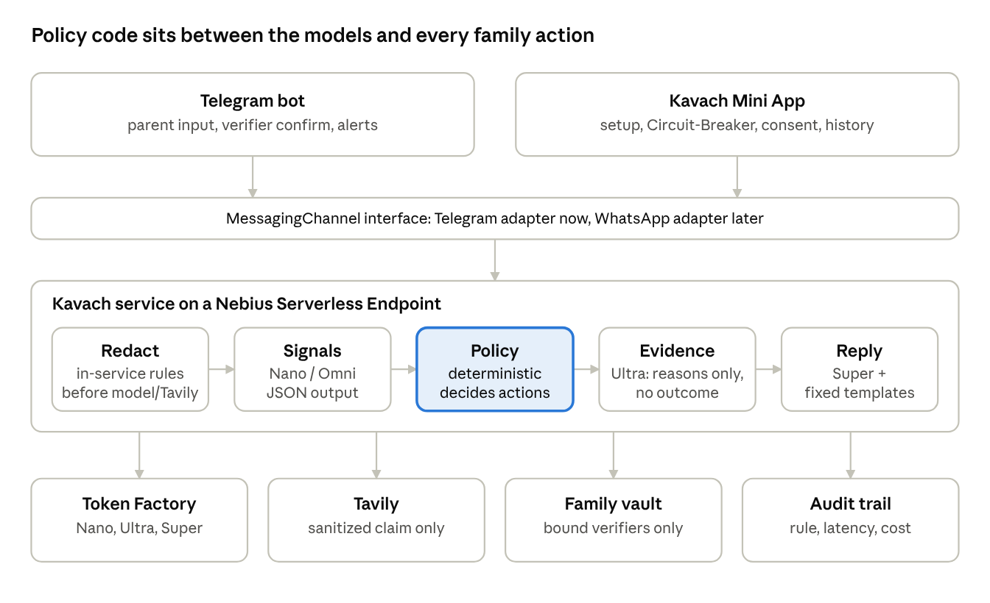
MVP architecture · channel layer, 5-step pipeline, 4 backing services
Models never call the vault, send alerts or mark anything Verified; only the policy step does.

Model routing
Step | Model | Called when | Output
Signal extraction | Nemotron Nano (text, screenshot) or Nano Omni (voice/video) | Every check | JSON: signals, claimed identity, payment request, language
Verdict | Nemotron Ultra | Only when policy marks the case uncertain | JSON: evidence summary, plain-language reasons, citation relevance (never an outcome)
Reply | Nemotron Super | Every check | Plain-language explanation in Telugu, Hindi or English
Safety-critical lines ("Pause. Do not pay.", the recovery checklist) come from fixed, human-reviewed templates in all three languages; Super only writes the explanation around them. Ultra never picks an outcome: deterministic policy alone selects Verified, Pause or Likely scam. The Mini App shows, per check, which models ran, latency per step, and cost in rupees.

Policy rules (examples)
Condition (first match wins) | Outcome
1. Payment pressure + secrecy + urgency (or authority impersonation + payment pressure) | Likely scam; Circuit-Breaker; guardian alert. Beats every rule below, even a confirmed verifier or a saved contact
2. Unknown contact claims to be family | Pause and verify; confirmation request to the pre-enrolled verifier
3. Pre-enrolled verifier confirms through their bound Telegram account, and rule 1 did not fire | Identity route verified (who answered, not "the payment is safe")
4. Verifier rejects the claim | Likely scam; Circuit-Breaker
5. No answer, or model output invalid or missing | Pause and verify; guardian alert

MessagingChannel interface
The policy, vault, model pipeline and audit trail import only these types. TelegramChannel implements them for the hackathon; a WhatsAppChannel can be added later without changing anything else.
from dataclasses import dataclass
from datetime import datetime
from typing import Literal, Optional, Protocol
@dataclass(frozen=True)
class InboundMessage:
channel: str # "telegram" now, "whatsapp" later
sender_id: str # channel-specific user id
kind: Literal["text", "image", "audio", "video", "other"]
text: str = ""
media_ref: Optional[str] = None
received_at: Optional[str] = None # no sender phone: never a trust signal
@dataclass(frozen=True)
class ConfirmationRequest: # single-use, for ONE pre-enrolled verifier
request_id: str
case_id: str
claimed_contact_id: Optional[str]
expected_verifier_id: str # their bound Telegram user ID
nonce: str
expires_at: datetime
prompt: str # fixed, reviewed template
consumed_at: Optional[datetime] = None
@dataclass(frozen=True)
class ConfirmationResponse:
channel: str
request_id: str
actor_id: str # who actually pressed the button
nonce: str
decision: Literal["confirm", "reject"]
class MessagingChannel(Protocol):
name: str
def parse_inbound(self, raw: Mapping[str, Any]) -> InboundMessage: ...
def parse_confirmation(self, raw: Mapping[str, Any]) -> ConfirmationResponse: ...
async def send_reply(self, reply: OutboundReply) -> None: ...
async def send_confirmation_request(self, request: ConfirmationRequest) -> None: ...
async def send_alert(self, alert: Alert) -> None: ...
async def open_circuit_breaker(self, event: CircuitBreakerEvent) -> None: ...

Verify before building (day 1–2)
Capability | How to verify | Fallback
Nano Omni accepts audio/video on Token Factory | List models via /v1/models; send a 30-second synthetic clip | Transcribe with an NVIDIA ASR model (check language support), then send the transcript to Nano; record the synthetic clip in English or Hindi
Nano reads screenshots | Send 5 synthetic screenshots | Nemotron vision/Parse model if listed; else OCR, then Nano on text
Ultra is available with JSON output | Test call with a schema | Super with the same schema
Super quality in Telugu and Hindi | 20 replies reviewed by a native speaker | Templates carry the meaning; explanation in English if quality is poor
JSON / structured output per model | Schema-validated test calls | Validate and retry once; still invalid → Pause
Tavily domain filter and published dates | Search with an include-domains list | Filter domains in code; cite only results with a visible date
Serverless Endpoint runs the webhook service | Deploy a hello-world container | Nebius AI Cloud VM
Telegram bot media size and Mini App | Upload the demo video; open a Mini App page | Trim the clip; host the Mini App as a plain web page
OpenShell egress policy (optional) | Timebox 1 day | Enforce the allowlist in app code
Telegram webhook secret token and Mini App initData | Validate both server-side with synthetic updates: tampered, wrong-bot, expired and missing-hash initData all rejected | Reject the request; there is no unauthenticated fallback
Verifier binding on Telegram | Each verifier starts the bot once; store their Telegram user ID; confirm that a button press carries that ID | No bound account means no verifier: the case stays on Pause
OpenShell is used only if the timebox works: running the service in an OpenShell sandbox whose network policy allows only Token Factory, Tavily and Telegram genuinely enforces the privacy rules. Hermes and NemoClaw are not used in the MVP.

7. Tavily and Nebius resource mapping
Each resource below has one job in the running product; nothing is listed just to add names.
Resource | Job in Kavach | Where judges see it
Nebius Token Factory | All inference for Nano / Nano Omni, Ultra and Super through one OpenAI-compatible API | Routing panel: model, latency, cost per step
NVIDIA Nemotron Nano / Nano Omni | Fast risk-signal extraction from text, screenshots, voice/video | Signals panel in the demo
NVIDIA Nemotron Ultra | Evidence-grounded structured verdict, uncertain cases only | Routing panel shows when it is skipped
NVIDIA Nemotron Super | Calm elder-friendly replies in Telugu, Hindi, English | The parent's reply
Nebius Serverless Endpoint | Hosts the Kavach service, Telegram webhook and Mini App | The live demo URL
Tavily Search | Sanitized claim against allowlisted official domains | Citation with source and date
Tavily Extract | Reads the chosen advisory page to quote one line and confirm its date | Quoted line under the verdict
NVIDIA OpenShell (optional, timeboxed) | Network policy limiting egress to Token Factory, Tavily, Telegram | README security section
Builders Program credits | Token Factory and Tavily usage; LangSmith for traces if time allows | README cost table

Tavily rules
- Query = a sanitized, generic claim built from extracted signals, never the raw message.
- Domains = a short allowlist of official sources (national cybercrime portal, central bank, telecom regulator, government press releases), kept in config and listed in the README.
- A result is cited only if it is from an allowlisted domain and shows a date; otherwise Kavach states that identity verification is still required and policy still applies. It never forces an unrelated citation.
- Results are untrusted text: they inform the explanation but cannot change the policy outcome. For the recorded demo one dated advisory is cached so the take is repeatable; a live Tavily refresh button stays in the Mini App.

8. Three-minute demo script
Two scams, one verified pause each, one benchmark slide; all data is synthetic and labelled so on screen.
Time | On screen | Voiceover
0:00–0:15 | Phone: a synthetic recorded "digital arrest" video call; caption "synthetic demo data" | "Scammers don't need to hack a phone. They only need a parent to panic."
0:15–0:35 | Parent forwards the clip to Kavach in Telegram; Mini App shows the redaction view: phone number, case number and UPI ID masked | "Before anything leaves the Kavach service, sensitive numbers are masked in the Kavach service."
0:35–1:00 | Signals light up: authority impersonation, secrecy, urgency, payment pressure. Routing panel: Nano Omni → policy → Ultra → Super, with latency and cost | "Nemotron extracts signals. Policy code, not the model, decides what happens next."
1:00–1:20 | Verdict: Likely scam, with a dated advisory from an allowlisted official site via Tavily, quoted line visible (cached for the recording; a live refresh button re-runs Tavily) | "When an official advisory applies, Kavach cites it, with its date."
1:20–1:45 | Circuit-Breaker: parent taps "Open Circuit-Breaker" in Telegram and the Mini App shows "Pause. Do not pay." in Telugu; Ravi's recorded message plays; one-tap call to the number Ravi shared; guardian gets an alert | "A real voice the family recorded. A real number Ravi shared himself. No AI clone."
1:45–2:15 | New message: "Mom, it's Ravi, I changed my number." Outcome: Pause and verify. Real Ravi gets Confirm / Reject in his own bound Telegram account, taps Reject. Parent sees "Unverified. Do not reply." | "Kavach doesn't guess who Ravi is. It asks the real Ravi."
2:15–2:40 | Benchmark slide: generic analysis vs. Kavach with family verification on the held-out set | "A generic checker can't tell a real new number from a fake one. Family verification can."
2:40–2:52 | Audit trail: every decision, rule, model, latency, cost; privacy note "Telegram prototype, not end-to-end private" | "Everything is logged, and we say plainly what this prototype does and doesn't protect."
2:52–3:00 | Logo and tagline | "Kavach does not decide whom to trust. It gives families a verified pause before panic becomes payment."
Record the benchmark numbers from the real run; do not script them in advance.

9. Benchmark and evaluation plan
One comparison carries the story: the same models without family verification versus Kavach with it, on a small held-out synthetic set. Models, prompts, redaction, policy rules and Tavily are held constant; only family verification varies.

Dataset
Split | Cases | Mix | Purpose
Development | 30 | Used while building prompts and rules | Tuning only
Held-out | 60 | 20 family-impersonation (half are a genuine relative with a new number), 20 authority/"digital arrest", 20 benign | Reported results
Held-out cases are written separately from development cases and frozen before the final run. Languages: Telugu, Hindi, English. Formats: text, screenshot, a few voice/video samples. Every identifier is synthetic.

Systems compared
System | What it is
A. Generic analysis | Same Nemotron models, same prompts, redaction, policy and Tavily evidence; no family verification step
B. Kavach | Identical to A, plus bound-verifier confirmation

Metrics
Metric | Target
Impersonation scams that reach a "trust it" outcome | Lower for Kavach; report both numbers
False Identity route verified | 0 for Kavach
Genuine new-number cases correctly verified after guardian confirmation | Report count
Benign messages wrongly paused | Report rate; keep low
Planted identifiers left unredacted before model/Tavily calls | 0
Verdicts with an applicable, allowlisted, dated citation (when one exists) | Report rate
Latency p50 and cost per check in rupees | Report
High-risk payment requests that reach Identity route verified or any trust outcome | 0 for Kavach
Guardian answers in the benchmark are simulated from case labels and stated as such. If time allows, three people rate 10 replies per language for clarity and calm tone.

10. Future work
These come after the hackathon, each only once the MVP's safety rules hold for it.
- WhatsApp adapter behind the same MessagingChannel interface.
- On-device redaction in a native app, so raw messages never reach a server.
- More languages and voice-first replies for parents who don't read easily.
- Consented practice scams for parents, measured over time.
- Multiple guardians with configurable escalation chains.
- Partnerships with banks or senior-citizen groups for pilots.
- Larger, independently written evaluation set and human studies with elders.

11. What to cut from the old plan
Everything below is removed from the hackathon build; a few items move to future work.
Old item | Decision | Reason
Live-call listening | Removed | Cannot be built or promised safely in the time
Location and routine tracking | Removed | Broad family profiling; not needed for verification
Bank-detail storage | Removed | Sensitive and unnecessary
Eight-model orchestration | Cut to three models | Judges reward clear roles over tool counts
LoRA fine-tuning of Nano | Removed | No real training data; synthetic fine-tuning adds risk, not value
5,000 synthetic-message generation | Replaced by a 90-case set | Small, held-out and honest beats large and self-graded
Scam Arena | Removed | Spectacle without user value in the MVP
Automatic retraining from family incidents | Removed | Family data must never become training data
Neighbourhood alert sharing | Removed | Privacy risk; future work at most
Automatic complaint filing | Removed | Replaced by a human-led recovery checklist
Large multi-screen dashboard | Cut to one Mini App page | Verification history, alerts, routing, cost
Static family safe word | Removed | Replaced by out-of-band verification
Hermes / NemoClaw agent runtime | Removed | Not needed for a deterministic workflow; OpenShell kept only as an optional egress sandbox
Scam Drills, Document Helper | Moved to future work | Outside the verified-pause story

12. Submission description and final tagline
Kavach: a verified pause before panic becomes payment
Scams against older parents work by creating panic: a fake police officer on a video call, or a "son" texting from a new number asking for money. Most tools try to classify the message. Kavach does something different: it gives families a verified pause.
A parent forwards a suspicious text, screenshot or recorded call to Kavach on Telegram. Kavach masks OTPs, account numbers and personal identifiers in its own service before any model or Tavily call, then uses NVIDIA Nemotron on Nebius Token Factory to extract risk signals: Nano or Nano Omni for fast extraction, Ultra to summarize evidence and reasons, and Super for calm replies in Telugu, Hindi or English. Deterministic policy code, not the model, decides the outcome: Identity route verified, Pause and verify, or Likely scam.
When an unknown number claims to be family, Kavach asks the real relative, through their bound Telegram account, to confirm or reject; a confirmed identity never makes a payment request safe. In high-risk cases the Circuit-Breaker shows "Pause. Do not pay.", plays a message the family recorded (never an AI voice), and offers a one-tap call to a number the family shared. When an applicable official advisory is found, Tavily grounds the warning in it, using only a sanitized claim; otherwise Kavach says identity verification is still required.
The prototype runs on a Nebius Serverless Endpoint with synthetic data only. It is built on Telegram and is not end-to-end private; the README documents its redaction and retention boundaries. On a held-out synthetic benchmark, we compare generic analysis with Kavach's family verification.
Tagline: Kavach does not decide whom to trust. It gives families a verified pause before panic becomes payment.

