Kavach — Implementation Plan
Oct 4, 2026 · @Lakshmi
Kavach ships as one Python service on Nebius: a Telegram webhook and Mini App API in front of the channel-agnostic core that already passes 55 tests. The rest is the model, Tavily, storage and Mini App layers, built in six phases to submit on Oct 29, 2026.

Architecture
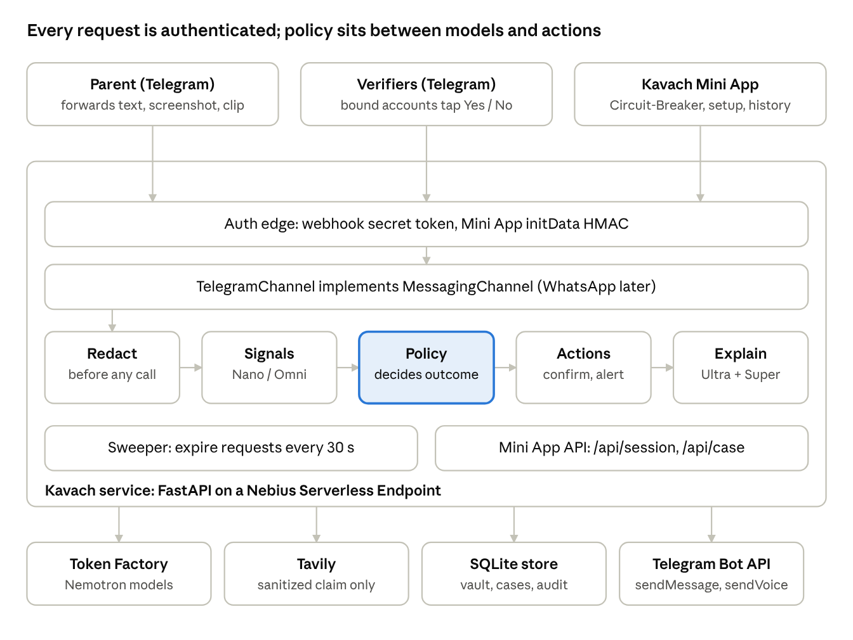
Kavach architecture · 3 clients, 1 service, 4 backing services
Requests pass the auth edge and the channel adapter before the core sees them; models feed signals and explanations, but only the Policy box chooses an outcome.

Components
The safety core is built and tested; the work left is adapters around it, and none of them may decide an outcome.
Component | Owns | Status
core/policy.py | The only place outcomes and actions are decided; precedence rules 1–5 | Built, tested
core/pipeline.py | Case lifecycle: redact, extract, decide, act; confirmation requests with nonce, expiry, single use | Built, tested
core/redaction.py | Masks OTP, card, account, UPI, IFSC, PAN, phone, password before any outbound call | Built, tested
core/vault.py | Guardian-approved verifiers bound to a channel ID; optional self-shared phone | Built, tested (in memory)
core/audit.py | Append-only redacted log with a keyed HMAC content digest | Built, tested (in memory)
channels/telegram.py | Telegram parsing, buttons, webhook secret and Mini App initData validation | Built, tested (fixtures only)
app/ (FastAPI) | Webhook route, Mini App API, static Mini App files, expiry sweeper | To build
adapters/http.py | Real HttpClient for Telegram with timeouts and retries | To build
models/ | Nano / Nano Omni extractor, Super replier, Ultra evidence explainer on Token Factory | To build
evidence/tavily.py | Sanitized-claim search, domain allowlist, date check, cached demo advisory | To build
store/ | SQLite persistence for vault, cases, requests, audit | To build
miniapp/ | Setup, Circuit-Breaker screen, consent, history, routing panel | To build
bench/ | 30 dev + 60 held-out synthetic cases, runner, metrics report | To build

Request flow
Three entry points reach the service; every one is authenticated before the core sees it.

1. Parent forwards a message (POST /tg/webhook)
- Check the X-Telegram-Bot-Api-Secret-Token header in constant time; reject on mismatch.
- Answer Telegram with 200 at once and run the check as a background task, so Telegram never retries.
- TelegramChannel.parse_inbound builds an InboundMessage; the pipeline rejects anyone who is not the bound parent.
- Media only: download the file by file_id to a temp path, send it to Nano Omni (or ASR then Nano), delete the file.
- redact() masks identifiers; only the redacted text goes to any model or to Tavily.
- Nano returns RiskSignals as schema-validated JSON; invalid twice means Pause.
- policy.decide() picks the outcome and actions.
- Actions run in a fixed order: confirmation request, Circuit-Breaker button, guardian alert.
- Tavily searches the sanitized claim; Ultra writes the evidence summary and reasons; Super writes the explanation around the fixed template.
- Reply to the parent, write the audit entry, store the case.

2. Verifier taps Yes or No (callback_query)
- Same webhook secret check.
- Parse kv:c|r:<request_id>:<nonce> and the actor's Telegram ID.
- Load the request; ignore it unless the actor, nonce, expiry and single-use checks all pass.
- Mark it consumed, run policy.apply_confirmation, notify the parent and audit.
- A sweeper every 30 seconds expires unanswered requests and escalates to the guardian.

3. Parent opens the Mini App (/app/pause?case=<id>)
- The page sends Telegram.WebApp.initData to POST /api/session.
- The server validates the HMAC with the bot token and the auth_date age, then issues a short session cookie.
- The API returns the case only if the signed user is that case's parent: headline, recorded message, callback number, recovery steps.
- The one-tap call is a tel: link to the contact's self-shared number; the URL never carries a phone number.

Data model and storage
Six SQLite tables behind a Store protocol hold everything; raw messages and media are never written to disk.
Table | Key columns | Never stores | Retention
family | family_id, parent_name, language, guardian_contact_id, recorded_message_ref, escalation_rule | Location, routines, bank details | Until the family deletes it
contact | contact_id, family_id, name, relationship, approved_by_guardian, is_guardian, phone (optional), phone_self_shared | A phone not shared by its owner | Until removed by the guardian
identity | contact_id, channel, user_id, bound_at | Telegram usernames or profile data | With its contact
case | case_id, reporter_id, redacted_text, signals JSON, outcome, history, high_risk, identity_route_verified, created_at | Raw text, media, unmasked numbers | 30 days
confirmation_request | request_id, case_id, claimed_contact_id, expected_verifier_id, nonce, expires_at, consumed_at | Answers from anyone but the expected verifier | With its case
audit | at, case_id, event, detail JSON (redacted), content_digest (HMAC) | Plain hashes of content | 30 days
The Store protocol keeps core/ free of SQL: the in-memory classes used by the tests stay as one implementation and store/sqlite.py is the other. SQLite sits on a mounted volume; if the Serverless Endpoint has no persistent volume, the same code runs on a Nebius VM (see Risks).

Repo layout and interfaces
New folders wrap the existing slice; core/ gains only two protocols and never imports a vendor SDK.
kavach/
channels/ base.py, telegram.py, fake.py (built)
core/ policy, pipeline, redaction, vault,
audit, templates, models (built)
+ store.py Store protocol
+ explain.py Explainer / Replier / EvidenceSource protocols
adapters/ http.py httpx client for Telegram
models/ nemotron.py extractor (Nano/Omni), replier (Super),
explainer (Ultra) via Token Factory
schemas.py JSON schemas for every model output
evidence/ tavily.py sanitized search, allowlist, date check, cache
allowlist.yaml official domains
store/ sqlite.py Store implementation + migrations
app/ main.py FastAPI: /tg/webhook, /api/*, /app/*, /healthz
sweeper.py expires requests every 30 s
settings.py env-based config, no defaults for secrets
miniapp/ index.html, pause.html, setup.html, history.html, app.js
bench/ cases/dev/*.json, cases/heldout/*.json, run.py, report.py
deploy/ Dockerfile, endpoint.yaml
tests/ existing 55 + new adapter, store, API and bench tests
The new protocols, so models stay advisory:
class Explainer(Protocol): # Ultra
async def explain(self, redacted_text: str, signals: RiskSignals,
evidence: list[Evidence]) -> Explanation: ...
# Explanation = summary, reasons, citation_relevance. No outcome field.
class Replier(Protocol): # Super
async def reply(self, template: str, explanation: Explanation,
language: str) -> str: ...
class EvidenceSource(Protocol): # Tavily
async def search(self, sanitized_claim: str) -> list[Evidence]: ...

Build schedule
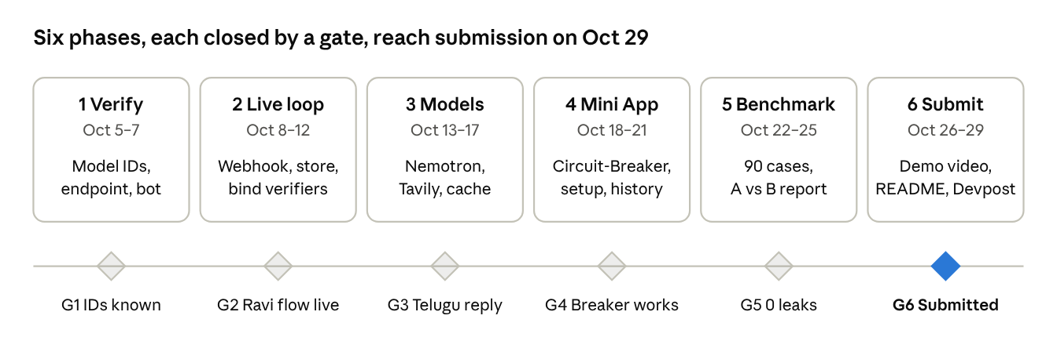
Build roadmap · 6 phases, 6 gates, Oct 5–29
A phase starts only when the previous gate passes; the gate criteria are in Testing and acceptance gates. The official deadline (Oct 30, 10:30 PM IST) leaves one day of buffer after G6.

Phase tasks
Each phase ends on a gate that is checked on a real phone, not only in tests.

Phase 1 — Verify capabilities (Oct 5–7)
- ☐ List Token Factory models via /v1/models; record exact IDs for Nano, Nano Omni, Super, Ultra
- ☐ Send one synthetic voice clip and one video clip to Nano Omni; note the ASR fallback if it fails
- ☐ Schema-validated JSON test call on each model
- ☐ Tavily search with an include-domains list; confirm results carry a date
- ☐ Deploy a hello-world container to a Nebius Serverless Endpoint; check for a persistent volume
- ☐ Create the bot with BotFather, set the webhook with a secret token, open a test Mini App page

Phase 2 — Live Telegram loop (Oct 8–12)
- ☐ app/main.py: webhook route, secret check, 200-then-background handling, /healthz
- ☐ adapters/http.py: httpx client with timeouts and one retry
- ☐ store/sqlite.py + Store protocol; switch the pipeline from in-memory dicts
- ☐ Verifier binding: /start <invite code> binds a Telegram ID to a guardian-approved contact
- ☐ Self-shared phone via a request_contact button, parsed by parse_self_shared_phone
- ☐ Expiry sweeper task

Phase 3 — Models and evidence (Oct 13–17)
- ☐ models/nemotron.py: extractor, replier, explainer behind the protocols; JSON schemas in models/schemas.py
- ☐ Media path: download, Omni or ASR, transcript redaction, temp-file delete
- ☐ evidence/tavily.py: sanitized claim builder, allowlist, date filter, Extract for one quoted line
- ☐ Cached demo advisory (dated) plus a live refresh endpoint
- ☐ Per-check trace: models called, latency, tokens, cost in rupees

Phase 4 — Mini App (Oct 18–21)
- ☐ /api/session with server-side initData validation
- ☐ Circuit-Breaker page: headline, recorded message player, one-tap tel: call, recovery checklist
- ☐ Setup page: add verifiers, record and approve the message, language, escalation rule, consent
- ☐ History page: cases, rule fired, routing panel, redaction before/after view

Phase 5 — Benchmark and hardening (Oct 22–25)
- ☐ Write 30 dev cases, then 60 held-out cases; freeze held-out before the run
- ☐ bench/run.py: systems A and B with everything held constant except family verification
- ☐ bench/report.py: the metrics table, latency p50, cost per check
- ☐ Native-speaker review of Telugu and Hindi templates
- ☐ Optional, 1-day timebox: OpenShell egress policy

Phase 6 — Demo and submission (Oct 26–29)
- ☐ Record the 3-minute demo on synthetic data with the cached advisory
- ☐ README: architecture, security, redaction and retention boundaries, cost table
- ☐ Devpost page, repo link, video; submit Thu Oct 29

Deployment, config and secrets
One container image runs on a Nebius Serverless Endpoint behind HTTPS; every secret comes from the environment and the app refuses to start without it.
Setting | Purpose | Where it lives
TELEGRAM_BOT_TOKEN | Bot API calls and initData validation | Endpoint secret
TELEGRAM_WEBHOOK_SECRET | Checked on every webhook call | Endpoint secret
NEBIUS_API_KEY | Token Factory calls (OpenAI-compatible, https://api.tokenfactory.nebius.com/v1/) | Endpoint secret
TAVILY_API_KEY | Evidence search | Endpoint secret
AUDIT_HMAC_KEY | Keyed audit digest, at least 16 bytes | Endpoint secret
MODEL_NANO, MODEL_OMNI, MODEL_SUPER, MODEL_ULTRA | Exact model IDs recorded in Phase 1 | Plain env
MINI_APP_URL | https base for Mini App buttons | Plain env
DB_PATH | SQLite file on the mounted volume | Plain env
The container is Python 3.13 slim with FastAPI, uvicorn, httpx and the OpenAI SDK, running as a non-root user. Logs carry case IDs and rule names only, never message text. The webhook URL is set once with setWebhook including secret_token.

Testing and acceptance gates
The 55 existing safety tests must stay green on every commit; each phase adds its own layer and one gate.
Layer | What it proves | Tool
Unit (existing) | Policy precedence, single-use requests, redaction, keyed audit, initData | pytest, FakeChannel
Store | SQLite and in-memory stores pass the same contract tests | pytest, parametrized
API | Webhook rejects a bad secret; Mini App API rejects bad initData and other parents' cases | FastAPI TestClient
Model adapters | Invalid JSON retried once then Pause; Ultra output has no outcome field | Recorded responses, no live calls in CI
Leak check | No planted OTP, account, card, UPI or password reaches a model, Tavily, a log or a reply | pytest with a recording HTTP stub
End to end | The three demo scenarios on a real Telegram account | Manual script, screen-recorded
Benchmark | A vs B on 60 held-out cases | bench/run.py

Gate | Pass when
G1 Capabilities known | Model IDs recorded; a fallback chosen for anything that failed
G2 Live loop | "Mom, it's Ravi" on two real phones: Ravi taps Reject, parent sees Likely scam
G3 Grounded replies | Digital-arrest clip gives Likely scam, a dated advisory or the "still verify" line, reply in Telugu
G4 Circuit-Breaker | Button opens the Mini App; recording plays; call button dials the shared number
G5 Numbers | Benchmark report generated; 0 false Identity route verified; 0 leaks
G6 Submitted | Video, repo and Devpost page live by Oct 29

Risks and fallbacks
Every risk below has a fallback that keeps the demo story intact; none of them touch the policy core.
Risk | Signal | Fallback
Nano Omni not available for audio/video | Phase 1 test call fails | NVIDIA ASR, then Nano on the transcript
Serverless Endpoint has no persistent volume | Phase 1 check | Same container on a Nebius VM
Telugu or Hindi reply quality is poor | Native review in Phase 5 | Fixed templates carry the meaning; explanation in English
Tavily returns no dated official advisory | Empty or undated results | Kavach says identity verification is still required; no forced citation
Model JSON invalid | Schema check fails twice | Pause and verify
Telegram media size limit on the demo clip | Upload fails in Phase 1 | Trim the clip
Schedule slips | A gate missed by more than one day | Cut the history page and OpenShell first; never cut the verification flow or the benchmark

