Ecommerce

**INDEX**

**1. Description Of Use Case**

**2. List Of API’s**

**3. Screen shots of each API Input and Output**

**4. Validations**

**5. Exceptions**

**6. Test cases for API’s**

**7. Code Coverage**

1. **Description Of Use case**

E-Commerce is platform to list the products for the various categories sellers can register and users can buy the various products.

Use Case:

* Register
  + Users can be sellers or buyers
  + Update the profile
* Login.
  + Users have to login to ecommerce platform.
* Products
  + Sellers can register the products of various categories
  + Get the list of the all products
  + Get the list of the products by category
  + Get the product details by name
* Get the list of users who are buyers
* Get the list of users who are sellers.

1. **List Of API’s**
2. **User Registration**

User through this api register with as a Seller or Buyer.

1. **Update User**

User through this api update profile.

1. **Login**

User through this api login with registered valid credentials.

1. **Add Category**

If User is a Seller can add the Category.

1. **Add Product**

If User is a Seller can add the Product.

1. **All Products**

If user is a Buyer can see all the available products.

1. **All Products By Category**

If user is a Buyer can see all the available products by category.

1. **Product Details**

If user is a Buyer can see the product details through product name.

1. **All Users**

Through user role we can see all the users.

1. API’s Screen Shot Input and Output
2. **User Registration**

User through this api register with as a Seller or Buyer.

**Input:**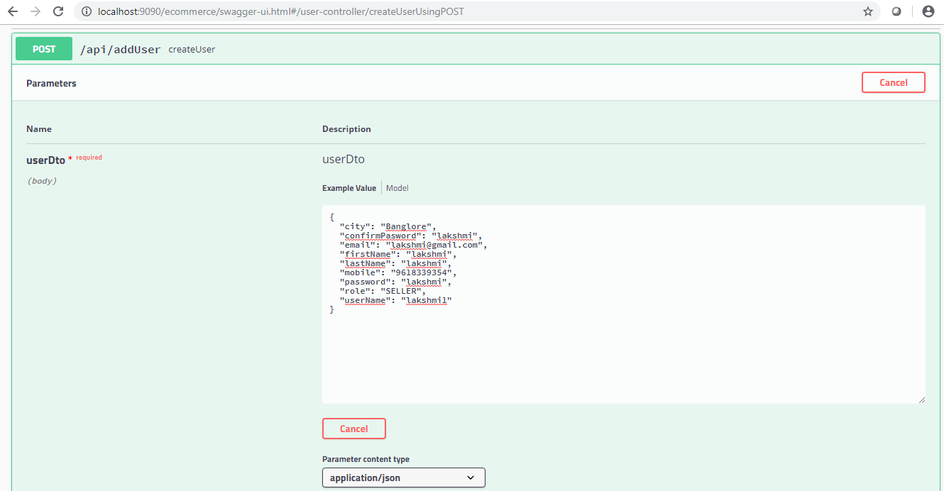

**Output:**

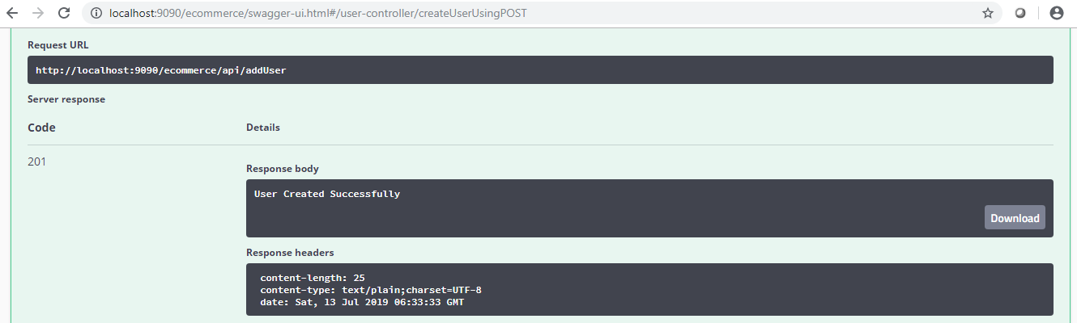

**DataBase:**

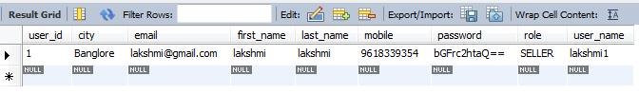

1. **Update User**

User through this api update profile.

**Input:**

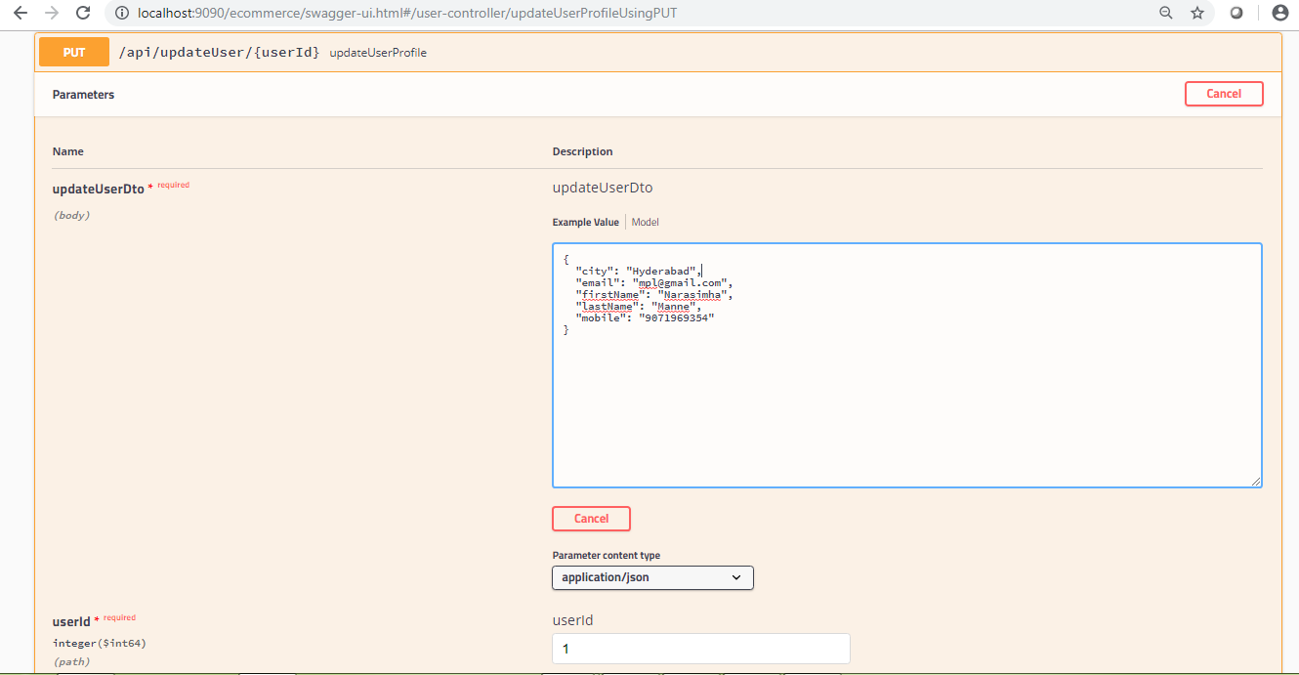

**Output:**

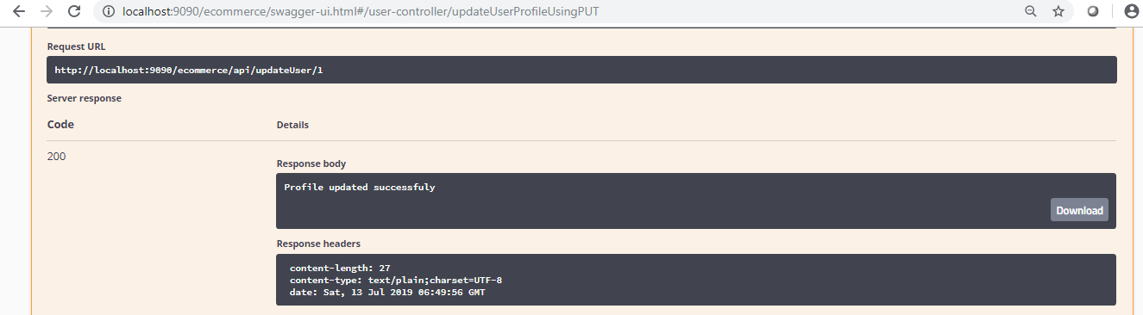

**DataBase:**

Before Updating:



After Updating:

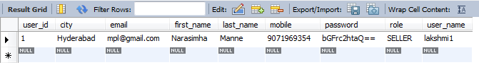

1. **Login**

User through this api login with registered valid credentials.

**Input:**

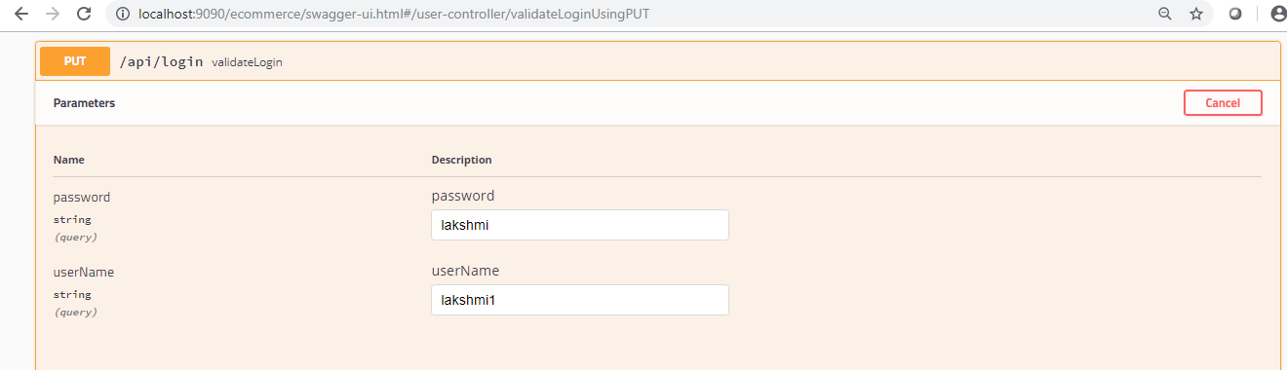

**Output:**

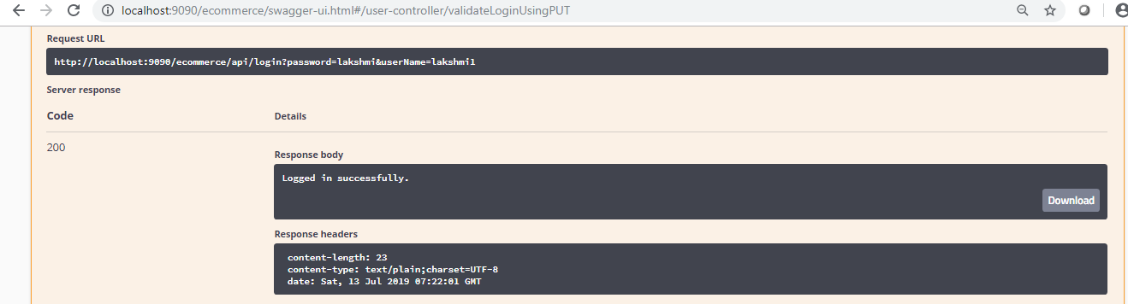

1. **Add Category**

If User is a Seller can add the Category.

**Input:**

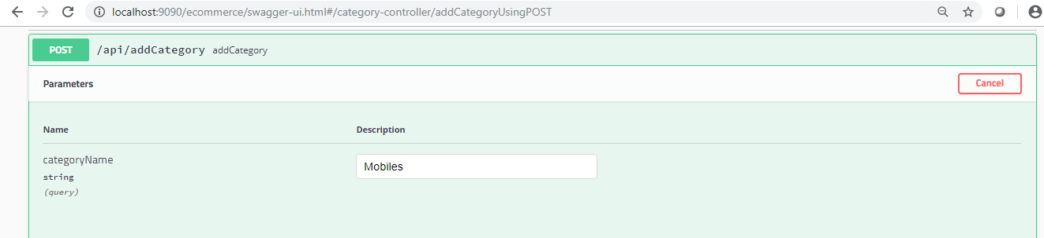

**Output:**

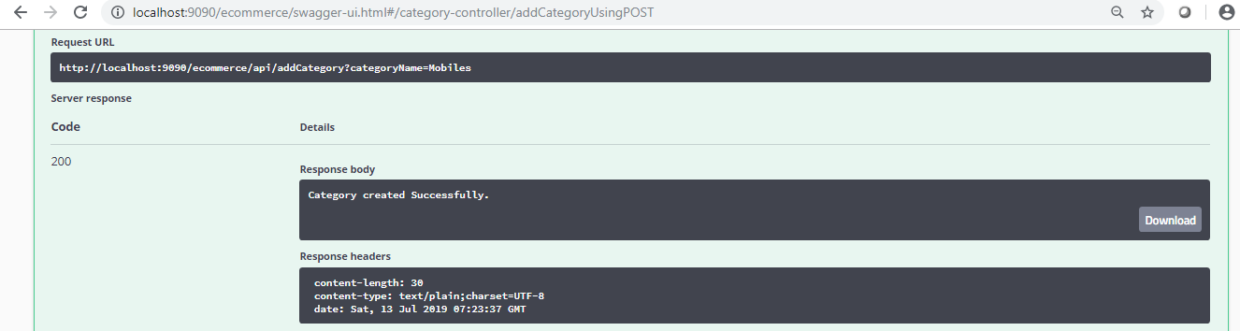

**DataBase:**

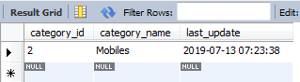

1. **Add Product**

If User is a Seller can add the Product.

**Input:**

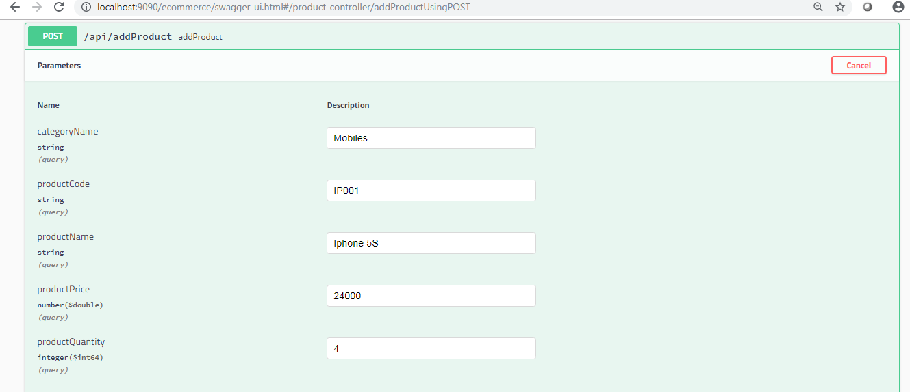

**Output:**

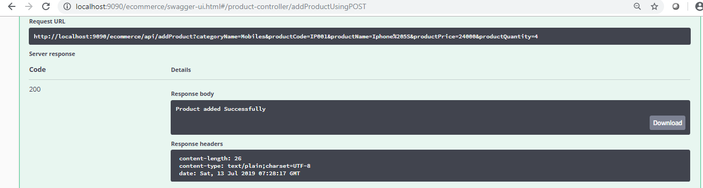

**DataBase:**

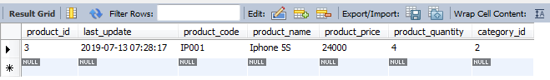

1. **All Products**

If user is a Buyer can see all the available products.

**Input:**

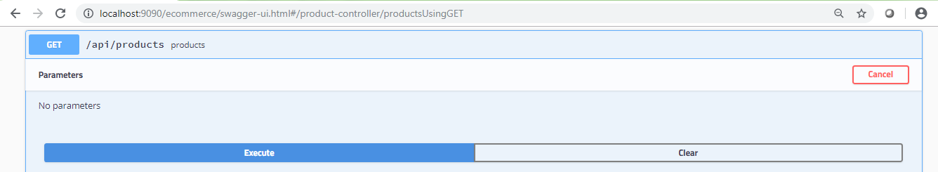

**Output:**

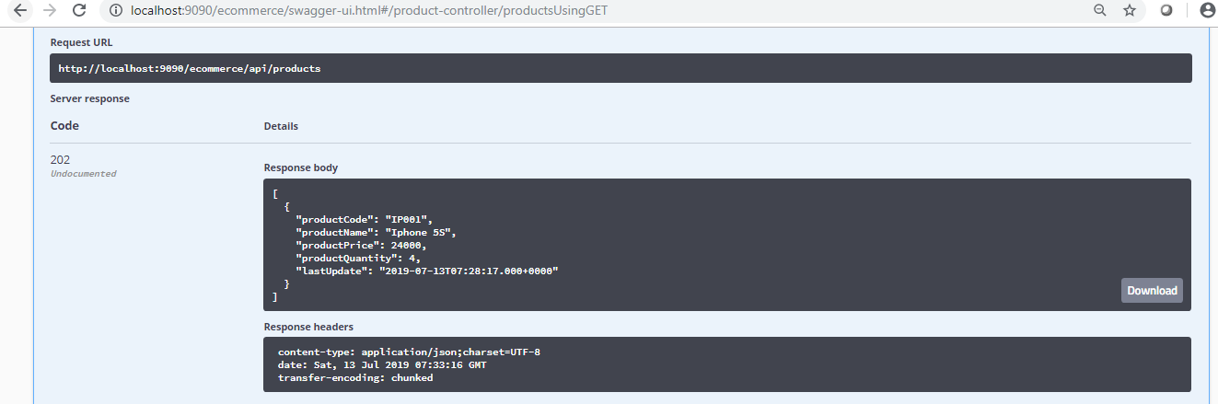

1. **All Products By Category**

If user is a Buyer can see all the available products by category.

**Input:**

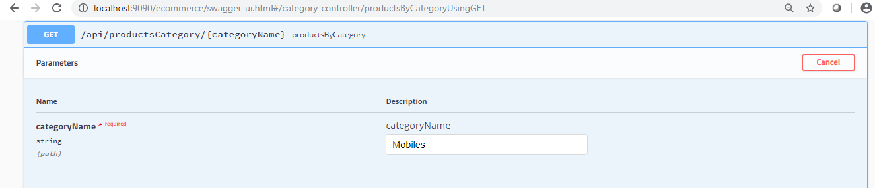

**Output:**

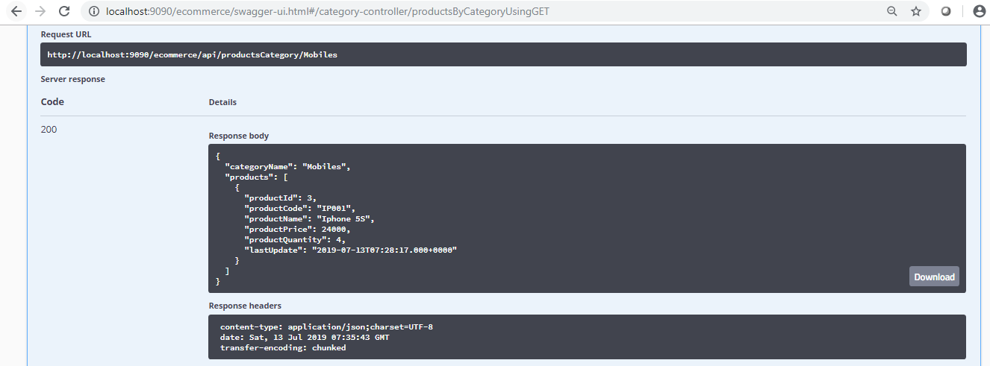

1. **Product Details**

If user is a Buyer can see the product details through product name.

**Input:**

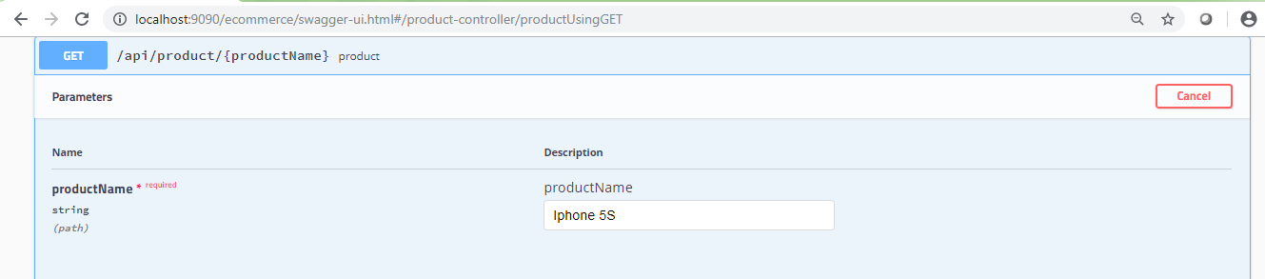

**Output:**

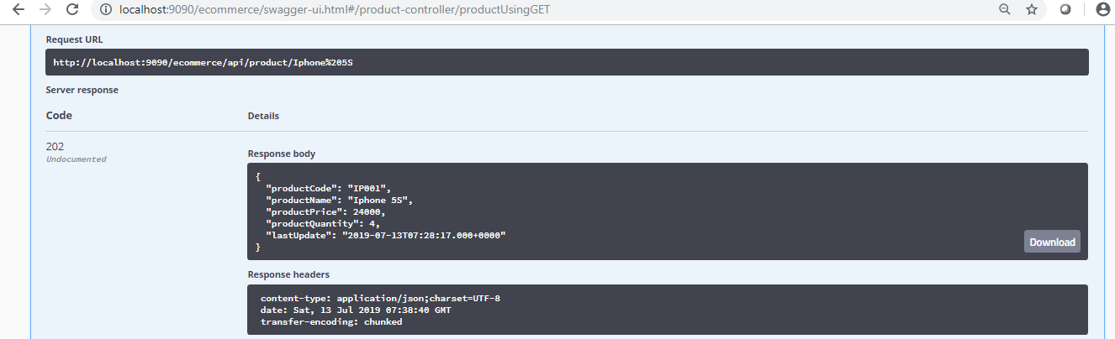

1. **All Users**

Through user role we can see all the users.

**Input:**

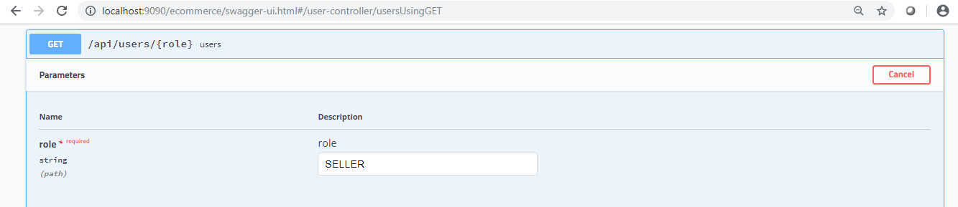

**Output:**

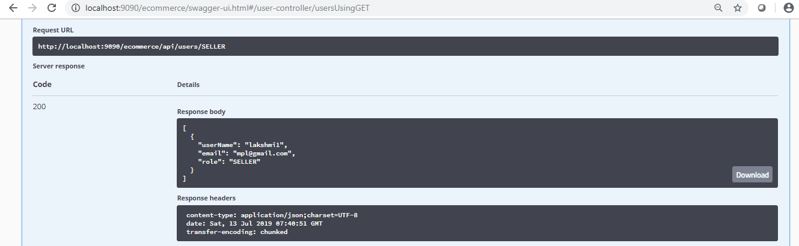

1. **Validations And Exceptions:**

**Add User , Update User Validations And Exceptions**

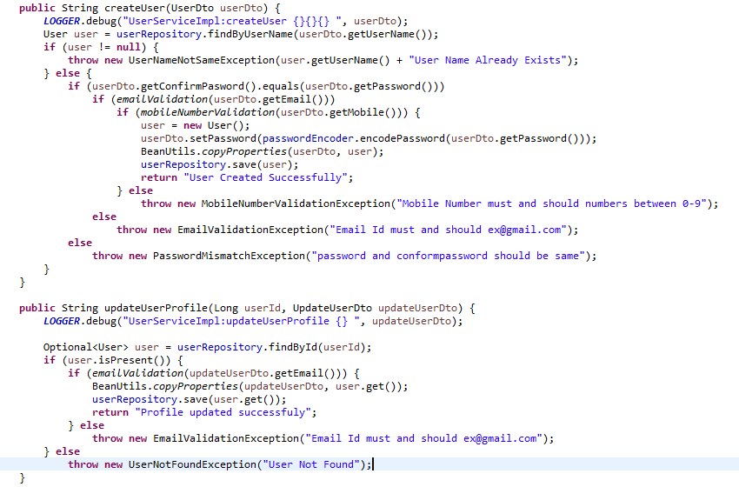

**Input With Wrong Email Pattern Same For Update and Add User**

In this input in email field I have missed with ‘@’

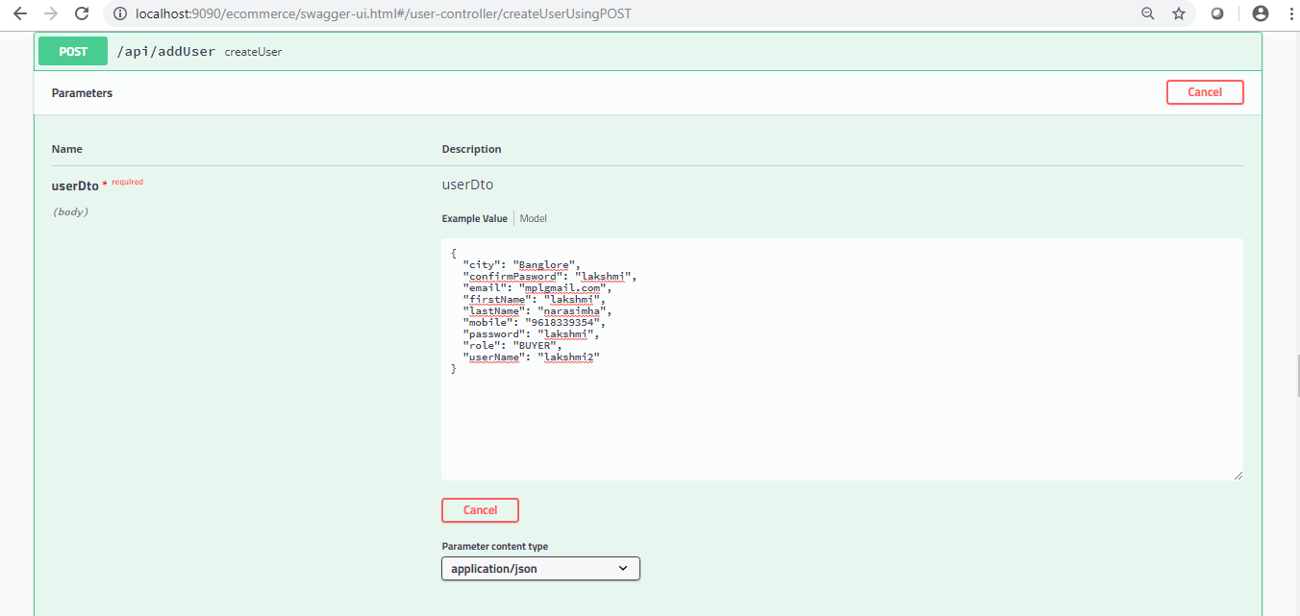

**Output :**

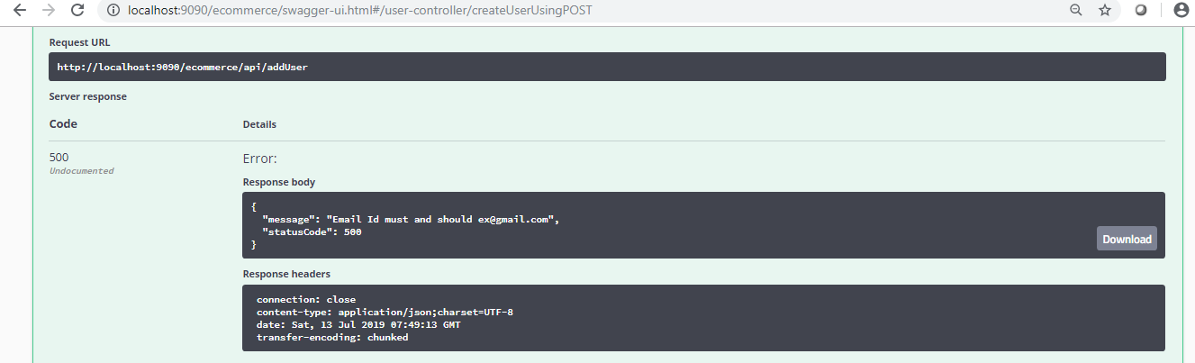

**Input With Wrong Mobile Number Pattern For Add User**

In this input I have given mobile number 9 digits

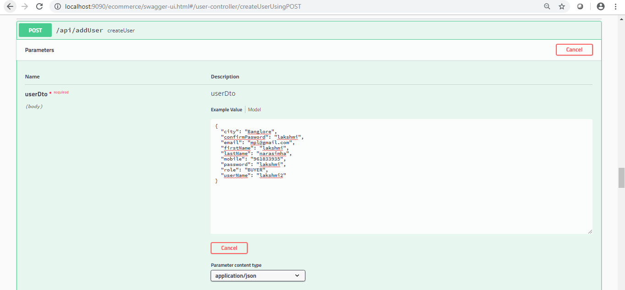

**Output :**

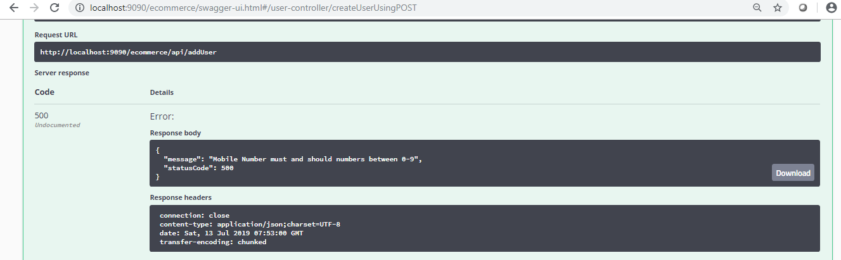

**Input With Wrong password and conform password For Add User**

In this input I have given password and conform password different.

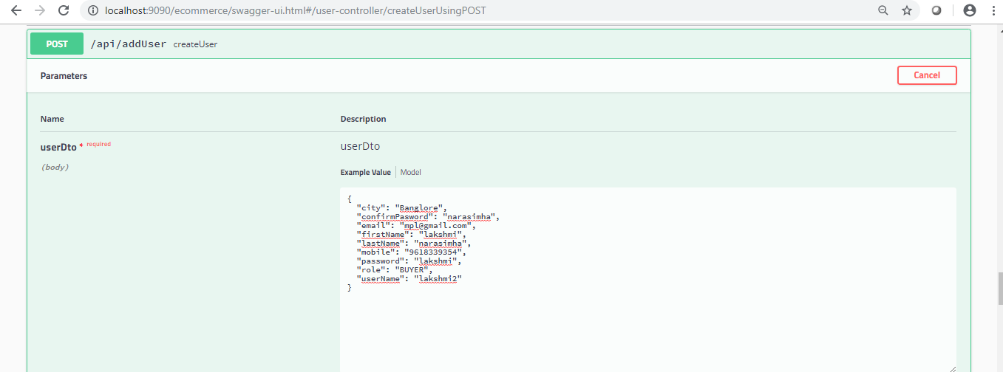

**Output :**

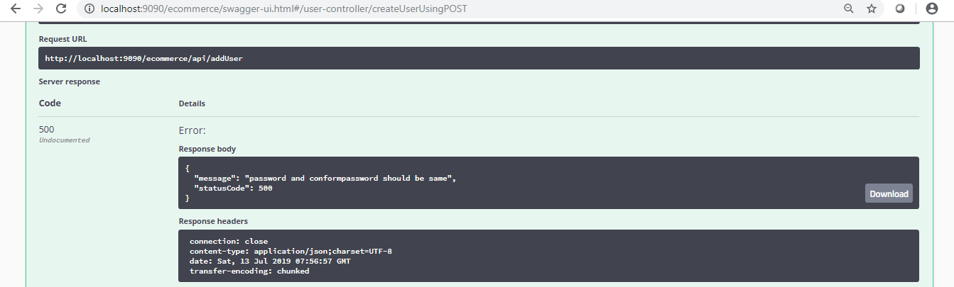

**Input With Same User Name In DatBase For Add User**

In this input I have given User Name in data base already we have username

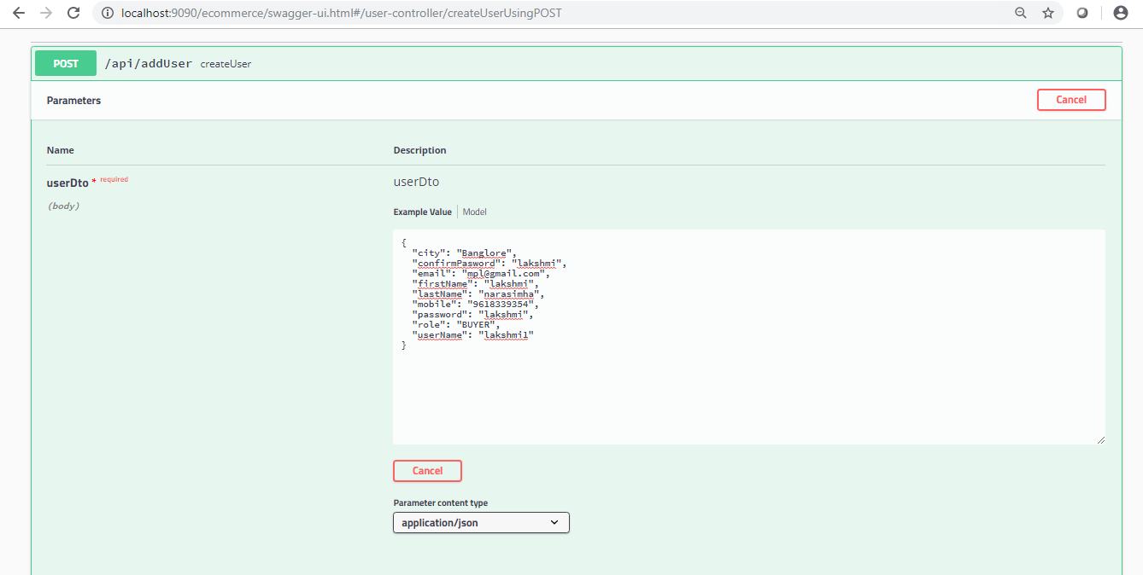

**OutPut:**

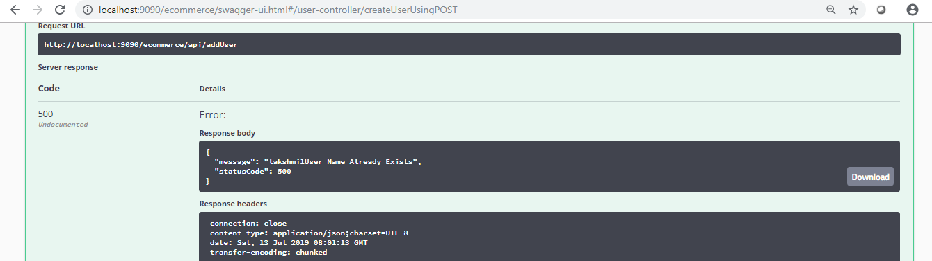

1. **Test cases for API’s & Code Coverage:**

This Test cases Report Pending, because of in my Laptop Some Sonar Qube Issues, I will come with Code Coverage report on Monday.