Mortgage

**INDEX**

**1. Description Of Use Case**

**2. List Of API’s**

**3. Screen shots of each API Input and Output**

**4. Validations**

**5. Exceptions**

**6. Test cases for API’s**

**7. Code Coverage**

1. **Description Of Use case**

Mortgage is platform for customer signup the different mortgages and if mortgage approved then customer can eligible for Mortgage.

1. **List Of API’s**
2. **SignUp**

Customer can signup with the valid data .

1. **Login**

If Customer is eligible they will give credentials.

1. **Account Summary**

After login to the customer it will show the accounts.

1. **Transactions**

After login if we click on the account page it will shows the transactions.

1. **Batch Process**

Here we are setting every month some transactional amount to process auto.

1. API’s Screen Shot Input and Output
2. **SignUp**.

**Business Logic:**

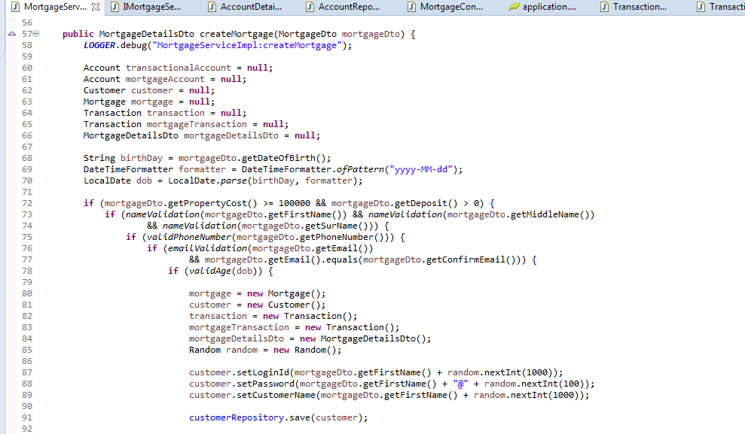

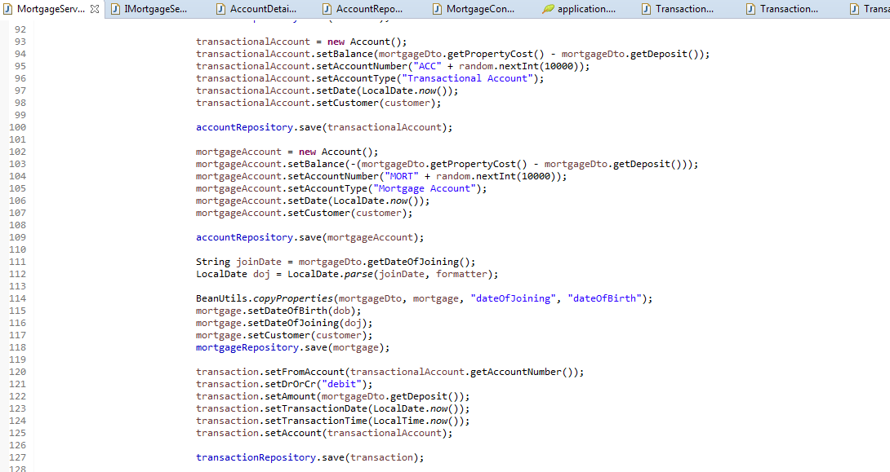

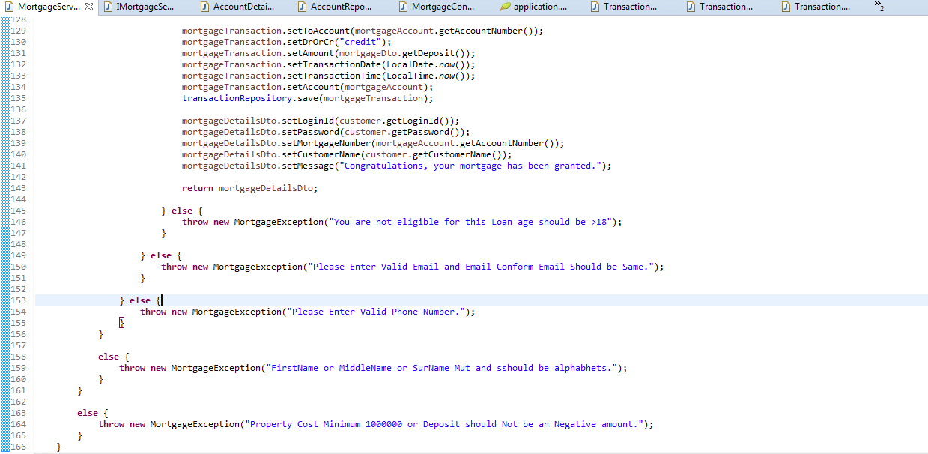

**Input:**

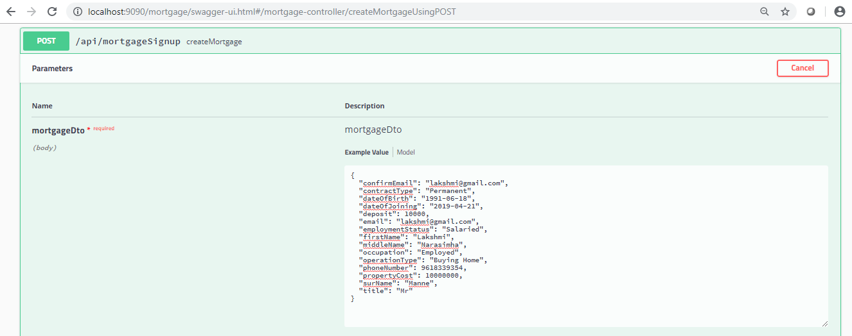

**Output:**

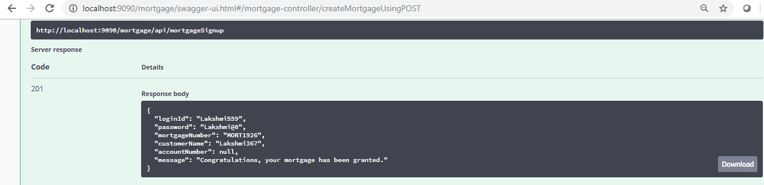

**DataBase:**

Mortgate :



Account:

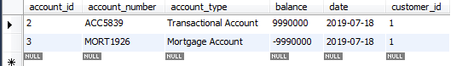

Customer



Transaction

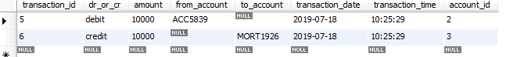

1. **Login**.

**Business Logic:**

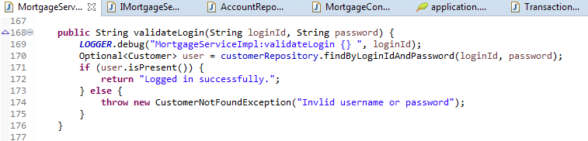

**Input:**

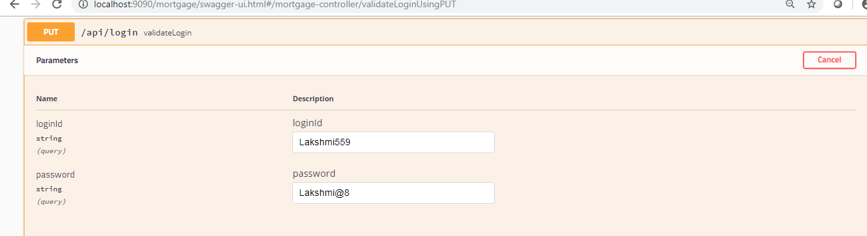

**Output:**

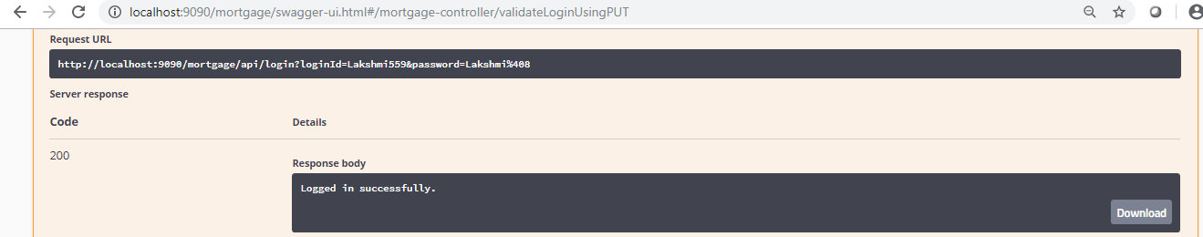

1. **Account Summary**

**Business Logic:**

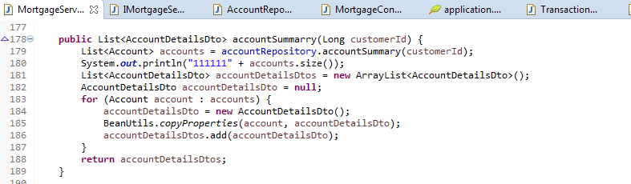

**Input:**

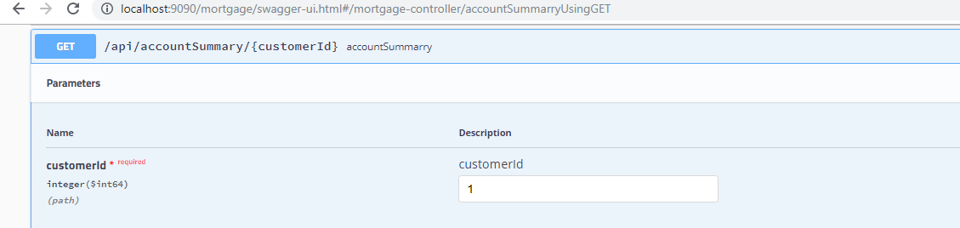

**Output:**

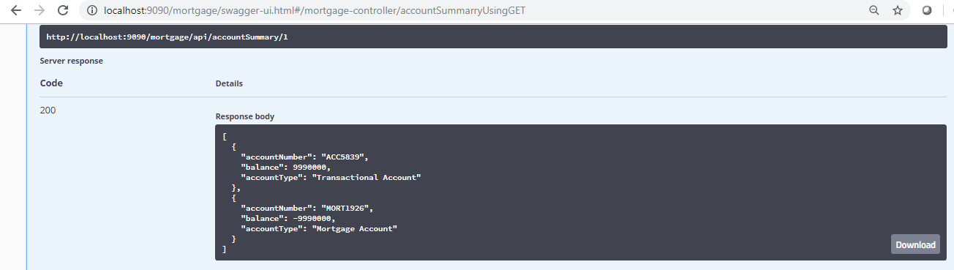

1. **Transactions**

**Business Logic:**

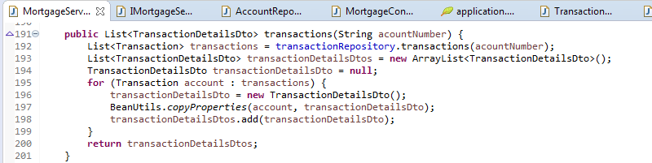

**Input:**

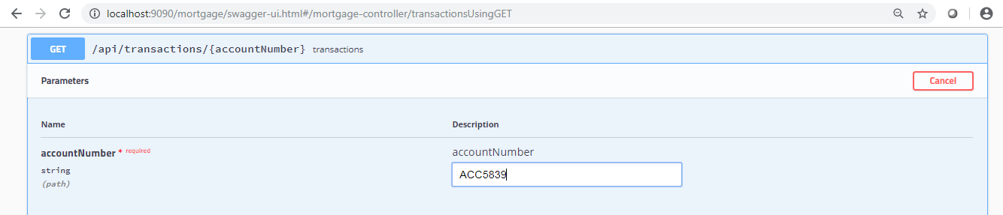

**Output:**

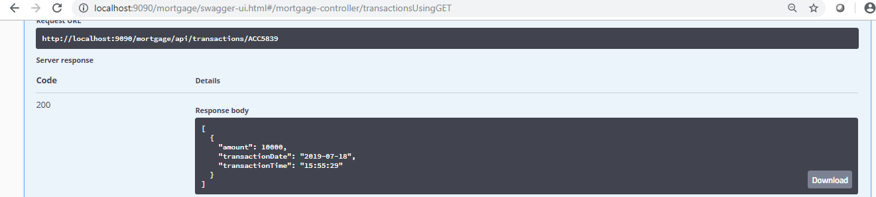

1. **Batch Process:**

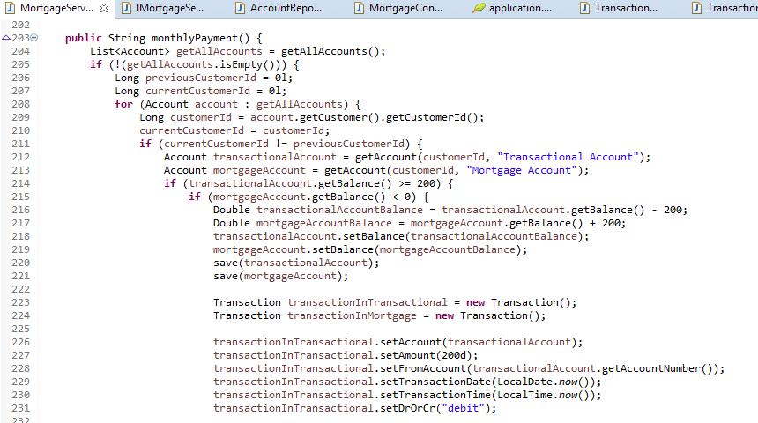

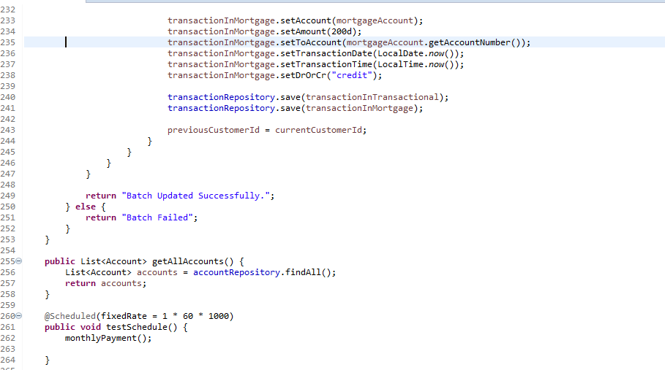

**Input:**

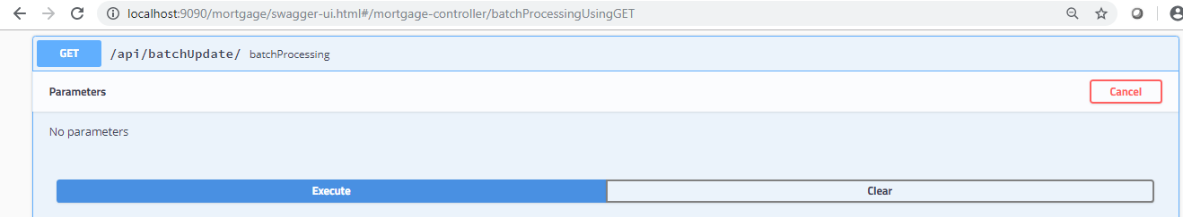

**Output:**

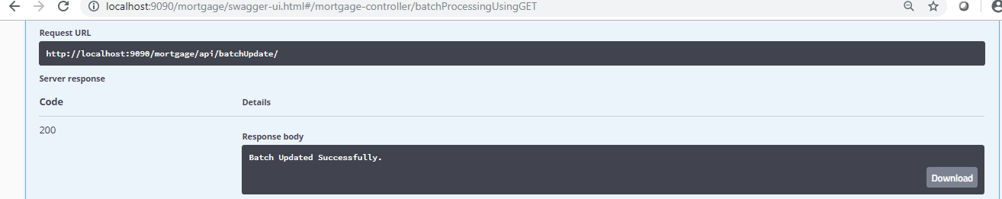

**DataBase:**

Befor Batch Process



After Batch Process

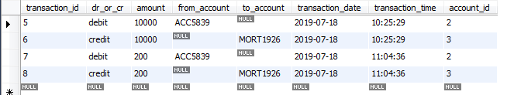

1. **Validations And Exceptions:**

**SignUp Mortgage Validations And Exceptions**

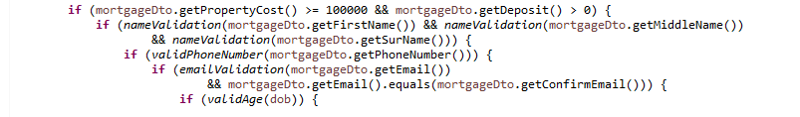

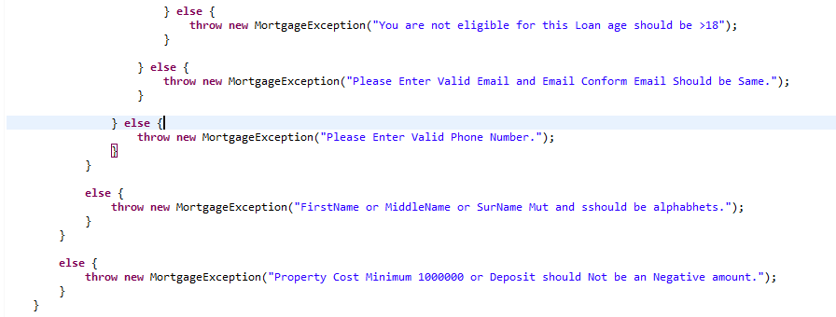

1. **Test cases for API’s & Code Coverage:**

Test cases and coverage I will give you later am working on that.