Splining Framework and Ontology

Lakshmi Krishnamurthy
v0.07, 20 Mar 2013

Framework Symbology and Terminology

- C⁰, C¹, and C² Continuity: C⁰ refers to base function continuity. C¹ refers to the continuity in the first derivative, and C² refers to continuity in the second.
- Parameterized Splines: Here the space formulation is in the local variate space that spans 0 to 1 within the given segment – this is also referred to as piece-wise parameterization. This appears to automatically render the coefficient matrix tri-diagonal!
- Bias: This is the left hand term in the Spline Objective Function – essentially measures the exactness of fit.
- Variance: This is the right hand term in the Spline Objective Function – essentially measures the curvature/roughness.

Motivation, Advantage and Purpose

- Definition: “Spline is a sufficiently smooth polynomial function that is piecewise-defined, and possesses a high degree of smoothness at the places where the polynomial pieces connect (which are known as knots).“ [1, 2, 3]
- Advantages:
  - Lower degree, gets rid of oscillation associated with the higher degrees [4]
  - Easy, accurate higher degree smoothness specification
- Uses: Polynomial interpolation

Literature Review

- Basic Spline: Covered in [1, 2, 3, 4].
- Tension Spline: Covered in [5]
- Smoothing Spline:

Purpose of the Document

- Construct a framework for knowledge-capture, system partition, functional implementation, different basis splines, and their properties, characterization, and calibration.
- Local/global formulation
- Calibration techniques
- Jacobian
- Smoothing

Generic Formulation

- Base Mathematical formulation:
- Analogies to energy minimization over stretches/surfaces
- Include notes on segment naturalization
- Span Boundary Specification:
- “Natural” Spline – Energy minimization problem
- “Financial” Spline
- Right Segment Locality Reduction: As you go from the left segment to the right segment, the local segment perturbation impact diminishes due to the fact that information gets transmitted (through the C¹, and C² continuity constraints) to the right from the left. Locality is enhanced if, in some sense, “local” information > the transmitted information. Interpolating splines strive to achieve this.

Interpolating Splines

- Hermite Cubic Splines: The “local information” here takes the form of user specified left/right slopes.
  - 2 User Specified local slopes + 2 points => 4 sets of equations. Solve for the coefficients.
  - C¹ continuity is maintained, and C² continuity is not.
  - Segment control is completely local.
- Catmull-Rom Cubic Splines: Instead of explicitly specifying the left/right segment slopes, they are inferred from the “averages” of the prior and the subsequent points, i.e., 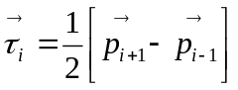, and 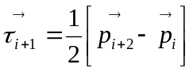. Here 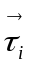refers to the slope vector, and 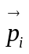 to the point vector.
  - Again, C¹ continuity is maintained, and C² continuity is not.
  - Segment control is not completely local, but still local enough – it only depends on the neighborhood of 3 points.
- Cardinal Cubic Splines: This is a generalization of the Catmull-Rom spline with a tightener coefficient , i.e., 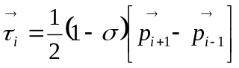, and 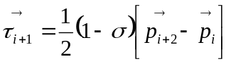. 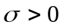 corresponds to tightening, and 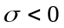 corresponds to loosening.
  - Again, C¹ continuity is maintained, and C² continuity is not.
  - Segment control is “local” in the Catmull-Rom sense - it only depends on the neighborhood of 3 points.

Space Curves and Loops

- Space Curve Reproduction: Here is one way to construct loops that are not possible using the ordered variates, i.e., 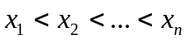.
- If the ordering is switched out in favor of the DAG 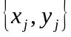, where the DAG vertices correspond to the loop trace, normal splines may be used to represent space curve loops.
- Second Degree Parameterization: However, on using a second-degree parameterization of x and y such as 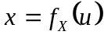 and 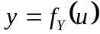, it may be possible to enforce the order 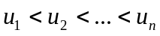. The corresponding control points are 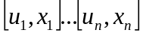 and 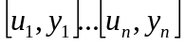.
  - Side effect of this – is that you need to work on two pairs of splines – one each for and .
  - This can offer additional customization and freedom in the design of the surface, at the expense of computing additional splines.
- Closed Loops: Further, if the start/end points coincide, this corresponds to a closed loop that satisfies the C² continuity criterion.
  - This also implies that no extra head/tail C¹ slope specifications are required.

Spline Calibration

- Spline Segment Calibrator: Spline segment calibration has an asymmetrical dependence on the left/right calibration value. For a given span, the calibration of the non-left most segment depends only on the right most value – the other coefficients come from the prior segments. The left most segment, of course, uses both the left/right values for calibration.
- Span-to-segment constraint transmission
- Number of unknowns analysis

Spline Jacobian

- Self-Jacobian: Given an ordered pair 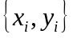 that needs to be interpolated/splined across, the self-Jacobian is defined as the vector 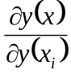.
  - Self-Jacobian tells you the story of sensitivity/perturbability of the interpolant (y) around non-local points. Among the splines, quadratic and greater splines cause fairly non-banded, dispersed Jacobians, indicating that the impact is non-local; linear splines produce simple banded/tri-diagonal Jacobians; and tension splines produce a combination of the two depending on the tension parameter.
  - Further Jacobian of any function 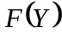 is going to be dependent on the self-Jacobian 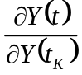 because of the chain rule.

Polynomial Spline

- Base functional specification (Linear, Quadratic, Cubic, Quartic, Polynomial)
- Linear, Quadratic, Cubic, Quartic, Polynomial Basis Functions
- Cubic Splines and Inflection Knots => Problem with the inflection knot points with cubic splines is that the “inflection” is now an extraneously supplied constraint, and in general may not be consistent with the C² criterion.
- Segment interpolation relation
- Control point analysis
- Truth-ness specification
- Smoothness constraint
- Span-to-segment constraint transmission
- Number of unknowns analysis
- Solving for coefficients

Interpolation Spline

- Hermite
- Catmull-Rom
- Cardinal

Tension Spline

- Types
- Base functional specification (Exponential and Hyperbolic)
- Exponential Basis Functions:
- Base Segment Formulation =>
  - 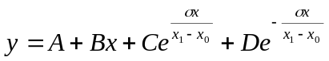
  - 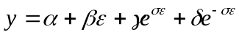
- Global <-> Local =>
  - 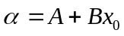
  - 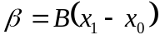
  - 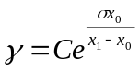
  - 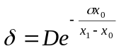
- Local <-> Global =>
  - 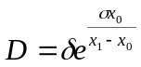
  - 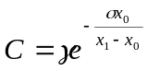
  - 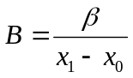
  - 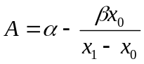
- Co-efficient Calibration =>
  - 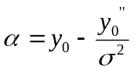
  - 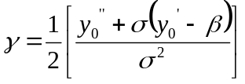
  - 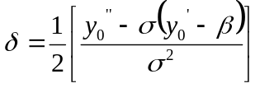
  - 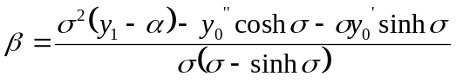
- Coefficient to Input Sensitivity Grid =>
  - 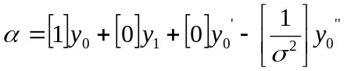
- Local Derivatives =>
  - 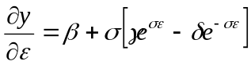
  - 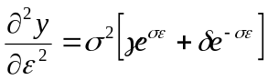
  - 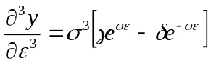
- Global <-> Local Derivatives =>
  - 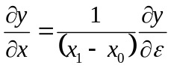
  - 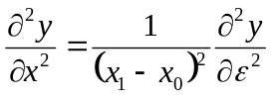
  - 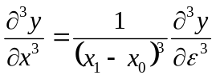
- Hyperbolic Basis Functions:
- Base Segment Formulation =>
  - 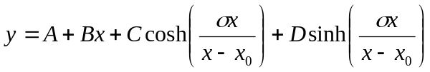
- Global <-> Local =>
  - 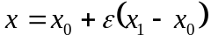
  - 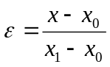
  - 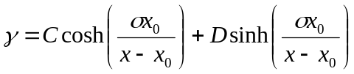
  - 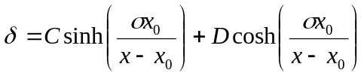
- Coefficient to Input Sensitivity Grid =>
  - 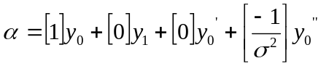
  - 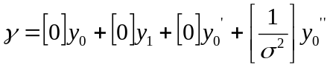
- Local Derivatives =>
  - 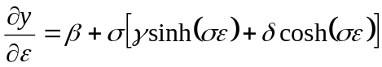
  - 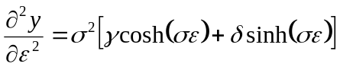
  - 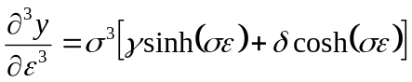
- Global <-> Local Derivatives =>
- Segment interpolation relation – reduction onto linear/cubic spline
- Switch between linear and cubic spline
- Alternate specifications of the segment interpolation [5, pp. 33 & 39, Question 3]
- Localized and normalized tension ([5], pages 22-23, 33 (Question 2), 35-38)
  - Finding σ when f is bound.
    - To get the minimum tension factor required we need to find the zeros of f’ [6].
  - Finding σ when f’ is bound.
    - To get the minimum tension factor required we need to find the zeros of f’ [6].
  - Finding σ from the bound values of convexity/concavity [6].
- Control point analysis
- Normalization of the tension parameter
- Truth-ness specification
- Smoothness constraint

Smoothing Splines

- Process Control using Weights: Dimensionless units (such as Reynolds’ number) can effectively account for the ratio of competing natural forces. Similar use can be done for process control to be able to guide/control between 2 or more competing objectives. For example in the instance of the smoothing spline:
- First Objective => Closeness of match using the most faithful reproducer, or curve fit.
- Second Objective => Smoothest curve through the given points, without necessarily fitting them – of course, “smoothest” possible “curve” is a straight line.
- Smoothing Spline Formulation: Given , and the function  that fits the points 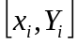 from 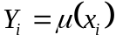. The smoothing spline estimate 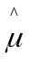 is the minimizer 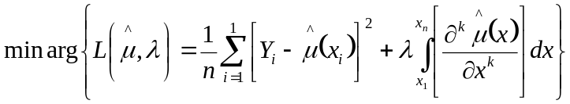
  - 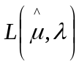 is called the Spline Objective Function.
  - 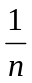 is needed to the left term to make it finite as , otherwise will also have to be infinite.
  - The derivative “k” corresponds to what makes 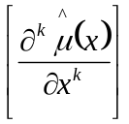 linear. Thus, for cubic splines, k = 2.
- Bias Curvature/Variance Fit Trade-off: Smaller the , the more you will fit for bias (low curvature penalty). Bigger the , more you fit for curvature/roughness penalty.
- Curvature Penalty Minimizer Spline: It can be theoretically shown that the curvature penalty minimizer spline is a cubic spline. Here is how.
  - First, notice that any spline of degree >= 0 can reproduce the knot inputs.
  - By default, curvature corresponds to k = 2. Thus, 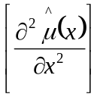 varies linearly inside a segment, thus this becomes the least possible curvature.
  - Higher order splines will have a non-linear curvature.
  - Lesser order (spline order less than 3) will violate the C² continuity constraint.
- Extension to k-Curvature Penalty: For the case where k > 2, we would need to choose a k+1 degree spline to retain linearity of the segment k-curvature – therefore, a k+1 degree spline is the k-curvature penalty minimizer spline. This also preserves the C^{k} continuity constraint,

Multi-dimensional Splines

- Radial Basis Functions: Use Cartesian/radial/axial basis functions to formulate the segments in terms of the surface vector coefficients
- Surface Energy Minimization: Surface energy minimization using the “sigma” tension parameter – formulate equation.
- Multi-dimensional smoothing: The trivial univariate ordering needs revising in the context of multivariates. A general “distance from focal node” makes to more sense to set in the ascending order. Thus 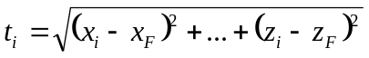, where 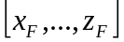 are the multivariate nodes corresponding to the focal node.

References

[1] Spline (Wiki): http://en.wikipedia.org/wiki/Spline_(mathematics)
[2] Judd, Kenneth L. (1998). Numerical Methods in Economics. MIT Press.
[3] Chen, Wai-Kai (2009). Feedback, Nonlinear, and Distributed Circuits. CRC Press.
[4] Runge’s phenomenan (Wiki): http://en.wikipedia.org/wiki/Runge%27s_phenomenon
[5] Trojand, D. (2011). Splines Under Tension. http://www.physics.mcgill.ca/~patscott/teaching/numeric/Trojand%20-%20Splines%20Under%20Tension.pdf
[6] Renka, R. J. (1987) Interpolator tension splines with automatic selection of tension factors. SIAM J. ScL. Stat. Comput. 8, 3, 393-415.

