Splining Framework and Ontology

Lakshmi Krishnamurthy
v0.13, 2 Apr 2013

Framework Symbology and Terminology

- Response Values: The nodal segment calibration values are also referred to as response values.
- C⁰, C¹, and C² Continuity: C⁰ refers to base function continuity. C¹ refers to the continuity in the first derivative, and C² refers to continuity in the second.
- Parameterized Splines: Here the space formulation is in the local variate space that spans 0 to 1 within the given segment – this is also referred to as piece-wise parameterization. This appears to automatically render the coefficient matrix tri-diagonal!
- Bias: This is the left hand term in the Spline Objective Function – essentially measures the exactness of fit.
- Variance: This is the right hand term in the Spline Objective Function – essentially measures the curvature/roughness.

Motivation, Advantage and Purpose

- Definition: “Spline is a sufficiently smooth polynomial function that is piecewise-defined, and possesses a high degree of smoothness at the places where the polynomial pieces connect (which are known as knots).“ [Spline (Wiki), Judd (1998), Chen (2009)]
- Advantages:
  - Lower degree, gets rid of oscillation associated with the higher degrees [Runge’s phenomenan (Wiki)]
  - Easy, accurate higher degree smoothness specification
- Uses: Polynomial interpolation

Literature Review

- Basic Spline: Covered in [Spline (Wiki), Judd (1998), Chen (2009)].
- Tension Spline: Covered in [Trojand (2011)]
- Smoothing Spline:

Purpose of the Document

- Construct a framework for knowledge-capture, system partition, functional implementation, different basis splines, and their properties, characterization, and calibration.
- Local/global formulation
- Calibration techniques
- Jacobian
- Span/Segment Control Parameters
- Multi-dimensional Splines
- Smoothing Spline / Variational Techniques
- Surface Construction / Fitting / Image / Contour Representation

Desired Properties of Interpolating Splines

- Symbols and Definition:
  - Data:
  - Interpolating function: 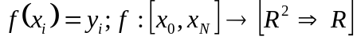
  - Optional Actual Function: 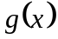
- Monotonicity: 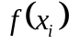 increases with increase in 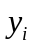 (and vice versa).
  - At the segment level, this becomes co-monotone. However, strict co-monotone implies that sub-segment monotonicity must also be met, so “local monotonicity” where monotonicity matches between and at the segment level, is what is accepted.
  - At most, one extremum is allowed in 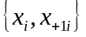.
- Convexity: should also be convex wherever is convex (and vice versa).
  - At the segment level this becomes co-convex. As before strict co-convexity is often highly restrictive, so local convexity is preferred.
  - Desirable to have at most one inflection in .
- Smoothness: Smoothness (also called shape-preserving) corresponds to the least curvature. Even C⁰ can be “smooth”, and so is C^{k}.
- Locality: Locality means that the dependence of 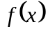 is primarily only on and . This is advantageous to schemes that locally modify/insert the points.
- Other Desired Criteria:
  - The interpolating proxy should be able to replicate the target 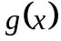.
  - Fairness – loosely a measure of “pleasing to the eye”.
  - Possible invariance under variate scaling/reflection.
  - Controlled derivative behavior => Small changes in x produce small changes in .

Generic Formulation

- Base Mathematical formulation:
- Linear of Segment Coefficients to the Response Values (): In all the spline formulations, the Jacobian 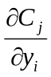 is constant (independent of the response values themselves, or their nodal derivative inputs).
- Analogies to energy minimization over stretches/surfaces
- Include notes on segment naturalization
- Span Boundary Specification:
- “Natural” Spline – Energy minimization problem
- “Financial” Spline
- Right Segment Locality Reduction: As you go from the left segment to the right segment, the local segment perturbation impact diminishes due to the fact that information gets transmitted (through the C¹, and C² continuity constraints) to the right from the left. Locality is enhanced if, in some sense, “local” information > the transmitted information. Interpolating splines strive to achieve this.
- Discrete Segment Mesh vs. Inserted Knots: Inserting knot point is similar to discretizing the segment into multiple grids, with one key difference:
- Discretization uses the same single spline across all the grid units of the segment.
- Inserted knots introduce additional splines – on between each knot pair.

B-Splines

- B-Spline Context Fixation: As postulated by de Boor et. al., B Splines have a very geometric interpolant context – thereby with the correspondingly strong CADG/curve/surface construction focus. Geometric smoothening occurs as a natural part of this.
- The B Spline generation scheme has a recurrence-based iterative polynomial generator that admits coinciding control points facilitates surface construction, although there are a lot of similarities with shape-preserving interpolatory splines.
- Lagrange Polynomial vs. k^{th} Order B-Spline Interpolant: Higher order B-Splines are defined by the recurrence 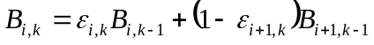 where 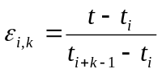 and 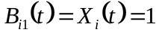 if 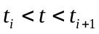, and 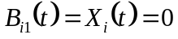 otherwise.
- Coinciding knots => 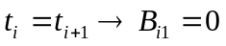.
- Recursive Interpolant Scheme: B Spline formulation is recursively interpolant, i.e., the order k spline is interpolant over the order 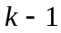 splines on nodes and 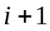 - this formulation automatically ensures 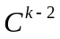 nodal continuity.
- B-Spline Order Relationships: Assuming no coincident knots, the following statements are all EQUIVALENT/TRUE:
- 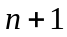 knot points.
- n^{th} order B Spline.
- Polynomial of degree 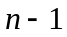.
- Continuity of 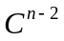.
- Expository Formulation:
- 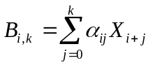
- 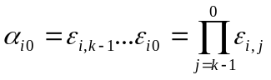 where 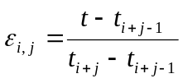
- 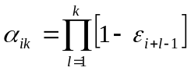 where 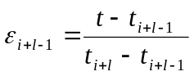
- Spline Coefficient Partition of Unity: Using the earlier formulation , it is easy to show that 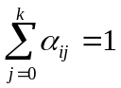. This simply follows from the recursive nodal interpolation property.
- Smoothness Multiplicity Order Linker: # smoothness conditions at knot + the multiplicity at the knot = B-Spline Order.
- Starting Node de-biasing: Left node is always weighted by 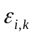 in the interpolation scheme, but the left node asymmetry is maintained because the denominator in - 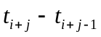 - increases in length.
- Other Single B-Spline Properties:
- 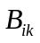 is a piece-wise polynomial of degree 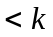 ( if the knots are distinct, lesser if the some of the knots coincide).
- is zero outside of 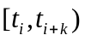.
- is positive in the open interval 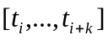.
- Formulation off of Starting Node and Starting Order: Given the starting node and the starting order , the contribution to the node 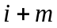 (i.e., m nodes after the start) and the order (i.e., n nodes after start) can be “series”ed as
- Nodal B-Spline Recursion Stepper: 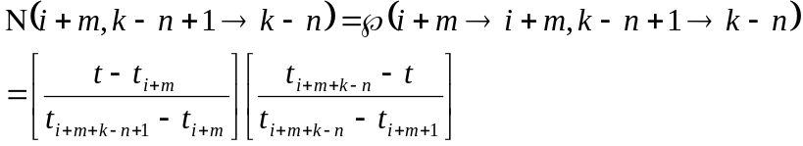
- Spline Order B Spline Recursion Stepper: 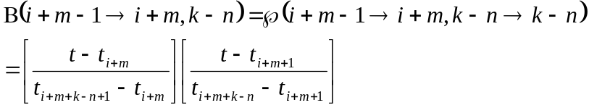
- B-Spline vs. Spline: B-Spline is just a single polynomial that is valid across a set of knots. “Spline” is a linear combination of such B Splines – i.e., the set of all the ’s.
- Cardinal B-Spline Knot Sequence: Knot sequence => Uniformly spaced knots, simplifying the interpolant/recursive analysis significantly - 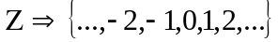.
- Also all Cardinal B-Splines of a given order k are translates of each other.
- Bernstein B-Spline Knot Sequence: Knot sequence 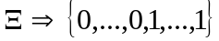 - 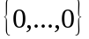 occurs  times, and 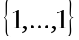 occurs times.
- 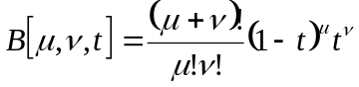 for 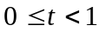.
- 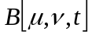 has 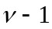 derivatives at 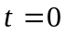, and 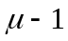 derivatives at 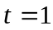 - this is also referred to as smoothness conditions at , and smoothness conditions at .
- Spline Definition: 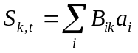 where 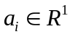. ’s are the coefficients – or nodal points 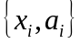 - that can be interpolated.

Interpolating Splines

- Hermite Cubic Splines: The “local information” here takes the form of user specified left/right slopes.
  - 2 User Specified local slopes + 2 points => 4 sets of equations. Solve for the coefficients.
  - C¹ continuity is maintained, and C² continuity is not.
  - Segment control is completely local.
- Catmull-Rom Cubic Splines: Instead of explicitly specifying the left/right segment slopes, they are inferred from the “averages” of the prior and the subsequent points, i.e., 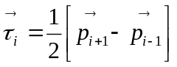, and 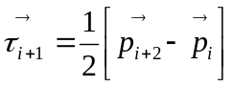. Here 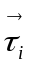refers to the slope vector, and 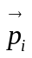 to the point vector.
  - Again, C¹ continuity is maintained, and C² continuity is not.
  - Segment control is not completely local, but still local enough – it only depends on the neighborhood of 3 points.
- Cardinal Cubic Splines: This is a generalization of the Catmull-Rom spline with a tightener coefficient , i.e., 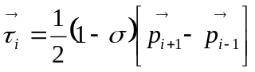, and 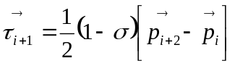. 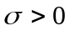 corresponds to tightening, and 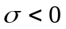 corresponds to loosening.
  - Again, C¹ continuity is maintained, and C² continuity is not.
  - Segment control is “local” in the Catmull-Rom sense - it only depends on the neighborhood of 3 points.

Space Curves and Loops

- Space Curve Reproduction: Here is one way to construct loops that are not possible using the ordered variates, i.e., 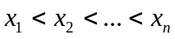.
- If the ordering is switched out in favor of the DAG 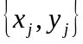, where the DAG vertices correspond to the loop trace, normal splines may be used to represent space curve loops.
- Second Degree Parameterization: However, on using a second-degree parameterization of x and y such as 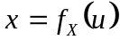 and 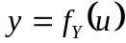, it may be possible to enforce the order 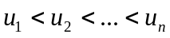. The corresponding control points are 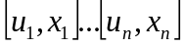 and 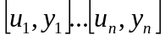.
  - Side effect of this – is that you need to work on two pairs of splines – one each for and .
  - This can offer additional customization and freedom in the design of the surface, at the expense of computing additional splines.
- Closed Loops: Further, if the start/end points coincide, this corresponds to a closed loop that satisfies the C² continuity criterion.
  - This also implies that no extra head/tail C¹ slope specifications are required.

Spline Calibration

- Spline Segment Calibrator: Spline segment calibration has an asymmetrical dependence on the left/right calibration value. For a given span, the calibration of the non-left most segment depends only on the right most value – the other coefficients come from the prior segments. The left most segment, of course, uses both the left/right values for calibration.
- Span-to-segment constraint transmission
- Number of unknowns analysis

Spline Jacobian

- Self-Jacobian: Given an ordered pair 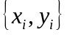 that needs to be interpolated/splined across, the self-Jacobian is defined as the vector 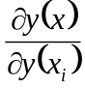.
  - Self-Jacobian tells you the story of sensitivity/perturbability of the interpolant (y) around non-local points. Among the splines, quadratic and greater splines cause fairly non-banded, dispersed Jacobians, indicating that the impact is non-local; linear splines produce simple banded/tri-diagonal Jacobians; and tension splines produce a combination of the two depending on the tension parameter.
  - Further Jacobian of any function 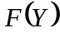 is going to be dependent on the self-Jacobian 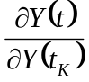 because of the chain rule.

Polynomial Spline

- Base functional specification (Linear, Quadratic, Cubic, Quartic, Polynomial)
- Linear, Quadratic, Cubic, Quartic, Polynomial Basis Functions
- Cubic Splines and Inflection Knots => Problem with the inflection knot points with cubic splines is that the “inflection” is now an extraneously supplied constraint, and in general may not be consistent with the C² criterion.
- Segment interpolation relation
- Control point analysis
- Truth-ness specification
- Smoothness constraint
- Span-to-segment constraint transmission
- Number of unknowns analysis
- Solving for coefficients

Tension Spline

- Curvature Design in Tension Splines: Cubic spline is interpolant on 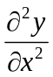 across the nodes, and linear spline is interpolant on y. Thus, 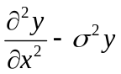 (the tension spline interpolant) offers the tightness vs. curvature smoothness trade-off.
- Tightness vs. Smoothness Generalization => 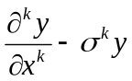 is linear in x, given k is even. Of course, for 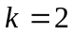 this describes a tension spline (hyperbolic or exponential).
- Interpolant and Tension Splines => Tension splines with 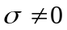 can never be a polynomial order interpolant – only polynomial splines of order k (and degree ) are continuous and interpolant!
- Types: Both exponential and hyperbolic basis splines with a linear spline satisfy .
- Exponential Basis Splines: 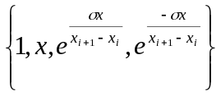
- Hyperbolic Basis Splines: 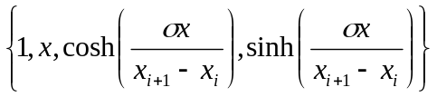
- Exponential Basis Functions:
- Base Segment Formulation =>
  - 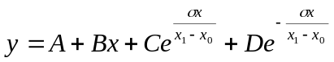
  - 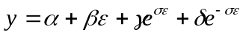
- Global <-> Local =>
  - 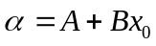
  - 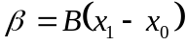
  - 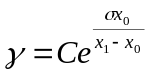
  - 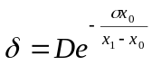
- Local <-> Global =>
  - 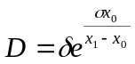
  - 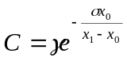
  - 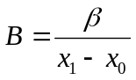
  - 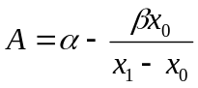
- Co-efficient Calibration =>
  - 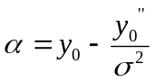
  - 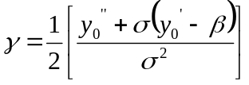
  - 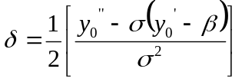
  - 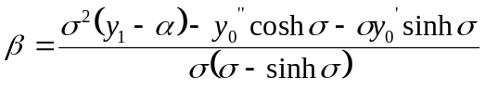
- Coefficient to Input Sensitivity Grid =>
  - 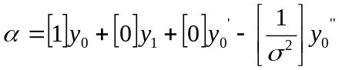
- Local Derivatives =>
  - 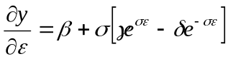
  - 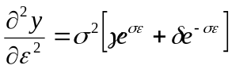
  - 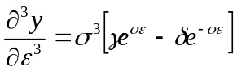
- Global <-> Local Derivatives =>
  - 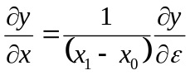
  - 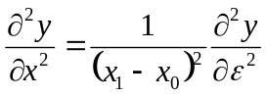
  - 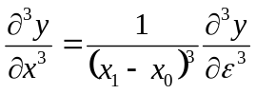
- Hyperbolic Basis Functions:
- Base Segment Formulation =>
  - 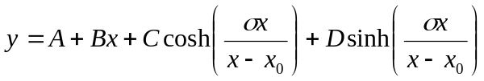
- Global <-> Local =>
  - 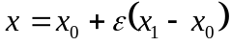
  - 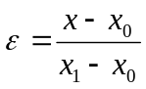
  - 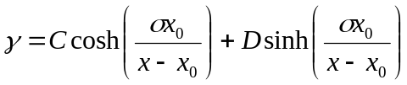
  - 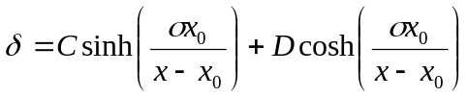
- Coefficient to Input Sensitivity Grid =>
  - 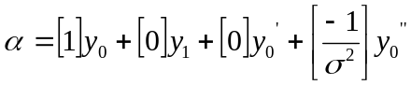
  - 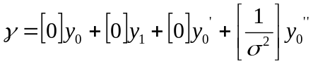
- Local Derivatives =>
  - 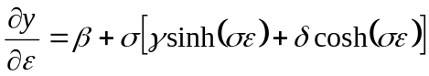
  - 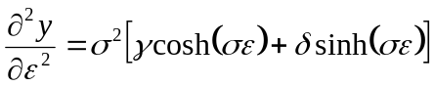
  - 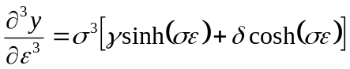
- Global <-> Local Derivatives =>
- Segment interpolation relation – reduction onto linear/cubic spline
- Switch between linear and cubic spline
- Alternate specifications of the segment interpolation [5, pp. 33 & 39, Question 3]
- Localized and normalized tension ([5], pages 22-23, 33 (Question 2), 35-38)
  - Finding σ when f is bound.
    - To get the minimum tension factor required we need to find the zeros of f’ [6].
  - Finding σ when f’ is bound.
    - To get the minimum tension factor required we need to find the zeros of f’ [6].
  - Finding σ from the bound values of convexity/concavity [6].
- Control point analysis
- Normalization of the tension parameter
- Truth-ness specification
- Smoothness constraint
- Problems with Hyperbolic/Tension Splines:
- Hyperbolic and exponential functions are time consuming to compute.
- They have been gradually pushed out rational splines.

Rational Spline

- Rational B-Spline Basis Functional: 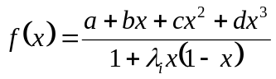 for 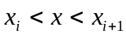.
- Monotonizing Parameters for Rational Splines: 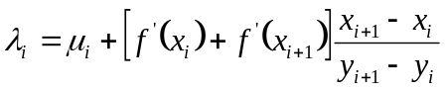, again for .
- 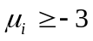 makes it monotone in this segment.
- 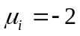 produces a rational quadratic.
- Convergence is 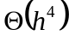 in all cases.
- Co-convex choice for : A similar analysis can be done to make the spline co-convex, but the corresponding formulation requires a non-linear solution for 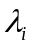.

Smoothing Splines

- Process Control using Weights: Dimensionless units (such as Reynolds’ number) can effectively account for the ratio of competing natural forces. Similar use can be done for process control to be able to guide/control between 2 or more competing objectives. For example in the instance of the smoothing spline:
- First Objective => Closeness of match using the most faithful reproducer, or curve fit.
- Second Objective => Smoothest curve through the given points, without necessarily fitting them – of course, “smoothest” possible “curve” is a straight line.
- Smoothing Spline Formulation: Given , and the function that fits the points 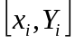 from 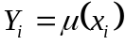. The smoothing spline estimate 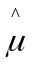 is the minimizer 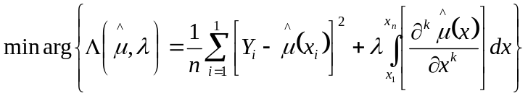
  - 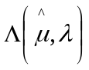 is called the Spline Objective Function.
  - 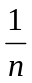 is needed to the left term to make it finite as , otherwise will also have to be infinite.
  - The derivative “k” corresponds to what makes 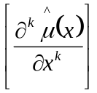 linear. Thus, for cubic splines, k = 2.
- Bias Curvature/Variance Fit Trade-off: Smaller the , the more you will fit for bias (low curvature penalty). Bigger the , more you fit for curvature/roughness penalty.
- Curvature Penalty Minimizer Spline: It can be theoretically shown that the curvature penalty minimizer spline is a cubic spline. Here is how.
  - First, notice that any spline of degree >= 0 can reproduce the knot inputs.
  - By default, curvature corresponds to k = 2. Thus, 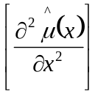 varies linearly inside a segment, thus this becomes the least possible curvature.
  - Higher order splines will have a non-linear curvature.
  - Lesser order (spline order less than 3) will violate the C² continuity constraint.
- Extension to k-Curvature Penalty: For the case where k > 2, we would need to choose a k+1 degree spline to retain linearity of the segment k-curvature – therefore, a k+1 degree spline is the k-curvature penalty minimizer spline. This also preserves the C^{k} continuity constraint.
- Relation of Lagrangian to Smoothing Spline:
  - Lagrangian objective function is used to optimize a multi-variate function 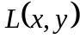 to incorporate the constraint 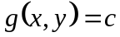 as 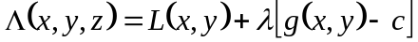. Here is the Lagrange multiplier.
  - Optimized formulation of the smoothing spline is given by minimizing the spline objective function (a form of optimization) 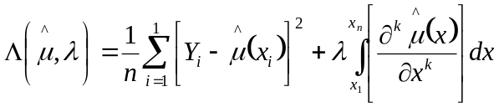. Here is the spline objective function shadow price of curvature penalty, i.e., 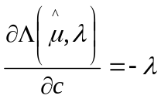, where c is the constraint constant defined analogous to the constraint constant in the Lagrangian objective function: 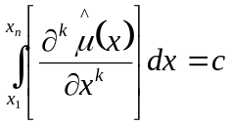.

Multi-dimensional Splines

- Symmetrical Multi-dimensional variates: The trivial univariate ordering needs revising in the context of certain multivariates, e.g., symmetrical multivariates.
  - A general “distance from focal node” makes to more sense to set in the ascending order. Thus 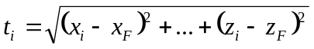, where 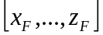 are the multivariate nodes corresponding to the focal node.
  - Use Cartesian/radial/axial basis functions to formulate the segments in terms of the surface vector coefficients in “symmetrical variate” situations.
- Surface Energy Minimization: Surface energy minimization using the “sigma” tension parameter – formulate equation.
  - Thin plate splines are an effective way to achieve surface energy minimization, i.e., for a 2D surface, the smoothing spline surface may be created by the minimization of the following least squares surface spline objective function 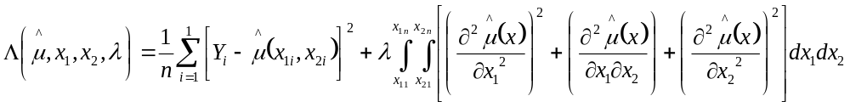. Again, apparently this is more appropriate if 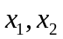 are symmetrical.
- Non-symmetrical multi-dimensional Variates: Again, considering 2D as an example, it makes sense to use the basis splines separately across both , as in 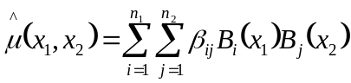.

References

- Chen, W (2009). Feedback, Nonlinear, and Distributed Circuits. CRC Press.
- Judd, K. (1998). Numerical Methods in Economics. MIT Press.
- Renka, R. J. (1987): Interpolator tension splines with automatic selection of tension factors. Society for Industrial and Applied Mathematics, J. ScL. Stat. Comput. 8 (3): 393-415.
- Runge’s phenomenan (Wiki): Wikipedia Entry for Runge’s phenomenan.
- Spline (Wiki): Wikipedia Entry for Spline.
- Trojand, D. (2011). Splines Under Tension.
Figure #1
SEGMENT/SPAN Structure Layout
SEGMENT
Inelastics
Elastic Coefficients
Elastic Parameters
SPAN
Segment #1
Segment #2
Segment #3
Segment #n
…

Figure #2
BASIS SPLINE HIERARCHY
SEGMENT
Basis Spline Polynomial
Basis Spline Hyperbolic Tension
Basis Spline Linear Polynomial
Basis Spline Exponential Tension
Basis Cubic Polynomial
Basis Spline Cubic Hermite
Basis Quartic Polynomial
Basis Spline Catmull Rom
Basis Cubic Rational
Basis Spline Cubic Cardinal
Segment #2
Segment #3

