**INTERDUCTION TO DATAMANAGEMENT PROJECT REPORT**

(Project Semester August-December 2019)



***Analysis on Indian General Elections-2019***

Submitted by

Name:B. Lakshmi Ajeeth Kumar

Registration No.: 11700845

Programme and Section: **B.Tech., C.S.E (Hons.,)**

Course Code : INT 217

Under the Guidance of

**Hargobind Singh , U.id: 23599, Asst.Professor**

**Discipline of CSE/IT**

**Lovely School of Computer Science And Engineering**

**Lovely Professional University, Phagwara**

**CERTIFICATE**

This is to certify that B. Lakshmi Ajeeth Kumar bearing Registration no. 11700845 has completed INT 217 project titled, **“*Analysis on Indian General Elections-2019”*** under my guidance and supervision. To the best of my knowledge, the present work is the result of his/her original development, effort and study.

**Signature and Name of the Supervisor**

**Designation of the Supervisor: Asst. Professor**

**School of Computer Science and Engineering**

Lovely Professional University

Phagwara, Punjab.

Date:

**DECLARATION**

I, B. Lakshmi Ajeeth Kumar, student of B.Tech., C.S.E (Hons.,) under CSE/IT Discipline at, Lovely Professional University, Punjab, hereby declare that all the information furnished in this project report is based on my own intensive work and is genuine.

Date: Signature

Registration No. 11700845 Name of the student: B. Lakshmi Ajeeth Kumar

**Acknowledgement**

I have taken efforts in this project. However, it would not have been possible without the kind support and help of many individuals and organizations. I would like to extend my sincere thanks to all of them.

I am highly indebted to Hargobind Singh for their guidance and constant supervision as well as for providing necessary information regarding the project & also for their support in completing the project.

I would like to express my gratitude towards my parents & friends for their kind co-operation and encouragement which help me in completion of this project.

I would like to express my special gratitude and thanks to all persons who helped in this project for giving me such attention and time.

**Table of Content**

1. Introduction………………………………………………………………….6
2. Objectives/Scope of the Analysis……………………………………………7
3. Source of dataset…………………………………………………………….7
4. ETL process…………………………………………………………………8
5. Analysis on dataset (for each analysis)……………………………………...8
6. Introduction
7. General Description
8. Specific Requirements, functions and formulas
9. Analysis results
10. Visualization
11. List of Analysis with results……………………………………………14
12. References………………………………………………………………15
13. Bibliography…………………………………………………………….15

**1.INTRODUCTION**

An election is a process in which people vote to choose a person or group of people to hold an official position. In this process winning and losing were part of it but what you do after losing is the important aspect of it. To know the reason for your defeat is a detailed analysis of the elections done is required.

The final project of this course this semester is “Analysis on Indian General Elections-2019”.

It is supposed to show the detailed analysis of elections held in India during 2019, and display all the objectives that were listed that incudes strong political party in that particular region. A user should be able to understand the output of the analysis done on the data so for the better understanding the care is being taken in the representation. And he also can have comparisons between two political parties in the nation to find the strongest party of both. Another property included is to find the strongest candidate of all candidates who participated in the elections in that particular year. Even for the state level one can have the detailed analysis of a particular state in the country. Which includes the result showing the winning party of that particular constitution. For the better completion of project some objectives were taken and completed,

For the better understanding of the results of the analysis the graphs and comparison graphs were involved where ever required.

The raw data set is being taken and performed required analysis is being done.

The taken data set contains some rows and columns, Rows involved were serial number, name of candidate, Place, state / UT, party, evm votes, migration votes, postal votes, total votes, percentage votes, rank. In this data set there were total 8569 columns and 10 rows.

**2.OBJECTIVES OF AYALYSIS**

* Objectives involved: -

1. To analysis the strongest party among BJP and INC in each state showing the results of number of votes they got in that state and for easy understating a graph is included.
2. To analysis the strongest candidate in country on the bases of percentage of votes one got. And display the results with an easily understandable graph.
3. To analysis the strongest party in North India on the bases on the number of seats won by each party. And for easy understating a graph is included.
4. To analysis the strongest party in South India on the bases on the number of seats won by each party. And for easy understating a graph is included.
5. To have the detailed of a particular state and have the winning result of each constitution in the state by showing which party won and displaying the votes they won. And display the comparison graph.

**3.SOURCE OF DATASET**

Name of Dataset: GE_India_2019_result

Web-site got from: Kaggle.com

Format: Microsoft Excel

Link:

https://www.kaggle.com/ankit2106/indian-general-election-2019-candidate-wise-data#GE_india_2019_results.csv

**4. ETL PROCESS**

Extract, Transfer, Load process must be applied for the raw data set which require cleaning, remove redundancy, remove null values, removing and filling missing values, take care of missing fields.

This used data set is extracted from Kaagle website the downloaded data set did not came to require any cleaning.

It was directly opened in Microsoft Excel 2016.

**5.Analysis on dataset**

1. To analysis the strongest party among BJP and INC in each state showing the results of number of votes they got in that state and for easy understating a graph is included.
2. Introduction: In this nation two leading and most popular and parties having best competition are Bharatheya Janatha Party and Indian National Congress. So this Analysis shows comparison between these two parties.
3. General Description: This analysis focuses on these two parties, showing their votes in each states they got.
4. Specific Requirements, functions and formulas: Requirements were Raw data, MS Excel, using povit table, filters, sorting, povit charts.
5. Analysis results: In Indian states like Andhra Pradesh, Kerala, Meghalaya, Nagaland, Punjab, Tamil Nadu, Telangana Indian National Congress is having more votes than BJP, in all reaming states BJP is in lead than INC.
6. Visualization:

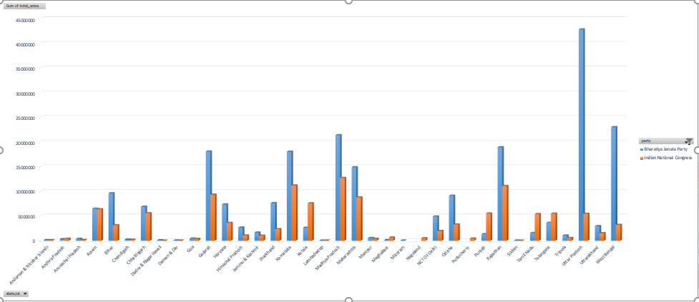

1. To analysis the strongest candidate in country on the bases of percentage of votes one got. And display the results with an easily understandable graph.
2. Introduction: It is also important to know about the best and strongest candidate in the nation this can be known by knowing the candidate with most number of votes and highest percentage on votes in this area.
3. General Description: This analysis focuses on finding the candidate who got most votes by calculating the candidate with most percentage of votes.
4. Specific Requirements, functions and formulas: Requirements were Raw data, MS Excel, using povit table, filters, sorting, povit charts.
5. Analysis Results: Darshana Vikram Jardosh is the strongest candidate in the nation on the basis on percentage of votes he secured 74.47% of total votes from his consistency.
6. Visualization:

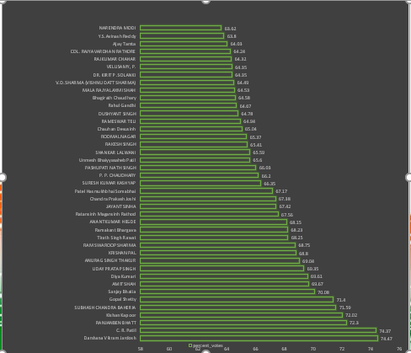

1. To analysis the strongest party in North India on the bases on the number of seats won by each party. And for easy understating a graph is included.
2. Introduction: It is important to know the strongest party in a particular region, so for this analysis first North India is taken to find the best and strongest party in this region.
3. General Description: All the states of North India were taken and on the basis of number of places that each party won the declaration of the strongest party is been declared.
4. Specific Requirements, functions and formulas: Requirements were Raw data, MS Excel, using povit table, filters, sorting, povit charts.
5. Analysis Results: Bharatiya Janatha Party is been declared as the strongest party in North India with winning 290 seats.
6. Visualization:

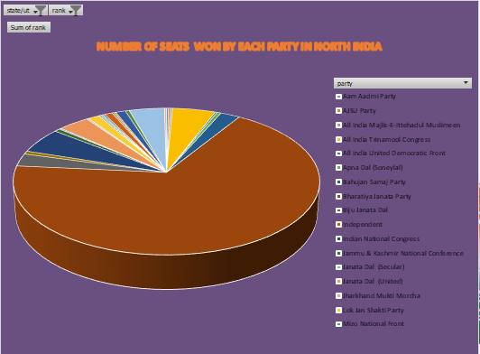

1. To analysis the strongest party in South India on the bases on the number of seats won by each party. And for easy understating a graph is included.
2. Introduction: It is important to know the strongest party in a particular region, so for this analysis first South India is taken to find the best and strongest party in this region.
3. General Description: All the states of South India were taken and on the basis of number of places that each party won the declaration of the strongest party is being declared.
4. Specific Requirements, functions and formulas: Requirements were Raw data, MS Excel, using povit table, filters, sorting, povit charts.
5. Analysis Results: Bharatiya Janatha Party is being declared as the strongest party in South India with winning 29 seats.
6. Visualization:

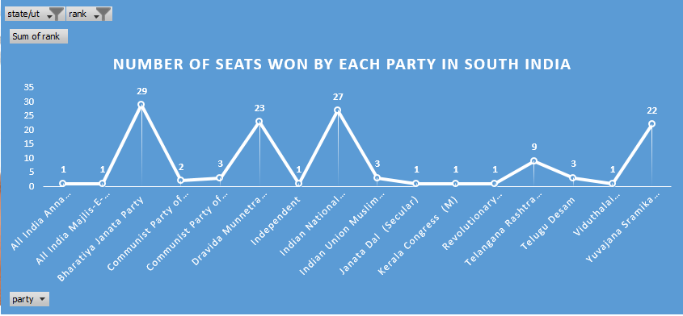

1. To have the detailed of a particular state and have the winning result of each constitution in the state by showing which party won and displaying the votes they won. And display the comparison graph.
2. Introduction: it is also important to know which party is strong in each particular state of the nation. And on the basis of number of seats won we can declare the strongest party in that particular state.
3. General description: Taking the state Andhra Pradesh detailed analysis is done by number of seats each party won in particular city of this state.
4. Specific Requirements, functions and formulas: Requirements were Raw data, MS Excel, using povit table, filters, sorting, povit charts.
5. Analysis Results: YSRCP can be told as strongest party in Andhra Pradesh state on the basis of number of votes it got and seats it secured in the state with 22 seats.
6. Visualization:

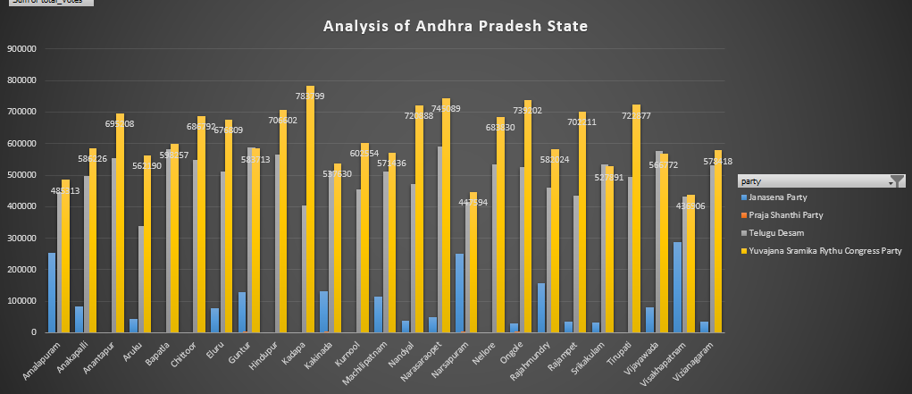

1. **List of Analysis with results**

Table-1 shows the list of analysis with objectives and their results.

|  |  |  |
| --- | --- | --- |
| Objective No. | Objective | Result after analysis |
| 1. | To analysis the strongest party among BJP and INC | BJP is the strongest party |
| 2. | To analysis the strongest candidate in country | Darshana Vikram Jardosh is the strongest candidate in the nation |
| 3. | To analysis the strongest party in North India | BJP is the strongest party in North India |
| 4. | To analysis the strongest party in South India | BJP is the strongest party in South India |
| 5. | To have the detailed of Andhra Pradesh | YSRCP is the strongest party in Andhra Pradesh State |

(Table-1)

1. **REFERENCES**
2. Microsoft Excel 2016 Bible: The comprehensive tutorial resource by John Walkenbach,

Wiley

1. YouTube

Links : i) <https://www.youtube.com/watch?v=4PWVFBiFVVU>

ii) <https://www.youtube.com/watch?v=9NUjHBNWe9M>

iii) <https://www.youtube.com/watch?v=RM8T1eYBjQY>

1. Kaagle.com- For data set.
2. Dataset link: https://www.kaggle.com/ankit2106/indian-general-election-2019-candidate-wise-data#GE_india_2019_results.csv
3. **Bibliography**

1)Microsoft Excel 2016 Bible: The comprehensive tutorial resource by John Walkenbach,

Wiley