**Blood bank management**

Contents

**What this project will do** 3

**Out of scope items** 4

**Project team members** 5

**High level design** 6

**Data Model** 8

**Class Diagram** 9

**User stories** 9

**API design** 11

**Database objects** 12

**Error messages & validations** 13

**Others** 14

# **What this project will do**

This project aims at the following.

Expose a set of REST API services which will do the following:

1. POST API which can be used to record collection of blood units
2. GET API which can be used to search for blood units availability. The API will accept blood group (A,B,O) & Rh Factor (+ve or -ve_)
3. POST API to record blood transfustion
4. GET API for getting session token for Login. The token that is generated from this API will be used for other APIs for authentication and authorization.

# **Out of scope items**

1. Patient data will not be part of this scope.
2. Authorization of API is limited to session token in header for each API
3. Concurrancy not part of scope.

# **Project team members**

* Bellcy Vinitha Samuelraj
* PADMA PRIYA E
* Sreeram Arivumuthu
* Sangeetha M
* Lakshminarayanan A.S

# **High level design**

|  |
| --- |
| Use case diagram |
|  |

|  |
| --- |
| Sequence diagram |
|  |

# **Data Model**

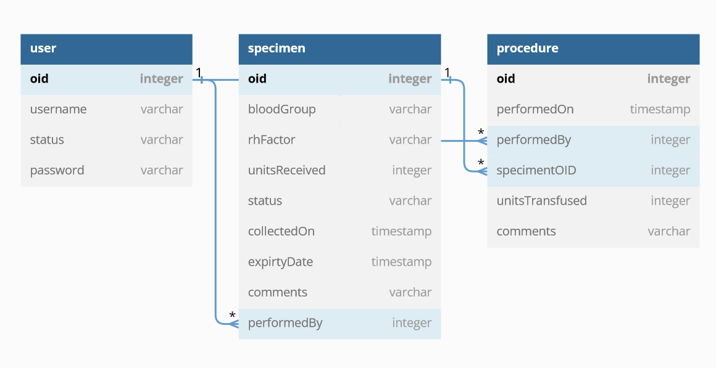

# **Class Diagram**

# **User stories**

| S.No | Description | Developer |
| --- | --- | --- |
| 1 | "POST Specimen | Sreeram |
| Summary: 1) Create record for every blood donation |
| 2) capture blood group, units donated, donatedOn, expiry date, rhfactor,Comments |
| Validation: 1) Check if units <=0 |
| 2) donatedOn > Now |
| 3) Rh factor cannot be null |
| 4) Blood group cannot be null |
| 5) expiry date cannot be < now" |
| 2 | PUT Specimen | Sreeram |
| Summary: 1) Record changes in donation |
| Validation: 1) Check for units donated- this can be 0 provided no transfusion has taken place so far |
| 2) if units >0 then check if units is less than or equal to units tranfused. For example: |
| if original record has 10 units |
| the transfusion is done for 6 units |
| in PUT request, if 5 units is sent then throw validation |
| if 6 units is sent it is accepted |
| if more than 6 units is sent then it is accepted |
|  |
| 3 | Get Specimen List | Padmapriyva |
| Summary: 1) Search speciment by type, number of units available |
| Validation: 1) Inputs for the api will be blood group, rh factor and optional number of units available |
| 2) if number of units is provided in reuqest then show entries which have that number of units. |
| 3) donot fetch specimen which are expired based on the expiry On date |
|  |
| 4 | Get Specimen by ID | Padmapriya |
| Summary: 1) Search speciment based on OID |
| Validation: 1) if OID is not provided in the request then throw error |
|  |
| 5 | POST Procedure | Sangeetha |
| Summary: 1) Create record for every blood transfusion |
| 2) capture SepcimenOID, units transused performed date,Comments |
| Validation: 1) Check if units <=0 |
| 2) performed on < Now |
| 3) SpecimentOID cannot be null |
|  |
| 6 | PUT Procedure | Sangeetha |
| Summary: 1) Record changes in transfusion |
| Validation: 1) Check if units is greater than units of specimen then throw error |
|  |
| 7 | Get Procedure List | Bellcy |
| Summary: |
| Validation: 1) Accept date of procedure, blood group, rh factor as parameter |
| 2) Return collection of procedures. |
|  |
| 8 | Get Procedure by ID | Bellcy |
| Summary: |
| Validation: return the procedure details |
|  |

# **API design**

# **Database objects**

Oracle Cloud Autonomous database is used for this project.

|  |  |  |  |
| --- | --- | --- | --- |
| **S.No** | **Object Name** | **Object type** | **Purpose** |
| 1 | User | Table | User table which can be used for login purpose in future |
| 2 | Specimen | Table | Used to record blood collections |
| 3 | Procedure | Table | Used to record blood transufions |
| 4 | Patient | Table | Patient details which will be used for Procedure table  This will be excel uploaded data |
|  |  |  |  |

# **Error messages & validations**

# **Others**