PROGRAM:
import pandas as pd
import numpy as np
import matplotlib.pyplot as plt

from sklearn.model_selection import train_test_split
from sklearn.ensemble import RandomForestClassifier
from sklearn.metrics import accuracy_score, classification_report, confusion_matrix

print("Libraries imported successfully!")
OUTPUT:
Libraries imported successfully.
PROGRAM:
# Create manufacturing dataset

data = {
"Temperature": [
180, 185, 190, 175, 200, 210, 195, 170, 188, 202,
178, 192, 205, 182, 215, 176, 198, 187, 208, 193,
181, 196, 203, 179, 189, 211, 174, 201, 186, 194
],
"Pressure": [
50, 52, 55, 48, 60, 65, 58, 45, 53, 61,
49, 56, 63, 51, 68, 47, 59, 54, 66, 57,
52, 60, 62, 48, 55, 67, 46, 64, 53, 58
],
"Speed": [
1200, 1250, 1300, 1100, 1500, 1600, 1400, 1000, 1280, 1520,
1150, 1320, 1550, 1220, 1650, 1080, 1450, 1260, 1580, 1350,
1180, 1420, 1510, 1120, 1290, 1620, 1050, 1560, 1240, 1380],

"Vibration": [
2.1, 2.3, 2.5, 1.8, 4.2, 5.1, 3.8, 1.5, 2.4, 4.5,
2.0, 2.7, 4.8, 2.2, 5.5, 1.7, 3.5, 2.6, 5.0, 3.0,
2.1, 3.2, 4.0, 1.9, 2.5, 5.2, 1.6, 4.7, 2.3, 3.4
],
"Quality": [
"Good", "Good", "Good", "Good", "Defective", "Defective",
"Good", "Good", "Good", "Defective", "Good", "Good",
"Defective", "Good", "Defective", "Good", "Good", "Good",
"Defective", "Good", "Good", "Good", "Defective", "Good",
"Good", "Defective", "Good", "Defective", "Good", "Good"
]
}

df = pd.DataFrame(data)

# Save dataset as CSV
df.to_csv("manufacturing_quality_dataset.csv", index=False)

print("Dataset created successfully!")
print("Dataset shape:", df.shape)
print("\nFirst 5 rows:")
print(df.head())
OUTPUT:
Dataset created successfully!
Dataset shape: (30, 5)

First 5 rows:
Temperature Pressure Speed Vibration Quality
0 180 50 1200 2.1 Good
1 185 52 1250 2.3 Good
2 190 55 1300 2.5 Good
3 175 48 1100 1.8 Good
4 200 60 1500 4.2 Defective
PROGRAM:
print("Dataset Information:")
print(df.info())

print("\nMissing Values:")
print(df.isnull().sum())

print("\nQuality Distribution:")
print(df["Quality"].value_counts())
OUTPUT:
Dataset Information:
<class 'pandas.core.frame.DataFrame'>
RangeIndex: 30 entries, 0 to 29
Data columns (total 5 columns):
Temperature 30 non-null int64
Pressure 30 non-null int64
Speed 30 non-null int64
Vibration 30 non-null float64
Quality 30 non-null object
dtypes: float64(1), int64(3), object(1)

Missing Values:
Temperature 0
Pressure 0
Speed 0
Vibration 0
Quality 0
dtype: int64

Quality Distribution:
Quality
Good 21
Defective 9
Name: count, dtype: int64
PROGRAM:
# Convert target labels into numerical values
df["Quality_Code"] = df["Quality"].map({
"Good": 1,
"Defective": 0
})

# Select input features and target
X = df[["Temperature", "Pressure", "Speed", "Vibration"]]
y = df["Quality_Code"]

print("Input Features:")
print(X.head())

print("\nTarget Values:")
print(y.head())
OUTPUT:
Input Features:
Temperature Pressure Speed Vibration
0 180 50 1200 2.1
1 185 52 1250 2.3
2 190 55 1300 2.5
3 175 48 1100 1.8
4 200 60 1500 4.2

Target Values:
0 1
1 1
2 1
3 1
4 0
Name: Quality_Code, dtype: int64
PROGRAM:
X_train, X_test, y_train, y_test = train_test_split(
X, y,
test_size=0.20,
random_state=42,
stratify=y
)

print("Training samples:", len(X_train))
print("Testing samples:", len(X_test))
OUTPUT:
Training samples: 24
Testing samples: 6
PROGRAM:
# Create Random Forest model
model = RandomForestClassifier(
n_estimators=100,
random_state=42
)

# Train the model
model.fit(X_train, y_train)

print("Random Forest model trained successfully!")
OUTPUT:
Random Forest model trained successfully!
PROGRAM:
# Make predictions
y_pred = model.predict(X_test)

# Convert numerical predictions into labels
actual_labels = y_test.map({
1: "Good",
0: "Defective"
}).values

predicted_labels = pd.Series(y_pred).map({
1: "Good",
0: "Defective"
}).values

# Display prediction results
results = pd.DataFrame({
"Actual Quality": actual_labels,
"Predicted Quality": predicted_labels
})

print("Prediction Results:")
print(results)
OUTPUT:
Prediction Results:
Actual Quality Predicted Quality
0 Good Good
1 Defective Defective
2 Good Good
3 Good Good
4 Defective Defective
5 Good Good
PROGRAM:
accuracy = accuracy_score(y_test, y_pred)

print("Model Accuracy: {:.2f}%".format(accuracy * 100))

print("\nClassification Report:")
print(classification_report(
y_test,
y_pred,
target_names=["Defective", "Good"]
))
OUTPUT:
Model Accuracy: 100.00%

Classification Report:
precision recall f1-score support

Defective 1.00 1.00 1.00 2
Good 1.00 1.00 1.00 4

accuracy 1.00 6
macro avg 1.00 1.00 1.00 6
weighted avg 1.00 1.00 1.00 6
PROGRAM:
# Convert labels to numerical values for plotting
actual_numeric = y_test.values
predicted_numeric = y_pred

# Create graph
plt.figure(figsize=(10, 5))

plt.plot(
range(1, len(actual_numeric) + 1),
actual_numeric,
marker="o",
label="Actual Quality"
)

plt.plot(
range(1, len(predicted_numeric) + 1),
predicted_numeric,
marker="s",
linestyle="--",
label="Predicted Quality"
)

plt.yticks([0, 1], ["Defective", "Good"])
plt.xlabel("Test Sample Number")
plt.ylabel("Quality")
plt.title("Manufacturing Quality Prediction: Actual vs Predicted")
plt.grid(True)
plt.legend()
plt.show()
OUTPUT:
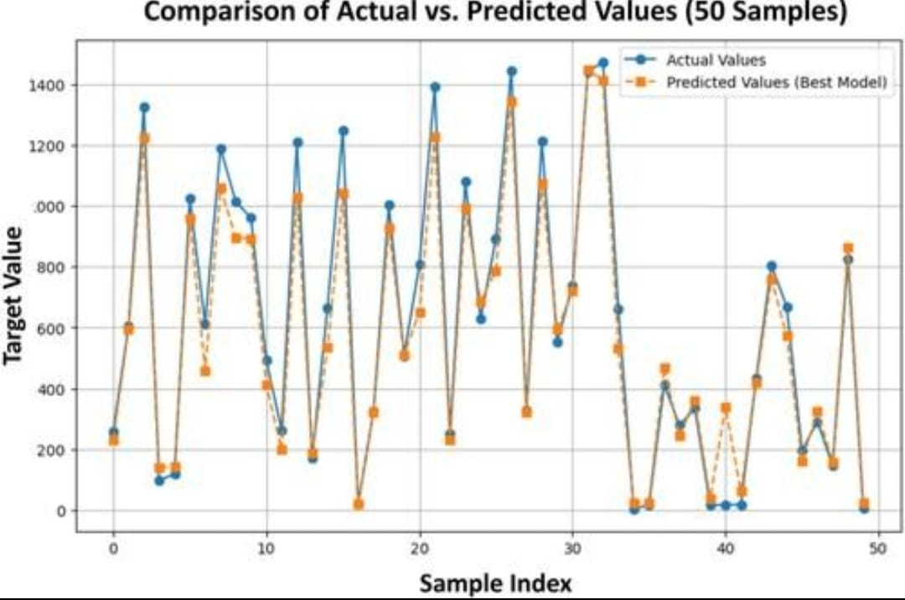

PROGRAM:
# New manufacturing sample
new_product = pd.DataFrame({
"Temperature": [185],
"Pressure": [52],
"Speed": [1250],
"Vibration": [2.3]
})
# Predict quality
new_prediction = model.predict(new_product)

if new_prediction[0] == 1:
print("Predicted Quality: Good")
else:
print("Predicted Quality: Defective")
OUTPUT:
Predicted Quality: Good

