KONERU LAKSHMAIAH EDUCATION FOUNDATION
(KLH University, Hyderabad – Off Campus, Bachupally)

DATABASE SYSTEMS (DBSE)
Student Case Study Execution Report
Project Title
Warehouse Product Management System – Spring Boot REST API with MySQL
Name | DEEPIKA
Section | SEC - 5
Course | DBSE
Week | WEEK - 8

1. Objective
To design and implement a complete CRUD (Create, Read, Update, Delete) REST API for managing product records in a warehouse, using Spring Boot, Spring Data JPA and a MySQL database, and to verify all operations end to end using a browser-based test client and MySQL Workbench.

2. Tools & Technologies Used
- Spring Tool Suite (STS) / Eclipse IDE — Spring Boot application development
- Java 17 (JRE System Library JavaSE-17)
- Spring Boot, Spring Web, Spring Data JPA
- MySQL Server + MySQL Workbench — database and query verification
- Maven — project build and dependency management
- HTML + JavaScript (fetch API) — test.html client to trigger and verify API calls
- Google Chrome — running and testing the client in the browser

3. Project Structure
The project is a Maven-based Spring Boot application named "warehouse", organized into standard layers: controller, entity, repository and service, along with the resources folder containing the test client and configuration.
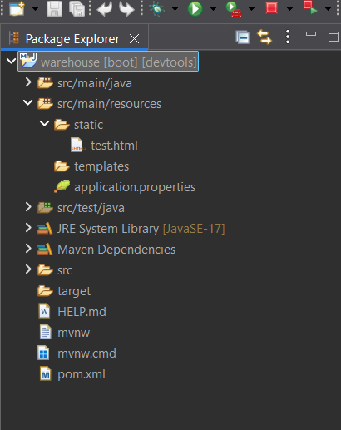
Fig 1: Package Explorer — overall project structure of the Spring Boot warehouse application

4. Entity Layer — Product.java
The Product entity is mapped to the "products" table using JPA annotations (@Entity, @Table, @Id, @GeneratedValue). It defines the fields id, name, description, price and quantity, along with a no-argument constructor, a parameterized constructor, and standard getter/setter methods for each field.
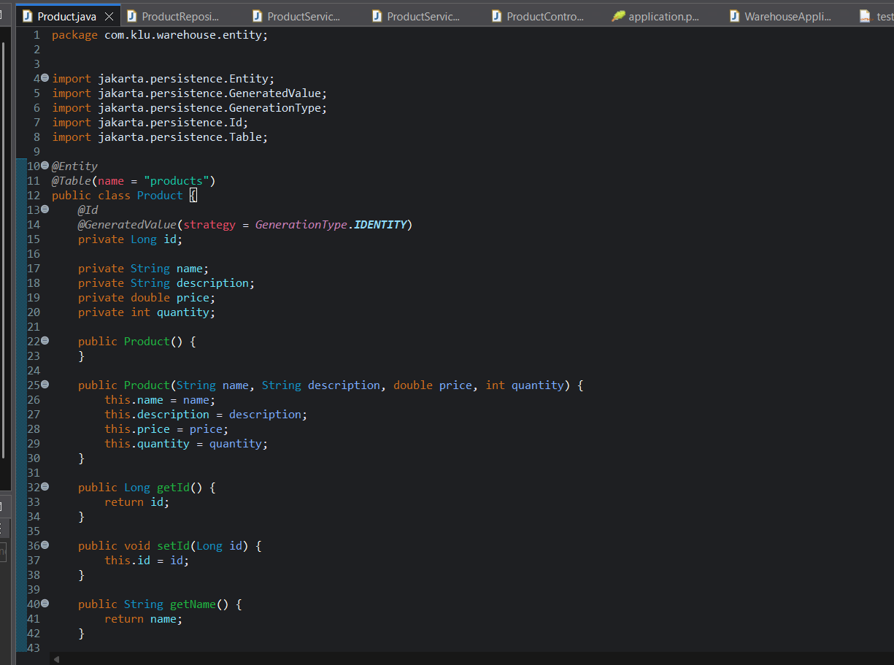
Fig 2: Product.java — entity fields, constructors and package/imports
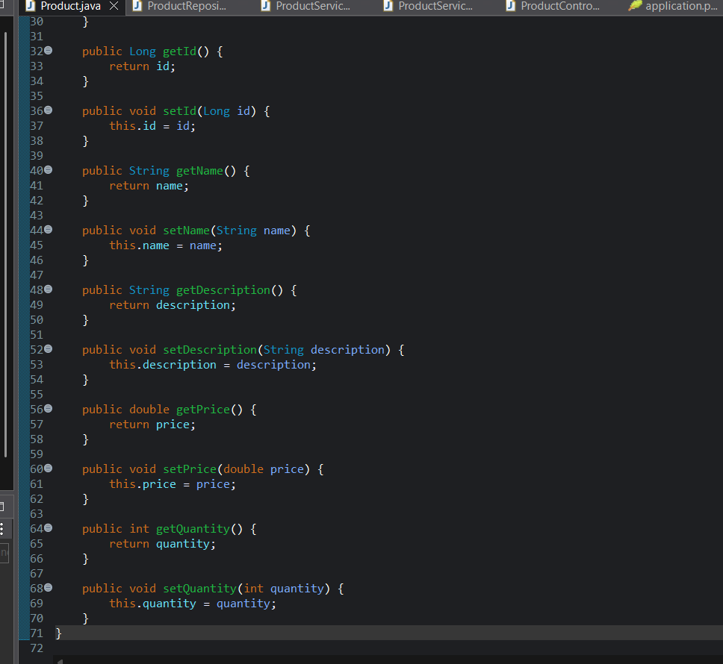
Fig 3: Product.java — getter and setter methods for all fields

5. Repository Layer — ProductRepository.java
ProductRepository is a Spring Data JPA repository interface that extends JpaRepository<Product, Long>, which automatically provides standard CRUD database operations (save, findAll, findById, deleteById) without requiring any implementation code.
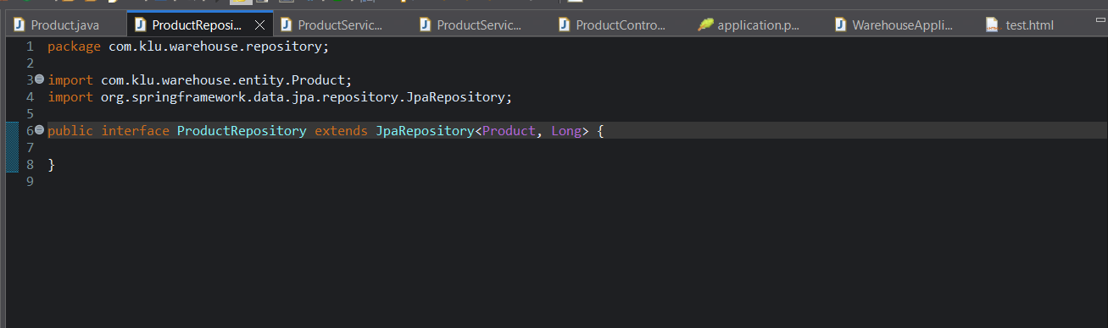
Fig 4: ProductRepository.java — JpaRepository interface for the Product entity

6. Service Layer
The service layer separates business logic from the controller. ProductService defines the contract (getAllProducts, getProductById, saveProduct, updateProduct, deleteProduct), and ProductServiceImpl provides the concrete implementation, delegating persistence operations to ProductRepository.
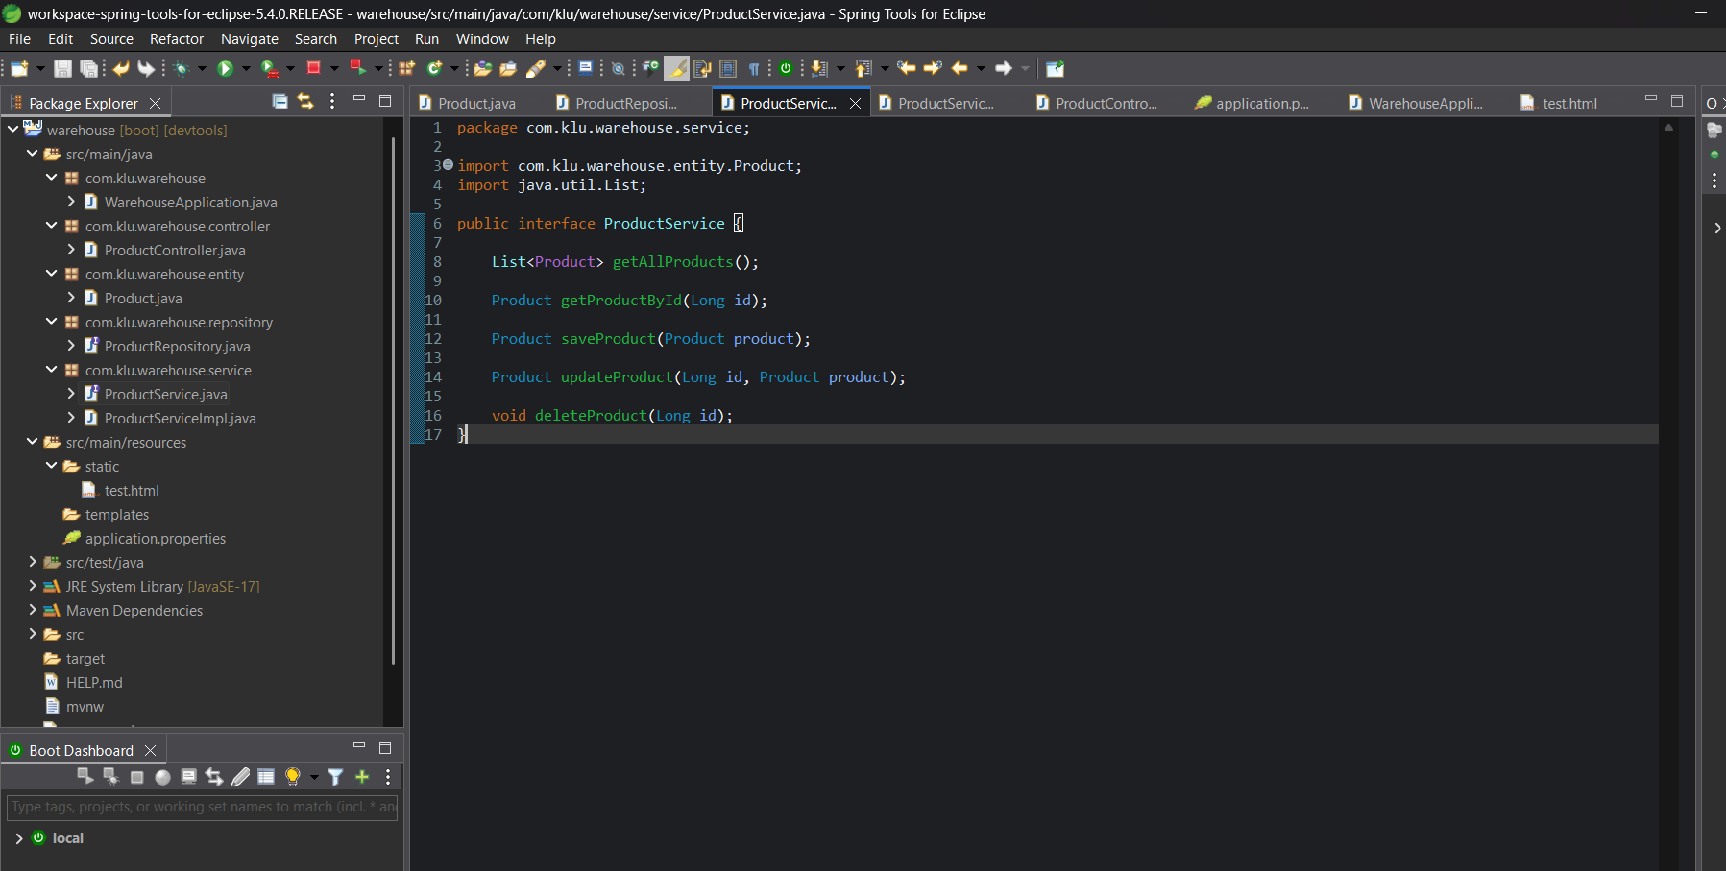
Fig 5: ProductService.java — service interface declaring CRUD method signatures
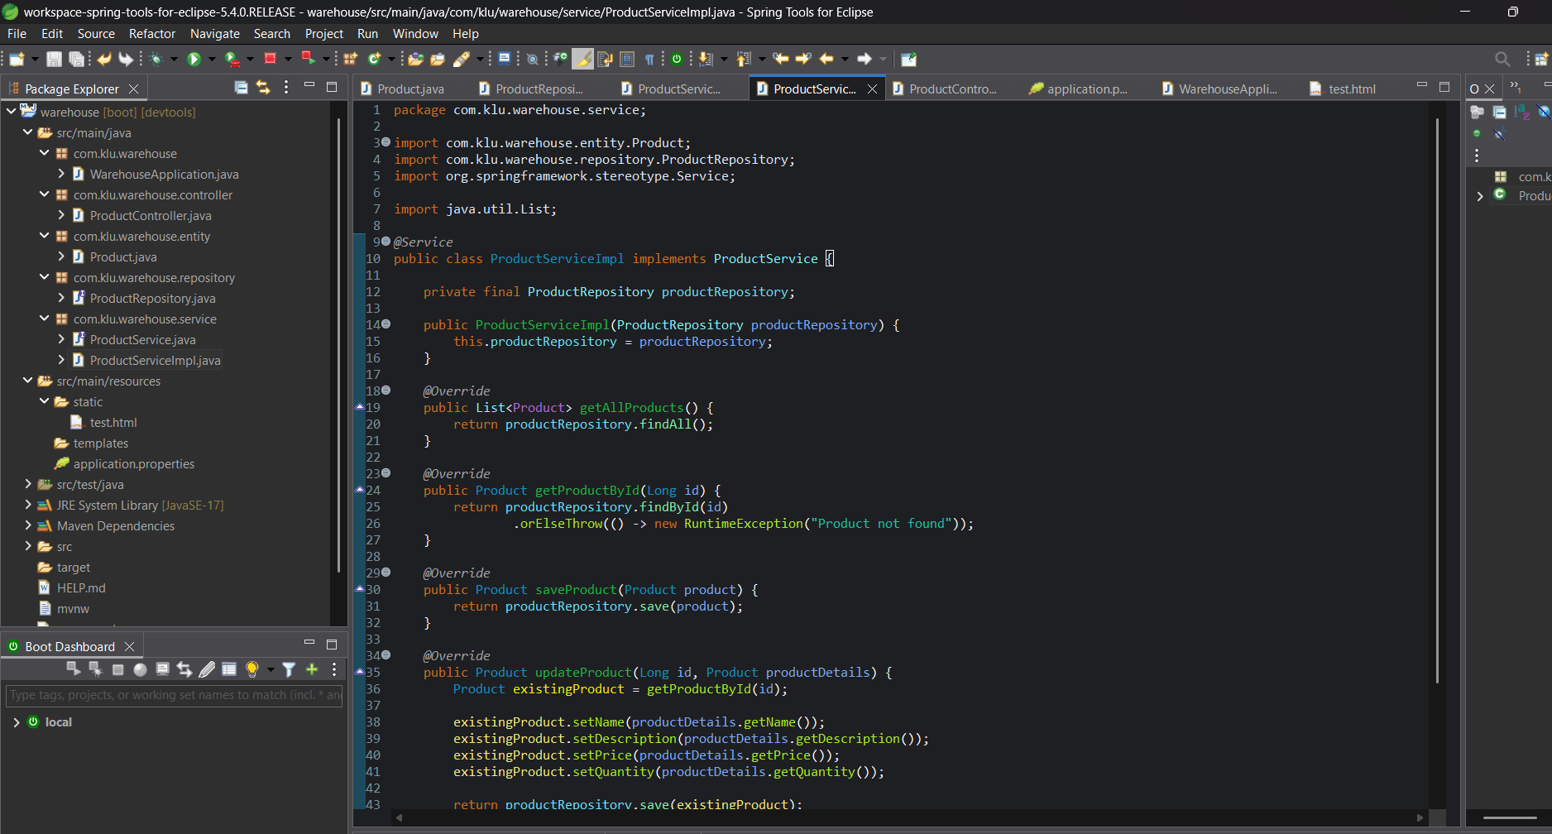
Fig 6: ProductServiceImpl.java — implementation of getAllProducts, getProductById, saveProduct and updateProduct
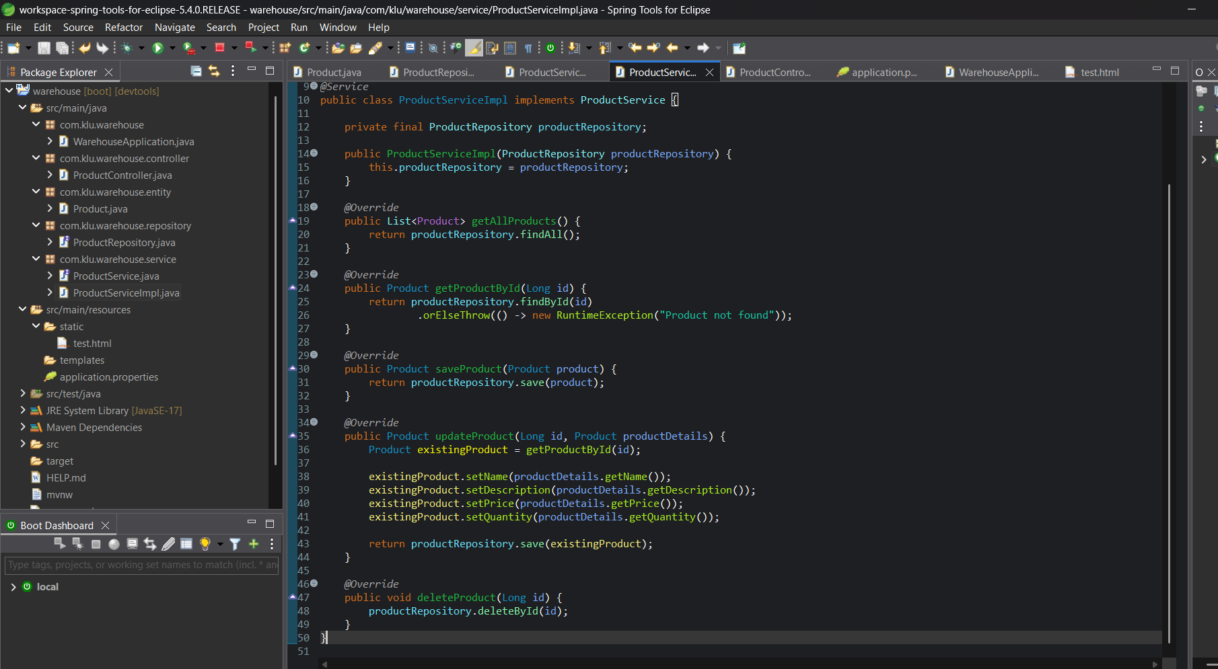
Fig 7: ProductServiceImpl.java — updateProduct logic and deleteProduct implementation

7. Controller Layer — ProductController.java
ProductController exposes the REST endpoints under the base path /api/products using @RestController and @RequestMapping. It defines endpoints for all CRUD operations: GET all products, GET product by id, POST to create a product, PUT to update a product, and DELETE to remove a product.
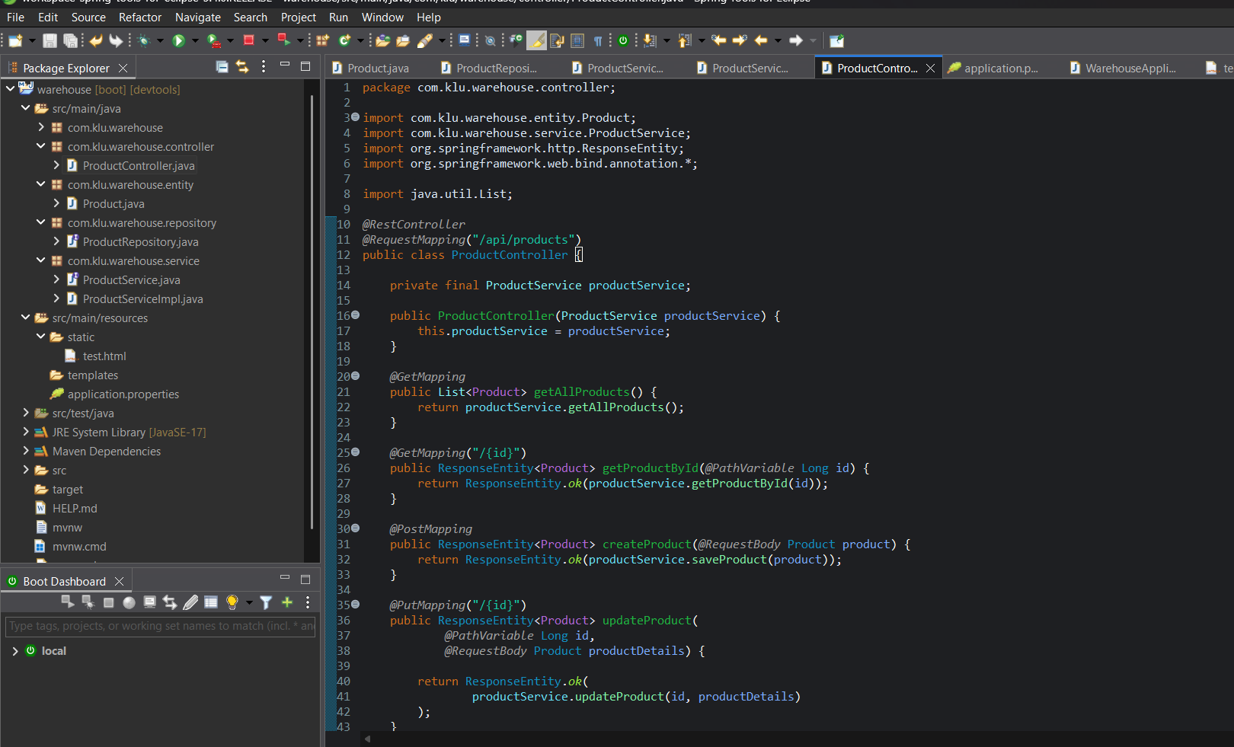
Fig 8: ProductController.java — GET, POST and PUT mappings for the /api/products endpoint
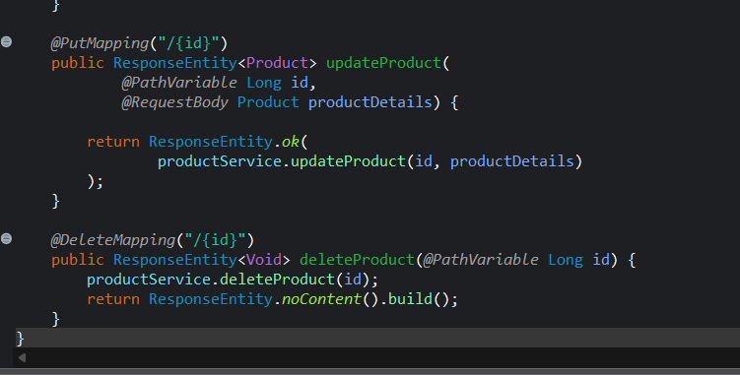
Fig 9: ProductController.java — PUT (update) and DELETE mappings completing the CRUD API

8. Test Client — test.html
A simple HTML page (placed under src/main/resources/static) with buttons for Create, Update and Delete operations. Each button triggers a JavaScript fetch() call to the corresponding REST endpoint (POST /api/products, PUT /api/products/1, DELETE /api/products/1) and displays the JSON response.
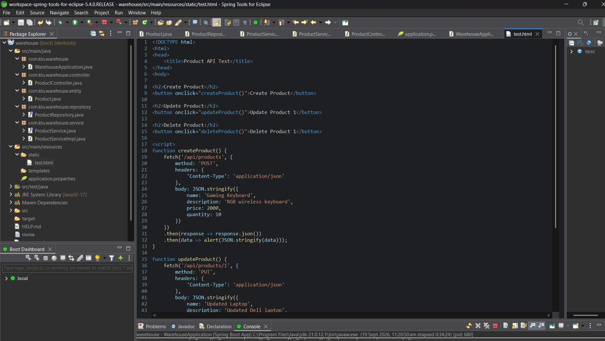
Fig 10: test.html — JavaScript fetch() calls used to test the Create and Update API endpoints

9. Running the Application
The Spring Boot application (WarehouseApplication) was run successfully on the embedded Tomcat server, and test.html was accessed in the browser at localhost:8989/test.html to trigger the Create, Update and Delete operations.
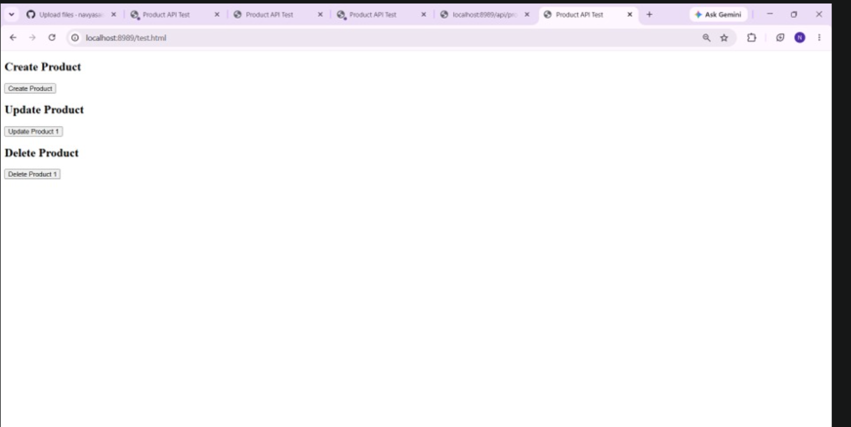
Fig 11: Browser view of test.html with Create Product, Update Product and Delete Product buttons

10. Database Verification — MySQL Workbench
The products table in the MySQL "kluh" database was verified directly using MySQL Workbench. Records inserted through the Create API were visible in the table, updates made through the Update API were reflected in the row data, and the DELETE FROM products WHERE id = 2 query confirmed successful deletion of a record, leaving only the remaining product in the result grid.
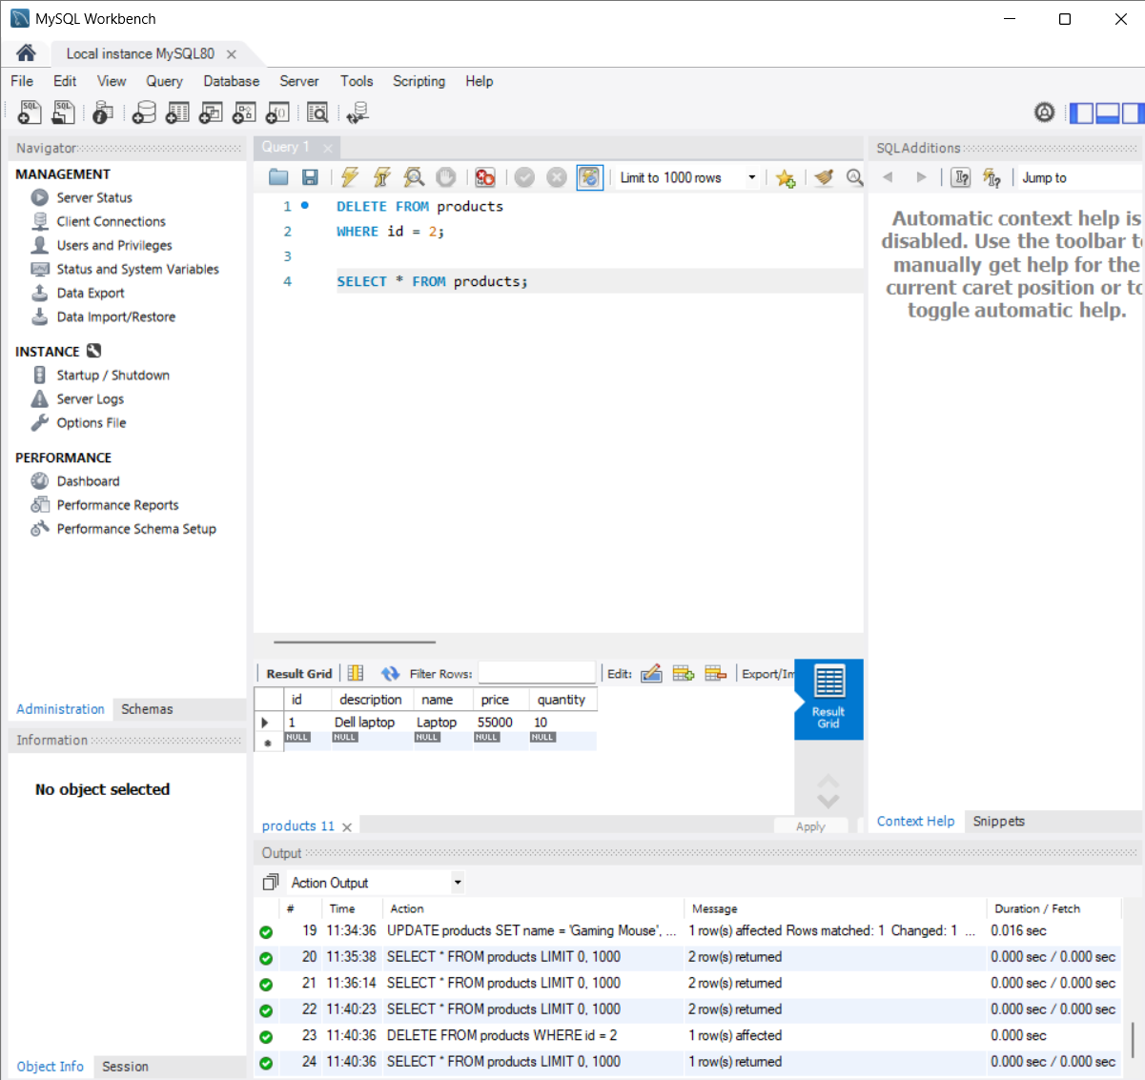
Fig 12: MySQL Workbench — DELETE query executed and resulting products table with one remaining record
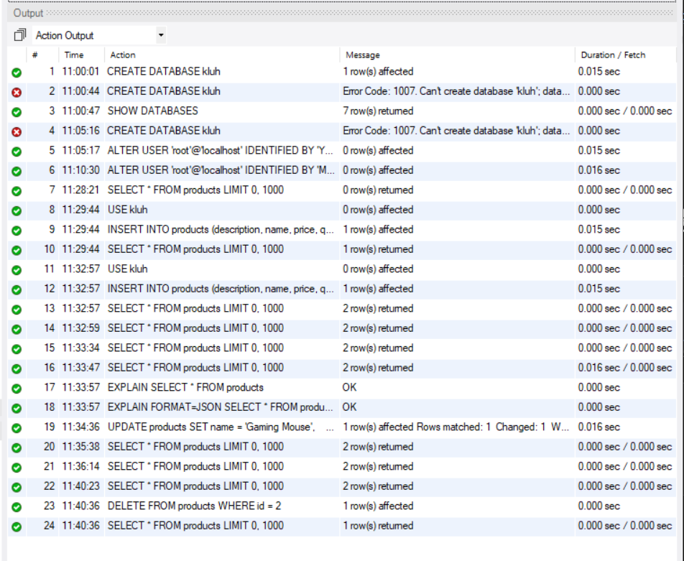
Fig 13: MySQL Workbench — Action Output log showing CREATE DATABASE, INSERT, SELECT, UPDATE and DELETE operations executed during testing

11. Conclusion
The Warehouse Product Management REST API was successfully implemented using Spring Boot, Spring Data JPA and MySQL, following a layered architecture (Entity → Repository → Service → Controller). All CRUD operations — Create, Read, Update and Delete — were tested successfully through the test.html client and verified directly in the MySQL database using MySQL Workbench, confirming that the API works correctly end to end.

