KONERU LAKSHMAIAH EDUCATION FOUNDATION
(Deemed to be University)
KLH Hyderabad Off-Campus, Bachupally

STUDENT LAB EXECUTION REPORT
Student Name | Deepika
Roll Number | 2520030137
Section | 5
Course | Database Management Systems (DBMS)
Week | Week 9 — CO3
Experiment Title | CRUD REST API with Spring Boot, MySQL and a React Frontend (Product Management System)

1. Aim
To design and implement a full CRUD (Create, Read, Update, Delete) REST API for a Product Management System using Spring Boot and Spring Data JPA, backed by a MySQL database, and to verify the API end-to-end using an HTML test client and a React frontend.

2. Tools and Technologies Used
- Spring Tools for Eclipse (STS) 5.4.0.RELEASE — backend development IDE
- Java 21 (JDK 21.0.12.1) with Spring Boot
- Spring Web, Spring Data JPA, Hibernate (ORM)
- MySQL 8.0 with MySQL Workbench for database verification
- HikariCP — JDBC connection pooling
- HTML/JavaScript (Fetch API) — test.html client for manual endpoint testing
- React + Vite — frontend product management UI (localhost:5173)

3. Project Structure
The Spring Boot project (week9_co3) follows a standard layered architecture:
com.klu
|-- Week9Co3Application.java (Spring Boot entry point)
|-- controller
| |-- ProductController.java (REST endpoints)
|-- service
| |-- ProductService.java (Service interface)
| |-- ProductServiceImpl.java (Service implementation)
|-- repository
| |-- ProductRepository.java (Spring Data JPA repository)
|-- model
|-- Product.java (Entity: id, name, description, price, quantity)

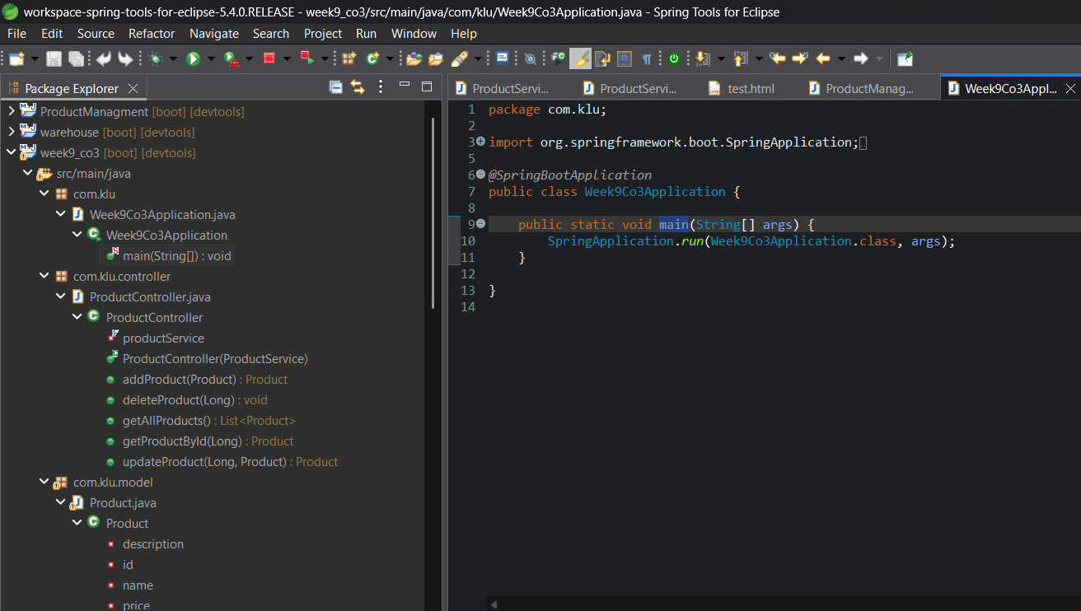
Fig 3.1 — Week9Co3Application.java, the Spring Boot application entry point

4. Database Design
The MySQL schema (database: kluh) contains a single products table, auto-generated by Hibernate from the Product entity. Its structure was verified in MySQL Workbench using SHOW TABLES and DESCRIBE products:
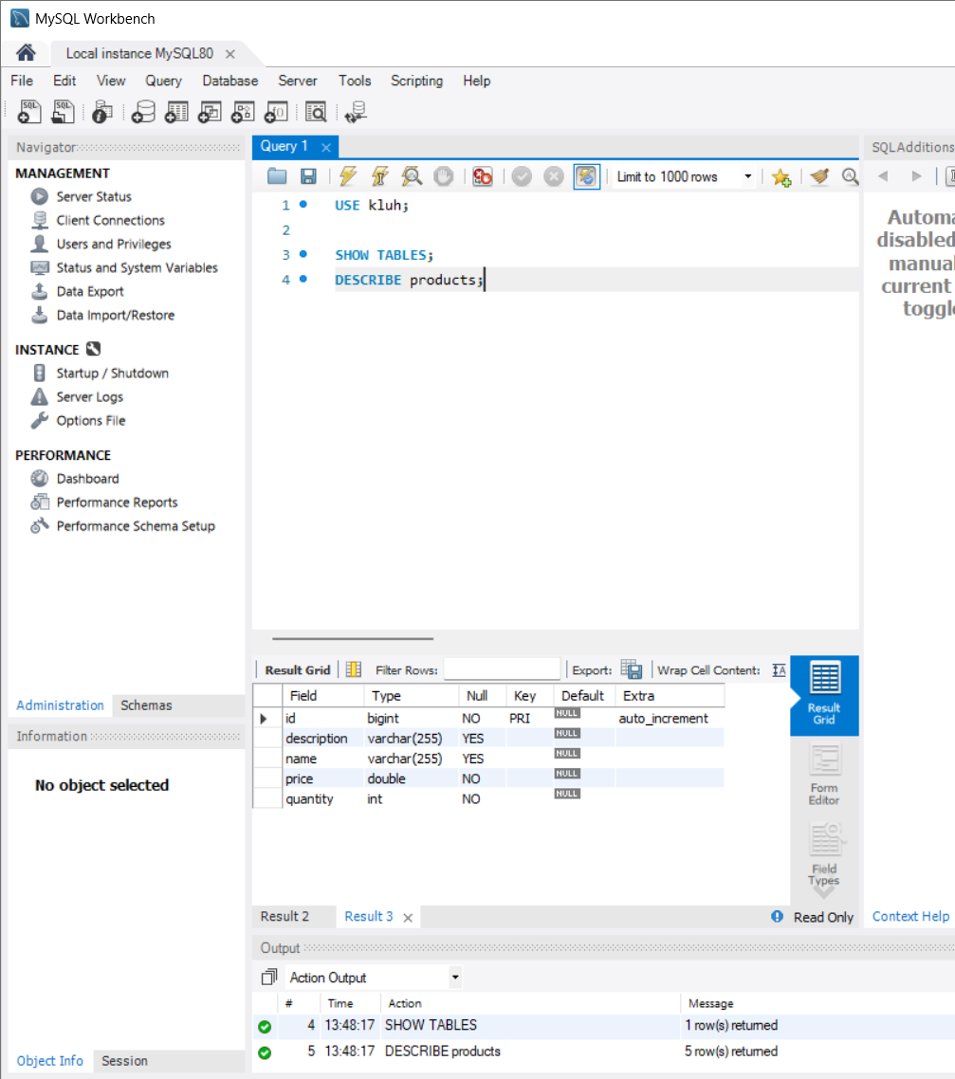
Fig 4.1 — MySQL Workbench: DESCRIBE products showing table structure
Field | Type | Null | Key | Extra
id | bigint | NO | PRI | auto_increment
description | varchar(255) | YES
name | varchar(255) | YES
price | double | NO
quantity | int | NO

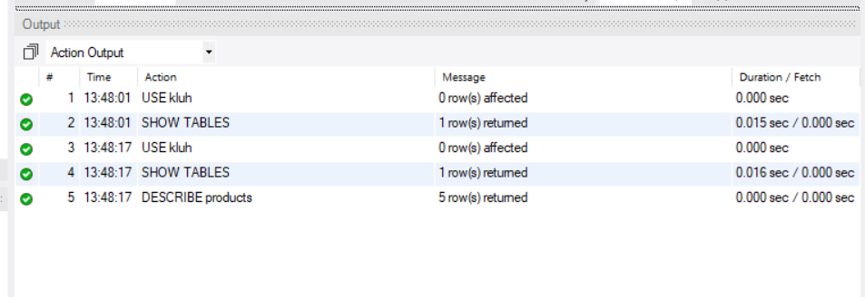
Fig 4.2 — Workbench action output confirming SHOW TABLES and DESCRIBE products

5. Backend Implementation

5.1 Service Interface — ProductService.java
package com.klu.service;
import com.klu.model.Product;

public interface ProductService {
List<Product> getAllProducts();
Product getProductById(Long id);
Product saveProduct(Product product);
Product updateProduct(Long id, Product product);
void deleteProduct(Long id);
}

5.2 Service Implementation — ProductServiceImpl.java
package com.klu.service;

@Service
public class ProductServiceImpl implements ProductService {
private final ProductRepository productRepository;

@Autowired
public ProductServiceImpl(ProductRepository productRepository) {
this.productRepository = productRepository;
}

@Override
public List<Product> getAllProducts() {
return productRepository.findAll();
}

@Override
public Product getProductById(Long id) {
return productRepository.findById(id).orElse(null);
}

@Override
public Product saveProduct(Product product) {
return productRepository.save(product);
}

@Override
public Product updateProduct(Long id, Product product) {
if (productRepository.existsById(id)) {
product.setId(id);
return productRepository.save(product);
}
return null;
}
// deleteProduct(...) removes the record via productRepository
}

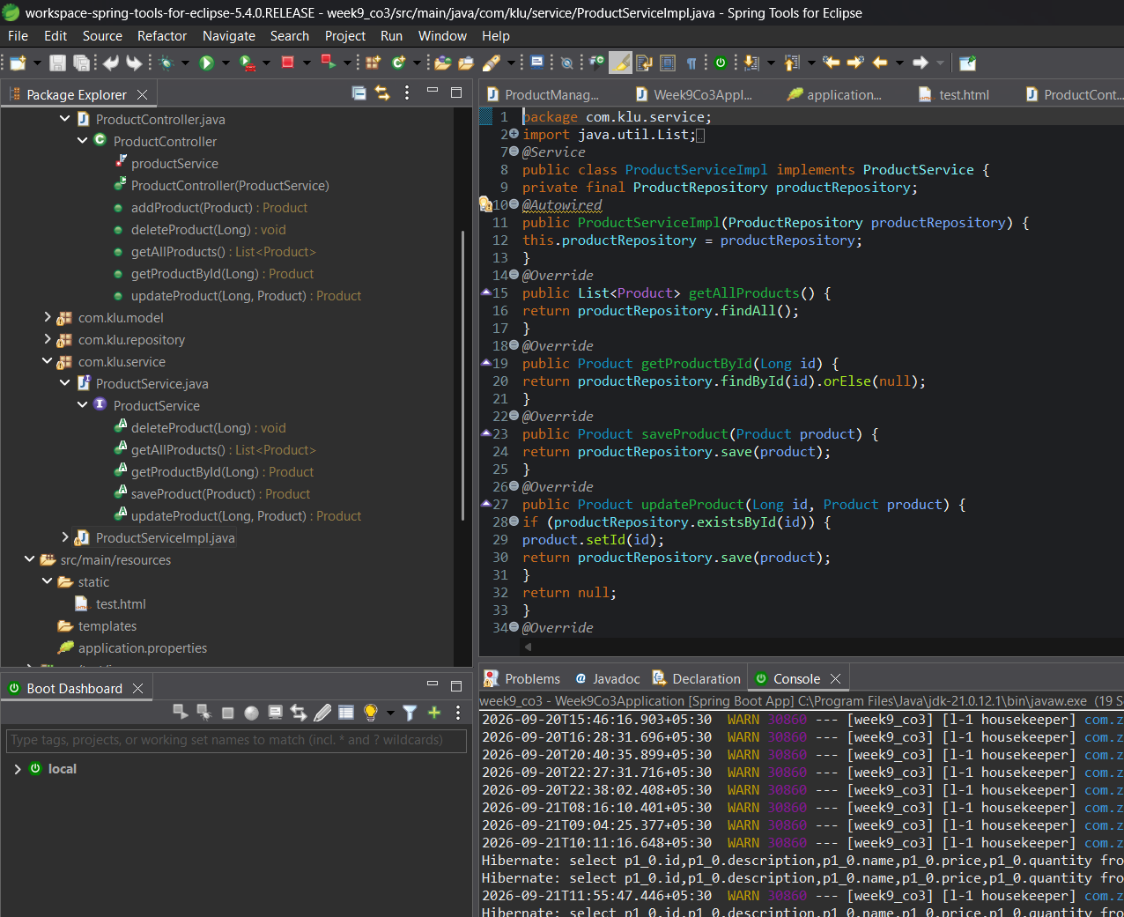
Fig 5.1 — ProductServiceImpl.java in STS

5.3 REST Controller — ProductController.java
package com.klu.controller;
import com.klu.model.Product;

@RestController
@RequestMapping("/api/products")
@CrossOrigin(origins = "http://localhost:5173")
public class ProductController {
private final ProductService productService;

public ProductController(ProductService productService) {
this.productService = productService;
}

@GetMapping
public List<Product> getAllProducts() {
return productService.getAllProducts();
}

@GetMapping("/{id}")
public Product getProductById(@PathVariable Long id) {
return productService.getProductById(id);
}

@PostMapping
public Product addProduct(@RequestBody Product product) {
return productService.saveProduct(product);
}

@PutMapping("/{id}")
public Product updateProduct(@PathVariable Long id, @RequestBody Product product) {
return productService.updateProduct(id, product);
}

@DeleteMapping("/{id}")
public void deleteProduct(@PathVariable Long id) {
productService.deleteProduct(id);
}
}

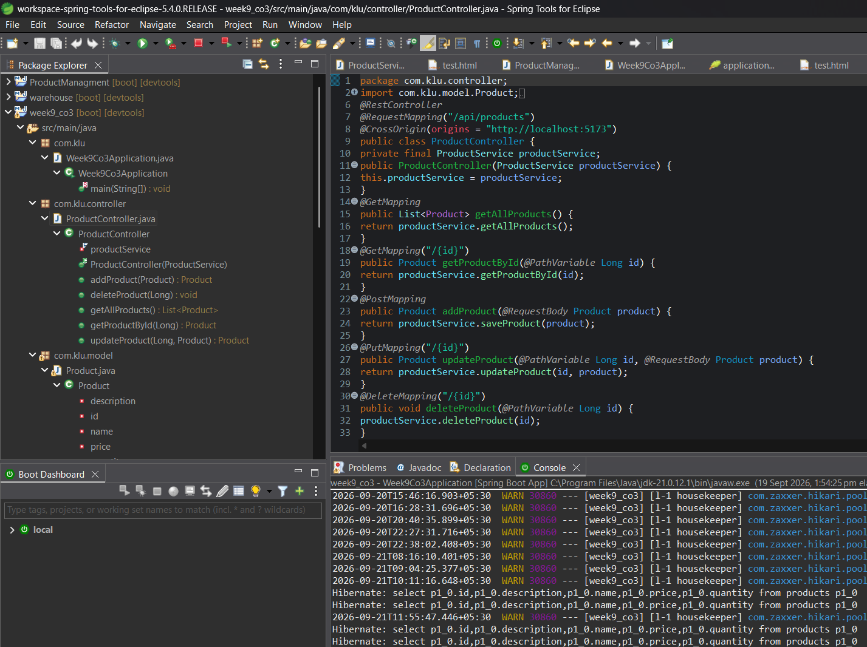
Fig 5.2 — ProductController.java, exposing /api/products endpoints

6. Testing the API — test.html
A static HTML page (src/main/resources/static/test.html) was used to manually invoke the Create, Update and Delete endpoints via the Fetch API before wiring up the React frontend.
<h2>Create Product</h2>
<button onclick="createProduct()">Create Product</button>

<h2>Update Product</h2>
<button onclick="updateProduct()">Update Product 1</button>

<h2>Delete Product</h2>
<button onclick="deleteProduct()">Delete Product 1</button>

<script>
function createProduct() {
fetch('/api/products', {
method: 'POST',
headers: { 'Content-Type': 'application/json' },
body: JSON.stringify({
name: 'Gaming Keyboard',
description: 'RGB wireless keyboard',
price: 2000,
quantity: 10
})
})
}

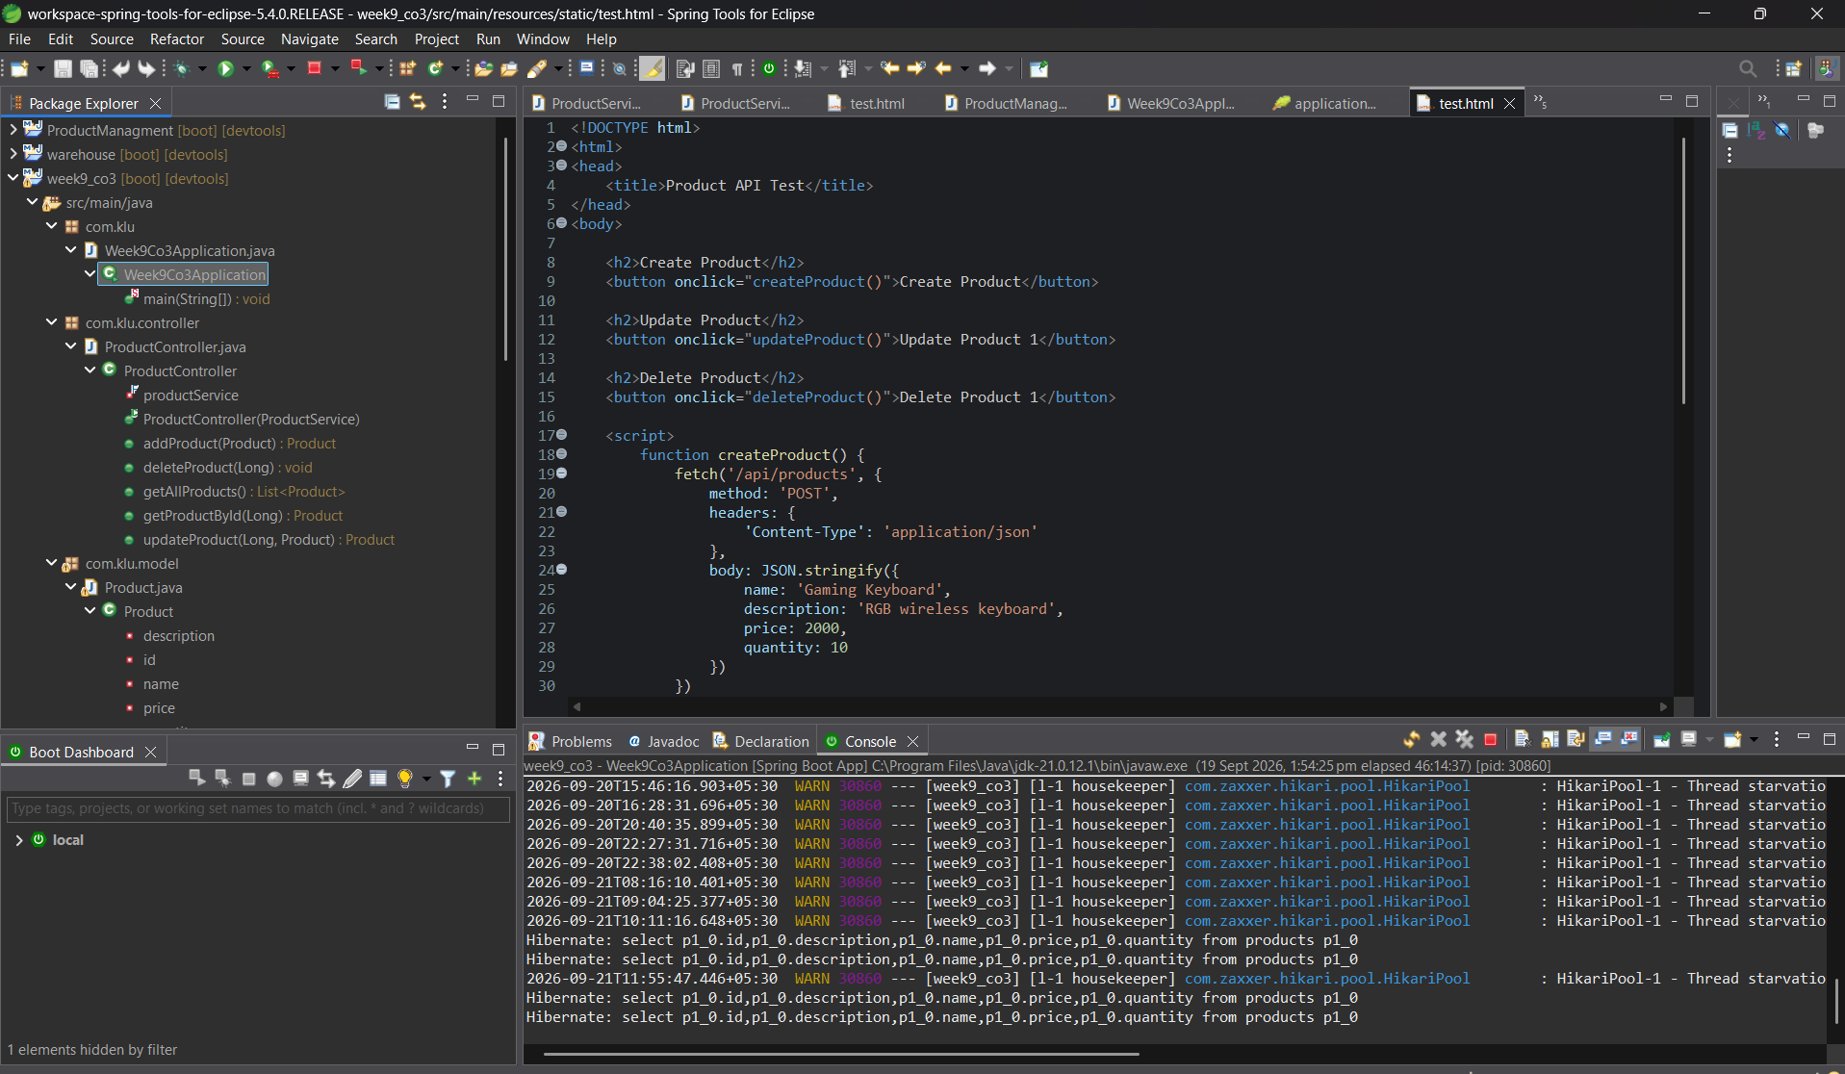
Fig 6.1 — test.html in STS, with the application console showing Hibernate SELECT queries executing against the products table

7. React Frontend
Two React (Vite) frontends running on localhost:5173 were connected to the API to display, add, edit and delete products, confirming the backend and CORS configuration work end-to-end.
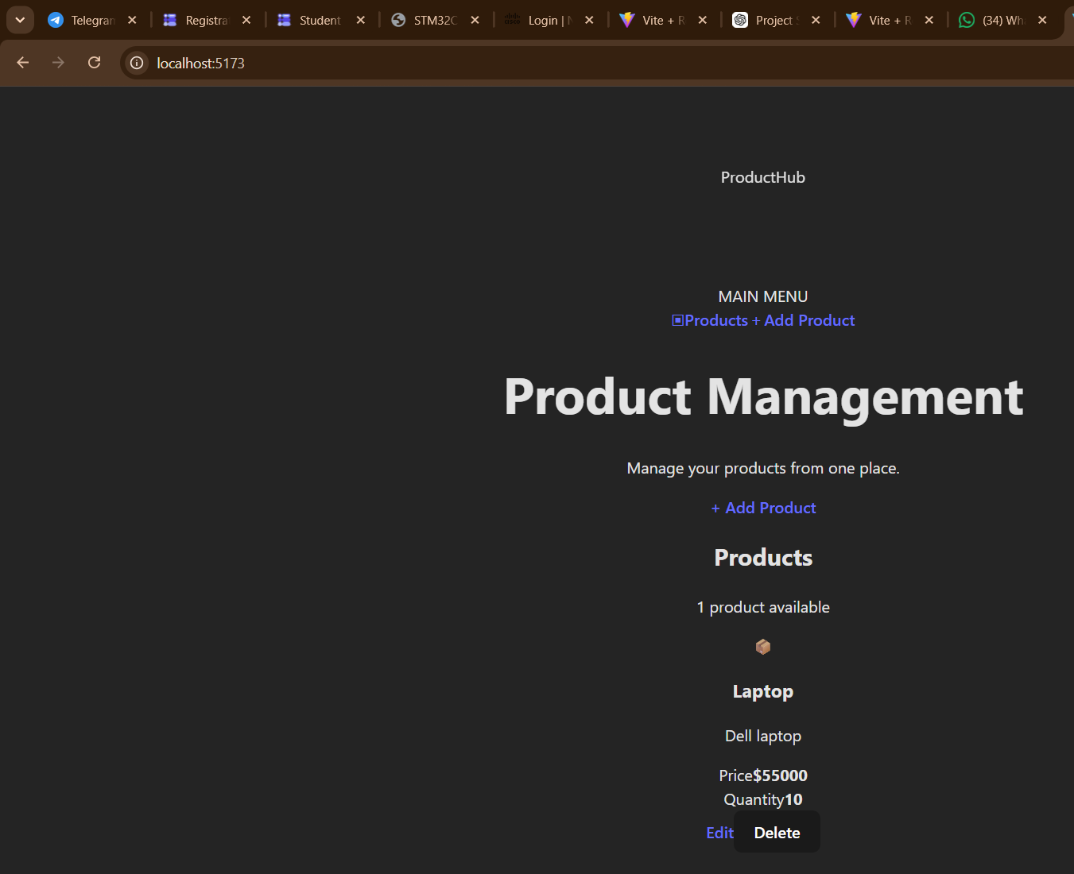
Fig 7.1 — "ProductHub" React UI listing the saved product (Laptop, $55000, Qty 10) with Edit/Delete
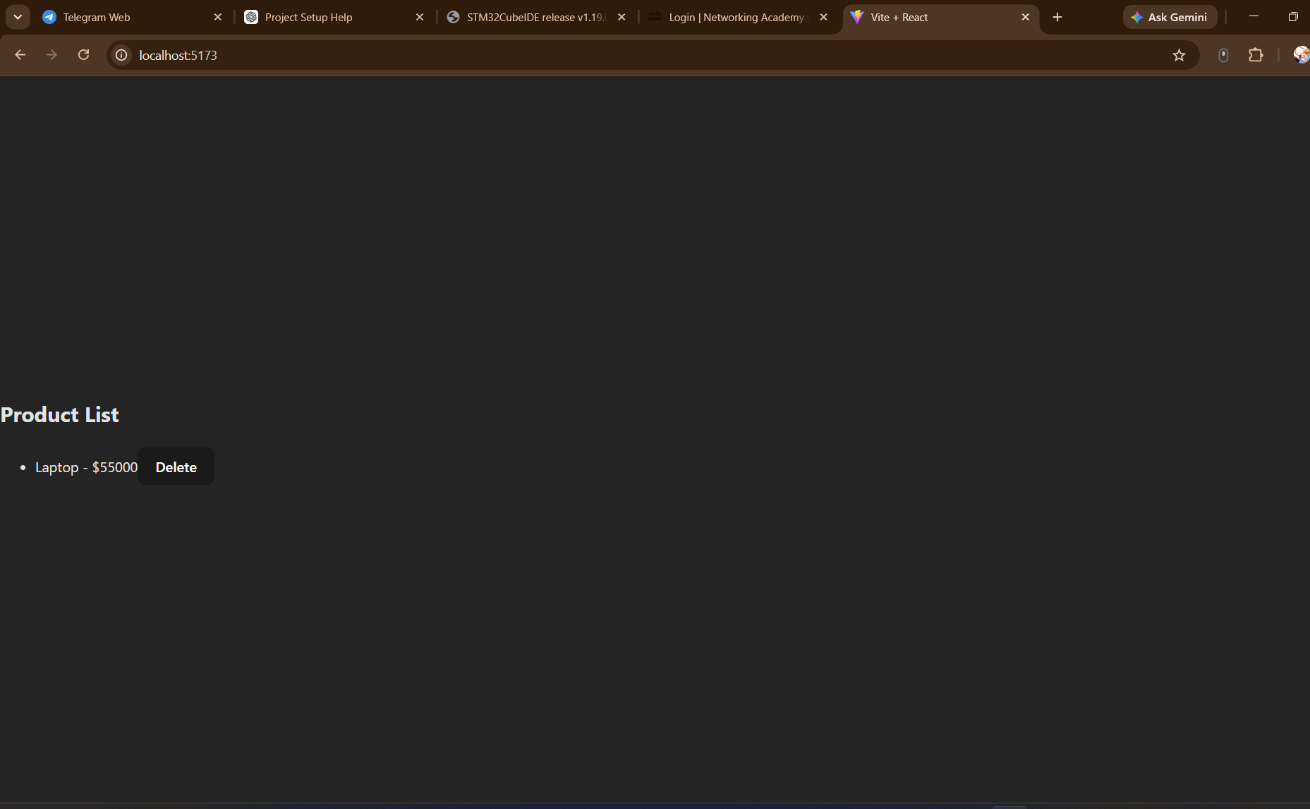
Fig 7.2 — Simpler "Product List" React UI confirming the same record via the API

8. Result
A complete CRUD REST API for the Product Management System was successfully implemented using Spring Boot, Spring Data JPA and MySQL. The products table was auto-created with the expected schema (id, name, description, price, quantity). All endpoints (GET /api/products, GET /api/products/{id}, POST /api/products, PUT /api/products/{id}, DELETE /api/products/{id}) were verified through test.html and Hibernate console logs, and the data was successfully rendered and manipulated through a React frontend, confirming correct end-to-end integration between the frontend, backend and database.

