**Customer Coupon Acceptance Analysis (M5 Practical Application)**

**Project Overview**

This project is part of Required Assignment 5.1 and focuses on analyzing whether a customer would accept a coupon delivered to their mobile phone under various circumstances. The use case involves a hypothetical scenario where customers receive location-based coupons while driving and must decide whether or not to accept the offer. The goal of the analysis is to predict coupon acceptance based on several factors such as the type of establishment, the presence of passengers, the weather, and time of day.

The dataset-coupons contains 12,684 entries with 26 columns, including both categorical and numerical data. Key features include factors like destination, weather, coupon type, and customer demographics (e.g., age, marital status), which are used to predict whether a customer accepts the coupon (Y column).

Data Cleaning: Checked for any missing data - The "car" column is dropped due to having only 109 non-null values, which is insignificant compared to the 12,684 total entries.

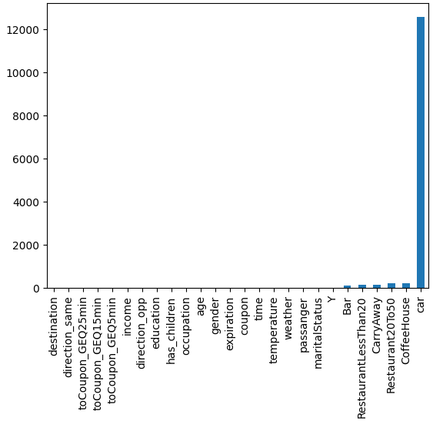

1. What proportion of the total observations chose to accept the coupon?

56.84% which is 7210 observations chose to accept the coupon out of 12684.

bar plot to visualize the coupon column.

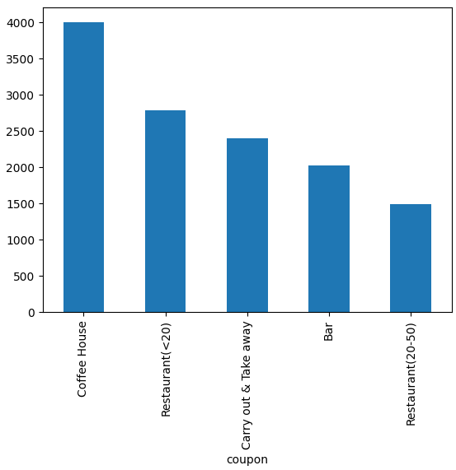

Histogram to visualize the temperature column.

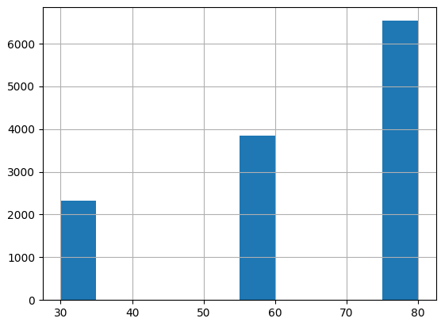

**Bar Coupons**

2. What proportion of bar coupons were accepted?

58.99% of bar coupons were accepted out of 2,017 drivers who received them.

3. Compare the acceptance rate between those who went to a bar 3 or fewer times a month to those who went more.

Result-3: The acceptance rate for drivers who go to the bar 3 times or fewer is 62.9%, while for those who go more than 3 times, it is 76.88%, indicating a higher acceptance rate among frequent bar-goers.

Assumption: The values in the "Bar" column are approximated for analysis, with blank and "never" = 0, "less1" = 1, "13" = 3, "48" = 8, and "gt8" = 9.

4. Compare the acceptance rate between drivers who go to a bar more than once a month and are over the age of 25 to all others. Is there a difference?

Result-4: The acceptance rate for drivers who go to a bar more than once a month and are over the age of 25 is 69.52%. This indicates a higher acceptance rate compared to other groups, suggesting that this demographic is more likely to accept bar coupons.

Assumption: The values '50plus' and 'below21' in the "age" column are approximated as 51 and 20, respectively, to facilitate numerical analysis.

5. Use the same process to compare the acceptance rate between drivers who go to bars more than once a month and had passengers that were not a kid and had occupations other than farming, fishing, or forestry.

Result-5: The acceptance rate for drivers who go to bars more than once a month, have passengers that are not kids, and have occupations other than farming, fishing, or forestry is approximately 71.3%, with 393 accepted coupons and 158 rejected.

6. Compare the acceptance rates between those drivers who:

* go to bars more than once a month, had passengers that were not a kid, and were not widowed OR
* go to bars more than once a month and are under the age of 30 OR
* go to cheap restaurants more than 4 times a month and income is less than 50K.

Result-6: The acceptance rate for the selected group is 53.4% with 486 drivers accepting the coupons and 424 drivers rejecting them.

7. Based on these observations, what do you hypothesize about drivers who accepted the bar coupons?

Result-7: The data indicates that younger, more frequent bar-goers, particularly those who do not have child passengers are more likely to accept coupons. Occupational status appears to have minimal impact on drivers' willingness to accept bar coupons compared to factors like frequency of bar visits, age, and income.

Using the bar coupon example as motivation, you are to explore one of the other coupon groups and try to determine the characteristics of passengers who accept the coupons.

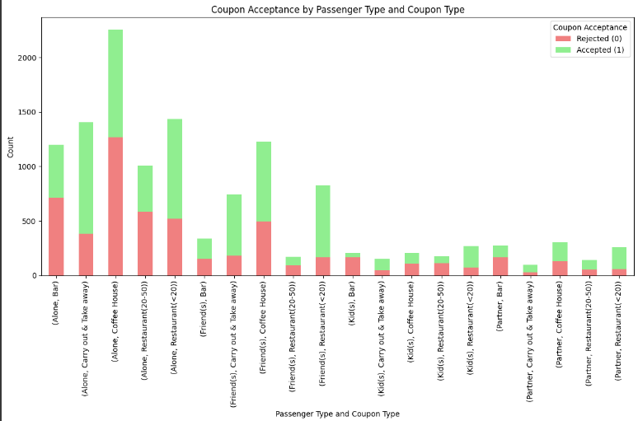

1. **Key Insight on Social Dynamics and Savings** : People dining alone tend to accept more coupons, especially at coffee houses and bars, showing they value savings when eating out. In contrast, when dining with friends or kids, coupon acceptance drops significantly, indicating that social settings may influence how much they prioritize discounts.

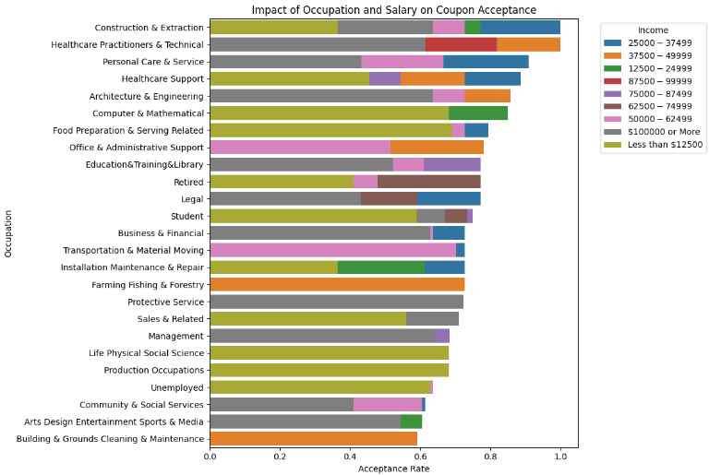

1. **Occupational and Income Trends**: Occupations like Construction and Personal Care tend to show higher coupon acceptance rates, likely due to job flexibility. Middle-income earners, such as those earning 37,500−49,999, tend to accept coupons more than higher earners. Higher-income groups may be less influenced by discounts, showing lower acceptance rates.

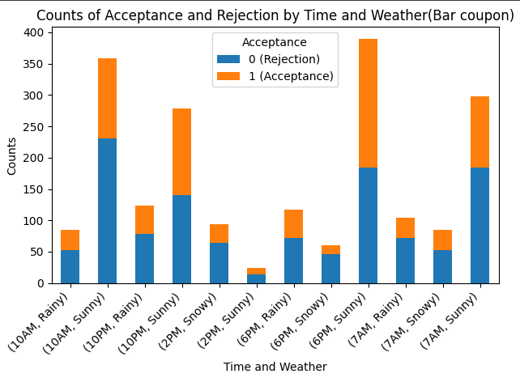

1. **Weather Patterns and Time Impact**: Acceptance rates peak during Sunny weather at 6PM with 205 acceptances, while Rainy and Snowy conditions yield lower rates. Additionally, Sunny weather at 10AM shows a notable 128 acceptances, underscoring the influence of weather on acceptance behavior.

Finally taking all these attributes into consideration, Coupon acceptance is higher among individuals dining alone, certain occupations with job flexibility, and middle-income earners. Social settings reduce coupon use, while external factors like weather significantly influence behavior, with sunny conditions yielding more acceptances. Higher-income earners show lower acceptance, suggesting less sensitivity to discounts.