Used Car Pricing Analysis Report

#### **Prepared for: Used Car Dealers**

### **Executive Summary**

Our analysis identifies the key factors influencing used car prices, equipping your dealership with actionable insights to fine-tune inventory management and pricing. By examining variables like age, mileage, fuel type, and condition, we provide data-driven recommendations to enhance profitability and cater to market demand.

### **Business Understanding:**

**Problem Statement**:  
The goal is to identify key factors influencing used car prices to help a used car dealership optimize inventory decisions, pricing strategies, and marketing efforts.

**Objectives**:

* Understand which features (e.g., age, mileage, fuel type, condition) drive car prices.
* Provide actionable insights to enhance the dealership's profitability and competitiveness.

### **Clean and Organized Notebook:**

1. **Data Cleaning**:
   * Missing values in key variables (year, odometer, condition, etc.) were imputed using median (for numerical features) and mode (for categorical features).
   * Outliers were removed by capping prices and mileage at the 1st and 99th percentiles.
2. **Feature Engineering**:
   * New features like age were created to capture vehicle depreciation.
   * Polynomial terms and interaction terms were added to account for non-linear relationships.
3. **Normalization**:
   * Standard scaling was applied to all numerical variables to ensure regression stability.

### **Descriptive and Inferential Statistics:**

1. **Descriptive Statistics**:
   * Average car price decreases significantly with higher mileage (odometer) and older cars (year).

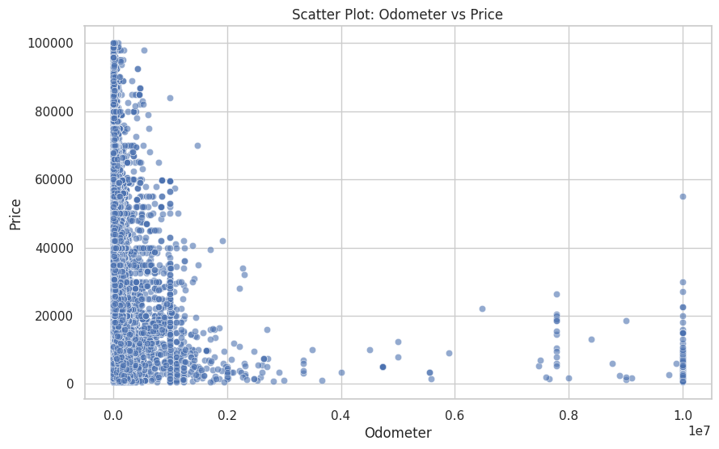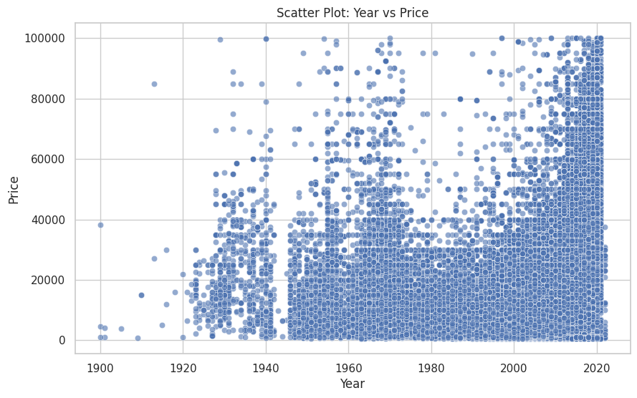

* + Alternative fuel vehicles and unique transmission types positively influence car prices.

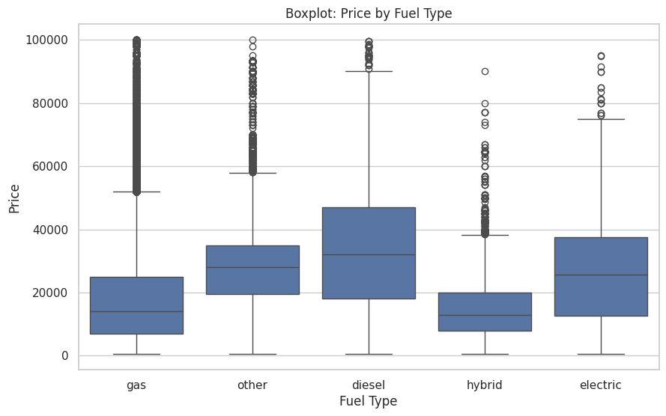

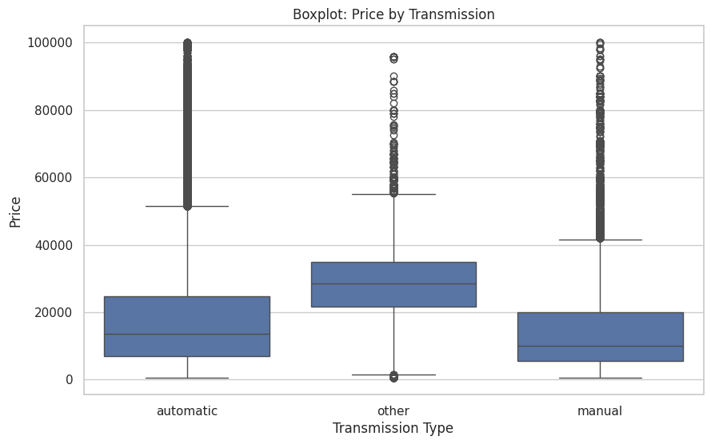

1. **Inferential Statistics**:
   * Ridge regression coefficients identified significant predictors:
     + **Negative Impact**: age, odometer, and fuel_gas.
     + **Positive Impact**: Alternative fuel types, interactions between features like age × fuel_other, and certain quadratic terms.
   * Models explained approximately **56%** of the variance in prices (R-Square) with an average prediction error (MAE) of **$6,843**.

### **Key Findings**

1. **Depreciation Effects**:
   * **Older Cars Lose Value**: Car age is the most significant factor in price reduction. On average, each additional year reduces the price by approximately **$7,171**.
   * **Higher Mileage Reduces Prices**: Vehicles with more miles on the odometer see significant depreciation, with an average reduction of **$5,173** per mileage increment.
2. **Fuel Type and Sustainability**:
   * **Alternative Fuels Command Premiums**: Hybrid and electric vehicles generally sell for higher prices than gasoline vehicles, indicating a growing consumer preference for sustainable options.
   * **Gasoline Cars Face Mixed Impact**: While gasoline cars remain common, they tend to have slightly lower resale values, particularly when paired with high mileage.
3. **Interactions and Niche Preferences**:
   * Certain combinations, such as **"older cars with alternative fuels"**, positively influence prices, suggesting demand in niche markets.
   * Unique transmission types (e.g., manual) can add value when paired with alternative fuels.
4. **Outlier Effects**:
   * Removing extreme values in price and mileage improved the model's prediction accuracy, revealing more stable patterns across the dataset.

### **Actionable Recommendations**

1. **Inventory Optimization**:
   * **Acquire More Sustainable Vehicles**: Expand the inventory of hybrid and electric cars to cater to growing consumer demand.
   * **Focus on Newer, Low-Mileage Cars**: These vehicles maintain value better and attract premium prices.
2. **Dynamic Pricing**:
   * **Adjust Pricing Based on Age and Mileage**: Implement dynamic pricing models to reflect depreciation trends accurately.
   * **Leverage Niche Features**: Highlight alternative transmissions and low mileage to justify premium pricing for specific cars.
3. **Marketing Strategy**:
   * **Promote Sustainability**: Position alternative fuel vehicles as eco-friendly and cost-effective options for consumers.
   * **Certify Pre-Owned Vehicles**: Introduce certification programs to reduce consumer hesitation around older or higher-mileage cars.

### **Data Insights**

**Statistical Highlights**:

* **Mean Absolute Error (MAE)**: $6,483 - This indicates that, on average, the model's price predictions deviate by $6,483.
* **R-Squared (R^2)**: 56.1% — Approximately 56.1% of the variance in car prices is explained by the model, leaving room for further feature exploration.

**Key Predictors**:

* **Age**: Largest depreciation factor (−$7,171-\$7,171).
* **Mileage**: Strong negative impact (−$5,173-\$5,173).
* **Fuel Type**: Hybrid/electric vehicles are consistently priced higher than gasoline-powered cars.

### **Next Steps**

1. **Expand Data Collection**:
   * Include features like make, model, and geographic data to refine predictions.
   * Integrate external factors like fuel prices and market trends to capture broader pricing influences.
2. **Advanced Modeling**:
   * Explore tree-based models (e.g., Random Forest, Gradient Boosting) to capture non-linear relationships.
   * Segment data by car type (luxury, economy, etc.) to improve model precision.
3. **Consumer Insights**:  
   * Conduct surveys or focus groups to understand consumer preferences for alternative fuels and unique features.

### **Conclusion**

By focusing on newer, low-mileage cars and promoting alternative fuel options, your dealership can position itself as a market leader. Implementing dynamic pricing and highlighting niche features will enhance customer engagement and profitability.