GOOGLE PLAY STORE APP PERFORMANCE & USER ENGAGEMENT ANALYTICS

1. Project Overview
Google Play Store App Performance & User Engagement Analytics is a data analytics project that analyses Google Play Store app data to understand app ratings, reviews, installs, pricing, categories, and user engagement. The project involves data cleaning, transformation, feature engineering, and EDA using Python, followed by visualization and dashboard preparation in Power BI to generate meaningful insights.
The objective of this project is to analyse Google Play Store application data and transform the raw data into meaningful insights related to app performance, user engagement, ratings, installs, pricing, categories, and other important factors.
The analysis focuses on eight major areas:
Cleaning and pre-processing the raw dataset, App ratings and user reviews, App installation trends, Free and paid applications, Popular app categories, User engagement through reviews and installs, Data-driven insights, Power BI visualization preparation

2. Problem Statement
Google Play Store contains a large number of applications across different categories, pricing types, ratings, review volumes, and installation levels. Without systematic analysis, it is difficult to identify which categories are popular, how installations relate to user engagement, how free and paid applications differ, and which factors are associated with app performance.
The purpose of this project is therefore to transform raw Google Play Store application data into meaningful business insights that can support better understanding of app popularity, user engagement, ratings, installation trends, and pricing patterns.

3. Project Objectives
• To clean and preprocess Google Play Store application data for accurate analysis.
• To identify important patterns, trends, relationships, and distributions through exploratory data analysis.
• To analyse app performance across categories, ratings, reviews, installations, pricing, and app type.
• To evaluate user engagement using reviews, installs, and the Review-to-Install Ratio.
• To compare free and paid applications and understand pricing patterns.
• To create an interactive Power BI dashboard and generate meaningful data-driven insights.

4. Dataset Description
The project uses the Google Play Store Apps Dataset, which contains information about Android applications, including their categories, ratings, reviews, installs, pricing, size, and other app details. The dataset contains approximately 10,841 records and 13 columns and is used to analyse app performance, popularity, user engagement, and free-versus-paid app trends.
Important fields include App, Category, Rating, Reviews, Size, Installs, Type, Price, Content Rating, Genres, Last Updated, Current Ver, and Android Ver. The dataset is a CSV file named googleplaystore.csv and is sourced from GitHub – Mainak-Repositor/Datasets.

5. Tools and Technologies Used
• Python and Google Colab were used for data loading, cleaning, transformation, feature engineering, and EDA.
• Pandas was used for data manipulation and analysis.
• NumPy was used for numerical operations and feature calculations.
• Matplotlib and Seaborn were used for exploratory visualizations and statistical plots.
• Power BI was used for interactive dashboard visualization.

6. Data Preparation and Cleaning
The raw Google Play Store dataset was inspected and pre-processed to improve data quality, consistency, and reliability before exploratory data analysis and Power BI dashboard development. The dataset structure, columns, data types, number of records, missing values, duplicate records, and inconsistent entries were reviewed. Numerical and categorical columns were also checked for data-quality issues.
Missing and invalid values were handled appropriately to avoid affecting the analysis, and records with unsuitable or unusable values were removed where necessary. Duplicate app records were identified and removed, with duplicate entries checked based on app-related information to prevent repeated records from affecting installation and review analysis.
Numerical fields such as Reviews, Installs, Rating, and Price were converted into appropriate numerical data types. Date-related information was converted into a suitable format for analysis. Categorical values such as Category, Type, and Content Rating were standardized, while text fields such as Genres were cleaned for analysis.

Feature Engineering:
• Updated-Year was extracted from the Last Updated date.
• Review-to-Install Ratio was calculated to measure user engagement relative to installations.
• Popularity Category was created to classify apps based on installation performance.
After cleaning and pre-processing, the dataset was validated and prepared for Exploratory Data Analysis (EDA), visualization, and Power BI dashboard development. The processed data was then used to analyse app popularity, installations, reviews, ratings, pricing, and user engagement.

7. Types of Analysis Performed
Descriptive analysis: Used to summarize app categories, ratings, reviews, installs, pricing, app type, and update trends.
Diagnostic analysis: Used to investigate differences between categories and understand patterns related to app popularity, user engagement, ratings, installations, and pricing.
Prescriptive analysis: Findings were interpreted to support data-informed business decisions and recommendations. Predictive analysis was not described as being performed in the source project.
Univariate analysis: Used to study individual variables such as app categories, ratings, reviews, installs, app size, pricing, app type, and update trends.
Bivariate analysis: Used to examine relationships between variables such as installations and reviews, category and engagement, and pricing and app performance.
Multivariate analysis: Used to examine combined patterns involving app category, installations, reviews, ratings, pricing, app type, and user engagement.
Correlation analysis: Used to examine relationships among relevant numerical variables through statistical summaries and visualizations.

8. PowerBI Dashboard
The Power BI report was created using the cleaned and feature-engineered Google Play Store dataset. The dashboard presents KPIs and visualizations related to app ratings, reviews, installations, app categories, pricing, app type, popularity, and update trends. Interactive filters and charts allow users to explore and compare app performance across categories and application types.

9. Overview Dashboard
The Overview page provides a high-level view of Google Play Store applications, focusing on app distribution, ratings, installs, reviews, and free versus paid applications. It helps users understand the overall performance and user engagement of the applications in the dataset.
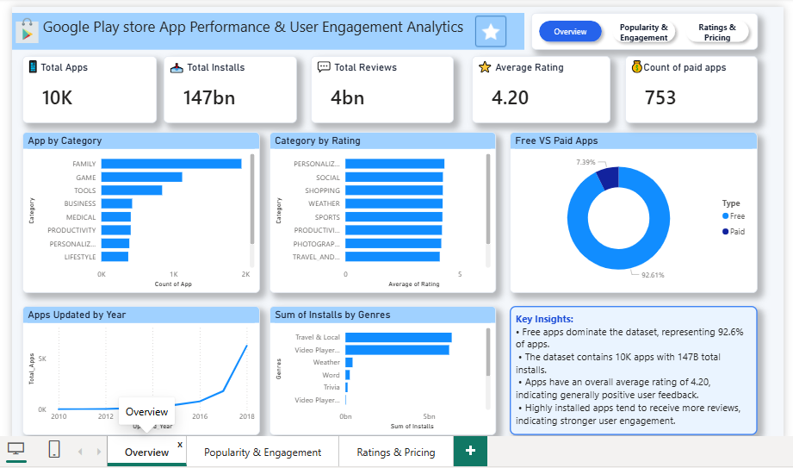

Charts Used:
• App distribution and category-level views help understand how applications are distributed across the Google Play Store.
• Rating and review views provide an overall understanding of user perception and engagement.
• Installation-related views highlight app popularity and reach.
• Free versus paid application comparisons provide an overview of app type distribution and performance.

10. Popularity & User Engagement
The Popularity & User Engagement page analyses app popularity and user engagement using installations, reviews, app categories, and app types. It helps identify popular applications and categories and understand user interaction patterns.
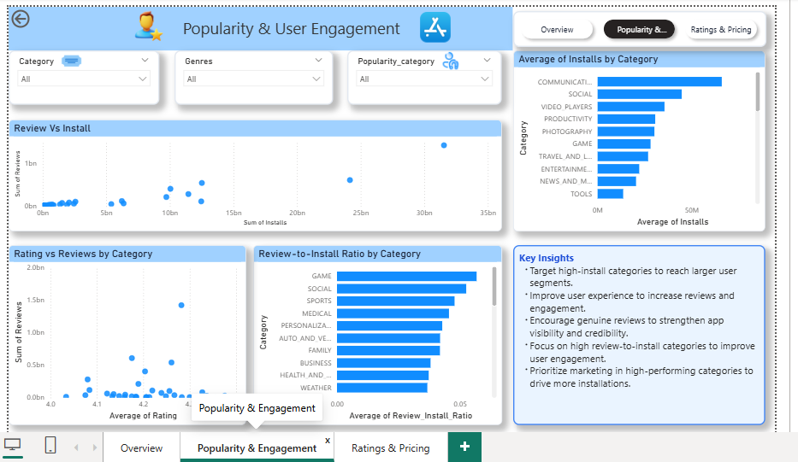

Charts Used:
• App and category installation analysis highlights applications and categories with stronger reach.
• Review analysis shows the level of user interaction across applications and categories.
• Review-to-Install Ratio analysis measures engagement relative to installations.
• App type comparisons help understand popularity and engagement across free and paid applications.

11. Rating & Pricing
The Rating & Pricing page analyses app pricing and ratings to understand how price relates to app performance and user perception. It also provides comparisons between free and paid applications.
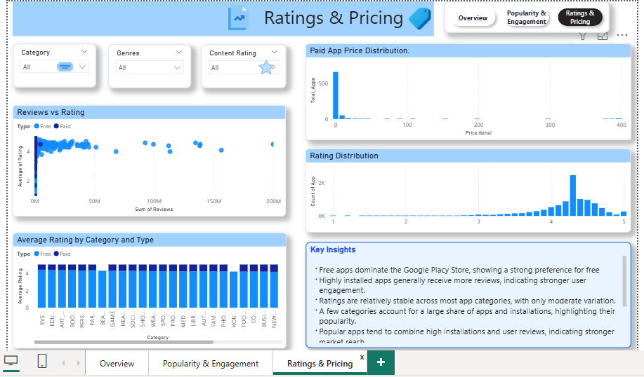

Charts Used:
• Rating analysis compares user ratings across applications and categories.
• Pricing analysis examines app price patterns and differences between free and paid applications.
• Free versus paid comparisons help evaluate how application type relates to ratings and performance.

12. Dashboard Navigation & Interactivity
The Power BI dashboard converts the analytical results obtained from Python into an interactive and user-friendly reporting format. Interactive filters and charts allow users to explore the dataset from different perspectives and compare app performance across categories and application types. The dashboard provides a consolidated view of app ratings, reviews, installations, pricing, categories, popularity, and update trends.

13. Key Insights
• Category performance varies significantly. A few categories account for a large share of installations and reviews, indicating that high-performing categories should be prioritized while lower-performing segments can be examined for opportunities.
• Higher installations generally correspond with more reviews, showing that app reach and visibility are associated with greater user engagement.
• Engagement differs across categories. The Review-to-Install Ratio varies by category, indicating differences in how effectively downloads translate into user interaction.
• Ratings alone do not indicate overall success. Ratings are relatively stable across most categories, so installations, reviews, and engagement should also be considered when evaluating app performance.
• Free applications dominate the dataset. Paid applications therefore need competitive pricing, trials, or clear value-added features to improve their ability to attract users.

14. Business Recommendations
• Prioritize high-performing categories. Businesses should focus resources on categories with strong installation and review performance while identifying opportunities in lower-performing segments.
• Improve app visibility and discoverability. App-store optimization, marketing, and user-experience improvements can help increase installations and engagement.
• Increase user engagement after installation. Better features, feedback mechanisms, and customer support can help convert downloads into active engagement.
• Evaluate app performance using multiple KPIs. Ratings should be analysed together with installations, reviews, engagement, and pricing rather than being used as the only measure of success.
• Use competitive pricing and value propositions for paid applications. Trials, clear value-added features, and appropriate pricing can help paid apps attract users.

15. Conclusion
This project demonstrates how Python-based data cleaning, transformation, feature engineering, and exploratory analysis combined with Power BI can transform Google Play Store application data into meaningful business intelligence. The analysis identifies patterns related to app popularity, user engagement, ratings, installations, categories, pricing, and free-versus-paid applications.
The findings show that sustainable app performance depends on more than downloads or ratings alone. A combination of category selection, visibility, user engagement, ratings, and pricing should be used to drive data-informed decisions. The final Power BI dashboard provides an interactive way to explore these findings and supports a better understanding of Google Play Store app performance and user engagement.

