**Screenshots**:

**UI**:

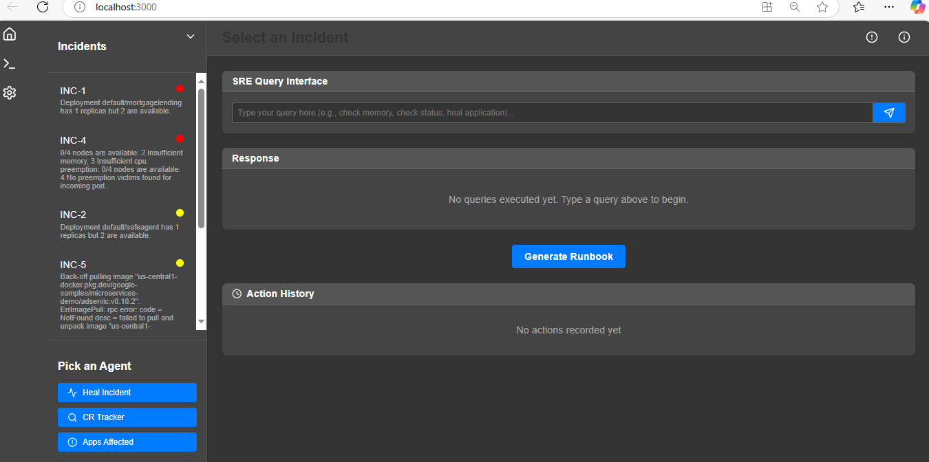

**User requested Incident details:**

**Click on Incident**

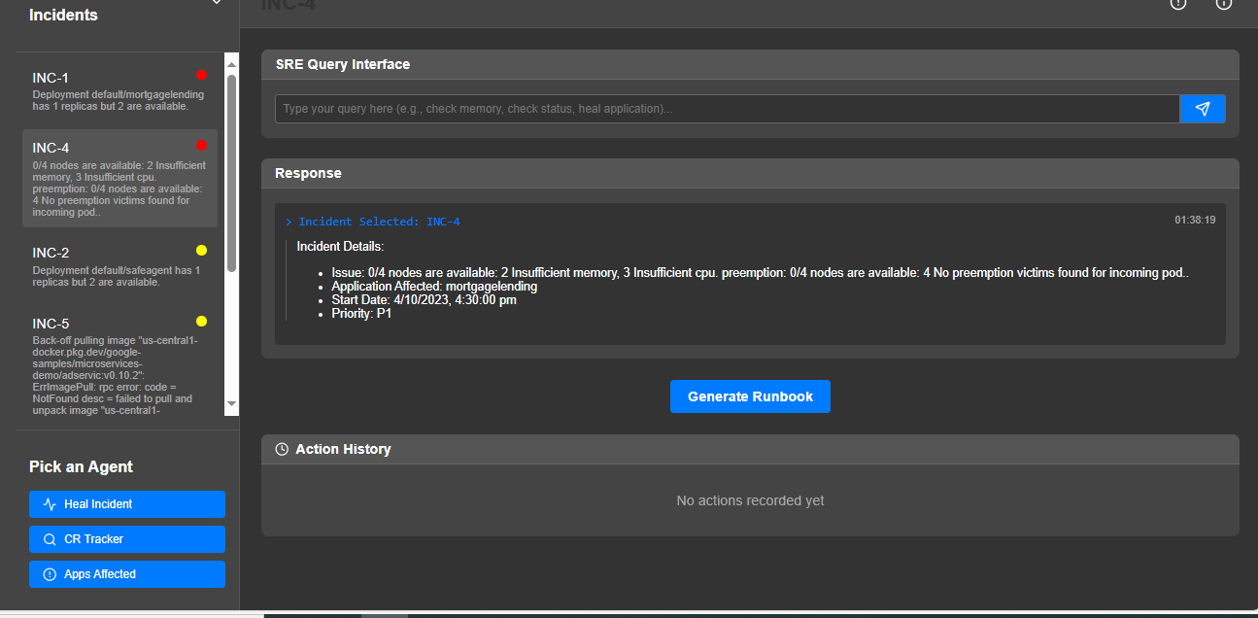

**User Requested CR details to check if it could have led to incident:**

**Click on CR Tracker**

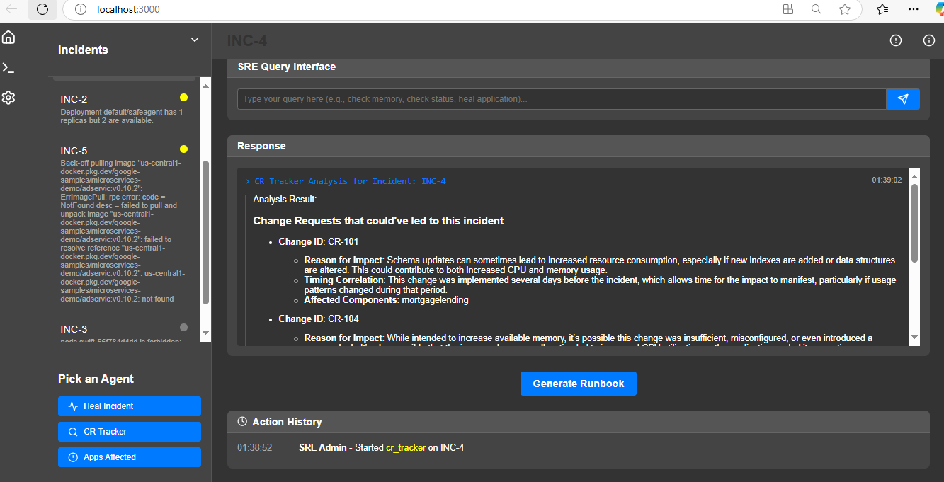

**User requested Heal incident to generate script:**

**Click on Heal Incident**

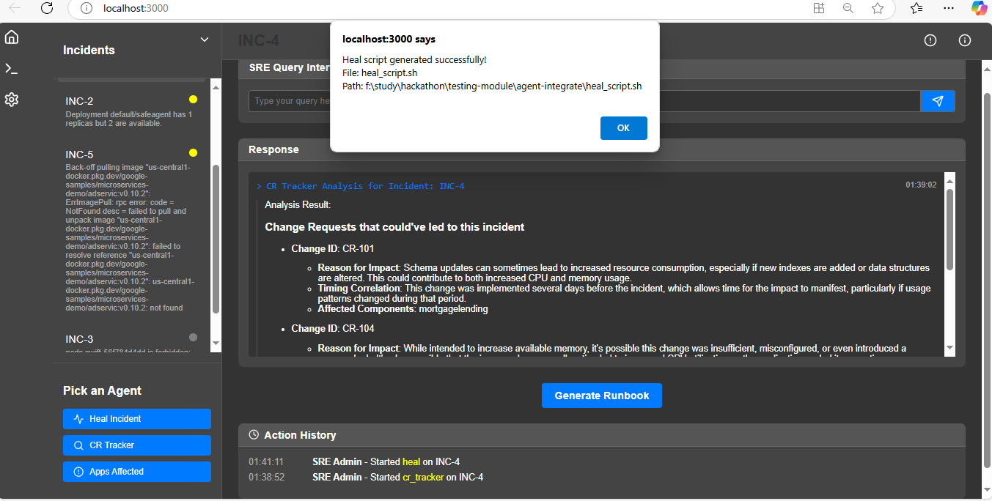

**User request to check upstream/downstream affected by Incident:**

**Click on CR Tracker**

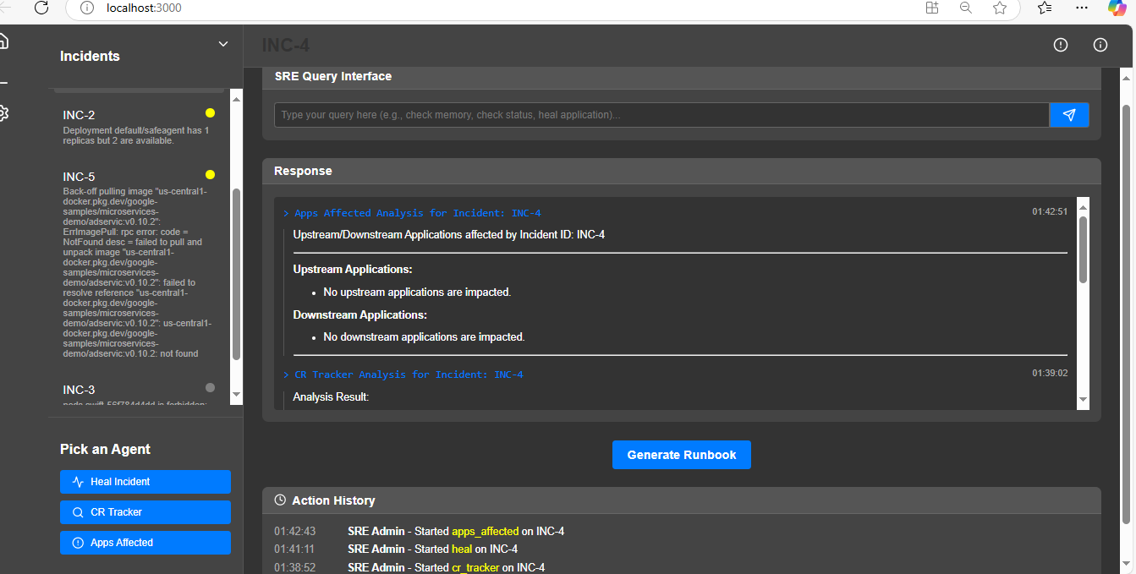

**User request to download runbook:**

**Click Generate Runbook**

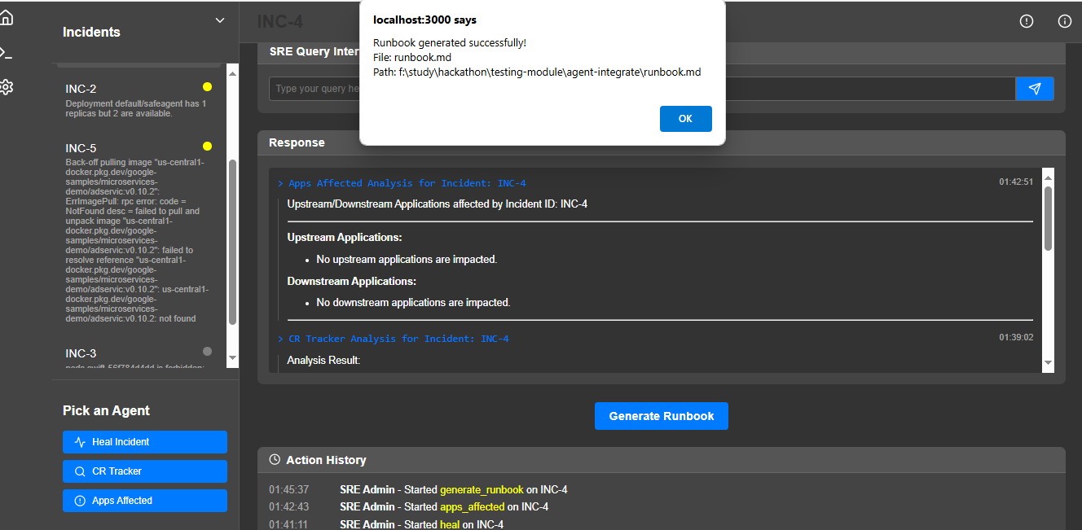

**Backend Logs:**

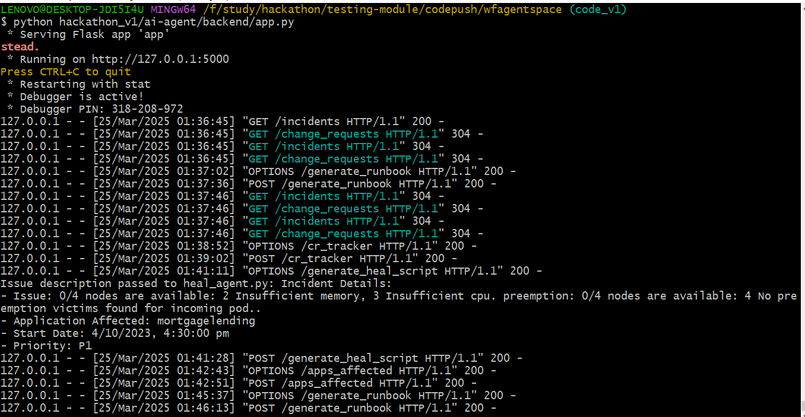

**UI start logs:**

