**Step 1: When the hill admin users or Registrar access the url** [**sascpass.skiatlanticseniorsclub.ca**](https://can01.safelinks.protection.outlook.com/?url=http%3A%2F%2Fsascpass.skiatlanticseniorsclub.ca%2F&data=05%7C01%7CW0463974%40nscc.ca%7C2800686cee4748f4a98f08dafe5305d3%7Cc59bd97a4b1b4dab89aca0ab6a8e4435%7C0%7C0%7C638101929775760308%7CUnknown%7CTWFpbGZsb3d8eyJWIjoiMC4wLjAwMDAiLCJQIjoiV2luMzIiLCJBTiI6Ik1haWwiLCJXVCI6Mn0%3D%7C3000%7C%7C%7C&sdata=yPWN8o67cXvn6kfdWw7l7%2BrjIQj0IK%2BoeI4q00G8T9k%3D&reserved=0)**, login page will be opened.**

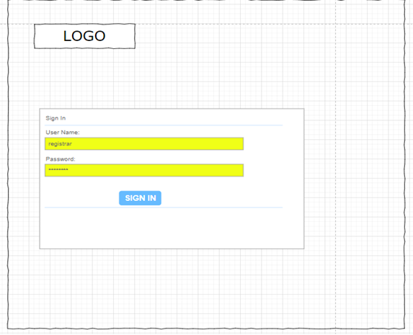

**Step 2: Landing page (dashboard) with “Generate SASC Pass #”, Members, Update a Visit, Reports menus. Generate SASC Pass # & Reports are available for Registrar only.**

**Step 3: Landing Page by default opens the first menu.**

**Step 4: Generate SASC Pass #  - Opens a page which allows the Registrar to generate the SASC numbers. They should be provided with buttons to Export the Generated Pass# to excel (for printing purpose) & Export the Unassigned Pass# to Excel (to see the cancelled & unused passes)**

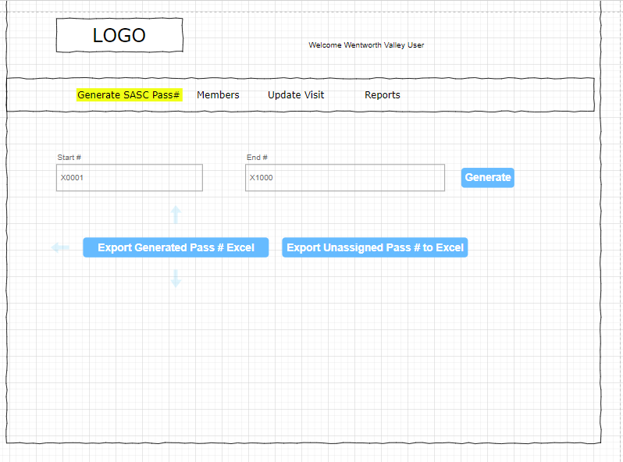

**Step 5: Members Menu allows the hill admins & registrar to view all members. Search box allows them to enter the pass number to verify the user. Edit button shows against the members let the admins edit the member data.**

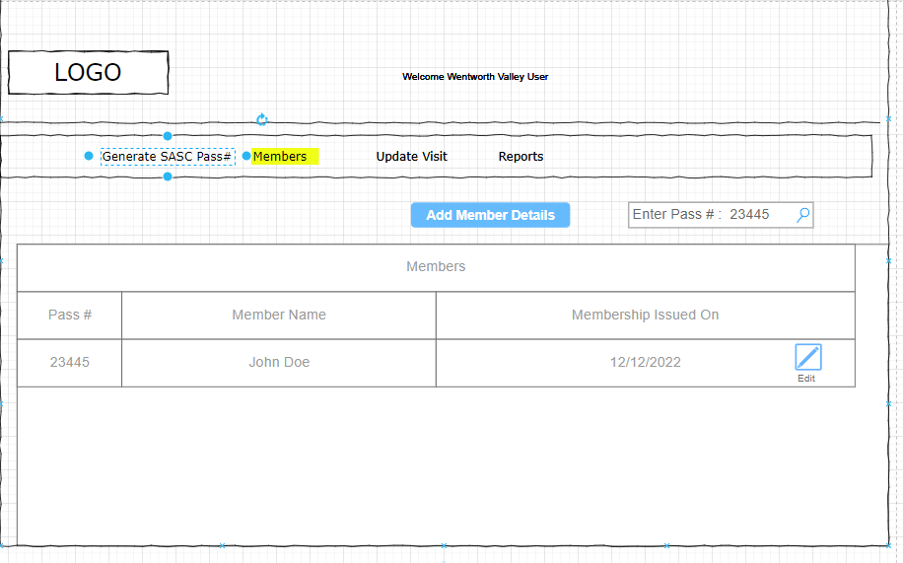

**Step 6: Add Member button will be available only to the Registrar where she adds the member’s personal info along with the pass #. The screen provides the list of unassigned pass# in a dropdown menu so that no duplicate pass# gets assigned to users.**

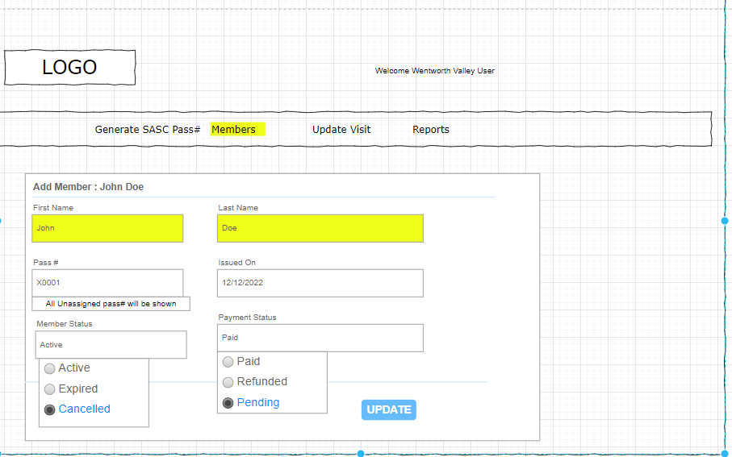

**Step 7: Update Visit – Admin users at the hill can access this menu and type in the pass#, to validate the usage on the day and issue the day pass. Validation messages will be shown (error in red, success in green)**

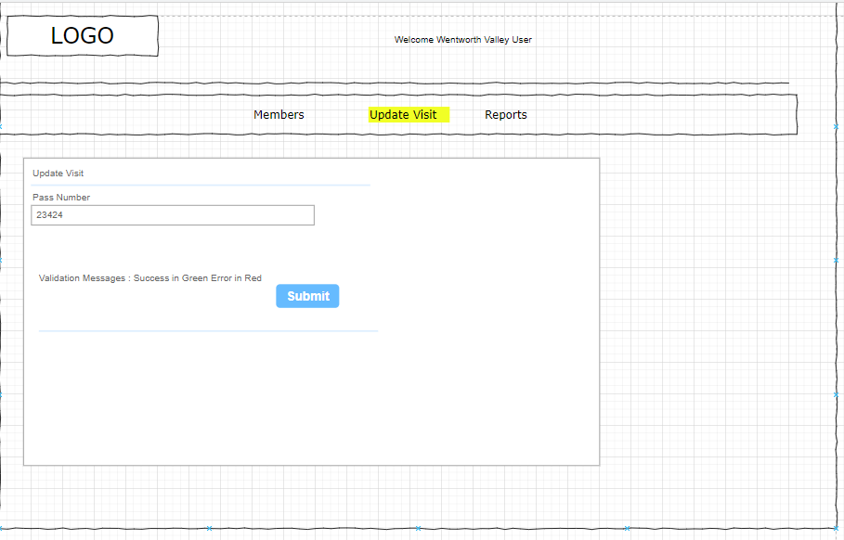

**Step 8: Reports – Menu available to Registrars. They can choose all hills, or particular hill and start & end dates to export the report to excel and csv.**

