Simulation of beamforming gain under steering angle, antenna elements, frequency,SNR, and interference

AIM: Simulation of beamforming gain under steering angle, antenna elements, frequency,
SNR, and interference
Objective
Simulate the beamforming gain of an antenna array by varying:
- Steering angle (θ)
- Number of antenna elements (N)
- Operating frequency (f)
- Signal-to-Noise Ratio (SNR)
- Interference level
clc;
clear;
close all;
N = [4 8 16];
theta = -90:1:90;
figure;
for k = 1:length(N)
n = N(k);
AF = zeros(size(theta));
for i = 1:length(theta)
psi = pi*sind(theta(i));
AF(i) = abs(sum(exp(1j*(0:n-1)*psi)));
end
AF = AF/max(AF);
subplot(3,1,k)
plot(theta,20*log10(AF),'LineWidth',2);
grid on;
xlabel('Steering Angle (degrees)');
ylabel('Gain (dB)');
title(['Beamforming Gain for N = ',num2str(n)]);
ylim([-40 0]);
end
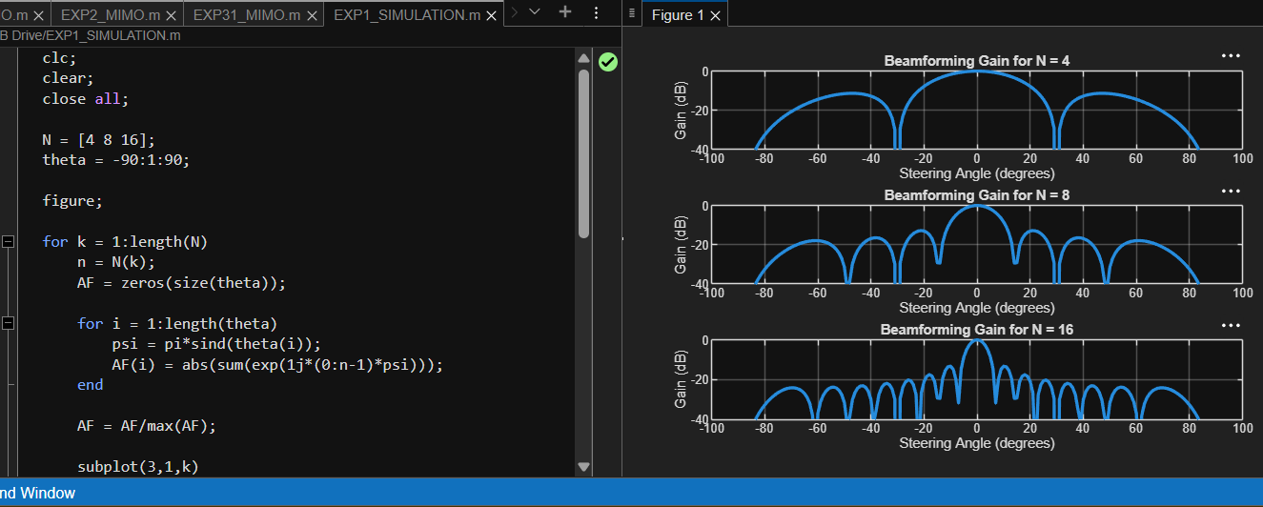
Expected Results
- Increasing antenna elements (N) increases beamforming gain and narrows the main beam.
- Changing the steering angle shifts the beam direction.
- Higher frequency provides a narrower beam (for the same array spacing in wavelengths).
- Increasing SNR improves signal quality and beamforming performance.
- Strong interference reduces received signal quality, but beamforming suppresses interference from unwanted directions.

