LAKSHMIKANTH K 231901026

EXNO: 01
Setting up Hyperledger Fabric Development Environment Aim
To install and configure the Hyperledger Fabric development environment on a Linux system using Docker, Go, and Fabric binaries, create a blockchain test network, and establish a communication channel between peer organizations

By the end of the experiment:
- Hyperledger Fabric installed
- Docker running
- Fabric binaries downloaded
- A blockchain network running
- A communication channel (mychannel) created between two organizations

Procedure:

sudo apt install -y git curl jq docker-compose

this command uses administrative privileges to automatically download and install four developer tools—Git, Curl, JQ, and Docker Compose

Verify the installation

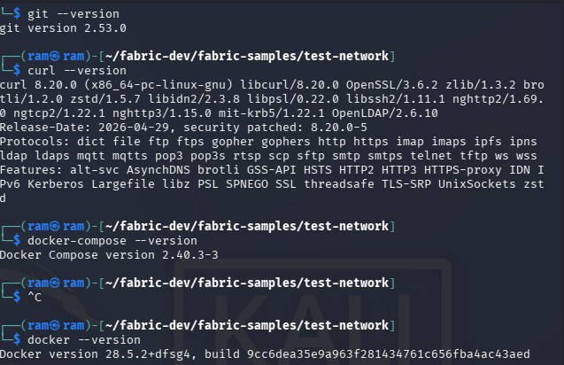

Start and enable the docker:

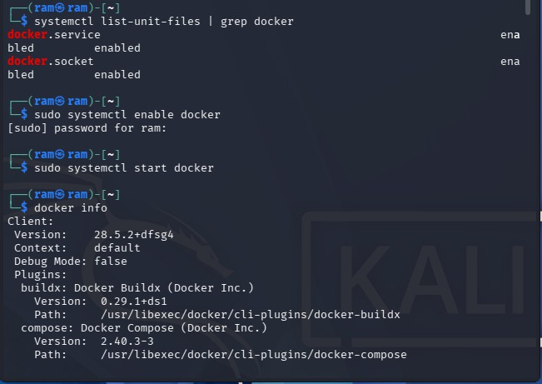

Add yourself to Docker group
sudo usermod -aG docker $USER

Refresh groups
newgrp docker

Test Docker

docker run hello-world

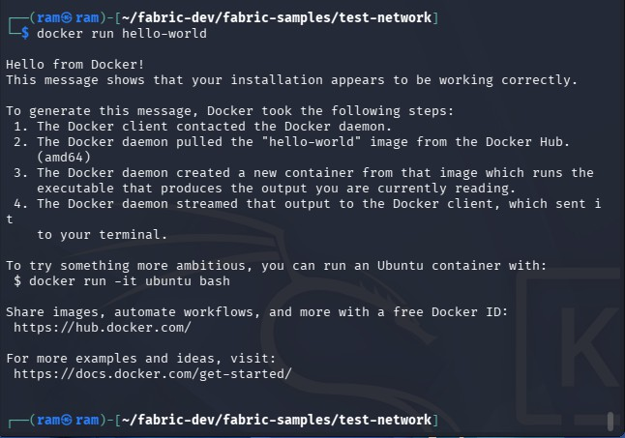

Check Go
sudo apt install golang-go go version
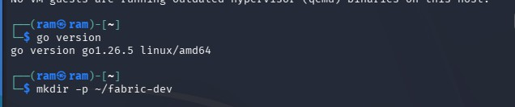

- Download Hyperledger Fabric curl -sSL https://bit.ly/2ysbOFE | bash -s This downloads:
Fabric binaries Docker images Sample applications

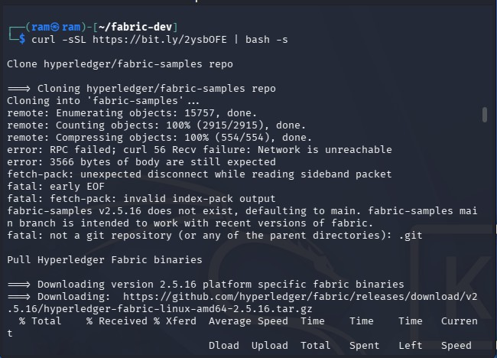

Enter the Sample Folder
cd fabric-samples

Configure PATH

echo 'export PATH=$PATH:$HOME/fabric-dev/fabric-samples/bin' >> ~/.bashrc source ~/.bashrc

Verify Installation

Check Peer: peer version

Check Orderer: orderer version

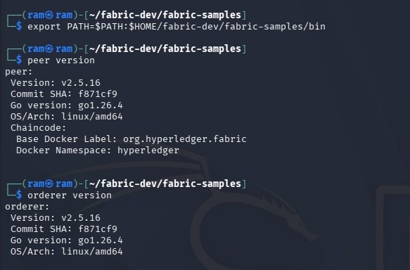

Start the Blockchain Network

Go into the test network
cd ~/fabric-dev/fabric-samples/test-network

Start it

./network.sh up

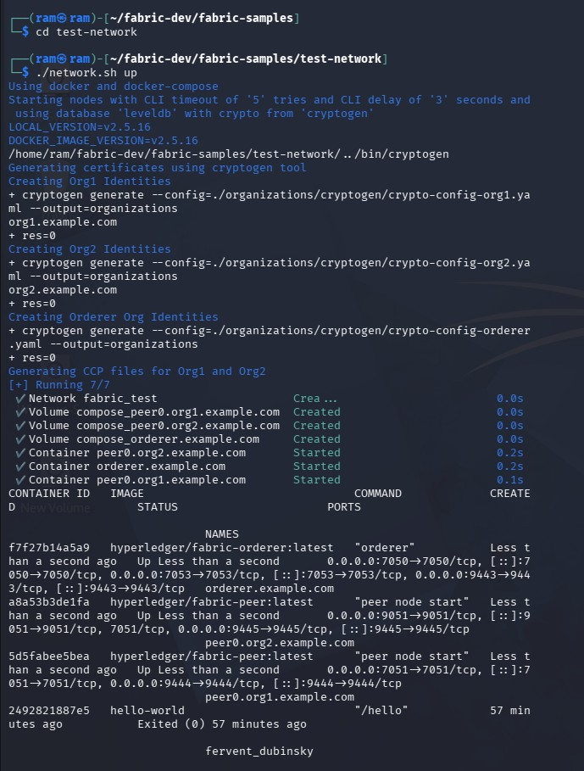

Create Channel

./network.sh createChannel -c mychannel
This creates a communication channel named mychannel. It also:
creates the channel joins both organizations configures anchor peers

