EX.NO: 2 Security Models and Principles
ROLL NO : 231901026
DATE : 12.02.2025 NAME: LAKSHMIKANTH K
AIM:
Study about the security triad and common security models and principles.
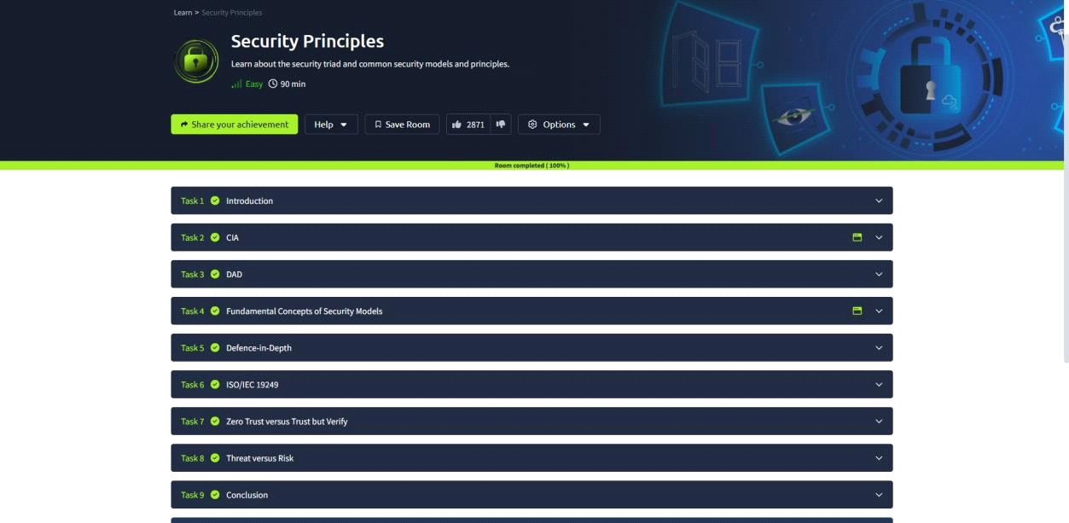
TASK 2 : CIA:
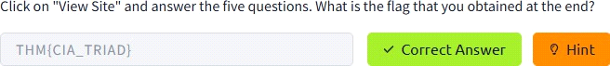

TASK 3 : DAD:
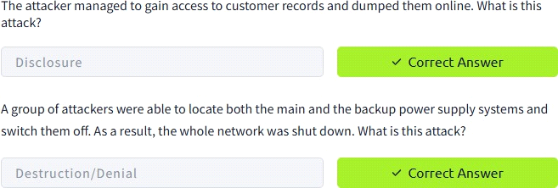

TASK 4 : FUNDAMENTAL CONCEPTS OF SECURITY MODELS
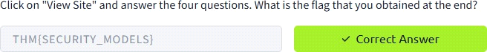

TASK 5 : DEFENCE-IN-DEPTH TASK 6 : ISO/IEC 19249
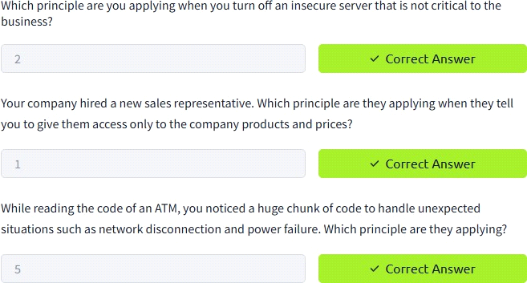

TASK 7 : ZERO TRUST VERSUS TRUST BUT VERIFY TASK 8 : THREAT VERSUS RISK
Conclusion:
Tryhackme platform security principle task is successfully completed.

