EX.NO: 5 Stack based buffer overflow attacks
ROLL NO : 231901026
DATE : 19.03.2025 NAME:LAKSHMIKANTH K
AIM:
Sudo Buffer Overflow
Exploring CVE-2019-18634 in the Unix sudo program. Room two in the SudoVulns series Buffer Overflow Prep
Practice stack based buffer overflows!

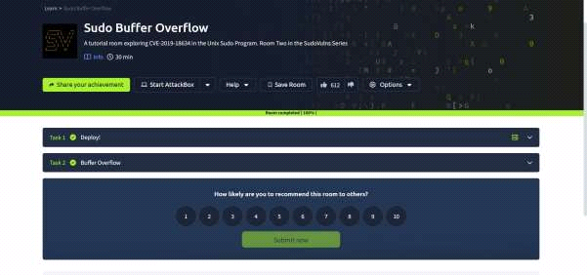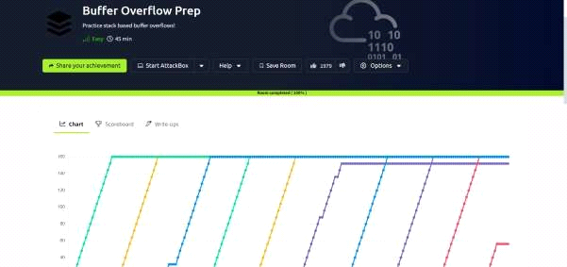

TASK 2 : BUFFER OVERFLOW

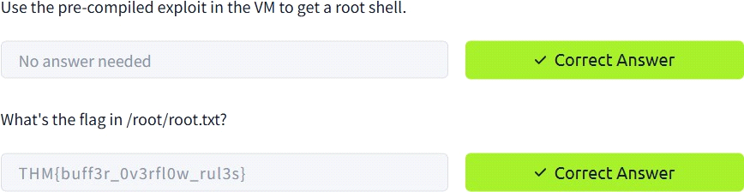

Buffer Overflow Prep
TASK 2 oscp.exe - OVERFLOW1
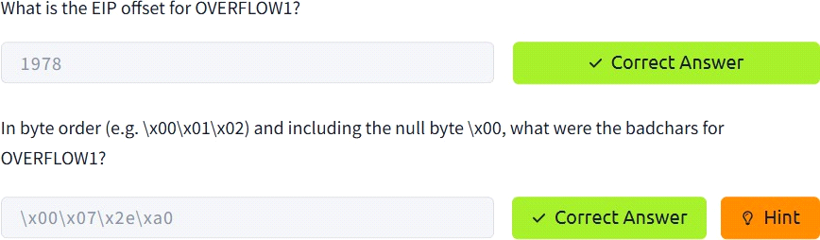

TASK 3 : oscp.exe - OVERFLOW2
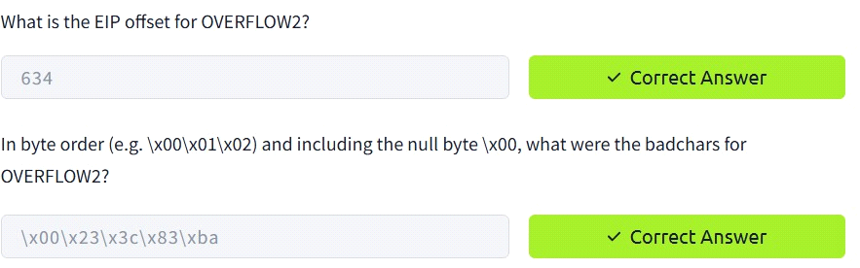

TASK 4 oscp.exe – OVERFLOW3
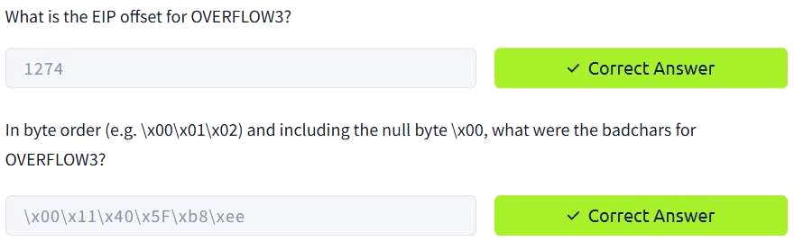
TASK 5 : oscp.exe - OVERFLOW4
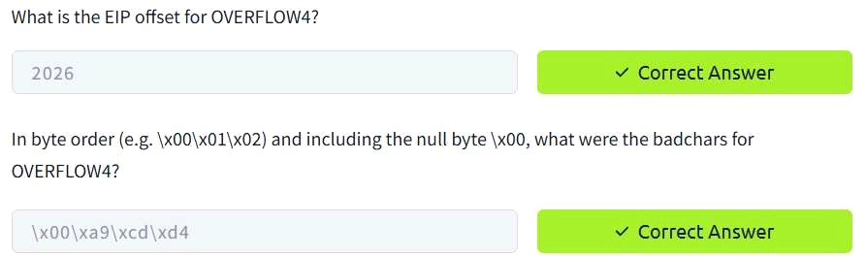
TASK 6 : oscp.exe - OVERFLOW5
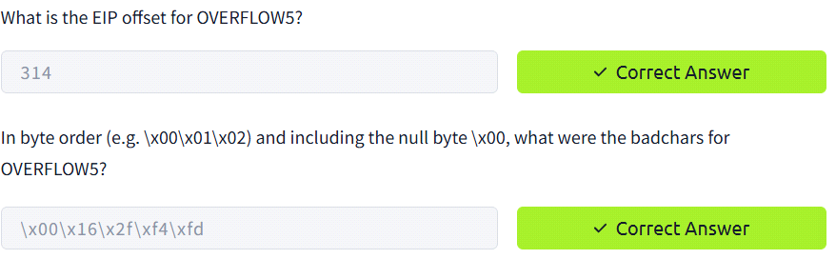
TASK 7 : oscp.exe - OVERFLOW6
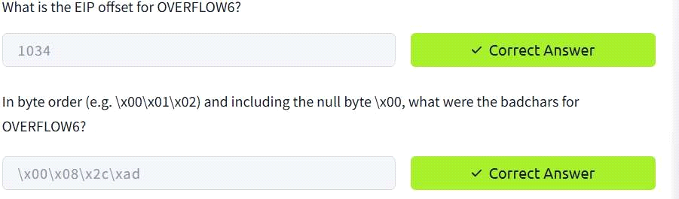

TASK 8 : oscp.exe - OVERFLOW7
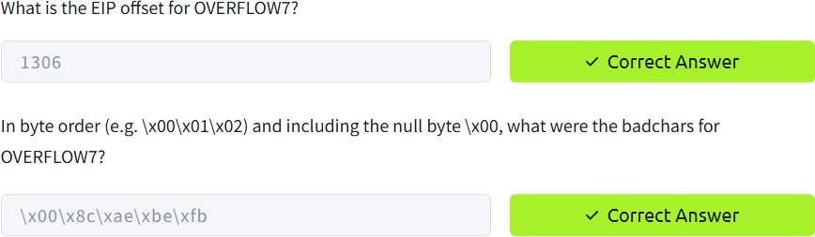
TASK 9 : oscp.exe - OVERFLOW8

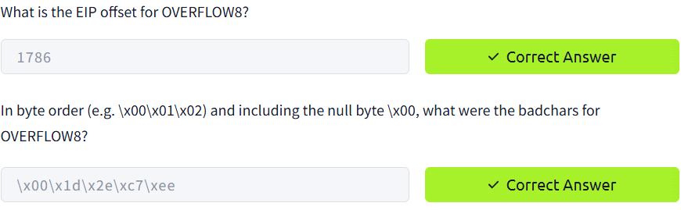
TASK 10 : oscp.exe - OVERFLOW9

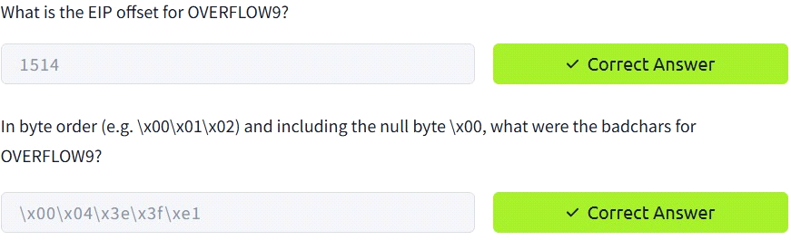
TASK 11 : oscp.exe - OVERFLOW10
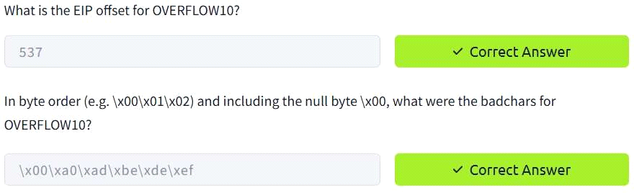

CONCLUSION:
Tryhackme platform Stack based buffer overflow attacks task is successfully completed.

