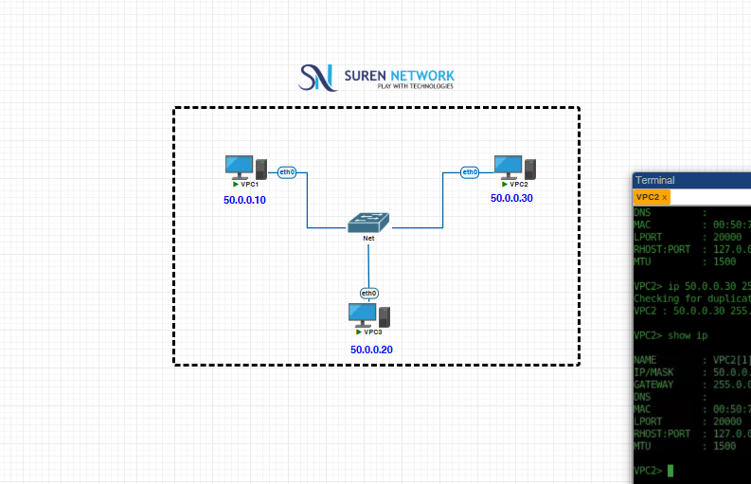

This Lab is using Virtual PC where we need to use syntax like
- Use small letters only
- Use ip<give ip address> subnet mask, default gateway
- To chk use show ip
- To chk connection – Ping ip address
- To use ? help for other cmd
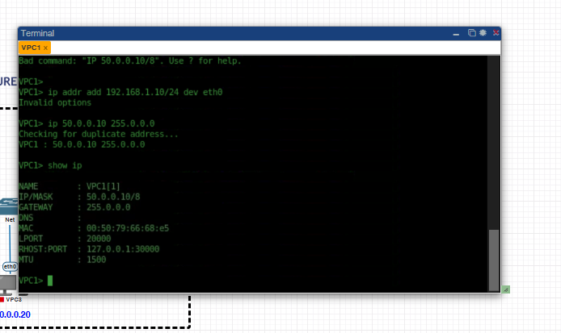
VPC 1 config

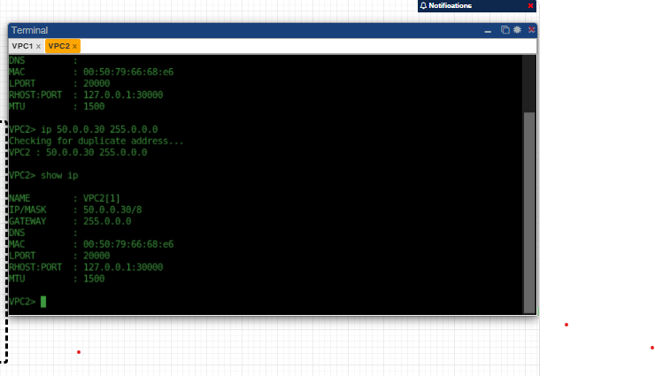
VPC 2 config
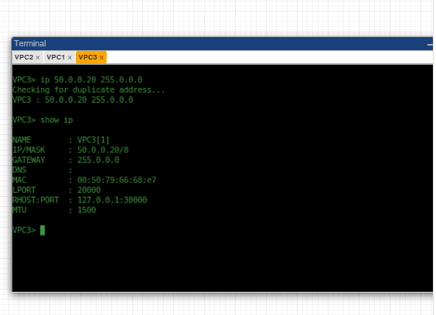
VPC 3 config

All VPC 1, 2, 3 are pinging with each other
