1. Create a Login authentication application using SpringBoot and Spring Data JPA.

The Jsp files are

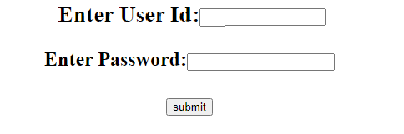

If any wrong user id or password then the page should reappear like below

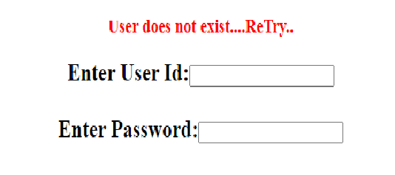

For this purpose create

1. class User with following private String member data ,

userId (not null and min length=5 max length= 10)

userPass (not null and min length=5 max length= 10)

create getter/setter and constructor.

It will also act as entity for Hibernate

1. interface UserRepository from JPARepository
2. class UserService with methods (shown in template)
3. LoginController with methods (shown in template)
4. loginPage.jsp (shown in template)
5. welcomePage.jsp (shown in template)
6. errorPage.jsp (shown in template)

The application will run in port number 9292.

After the above create an application for online mobile recharging whose user id & password to be validated . A JSP page to accept mobile number and select plan id will be provided as below:

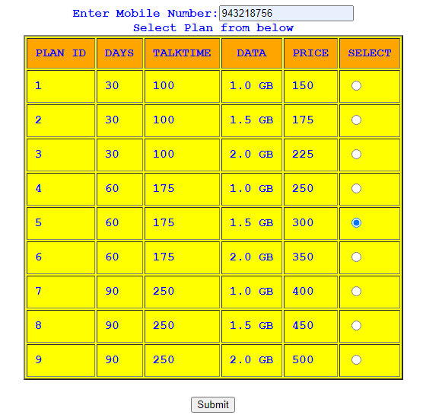

Output will be

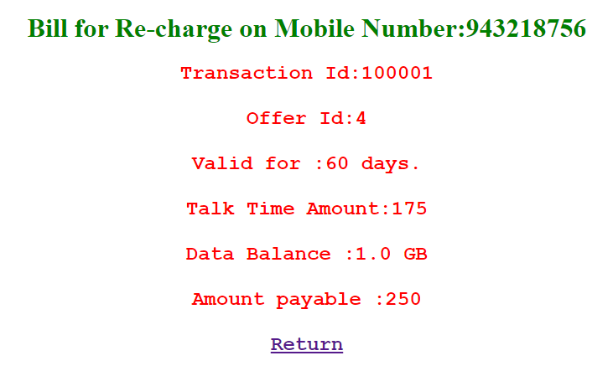

Transaction id will be auto generated then this record will be stored in a database using SpringBoot and Spring Data JPA. For this purpose create

1. class Offer with following private member data ,

Long id (it will be auto generated in JPA)

Integer days;

Integer talkTime;

Double data;

Integer price;

create getter/setter and constructor.

It will also act as entity for Hibernate

1. class Bill with following private member data

Long transactionId (it will be auto generated min value=100001L)

Integer mobileNumber (must be 8-10 digited figure)

Long offerId ;

create getter/setter and constructor.

It will also act as entity for Hibernate

1. interface OfferRepository from JPARepository.
2. interface BillRepository from JPARepository
3. class RechargeService with methods (shown in template)
4. RechargeController with methods (shown in template)
5. Jsp pages are already given in template.

The application will run in port number 5959.