***It is a SpringBoot and Spring Data JPA application.***

***Global Exchange Centre(GlobEx)*** is a Stock Exchange for corporate share trading. It’s website displays listed different companies name and it’s current share price in Indian rupees. So the computer personals of ***GlobEx*** need to update share prices of each company at that whenever there is a change in a single day. The personals also need to enter newly listed company’s name, share price and a generated id number for that company. If requires they need to remove an existing listed company’s details. You need to develop a web based application for ***these operation*** on **SpringBoot** with **Spring Data JPA*.*** User interface ***will be only in jsp.*** You can include javascript or CSS pages.Database can be MySQL or Oracle.

Application starts with *localhost:7979/index* (i.e you need to configure port no in application.properties file), the output:-

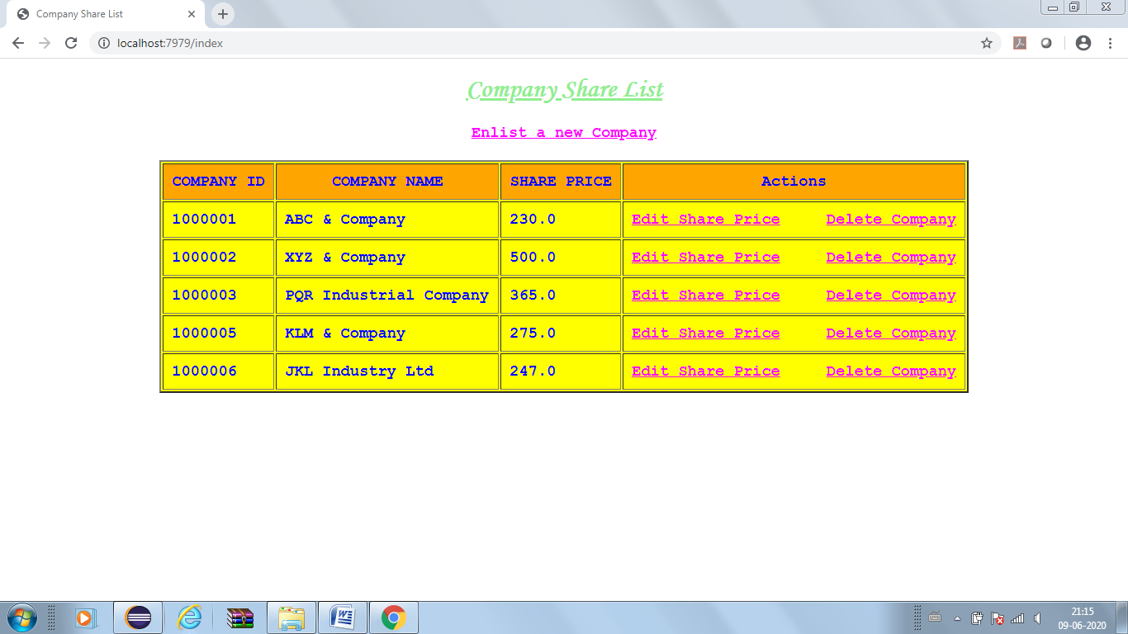

“Enlist new Company” allows you to enlist a new company. The Company id will be auto generated. “Delete Company” will delete a company’s name in share details. “Edit Share price” will allow to change any company’s share price.

For all above operations create the followings:-

**Create table Company_Share in Database.** The table has the following fields:-

company_id, company_name, share_price.

**Create appliaction.properties file** to connect database from Java

*Entry will be likely as follows:*

spring.datasource.url=jdbc:mysql://localhost:3306/<database-name>

or

spring.datasource.url=jdbc:oracle:thin:@localhost:1521:<database_name>

spring.datasource.username=<user-name>

spring.datasource.password=<password-value>

**Create class CompanyShare** with following attributes:-

private Long companyId,

private String companyName,

private Double sharePrice

**Create getter and setter methods.**

**Create class ShareController** as Controller class

Please create html files for input/output purpose.