AIRSENSE
Airline Customer Sentiment & GenAI Insights Analysis
Streamlit Dashboard v1.0 | Twitter Sentiment Analysis
✈️ Powered by Google Gemini 2.5 Flash AI

Submitted By  Lakshmi Mahitha Noudu  Data Analyst | Personal Project | Project Type  Personal Project  GenAI & NLP Analytics
Submission Date  May 2026 | AI Model Used  Google Gemini 2.5 Flash

ABSTRACT

This report presents a comprehensive analysis of Twitter sentiment data for six major US airlines — United, US Airways, American, Southwest, Delta, and Virgin America — using 14,640 tweets collected between February 17–24, 2015. The analysis examines overall sentiment distribution, airline-specific performance, complaint categories, temporal patterns, and AI confidence scores. Google Gemini 2.5 Flash API is integrated to generate real-time executive summaries, airline-specific recommendations, and answer custom analytical questions. Key findings reveal a 62.69% overall negative sentiment rate, with US Airways recording the worst performance at 77.7% negative and Virgin America demonstrating the best customer satisfaction.

1. INTRODUCTION
Social media platforms, particularly Twitter, have become the primary channel through which airline customers express their experiences, complaints, and satisfaction. The immediacy and public nature of Twitter feedback provides airlines with real-time customer intelligence that traditional surveys cannot capture. This project, AirSense, builds a comprehensive sentiment analytics framework around Twitter data for six major US airlines, powered by Google Gemini 2.5 Flash generative AI.

This is an independent personal project built to demonstrate GenAI integration skills, combining traditional data analytics with Google Gemini 2.5 Flash API to produce dynamic, AI-generated business insights from customer sentiment data.

2. PROBLEM STATEMENT
Airlines receive thousands of social media complaints daily but lack systematic tools to quantify sentiment patterns, identify root causes, and generate actionable recommendations in real time. This project addresses three core analytical questions:

- Which airlines have the highest and lowest customer satisfaction based on Twitter sentiment?
- What are the primary categories of customer complaints and how do they vary by airline?
- How can generative AI (Gemini 2.5 Flash) enhance the analytical value of sentiment data?

3. DATASET DESCRIPTION
The Twitter US Airline Sentiment dataset was sourced from Crowdflower via Kaggle. It contains 14,640 tweets from February 17–24, 2015 covering six major US airlines with human-annotated sentiment labels and confidence scores.

Attribute | Value
Total Tweets | 14,640
Date Range | Feb 17–24, 2015
Airlines Covered | 6
Sentiment Labels | 3 (pos/neu/neg)
Negative Reasons | 10 categories
Avg Confidence | 0.900
Missing Sentiments | 0

4. TOOLS & TECHNOLOGIES
Tool | Purpose
Python / pandas | Data loading, cleaning, EDA
matplotlib / seaborn | All charts and visualizations
Streamlit | Interactive web dashboard (4 pages)
Google Gemini 2.5 Flash | AI insights, summaries, recommendations
requests (REST API) | Gemini API integration via HTTP
Jupyter Notebook | EDA and analysis documentation

5. KPI SUMMARY
KPI | Value
Total Tweets | 14,640
Overall Negative Rate | 62.69%
Overall Positive Rate | 16.14%
Avg AI Confidence | 90.0%
Worst Airline | US Airways 77.7%
Best Airline | Virgin America
#1 Complaint | Cust. Service

6. SENTIMENT DISTRIBUTION ANALYSIS
Figure 1 shows that 62.69% of all 14,640 tweets are negative — an alarmingly high rate indicating widespread customer dissatisfaction across the US airline industry. Only 16.14% of tweets are positive, compared to 21.17% neutral.

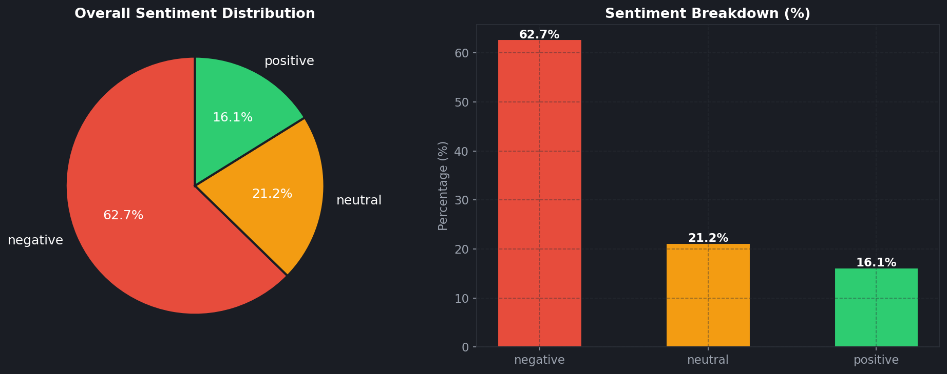
Figure 1: Overall Sentiment Distribution — Pie and Bar breakdown

Key Finding: The 62.69% negative rate is nearly 4x the positive rate, indicating a systemic customer experience problem across the entire US airline industry.

7. AIRLINE PERFORMANCE COMPARISON
7.1 Negative Rate Ranking
Figure 2 shows the negative sentiment rate per airline sorted from worst to best. US Airways leads with 77.7% negative tweets — more than double the best performer Virgin America at 35.9%. The 41.8 percentage point gap between worst and best demonstrates significant airline-specific performance differences.

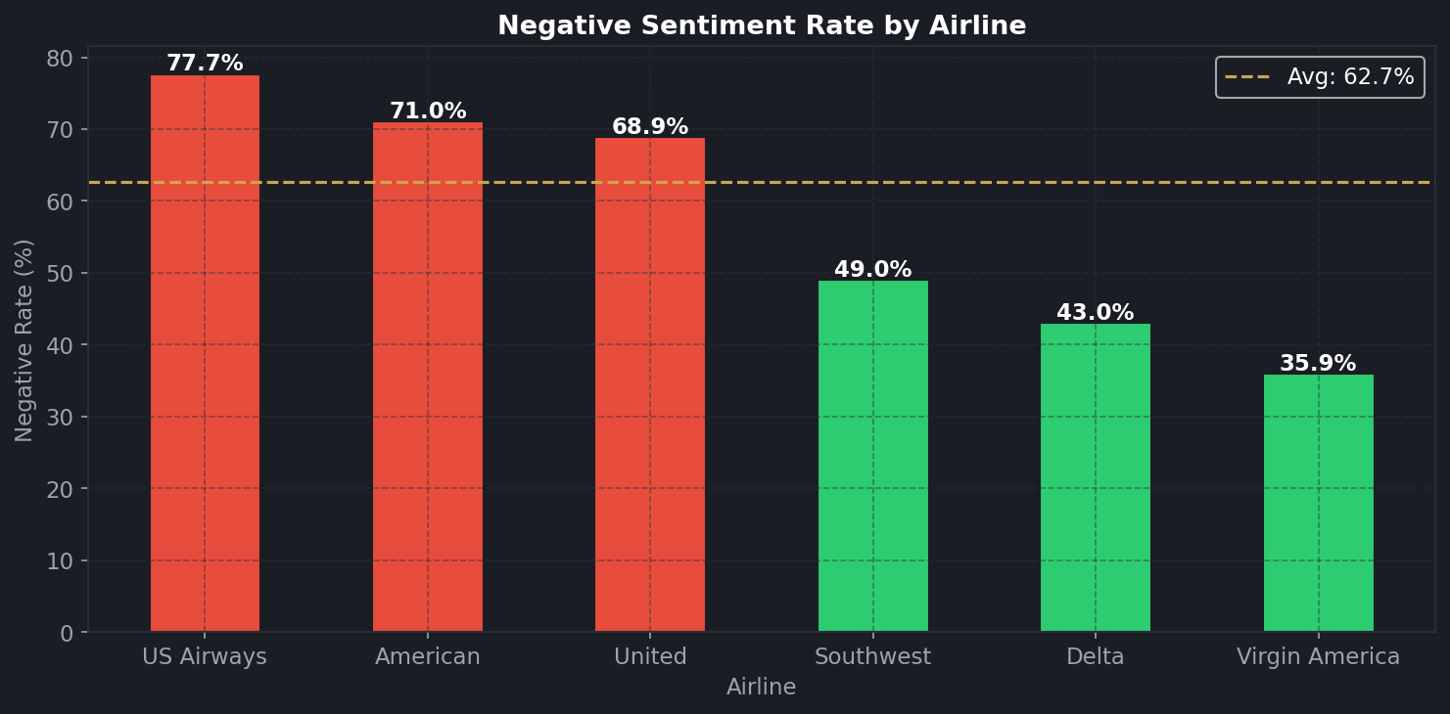
Figure 2: Negative Sentiment Rate by Airline — Red bars exceed overall average

Airline | Negative | Neutral | Positive
US Airways | 77.7% | 13.1% | 9.2%
American | 71.0% | 16.8% | 12.2%
United | 68.9% | 18.2% | 12.9%
Southwest | 49.0% | 27.4% | 23.6%
Delta | 43.0% | 32.5% | 24.5%
Virgin America | 35.9% | 33.9% | 30.2%

7.2 Grouped Sentiment Comparison
Figure 3 shows grouped bars of positive, neutral, and negative sentiment percentages for all 6 airlines simultaneously, making it easy to visually compare the overall sentiment health of each carrier.

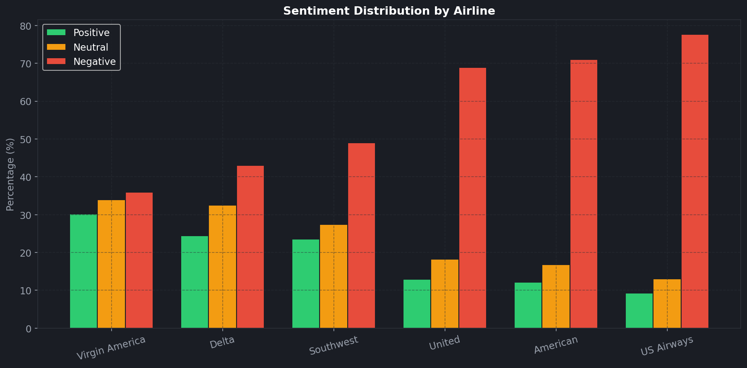
Figure 3: Grouped Sentiment % by Airline — positive (green), neutral (orange), negative (red)

8. COMPLAINT CATEGORY ANALYSIS
Figure 4 shows that Customer Service Issues dominate complaints at 2,910 tweets (31.7% of all negative tweets), followed by Late Flights at 1,665 (18.1%) and Cancelled Flights at 847 (9.2%). Customer Service Issues are the top complaint for 5 of 6 airlines — only Delta's top complaint is Late Flights.

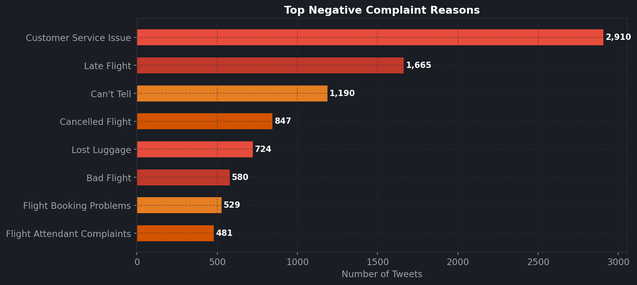
Figure 4: Top Complaint Categories (left) and Airline × Reason Heatmap (right)

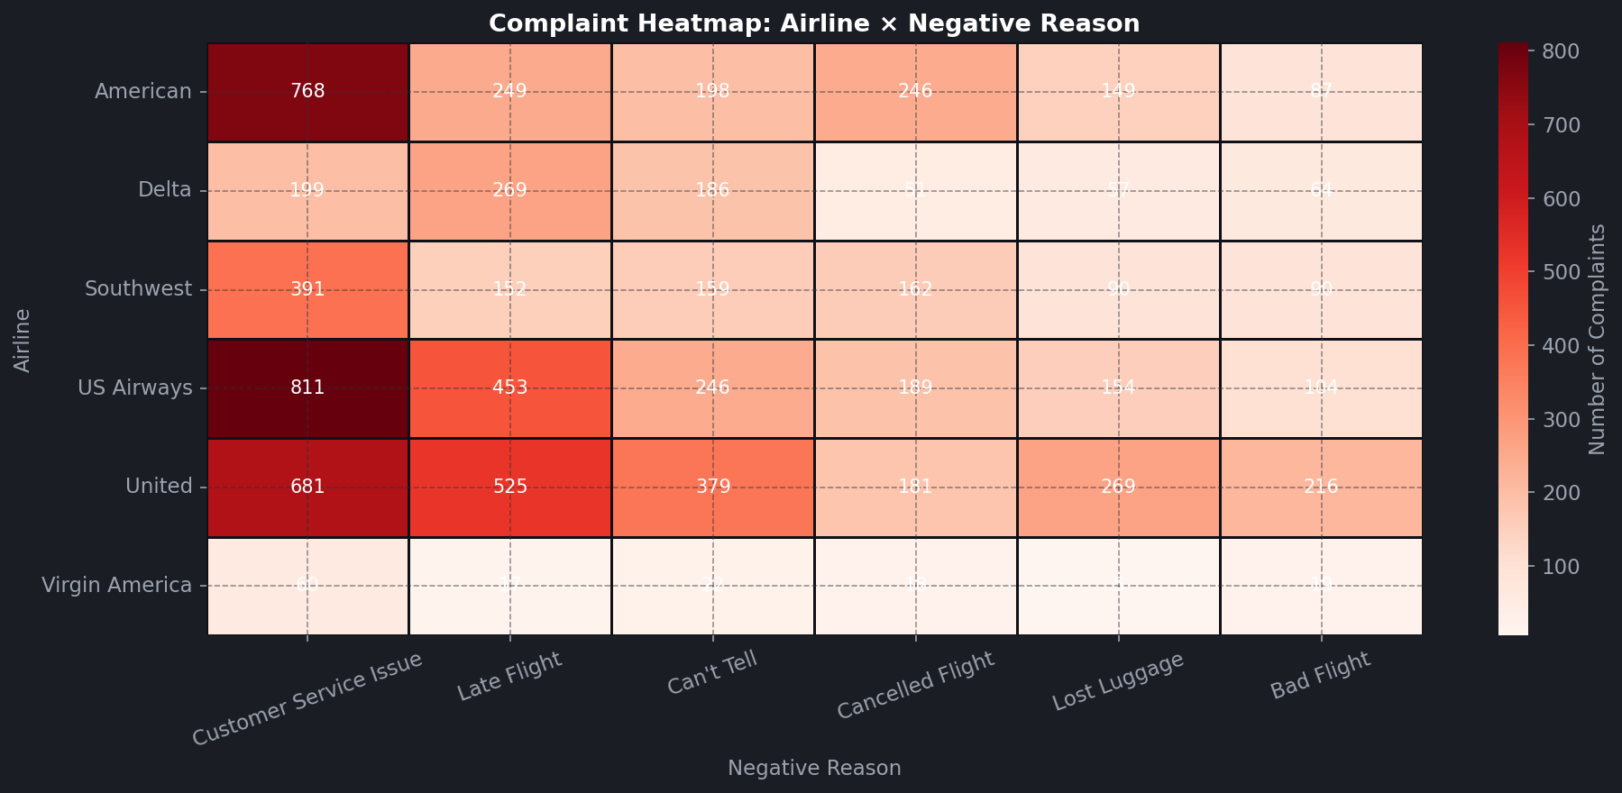
Figure 5: Detailed Complaint Heatmap — Airline × Negative Reason count

9. TEMPORAL & CONFIDENCE ANALYSIS
9.1 Time-Based Patterns
Figure 6 shows tweet volume over the 8-day collection period and hourly distribution. Peak tweet activity occurs at 21:00 UTC, corresponding to US evening hours when passengers are travelling or reflecting on their experience.

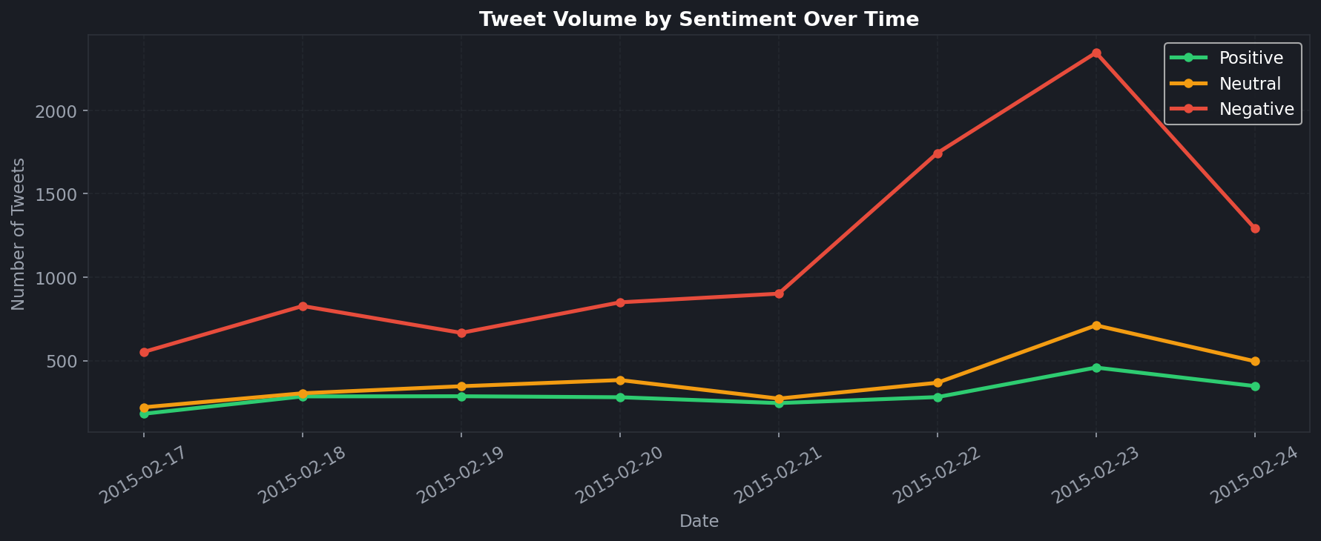
Figure 6: Daily Tweet Volume by Sentiment (left) and Hourly Activity (right)

9.2 AI Confidence Scores
Figure 7 shows the distribution of confidence scores by sentiment. Negative tweets have the highest average confidence at 0.933, indicating annotators were most certain about negative labels. This validates the reliability of negative sentiment classifications used throughout this analysis.

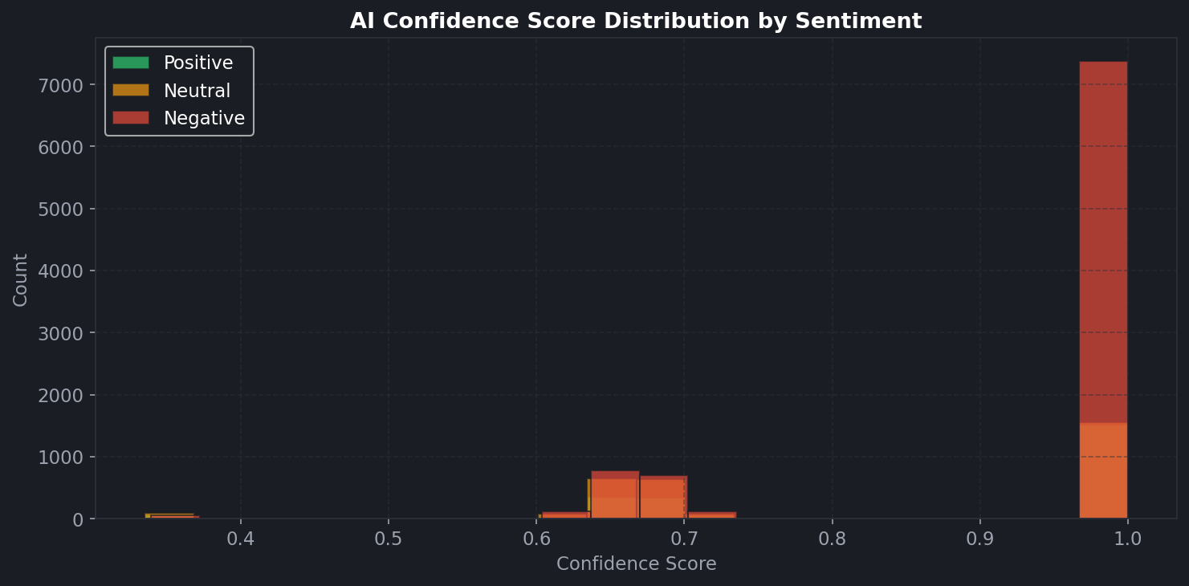
Figure 7: Sentiment Confidence Score Distribution — Negative tweets most confidently labelled

10. GENAI INTEGRATION — GOOGLE GEMINI 2.5 FLASH
This project integrates Google Gemini 2.5 Flash via REST API to provide three AI-powered features in the Streamlit dashboard:

Auto Executive Summary: Gemini analyses the filtered dataset context and generates a 200-word business summary including severity assessment, airline rankings, and strategic priorities.

Per-Airline Recommendations: User selects any airline and Gemini generates 3 specific, actionable improvement strategies based on that airline's complaint profile.

Custom Q&A: Users ask natural language questions (e.g. 'Which airline should I fly?') and Gemini responds using dataset context, democratising data access for non-technical stakeholders.

The API is called using Python requests library with the v1 endpoint and gemini-2.5-flash model, making it fully compatible with Streamlit Cloud without any additional SDK installation.

11. DASHBOARD ARCHITECTURE
Page | Content
Sentiment Overview | Pie, negative rate, daily volume trend, hourly bar
Airline Deep Dive | Grouped bars, heatmap, top reasons, confidence dist.
GenAI Insights | Gemini summary, per-airline recs, custom Q&A
Tweet Explorer | Keyword search, 500-row table, CSV download

12. DATA LIMITATIONS
Dataset Age: Data is from February 2015 — 10 years old. Airline industry has changed significantly since then.

Single Week: Only 8 days of data. Seasonal patterns or events could distort results.

English Only: All tweets are in English. International passengers are underrepresented.

AI Hallucination Risk: Gemini-generated insights are based on context provided. Always validate against raw data before business decisions.

13. RECOMMENDATIONS
R1 — US Airways Emergency Overhaul: 77.7% negative demands immediate action — 24/7 social media teams, customer service retraining, real-time escalation protocols.

R2 — Reduce Late Flights & Cancellations: 2,512 combined complaints — invest in predictive delay management and proactive passenger notification.

R3 — Benchmark Virgin America: 30.2% positive rate is the industry benchmark — competitor airlines should study their service model.

R4 — Peak Hour Staffing: Complaints peak at 21:00 UTC — ensure full social media coverage during 19:00–23:00 UTC.

R5 — Deploy GenAI Complaint Routing: Integrate LLMs to auto-categorise and route complaints, reducing response time from hours to minutes.

14. CONCLUSION
AirSense establishes a data-driven, AI-enhanced framework for monitoring airline customer sentiment at scale. The 62.69% negative rate reveals a deeply troubled US airline industry, with customer service failures as the primary driver. The integration of Google Gemini 2.5 Flash elevates this project beyond traditional analytics — enabling natural language insights and interactive Q&A that makes data accessible to non-technical stakeholders.

REFERENCES
- Twitter US Airline Sentiment Dataset — Crowdflower via Kaggle, 2015
- Google Generative AI. Gemini API Documentation. https://ai.google.dev
- Python Software Foundation. pandas Documentation. https://pandas.pydata.org
- Streamlit Inc. Streamlit Documentation. https://docs.streamlit.io
- Matplotlib Development Team. https://matplotlib.org

