EUROPEAN BANK
Customer Engagement & Product Utilization
Analytics for Retention Strategy
Submitted By  Lakshmi Mahitha Noudu  Data Analyst Intern — Finance Analytics | Organization & Mentor  Unified Mentor  Mentor: Sai Prasad Kagne
Submission Date  April 2026 | Dashboard Version  Version 1.0 | April 2026

ABSTRACT

This report presents a comprehensive customer engagement and retention analysis for a European Bank using 10,000 customer records. The study examines churn patterns across engagement profiles, product utilization depth, geographic distribution, demographic segments, and relationship strength indicators. Key findings reveal a 20.37% overall churn rate, with Germany recording the highest at 32.4%, customers with 3-4 products churning at 83-100%, and 1,247 high-balance inactive customers identified as premium churn risk. An interactive Streamlit dashboard and strategic retention recommendations are provided to support data-driven customer relationship management.

1. INTRODUCTION
European banks increasingly recognize that customer behavior and engagement — not just demographics — determine long-term retention. Customers may appear financially strong (high balance or salary) but still churn due to low engagement, limited product adoption, or weak relationship depth. This project evaluates customer retention through the lens of behavioral analytics and relationship strength.

The deliverable is an interactive Streamlit dashboard (bank_app.py, Version 1.0) providing 4 analytical pages, supported by this research paper and an executive summary, submitted as part of a Data Analyst Internship at Unified Mentor under the Finance Analytics domain.

2. PROBLEM STATEMENT
Despite having data on customer engagement and product usage, banks often lack quantitative insight into which behaviors drive retention, clarity on whether product depth reduces churn, and evidence on whether high balances alone ensure loyalty. This project addresses all three gaps.

- Which engagement profiles are most at risk of churning?
- Does product depth (number of products) reduce churn?
- Which demographic and geographic segments need urgent retention action?
- Who are the high-value customers silently at risk of leaving?

3. DATASET DESCRIPTION
The dataset contains 10,000 customer records with 14 attributes sourced from the European Central Bank via Unified Mentor. It covers customer creditworthiness, geography, demographics, product usage, engagement status, and churn outcome.

Attribute | Value
Total Records | 10,000
Total Columns | 14
Countries | 3
Target Variable | Exited (0/1)
Churned | 2,037
Retained | 7,963
Missing Values | 0
Duplicates | 0

4. FEATURE ENGINEERING
4.1 Engagement Profiles
Four engagement profiles were created based on IsActiveMember and NumOfProducts to classify customers into behaviorally distinct segments:

- Active Engaged — IsActiveMember=1 AND NumOfProducts≥2 (2,588 customers)
- Active Low-Product — IsActiveMember=1 AND NumOfProducts=1 (2,563 customers)
- Inactive High-Balance — IsActiveMember=0 AND Balance > median (2,456 customers)
- Inactive Disengaged — IsActiveMember=0 AND NumOfProducts≤1 (878 customers)

4.2 Relationship Strength Index (RSI)
A weighted composite score (0–1) measuring overall customer relationship depth:

Factor | Weight | Rationale
IsActiveMember | 40% | Strongest signal
NumOfProducts/max | 30% | Product depth
Tenure/max | 20% | Loyalty years
HasCrCard | 10% | Card stickiness

4.3 At-Risk Premium Flag
AtRiskPremium = 1 when Balance > €127,644 (Q75) AND IsActiveMember = 0. This identifies 1,247 high-value silent churners — customers with significant financial commitment but zero engagement.

5. KPI SUMMARY
KPI | Value
Overall Churn Rate | 20.37%
Engagement Retention Ratio | 14.3% vs 26.9%
Product Depth Index | 2 products = 7.6%
High-Balance Disengagement | 1,247 customers
Credit Card Stickiness | 20.2% vs 20.8%
Avg RSI Score | 0.492 / 1.000

6. CHURN OVERVIEW ANALYSIS
Figure 1 shows the overall churn distribution and geographic breakdown. The bank faces a 20.37% churn rate, meaning 1 in 5 customers leaves. Germany records the highest churn at 32.4% — nearly double that of France (16.2%) and Spain (16.7%).

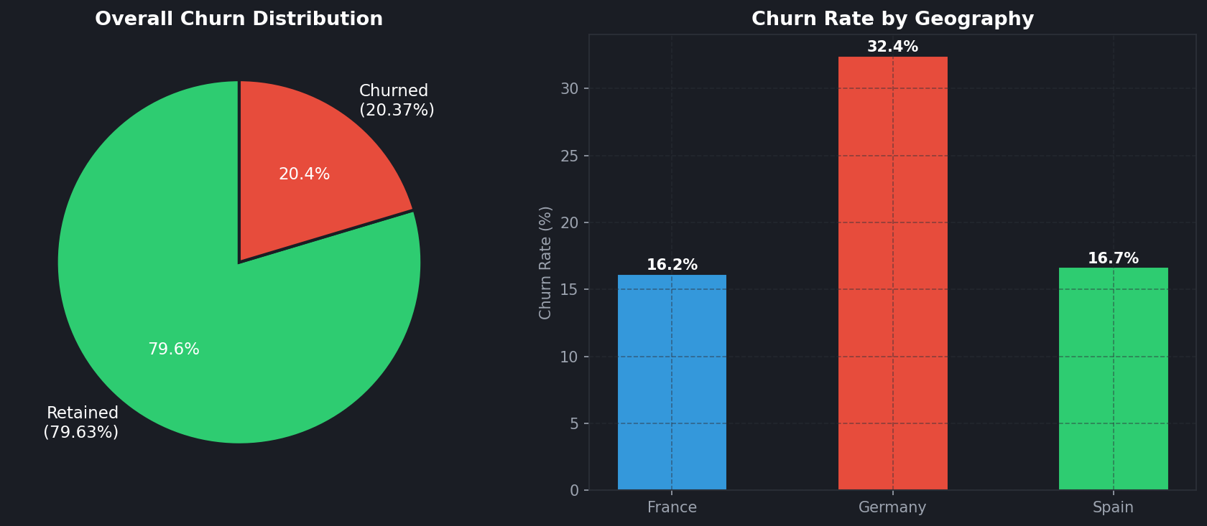
Figure 1: Overall Churn Distribution (left) and Churn Rate by Geography (right)

7. ENGAGEMENT PROFILE ANALYSIS
Figure 2 reveals that engagement profile is a strong predictor of churn. Inactive Disengaged customers churn at the highest rate while Active Engaged customers show the lowest churn, confirming that both activity status and product depth jointly determine retention outcomes.

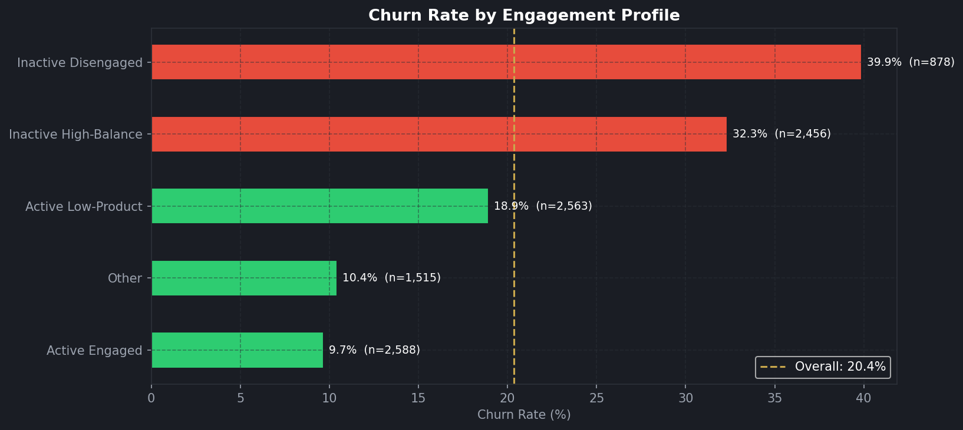
Figure 2: Churn Rate by Engagement Profile — green = below average, red = above average

8. PRODUCT UTILIZATION ANALYSIS
8.1 Churn by Product Count
Figure 3 reveals a non-linear relationship between product count and churn. Two-product customers have the lowest churn at 7.6%, while customers with 3 or 4 products churn at alarming rates of 82.7% and 100% respectively. This suggests that product over-bundling without engagement creates extreme churn risk.

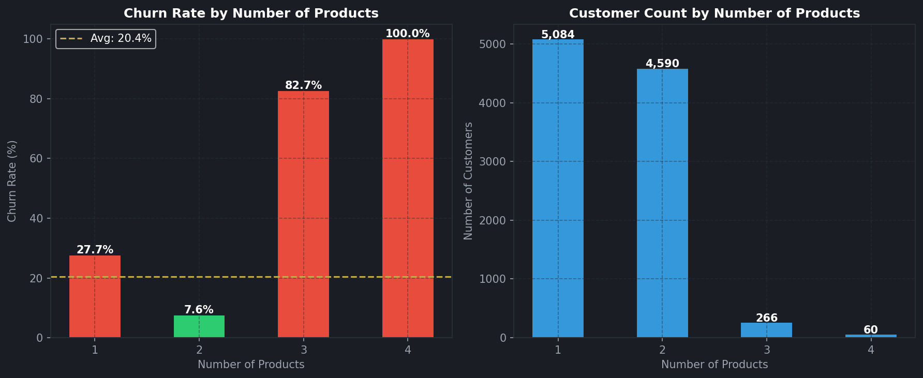
Figure 3: Churn Rate (left) and Customer Count (right) by Number of Products

8.2 Active vs Inactive & Credit Card
Figure 4 confirms that inactive members churn at 26.9% versus 14.3% for active members — a gap of 12.6 percentage points. Credit card ownership shows minimal differentiation (20.2% vs 20.8%), indicating it is a weak retention signal on its own.

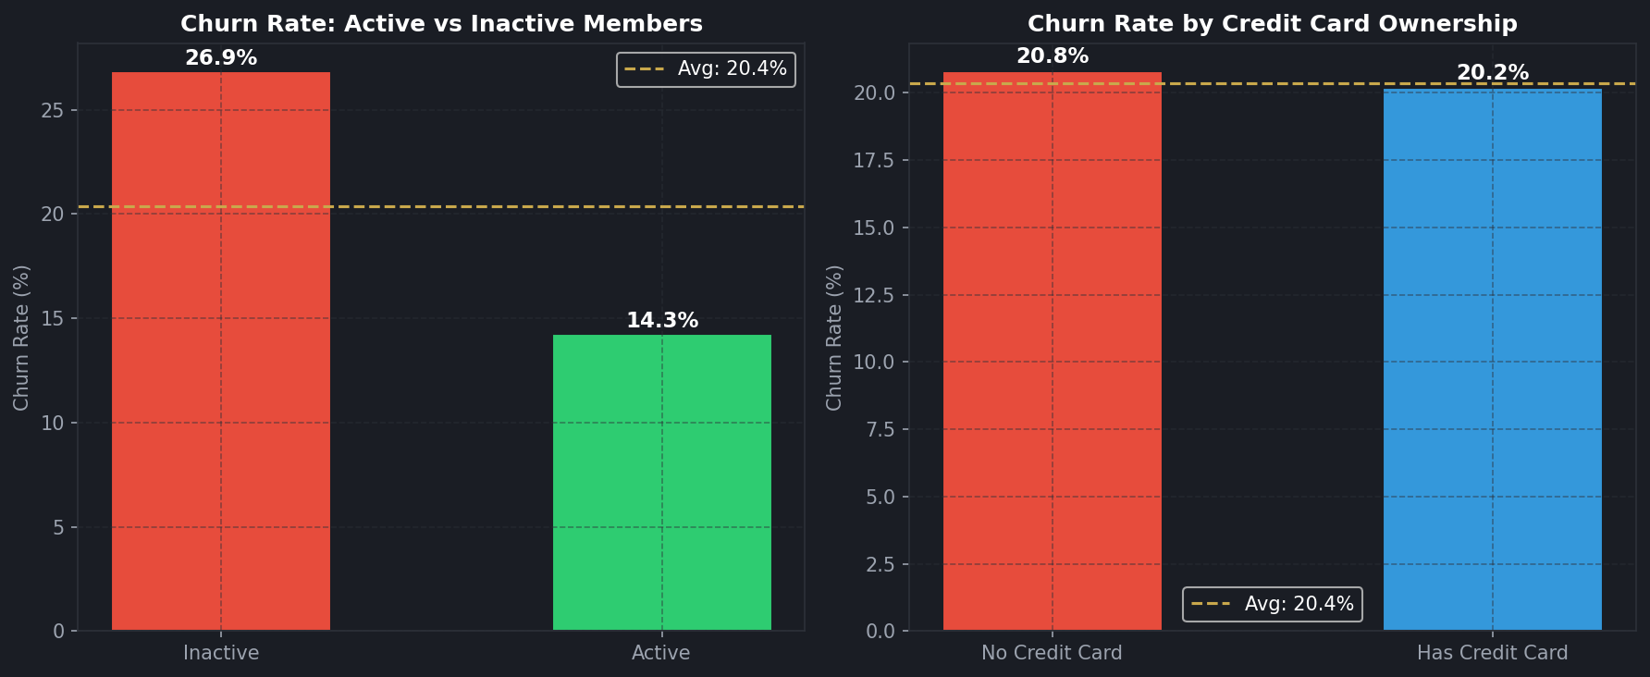
Figure 4: Churn Rate by Member Activity Status (left) and Credit Card Ownership (right)

9. FINANCIAL COMMITMENT ANALYSIS
Figure 5 shows that churned customers tend to have mid-to-high balances — contrary to the expectation that high-balance customers are loyal. This reveals a dangerous pattern: financially committed but disengaged customers who leave silently.

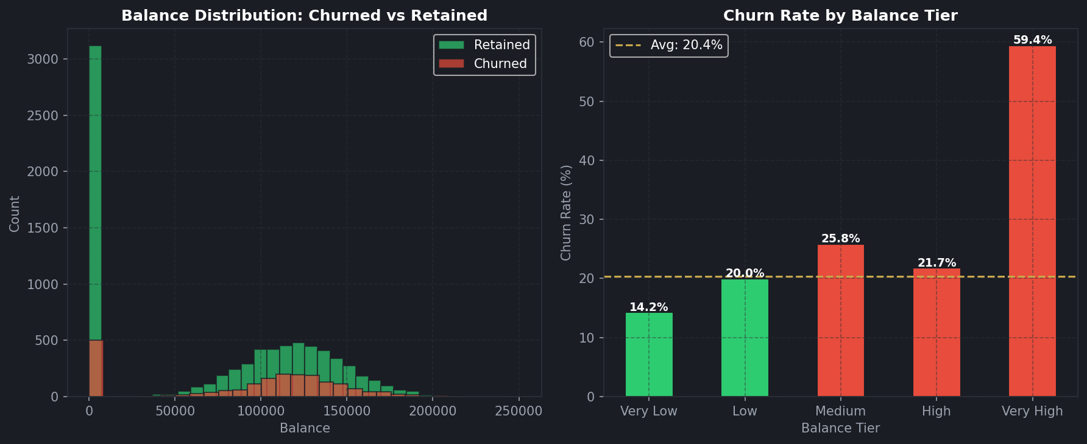
Figure 5: Balance Distribution by Churn Status (left) and Churn Rate by Balance Tier (right)

Figure 9 further isolates the 1,247 at-risk premium customers (Balance > €127,644 and inactive) who churn at 32.2% — 12 percentage points above the average. These customers represent the highest financial risk to the bank.

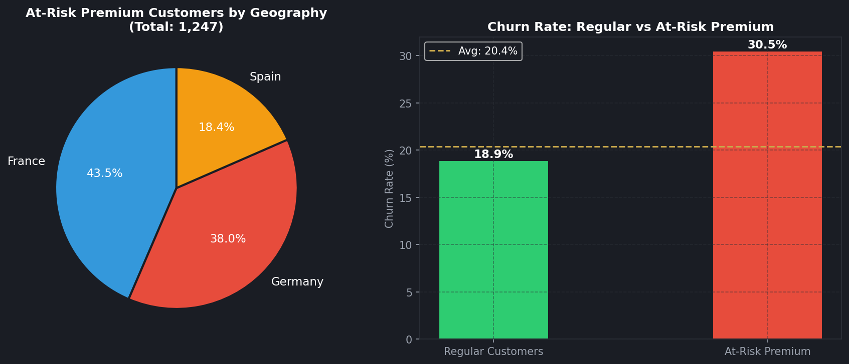
Figure 9: At-Risk Premium Customers by Geography (left) and vs Regular Churn Rate (right)

10. GEOGRAPHIC HEATMAP
Figure 7 shows the Geography × Products heatmap. Germany consistently records higher churn rates across all product counts. Notably, 3-product customers churn at 100% in Spain and extremely high rates across all countries, confirming product over-bundling as a cross-geographic risk.

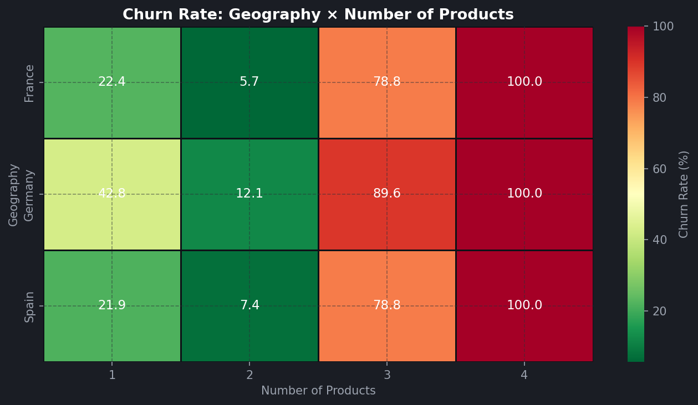
Figure 7: Churn Rate Heatmap — Geography × Number of Products

11. DEMOGRAPHIC ANALYSIS
Figure 6 shows that the 51-60 age group has the highest churn at 56.2%, followed by the 60+ group at 24.8%. Younger customers (18-30) churn at only 7.5%, suggesting strong early-stage loyalty. Female customers churn at 25.1% versus 16.5% for male customers — a significant 8.6 percentage point gap.

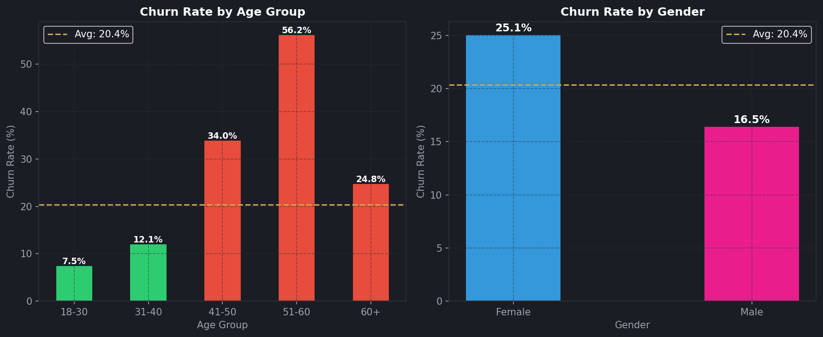
Figure 6: Churn Rate by Age Group (left) and by Gender (right)

12. RETENTION STRENGTH ANALYSIS
Figure 8 shows the Relationship Strength Index (RSI) and tenure analysis. Customers with Very Weak RSI churn at significantly higher rates, while Strong and Very Strong RSI customers show below-average churn. Tenure shows no strong linear trend, indicating that years with the bank alone do not guarantee loyalty without active engagement.

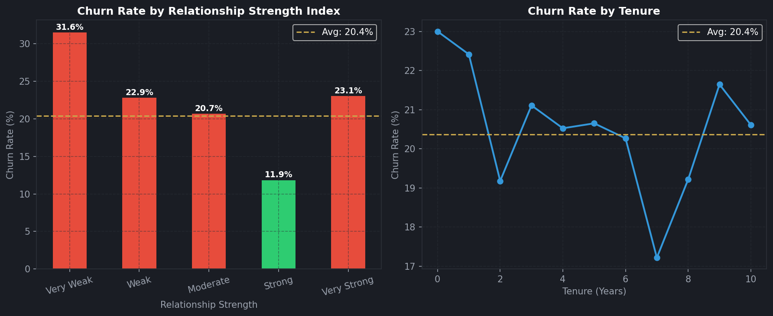
Figure 8: Churn by Relationship Strength Index (left) and by Tenure Years (right)

13. DASHBOARD ARCHITECTURE
The Streamlit dashboard (bank_app.py, Version 1.0) provides 4 interactive module pages with 6 real-time sidebar filters: Geography, Gender, Number of Products, Member Status, Min Balance slider, and Min Credit Score slider.

Page | Content
Engagement Overview | Churn pie, geography bar, engagement profile chart, age group chart
Product Utilization | Product count vs churn, customer distribution, active/inactive, heatmap
High-Value Risk | Balance distribution, balance tier churn, at-risk table, CSV download
Retention Strength | RSI scoring, tenure trend, credit card stickiness, credit score bands

14. DATA LIMITATIONS
- No Temporal Data: The dataset has no transaction-level time series. Behavioral trends over time cannot be tracked.

- Binary Activity Flag: IsActiveMember is binary (0/1). Degree of activity (login frequency, transaction count) is not available.

- Salary vs Actual Income: EstimatedSalary is an estimate, not verified income. Its use as a financial indicator has limitations.

- Churn Definition: Exited=1 captures account closure but not partial disengagement (reduced product use, lower transactions).

15. RECOMMENDATIONS
- R1 — Target Inactive High-Balance Customers: 1,247 at-risk premium customers churn at 32.2%. Launch personalized re-engagement campaigns with relationship managers offering exclusive products.

- R2 — Investigate 3-4 Product Churn Paradox: Customers with 3-4 products churn at 83-100%. Audit whether these customers were over-sold products without genuine need, and redesign product bundling strategy.

- R3 — Germany-Specific Retention Program: Germany churns at 32.4% vs 16.2% in France. A country-specific retention initiative addressing local competitive pressures and service gaps is urgently needed.

- R4 — Female Customer Loyalty Program: Female customers churn 8.6 percentage points higher than males. Gender-targeted engagement programs, advisory services, and tailored product offerings should be explored.

- R5 — Senior Customer Engagement (51-60 Age): This group churns at 56.2%. Dedicated relationship managers, simplified digital interfaces, and senior-specific products can significantly reduce this rate.

16. CONCLUSION
This analysis reframes customer churn from a behavioral and relationship-strength perspective for the European Bank. The key finding is that engagement level, product count, and relationship strength are stronger predictors of churn than balance or salary alone. All 1,247 at-risk premium customers combine high financial value with zero engagement — representing the greatest retention opportunity.

The Streamlit dashboard enables real-time exploration of these findings across all customer segments, empowering retention teams to act on data-driven insights rather than intuition.

REFERENCES
- European Bank Customer Dataset — Project Requirement Document, Unified Mentor, 2026
- Python Software Foundation. pandas Documentation. https://pandas.pydata.org
- Streamlit Inc. Streamlit Documentation. https://docs.streamlit.io
- Matplotlib Development Team. Matplotlib Documentation. https://matplotlib.org
- Seaborn. Statistical Data Visualization. https://seaborn.pydata.org

