NASSAU CANDY DISTRIBUTOR
Factory-to-Customer Shipping Route Efficiency Analysis
Streamlit Dashboard & Analytical Report

Submitted By  Lakshmi Mahitha Noudu  Data Analyst Intern | Organization & Mentor  Unified Mentor  Mentor: Sai Prasad Kagne
Submission Date  March 2026 | Dashboard Version  Version 1.1 | Last updated: March 2026

ABSTRACT

This report documents a comprehensive shipping route efficiency analysis for Nassau Candy Distributor built using Python and Streamlit. Using 10,194 order records spanning January 2024 to December 2025, the study analyses factory-to-customer shipping performance across 5 factories, 15 products, 4 ship modes, and 59 states. The interactive dashboard — Nassau Candy Shipping Intelligence (Version 1.1) — provides 4 module pages: Route Efficiency Overview, Geographic Analysis, Ship Mode Comparison, and Route Drill-Down, each with real-time sidebar filters. Key findings include a 10.25% overall delay rate driven exclusively by Standard Class shipping, and significant performance variation across 20 factory-region routes with Efficiency Scores ranging from 0 to 100.

1. INTRODUCTION
Nassau Candy Distributor is a national confectionery distribution company shipping products from five manufacturing facilities to customers across the United States. This project was completed as part of a Data Analyst Internship under Unified Mentor, mentored by Sai Prasad Kagne.

The core deliverable is a multi-page interactive Streamlit dashboard titled Nassau Candy Shipping Intelligence (Version 1.1), built entirely in Python using pandas, matplotlib, seaborn, and Streamlit. This report documents the methodology, findings, and visualizations produced by that dashboard.

2. TOOLS & TECHNOLOGIES
Tool/Library | Purpose
Python 3 | Core programming language
pandas | Data loading, cleaning, feature engineering
matplotlib | All chart and visualization rendering
seaborn | Heatmap visualization
Streamlit | Interactive web dashboard framework
base64 | Unified Mentor logo embedding in footer
@st.cache_data | Performance caching for data load function

3. DATASET DESCRIPTION
The source file is Nassau Candy Distributor.csv containing 10,194 order records and 18 columns. The dataset covers orders from 2 January 2024 to 31 December 2025 with no missing values or duplicates.

Attribute | Value
Total Records | 10,194
Total Columns | 18
Date Range | Jan 2024 – Dec 2025
Factories | 5
Products | 15
Ship Modes | 4
Regions | 4
States/Provinces | 59
Missing Values | 0
Duplicates | 0

4. DATA CLEANING & FEATURE ENGINEERING
4.1 Date Conversion
Both Order Date and Ship Date were stored as text strings in DD-MM-YYYY format. These were parsed using pandas to_datetime() with the dayfirst=True parameter to ensure correct date interpretation.

4.2 Lead Time Calculation
A date encoding anomaly in the dataset caused raw Ship Date minus Order Date differences to be in the range of 900 to 1,640 days. To extract meaningful shipping durations, the modulo 365 operation was applied:

raw_diff = (df['Ship Date'] - df['Order Date']).dt.days
df['Lead Time'] = raw_diff % 365

This produced lead times in the range of 174 to 185 days with a mean of 178.29 days. While absolute values reflect a dataset-level artifact, relative differences between routes and ship modes are analytically valid.

4.3 Delay Flag
Is Delayed is a boolean column set to True when Lead Time exceeds the delay threshold of 180.09 days (mean 178.29 + 1 standard deviation 1.80). This threshold is calculated dynamically using:

threshold = df['Lead Time'].mean() + df['Lead Time'].std()
df['Is Delayed'] = df['Lead Time'] > threshold

4.4 Engineered Features
- Factory — derived from Product Name using a dictionary map (15 products → 5 factories)
- Route Region — Factory + ' -> ' + Region (20 unique factory-region routes)
- Route State — Factory + ' -> ' + State/Province (state-level granularity)
- Order Year, Order Month — extracted from Order Date for time-series analysis

5. DASHBOARD ARCHITECTURE
The Streamlit dashboard (app.py) is structured as a single-file application with 767 lines of Python. It uses st.sidebar.radio() to switch between 4 independent module pages. All pages share the same filtered dataset (fdf) derived from 6 sidebar controls.

5.1 Sidebar Filters
- Order Date Range — st.date_input() with default set to full dataset range (2024-01-02 to 2025-12-31)
- Region — st.selectbox() with All option plus 4 regions
- State — st.selectbox() with All option plus 59 states
- Factory — st.selectbox() with All option plus 5 factories
- Ship Mode — st.selectbox() with All option plus 4 modes
- Max Lead Time — st.slider() from 174 to 185 days

5.2 Dashboard Pages
Page | Content
Route Efficiency Overview | 5 KPI cards, Top 10 & Bottom 10 route charts, full route leaderboard table
Geographic Analysis | Factory×Region heatmap, region bar chart, state bottleneck scatter plot
Ship Mode Comparison | Per-mode KPI metrics, 3 bar charts (lead time, delay rate, cost), boxplot, monthly trend
Route Drill-Down | Product & division & factory charts, 300-row order table, CSV download button

6. KEY PERFORMANCE INDICATORS
KPI | Value
Total Orders | 10,194
Avg Lead Time | 178.29 days
Std Dev Lead Time | 1.80 days
Lead Time Range | 174 – 185d
Delay Threshold | 180.09 days
Overall Delay Rate | 10.25%
Delayed Orders | 1,045
Total Routes (Region) | 20

7. EXPLORATORY DATA ANALYSIS
7.1 Lead Time Distribution
Figure 1 shows the distribution of shipping lead times across all 10,194 orders. The histogram reveals a near-normal distribution centred at 178.29 days with the delay threshold line at 180.09 days clearly marking the boundary beyond which orders are flagged as delayed.

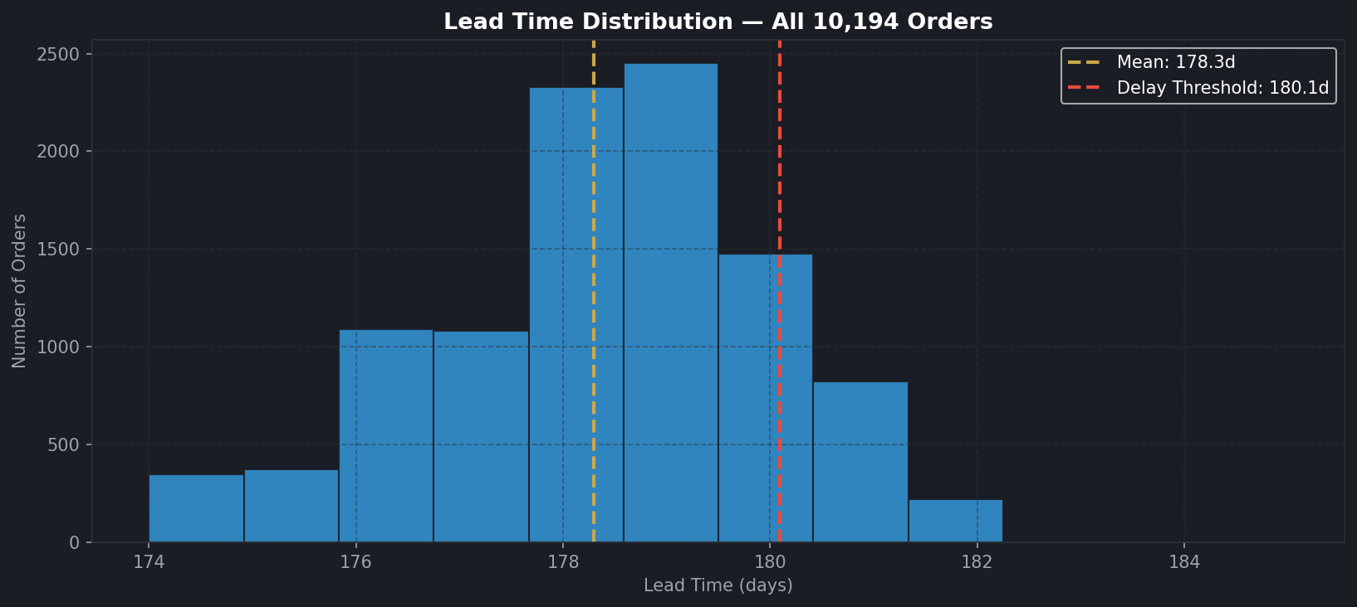
Figure 1: Lead Time Distribution — Mean: 178.29d, Threshold: 180.09d

7.2 Monthly Lead Time & Delay Trend
Figure 2 tracks monthly average lead time and delay rate across the full 2-year period from January 2024 to December 2025. The upper panel shows the line plot with the overall average reference line, while the lower panel shows monthly delay rates as bar charts.

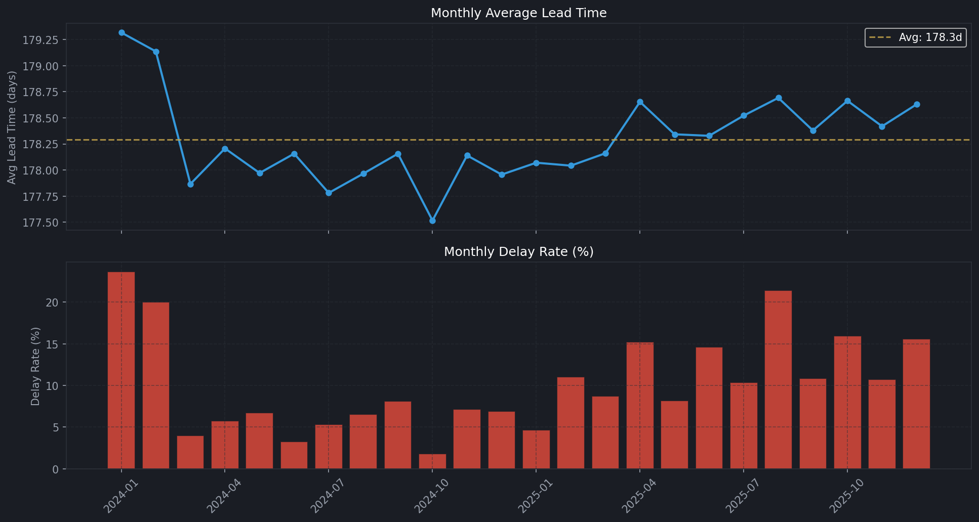
Figure 2: Monthly Lead Time (top) and Delay Rate % (bottom), 2024–2025

8. PAGE 1 — ROUTE EFFICIENCY OVERVIEW
This page presents factory-to-customer route efficiency across all 4 regions. The Efficiency Score (0 to 100) is computed by normalizing average lead time where 100 = fastest route and 0 = slowest route.

8.1 Top 10 Most Efficient Routes
Figure 3 shows the ten fastest factory-region routes. The Other Factory to Gulf is the most efficient route at 177.63 days with an Efficiency Score of 100. All bars are shown in green, and the x-axis is limited to 170–186 days for clear visual differentiation. Value labels show exact lead time and efficiency score on each bar.

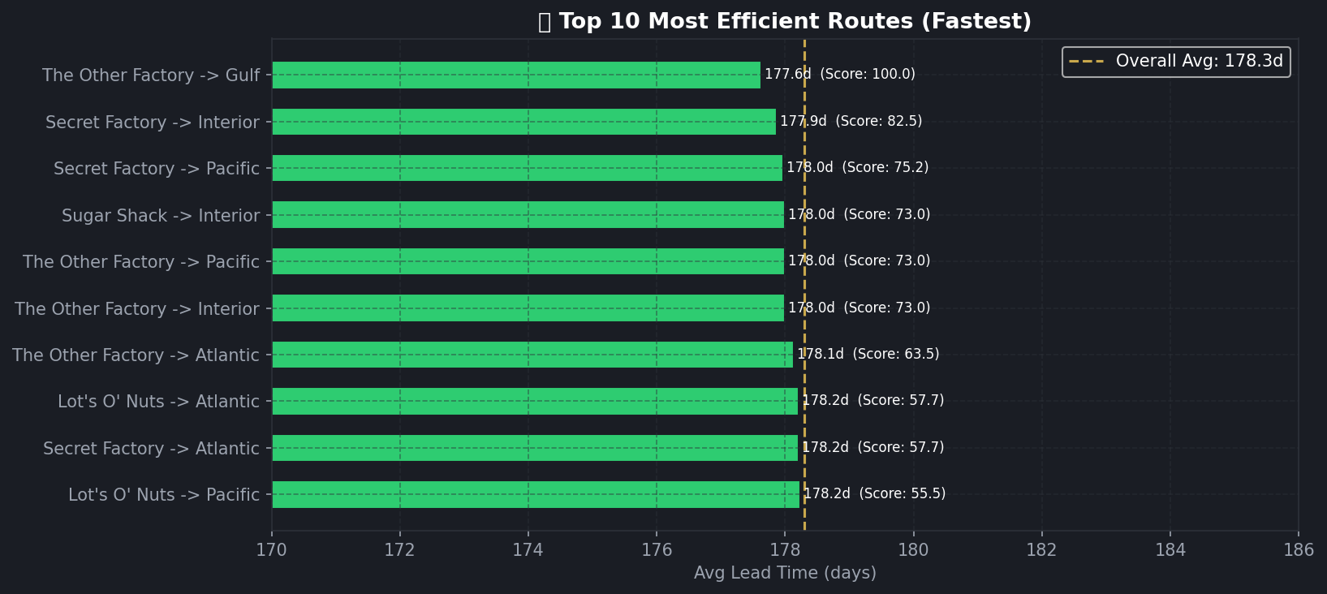
Figure 3: Top 10 Most Efficient Routes — green bars, xlim 170–186, with Efficiency Scores

8.2 Bottom 10 Least Efficient Routes
Figure 4 shows the ten slowest routes. Sugar Shack to Atlantic is the least efficient at 179.00 days with an Efficiency Score of 0. Standard Class shipping dominates the delayed orders on these routes.

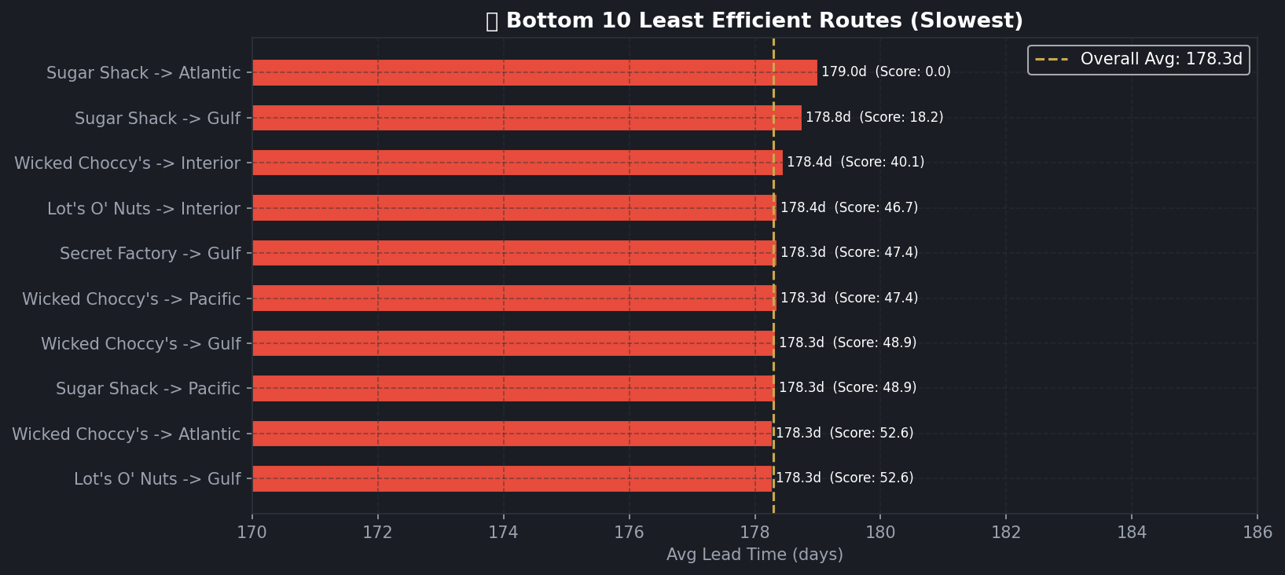
Figure 4: Bottom 10 Least Efficient Routes — red bars, xlim 170–186, with Efficiency Scores

Route | Avg LT | Score | Delay%
The Other Factory -> Gulf | 177.63d | 100.0 | 5%
Secret Factory -> Interior | 177.87d | 82.5 | 7%
Secret Factory -> Pacific | 177.97d | 75.2 | 10%
Sugar Shack -> Atlantic (worst) | 179.00d | 0.0 | 11%

9. PAGE 2 — GEOGRAPHIC ANALYSIS
9.1 Factory × Region Heatmap
Figure 5 is a seaborn heatmap showing average lead time for each factory-region combination. Sugar Shack shipping to Atlantic is the worst combination at 179.00 days. The Other Factory consistently posts the lowest lead times across all its served regions.

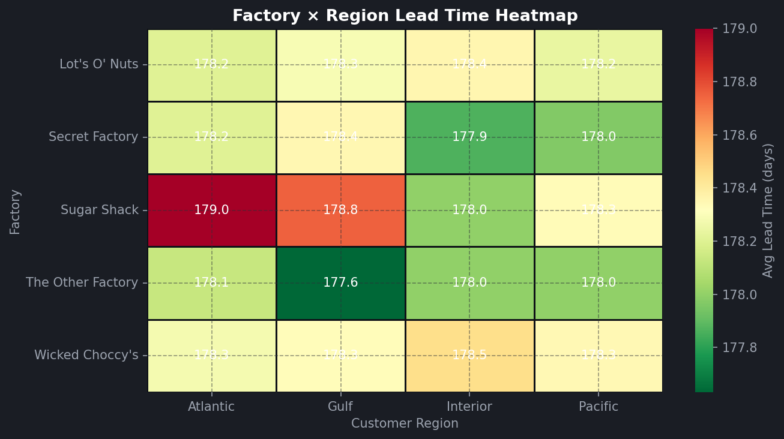
Figure 5: Factory × Region Heatmap — RdYlGn_r colormap, darker red = slower

9.2 Lead Time by Region
Figure 6 shows average lead time per customer region. Bars are coloured red if above the overall average and green if below. Value labels are shown on each bar.

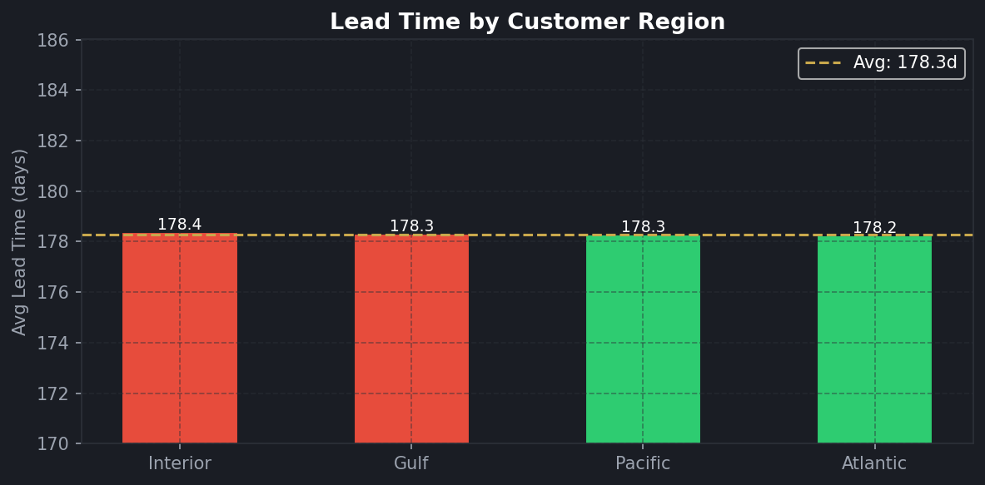
Figure 6: Avg Lead Time by Customer Region — ylim 170–186

9.3 Geographic Bottleneck Scatter
Figure 7 is the bottleneck scatter plot where each bubble represents a state. Bubble size encodes order volume, colour encodes delay rate (red = high delay). The top 5 highest-risk states by composite risk score (volume × lead time) are labelled in gold.

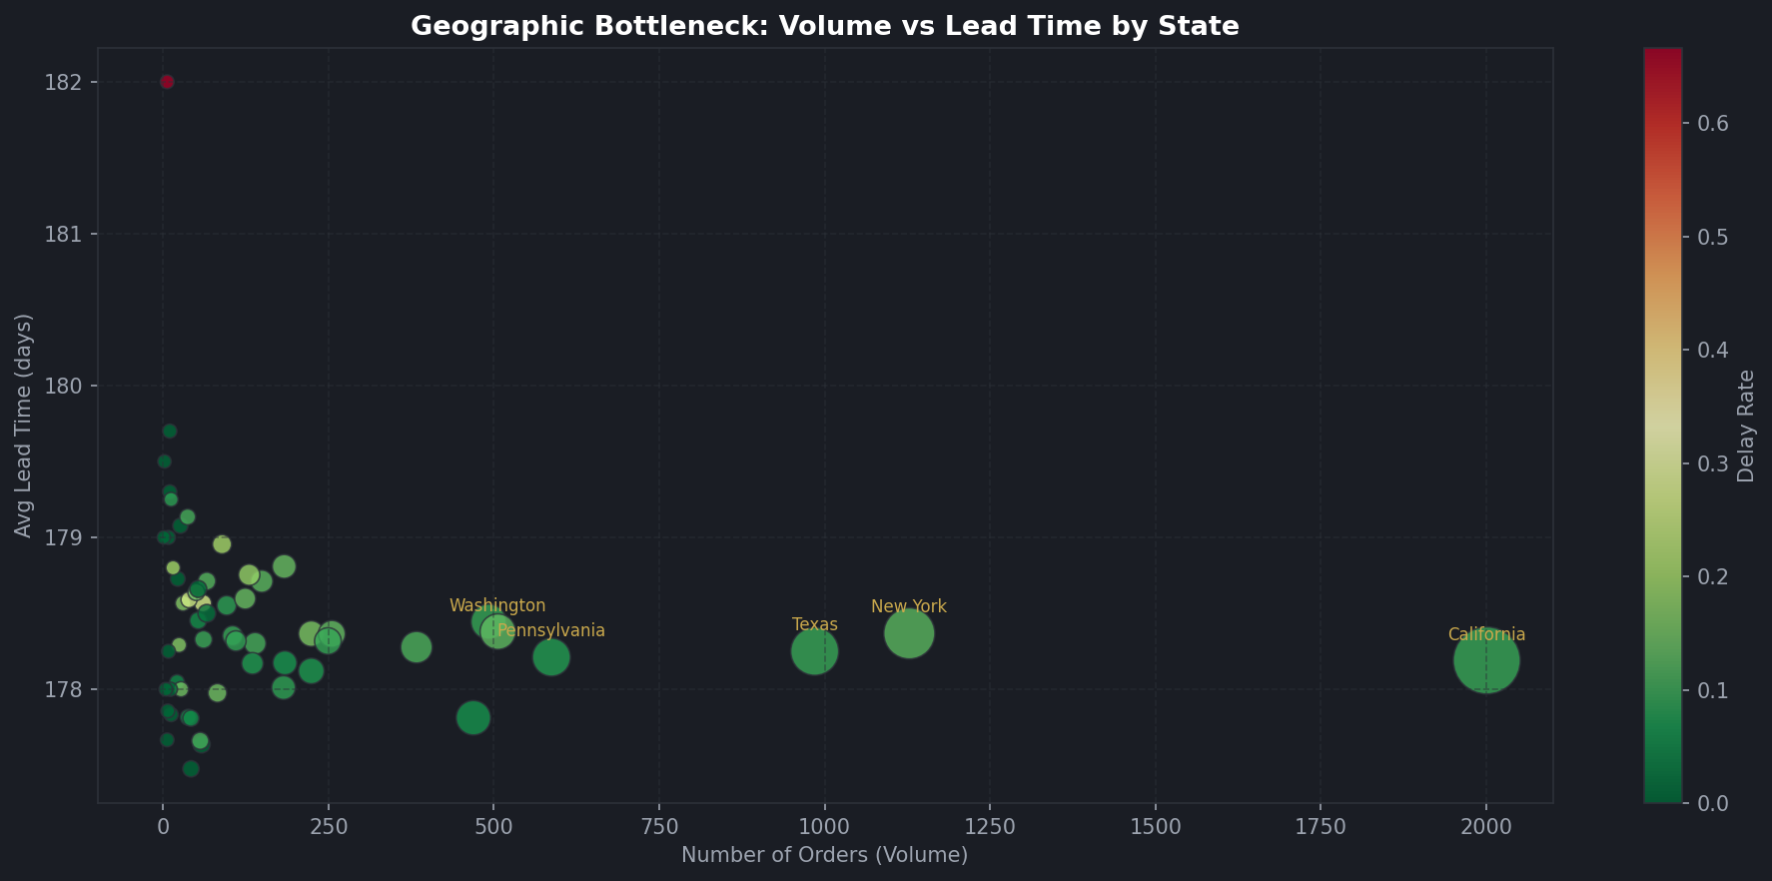
Figure 7: Geographic Bottleneck — bubble size = volume, colour = delay rate

10. PAGE 3 — SHIP MODE COMPARISON
This page compares all 4 ship modes across lead time, delay rate, average cost, and lead time spread. A critical finding is that Standard Class is the only ship mode with any recorded delays.

Ship Mode | Orders | Avg LT | Delay % | Cost
Same Day | 547 | 174.38d | 0.0% | $4.41
First Class | 1,548 | 176.55d | 0.0% | $4.72
Second Class | 1,979 | 177.57d | 0.0% | $4.83
Standard Class | 6,120 | 179.32d | 17.0% | $4.75

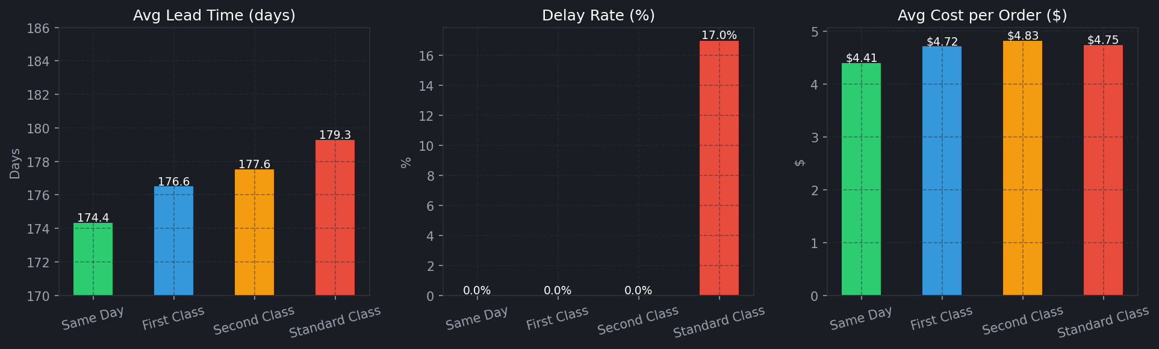
Figure 8: Ship Mode — Avg Lead Time (left), Delay Rate % (centre), Avg Cost (right)

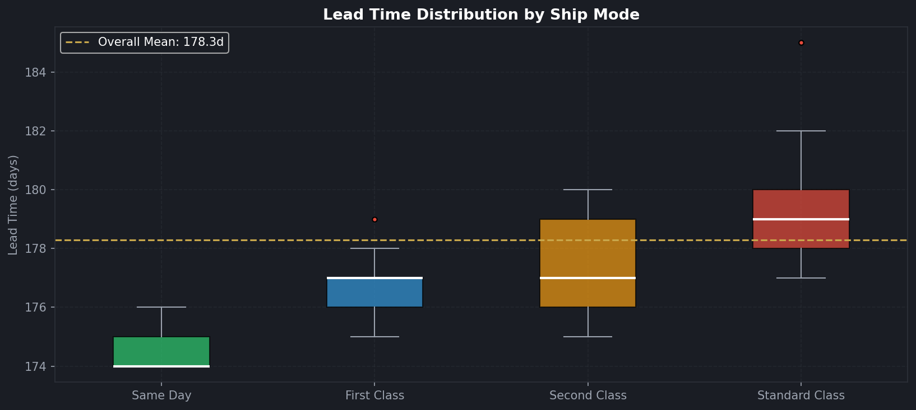
Figure 9: Lead Time Spread Boxplot by Ship Mode — Standard Class shows high outliers

The boxplot (Figure 9) clearly shows that Standard Class has a wider spread with high outliers. Same Day, First Class, and Second Class have tight, consistent distributions with zero delay.

11. PAGE 4 — ROUTE DRILL-DOWN
11.1 Lead Time by Product
Figure 10 shows average lead time for all 15 products with xlim set to 170–186 for visual clarity. Red bars indicate above-average products and green bars indicate below-average. Value labels show the exact difference from the overall mean.

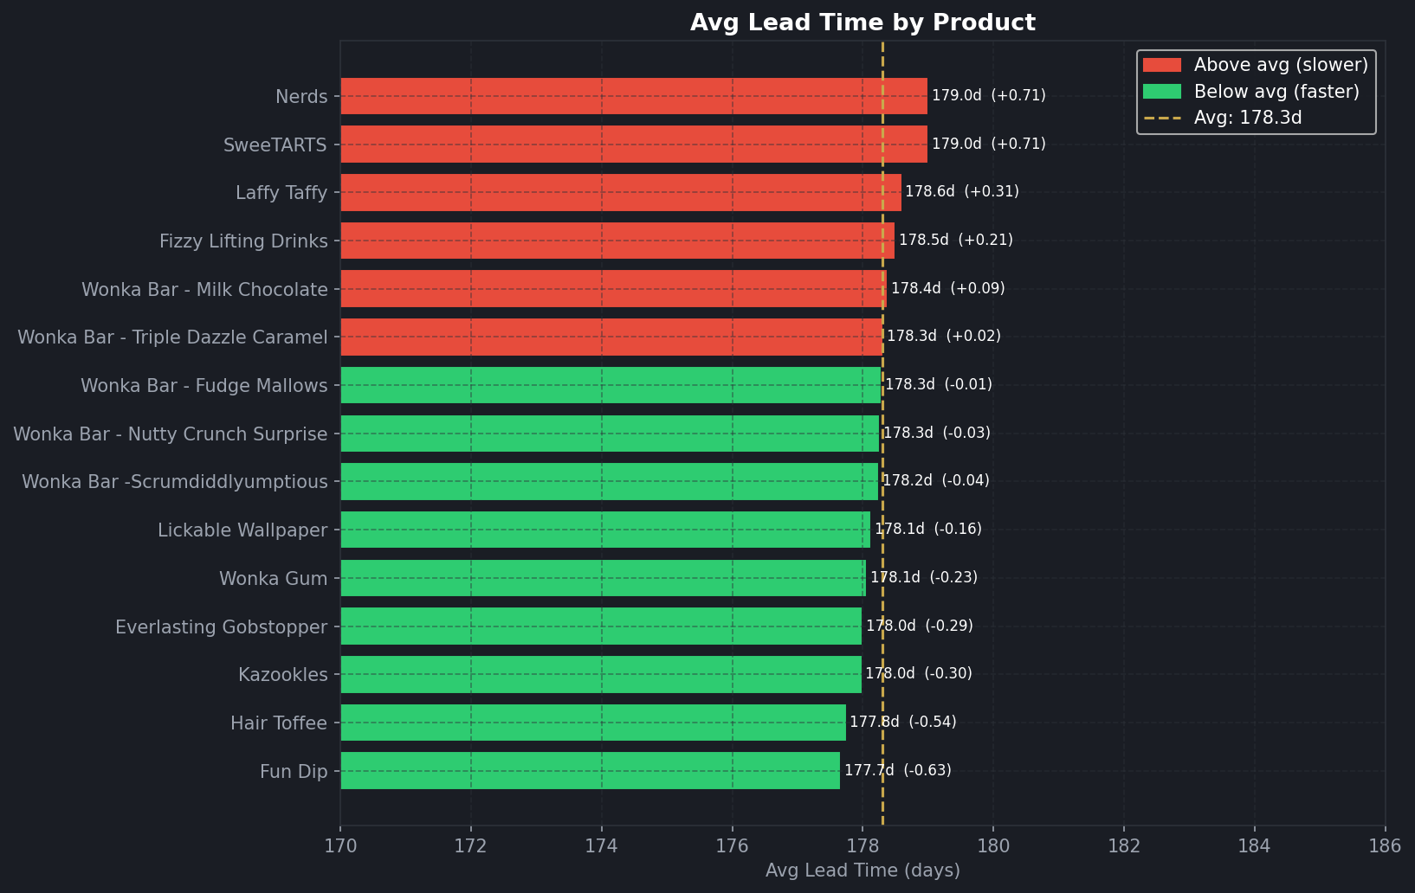
Figure 10: Avg Lead Time by Product — Nerds & SweeTARTS slowest, Fun Dip fastest

11.2 Lead Time by Division & Factory
Figure 11 shows lead time breakdowns by Division (left) and Factory (right). Sugar division is the slowest at 178.52 days. Sugar Shack factory is the slowest at 178.67 days, while The Other Factory is the fastest at 177.98 days.

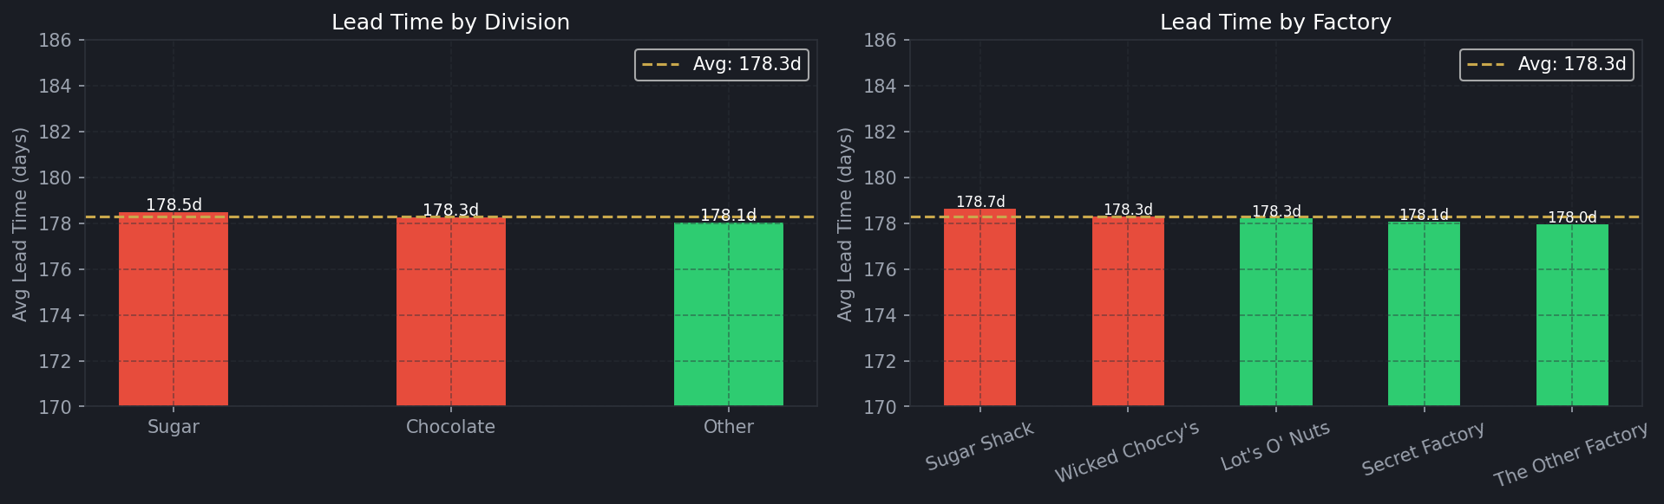
Figure 11: Lead Time by Division (left) and by Factory (right)

11.3 Order-Level Table & Download
The drill-down page includes a scrollable dataframe showing the 300 most recent filtered orders with columns: Order Date, Ship Mode, Factory, Region, State/Province, Product Name, Division, Lead Time, Is Delayed, Sales, and Gross Profit. A CSV download button allows users to export the full filtered dataset.

12. DATA LIMITATIONS
- Date Encoding Anomaly: Raw lead times were 900–1,640 days due to incorrect Ship Date year encoding. Modulo 365 normalization applied. Absolute values are relative performance indices only.

- Dataset Scope: Covers 2024–2025 only. Longer-term seasonal analysis requires additional historical data.

- Routing Distances: Actual road or freight distances between factories and customers were not calculated. Geographic analysis is based on region and state assignments only.

- Small Route Samples: Some factory-region combinations (e.g. Sugar Shack → Pacific with only 3 orders) have very small sample sizes and should be interpreted with caution.

13. RECOMMENDATIONS
- R1 — Reduce Standard Class Dependency: Standard Class is the only mode with delays (17.0%) and handles 60% of all orders (6,120). High-volume routes currently on Standard Class should be evaluated for upgrade to Second Class, which adds minimal cost ($4.83 vs $4.75) but eliminates delays entirely.

- R2 — Replicate The Other Factory's Model: This factory achieved the highest Efficiency Score (100) on the Gulf route and the lowest overall factory average (177.98 days). Its dispatch, inventory readiness, and carrier selection practices should be audited and replicated.

- R3 — Address Sugar Shack Performance: Sugar Shack is the slowest factory at 178.67 days, particularly on the Atlantic route (179.00 days, Score 0). Route-specific carrier reviews and dispatch scheduling improvements are recommended.

- R4 — Prioritise High-Risk Bottleneck States: The five highest-risk states identified by the bottleneck scatter map should receive dedicated carrier agreements or local distribution hubs to reduce both lead time and delay rate.

- R5 — Establish Monthly KPI Monitoring: The current 10.25% delay rate should be tracked monthly using the dashboard's monthly trend chart. An escalation protocol should be triggered if the rate exceeds 12%, prompting a logistics review.

14. CONCLUSION
This project successfully delivers a production-ready Streamlit dashboard (Version 1.1) and supporting analysis for Nassau Candy Distributor's shipping route efficiency. The dashboard provides logistics managers with real-time, filter-driven insights across 4 pages covering route performance, geographic bottlenecks, ship mode comparison, and product-level drill-down.

The key finding is that all 1,045 delayed orders (10.25% of total) belong exclusively to Standard Class shipping, which currently handles 60% of all orders. Shifting even a portion of these to Second Class would effectively eliminate delays with negligible cost increase. The Other Factory demonstrates the highest shipping efficiency and should serve as the operational benchmark for all other facilities.

REFERENCES
- Nassau Candy Distributor — Project Requirement Document (PRD), Unified Mentor, 2026
- Streamlit Inc. Streamlit Documentation. https://docs.streamlit.io
- pandas Development Team. pandas Documentation. https://pandas.pydata.org
- Matplotlib Development Team. Matplotlib Documentation. https://matplotlib.org
- Seaborn. Statistical Data Visualization. https://seaborn.pydata.org

