Analysis of Hospital Patient Data for Admission Patterns and Severity Prediction using Machine Learning

Suvarnam Lakshmi Mallesh
B.Tech Computer Science Engineering
Lovely Professional University
Punjab, India

Abstract—This study focuses on the analysis of hospital patient data to understand patterns in patient demographics, disease distribution, and hospital admission trends. The dataset used in this study consists of approximately 500,000 patient records, including features such as age, gender, type of admission, severity of illness, and length of hospital stay.

Exploratory Data Analysis (EDA) techniques were applied to identify meaningful relationships between different variables and to extract key insights related to patient behavior and hospital workload. The analysis shows that factors such as severity of illness and type of admission have a noticeable impact on the duration of hospital stay.

In addition to data analysis, a machine learning model based on the Random Forest algorithm was implemented to predict the severity of illness using patient and hospital-related attributes. The model achieved an accuracy of approximately 75%, indicating good predictive performance.

The results of this study highlight the importance of data-driven approaches in healthcare and demonstrate how analytical and predictive techniques can support better hospital management and decision-making.

Keywords—Healthcare, Machine Learning, Hospital Data, EDA, Random Forest

I. INTRODUCTION
Healthcare systems generate a large volume of data related to patient records, hospital admissions, and treatment outcomes. Analyzing this data is essential for improving hospital management, optimizing resource utilization, and enhancing patient care. With the increasing demand for efficient healthcare services, data-driven approaches have become important in understanding healthcare patterns and supporting decision-making processes.

One of the major challenges in hospital management is analyzing patient admission trends and identifying factors that influence the duration of hospital stay. Variables such as age, gender, type of admission, and severity of illness play a significant role in determining patient outcomes and hospital workload. Understanding these relationships helps in identifying high-risk groups and improving operational efficiency.

In recent years, machine learning techniques have been widely used in healthcare data analysis to extract meaningful insights and make predictions. These techniques enable the identification of complex patterns that are difficult to detect using traditional analytical methods.

In this study, hospital patient data is analyzed to explore patterns in patient demographics, disease distribution, and admission trends. Exploratory Data Analysis (EDA) is performed to understand relationships between different variables. Additionally, a machine learning model is developed to predict the severity of illness based on patient and hospital-related features.

The objective of this study is to provide insights that can assist in improving hospital resource management and support better healthcare decision-making.

II. LITERATURE REVIEW
Several studies have explored the use of data analysis and machine learning techniques in healthcare to improve patient care and hospital management. Predicting the length of hospital stay has been a major focus in many research works, as it helps in efficient resource allocation and reduces operational costs [1].

Previous research has applied various machine learning algorithms such as Decision Trees, Logistic Regression, and Random Forest to analyze hospital data and predict patient outcomes. These studies demonstrate that machine learning models can effectively identify patterns in patient data and provide reliable predictions [2].

Some advanced approaches have also used deep learning models, including convolutional and recurrent neural networks, to improve prediction accuracy. These models are capable of handling large and complex datasets, although they require higher computational resources [3].

In addition to predictive modeling, several studies have emphasized the importance of exploratory data analysis in understanding factors that influence hospital stay. Variables such as patient age, severity of illness, and type of admission have been identified as key factors affecting patient outcomes and hospital workload [4].

Based on these studies, it is evident that combining data analysis techniques with machine learning models can provide valuable insights into healthcare systems. This study follows a similar approach by analyzing hospital patient data and applying a machine learning model to understand patterns and predict severity of illness.

III. DATASET DESCRIPTION
The dataset used in this study consists of hospital patient records obtained from a publicly available open-source data repository (Hugging Face). The dataset, titled “healthcare data”, contains approximately 500,000 records, representing a large and diverse collection of patient information suitable for healthcare analysis.

The dataset includes a variety of features related to patient demographics, hospital details, and admission characteristics. Key attributes include age, gender, department, ward facility code, type of admission, and admission deposit. In addition, it contains medical-related features such as severity of illness and health conditions.

A crucial variable in the dataset is the length of hospital stay, measured in days, which provides insight into treatment duration and hospital workload. Another important attribute is the severity of illness, which is used as the target variable for prediction in this study.

The dataset also contains supporting features such as staff availability, number of visitors with the patient, and insurance information. These attributes help in analyzing hospital resource utilization and patient management. The richness and diversity of features make this dataset suitable for both exploratory data analysis and machine learning applications.

IV. METHODOLOGY

The methodology of this study consists of multiple stages, including data preprocessing, exploratory data analysis, and machine learning implementation. The overall workflow is designed to extract meaningful insights from the dataset and build a predictive model based on patient and hospital attributes.

In the first stage, data preprocessing was carried out to ensure data quality and consistency. Missing values were identified and handled appropriately, and categorical variables were converted into numerical format using encoding techniques. The dataset was then cleaned and prepared for further analysis.

In the second stage, Exploratory Data Analysis (EDA) was performed to understand the distribution of variables and relationships between different features. Various visualizations were created to analyze patient demographics, admission patterns, and factors affecting hospital stay. This step helped in identifying important trends and patterns within the data.

In the final stage, a machine learning model was implemented to predict the severity of illness. The dataset was divided into training and testing sets to evaluate model performance. A Random Forest classifier was used due to its ability to handle complex data and provide accurate predictions. The model was trained on the selected features and evaluated using accuracy as the performance metric.

This structured approach ensures that both data analysis and predictive modeling are effectively integrated to achieve the objectives of the study.

V. RESULTS AND ANALYSIS

The dataset was analyzed using various visualization techniques to understand patterns in patient demographics, hospital admissions, and treatment outcomes. The key findings from the analysis are discussed below.

A. Age Distribution

The distribution of patients across different age groups was analyzed to understand demographic trends. It is observed that the majority of patients belong to the age group 21–30, indicating higher hospital admission rates among young adults.

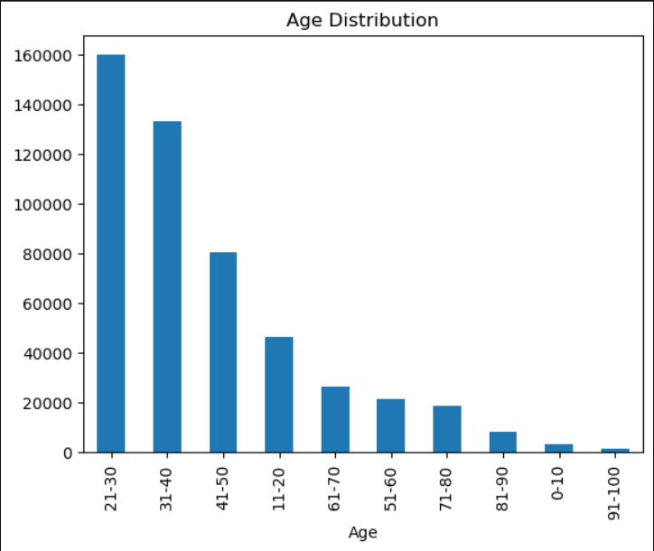
Fig. 1. Age Distribution of Patients

B. Gender Distribution

The gender distribution analysis shows that female patients constitute approximately 74.2% of the total dataset, indicating a higher representation of female patients in hospital records.

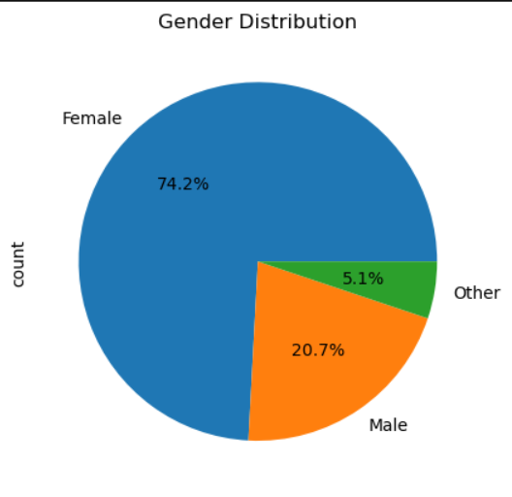
Fig. 2. Gender Distribution of Patients

C. Department-wise Distribution

The distribution of patients across hospital departments was examined to understand resource utilization. The gynecology department accounts for the highest proportion of admissions (68.7%), followed by radiotherapy and anesthesia departments.

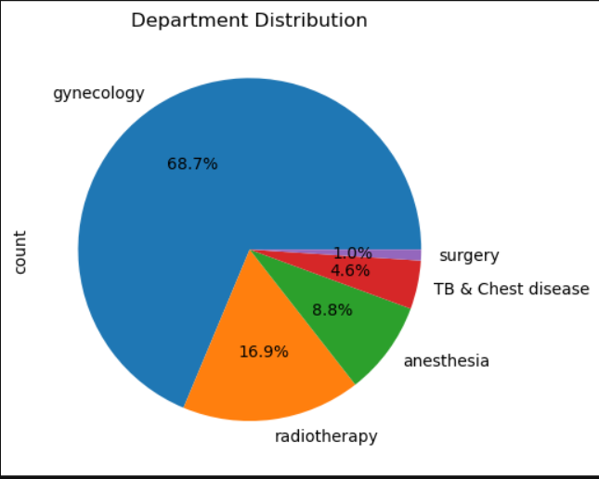
Fig. 3. Department-wise Patient Distribution

D. Admission Type Analysis

The analysis of admission types reveals that trauma cases account for the highest number of hospital admissions, followed by emergency and urgent cases. This suggests that a significant portion of hospital visits are related to injuries or critical conditions.

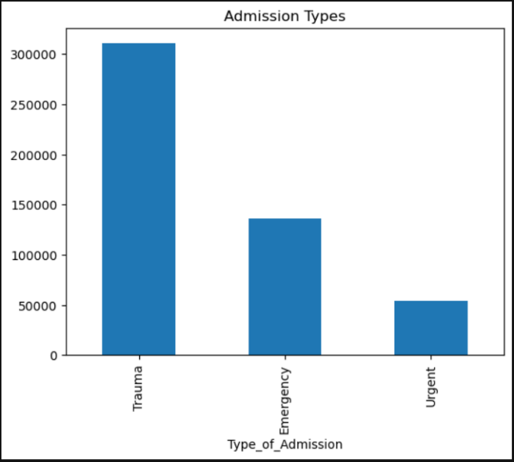
Fig. 4. Distribution of Admission Types

E. Disease Distribution

The most common health conditions were analyzed to identify disease patterns. The results show that “Unknown” and “Other” categories have the highest frequency, followed by conditions such as high blood pressure and diabetes.

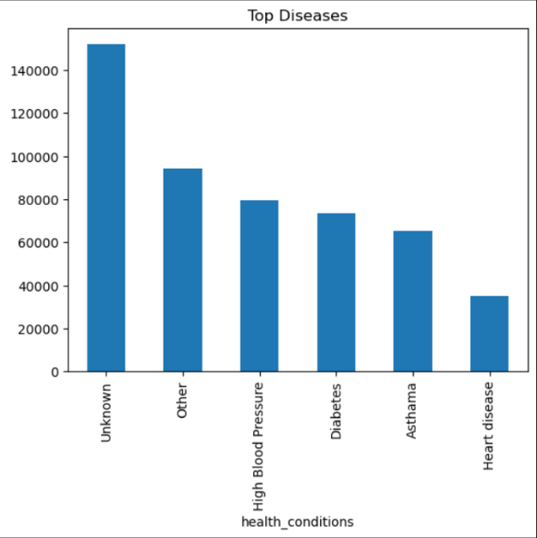
Fig. 5. Most Common Health Conditions

F. Disease vs Gender

The relationship between health conditions and gender was examined to identify patterns across different groups. The analysis indicates that female patients have a higher frequency across most disease categories compared to male patients.

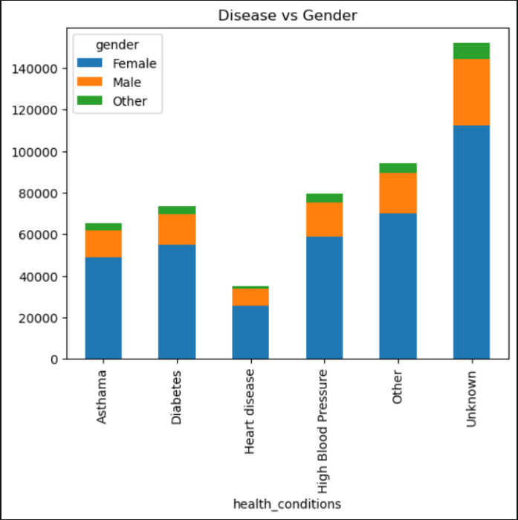
Fig. 6. Health Conditions Across Gender

G. Stay Distribution

The distribution of hospital stay duration shows that most patients are treated within 7–10 days, while only a small number of patients require extended hospitalization beyond 20 days. This indicates that the majority of cases are resolved within a limited duration.

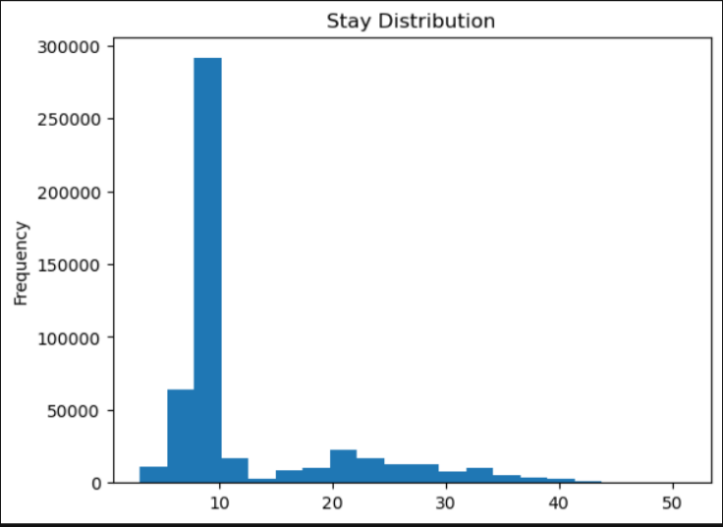
Fig. 7. Distribution of Hospital Stay Duration

H. Severity of Illness vs Stay

The relationship between severity of illness and hospital stay duration was analyzed. It is observed that patients with moderate and extreme illness tend to have slightly longer hospital stays compared to minor cases, indicating increased treatment complexity.

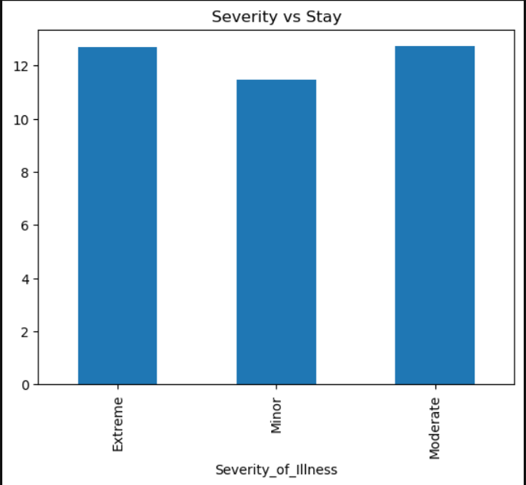
Fig. 8. Severity of Illness vs Hospital Stay

I. Disease vs Stay

The analysis of different health conditions and their corresponding hospital stay duration shows that the average stay is relatively consistent across diseases. This suggests a standardized treatment approach within the hospital system.

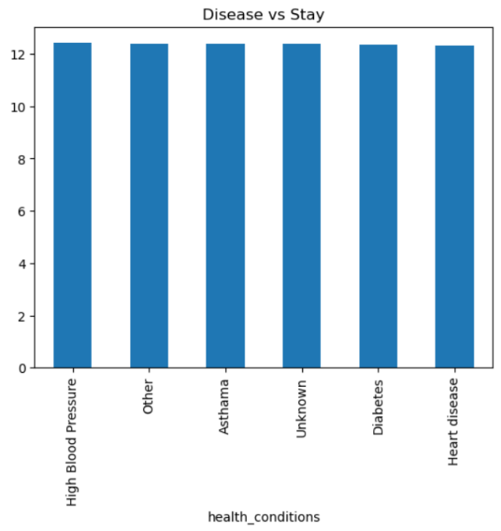
Fig. 9. Health Conditions vs Hospital Stay

J. Machine Learning Insight

A Random Forest classifier was implemented to predict the severity of illness based on patient and hospital attributes. The model achieved an accuracy of approximately 75%, indicating good predictive performance.

The model was trained on historical data and tested on unseen data, where it demonstrated the ability to correctly predict severity levels. This shows that the model effectively captures patterns within the dataset.

Overall, the analysis highlights important patterns in patient demographics, disease distribution, and hospital admissions. These findings provide valuable insights into hospital operations and healthcare efficiency.

VI. MACHINE LEARNING MODEL

In this study, a machine learning model was developed to predict the severity of illness based on patient and hospital-related features. The objective of the model is to learn patterns from historical data and provide predictions for new unseen cases.

A Random Forest classifier was selected due to its robustness, ability to handle both numerical and categorical data, and effectiveness in capturing complex relationships within the dataset. The model was trained using multiple decision trees, where each tree contributes to the final prediction.

Before training, the dataset was pre-processed by encoding categorical variables into numerical form. The dataset was then divided into training and testing sets to evaluate the model’s performance on unseen data.

The model achieved an accuracy of approximately 75%, indicating good predictive capability. This shows that the model is able to learn meaningful patterns from the dataset and make reliable predictions.

The predicted results were compared with actual values, and in sample cases, the predictions matched correctly. This demonstrates that the model performs effectively and generalizes well to new data.

Overall, the machine learning model highlights the practical application of predictive analytics in healthcare, where such models can assist in early identification of patient severity and support better decision-making in hospital management.

VII. CONCLUSION

This study presented a comprehensive analysis of hospital patient data to understand patterns in patient demographics, disease distribution, and hospital admission trends. Exploratory Data Analysis was used to identify key relationships between variables such as age, gender, admission type, and severity of illness.

The findings revealed that most patients fall within the young adult age group and that the majority of hospital stays are relatively short. It was also observed that severity of illness has a noticeable impact on the duration of hospital stay, although the variation remains moderate across different conditions.

A machine learning model based on the Random Forest algorithm was implemented to predict the severity of illness. The model achieved an accuracy of approximately 75%, demonstrating its effectiveness in learning patterns from the dataset and making reliable predictions.

Overall, the study highlights the importance of data-driven approaches in healthcare. The insights obtained from the analysis and the predictive capability of the model can assist in improving hospital resource utilization, patient management, and decision-making processes.

In future work, the model can be further improved by incorporating additional features and comparing multiple machine learning algorithms to enhance prediction accuracy.

REFERENCES

[1] Chowdhury, T. N., Mou, S. A., & Rahman, K. N. (2024). A Hybrid Data-Driven Approach For Analyzing And Predicting Inpatient Length Of Stay In Health Centre. Department of Mechatronics & Industrial Engineering, Chittagong University of Engineering & Technology (CUET). (p. 1)

[2] Jain, R., Singh, M., Rao, A. R., & Garg, R. (2024). Predicting hospital length of stay using machine learning on a large open health dataset. BMC Health Services Research, 24(1), 860. doi.org (p. 1)

[3] Neshat, M., Phipps, M., Browne, C. A., Vargas, N. T., & Mirjalili, S. (2024). Predicting the Stay Length of Patients in Hospitals using Convolutional Gated Recurrent Deep Learning Model. (Preprint).(p. 1)

[4] Dataset: “healthcare_data,” Hugging Face Repository, Available: https://huggingface.co/datasets/nicolybgs/healthcare_data

[5] Derntl, M. (2014) ‘Basics of research paper writing and publishing’, Int. J. Technology Enhanced Learning, Vol. 6, No. 2, pp.105–123 (p. 1

