class Book
{
int bookid;
String title;
String author;
double price;
static int totalBooks=0;
Book(int id,String Title,String Author,double Price)
{
bookid=id;
title=Title;
author=Author;
price=Price;
totalBooks++;
}
void display(){
System.out.println("Book id:"+ bookid);
System.out.println("Title:"+ title);
System.out.println("Author:"+ author);
System.out.println("Price:"+ price);
}
boolean search(int id)
{
return bookid==id;
}
boolean search(String Title)
{
return title.equalsIgnoreCase(Title);
}
Book costlier(Book b) {
if (this.price > b.price)
return this;
else
return b;
}
}
class Main {
public static void main(String[] args) {
Book b1 = new Book(101, "Java Programming",
"James Gosling", 500);
Book b2 = new Book(102, "Python Programming",
"Guido van Rossum", 600);
Book b3 = new Book(103, "Data Structures",
"Mark Allen", 450);
System.out.println("BOOK DETAILS");
System.out.println("=========================");
b1.display();
b2.display();
b3.display();
System.out.println("Searching Book ID 102:");
if (b2.search(102))
System.out.println("Book found!");
else
System.out.println("Book not found!");
System.out.println();
System.out.println("Searching for title: Data Structures");
if (b3.search("Data Structures"))
System.out.println("Book found!");
else
System.out.println("Book not found!");
System.out.println();
Book costly = b1.costlier(b2);
System.out.println("Costlier Book:");
costly.display();
System.out.println("Total number of books created: "
+ Book.totalBooks);
}
}
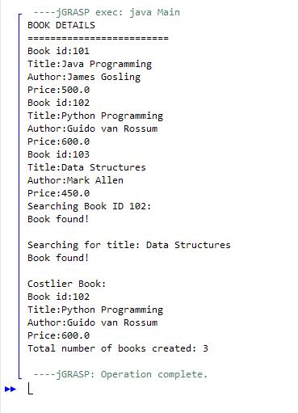
LAKSHMI MANOGNA M 1BF25CS137

