**LAB TASK-1**

**CODE TO PRINT HELLO WORLD!:**

org 100h

jmp start

msg: db "HELLO WORLD!", 0Dh,0Ah, 24h

start: mov dx, msg

mov ah, 09h

int 21h

mov ah, 0

int 16h

ret

**OUTPUT:**

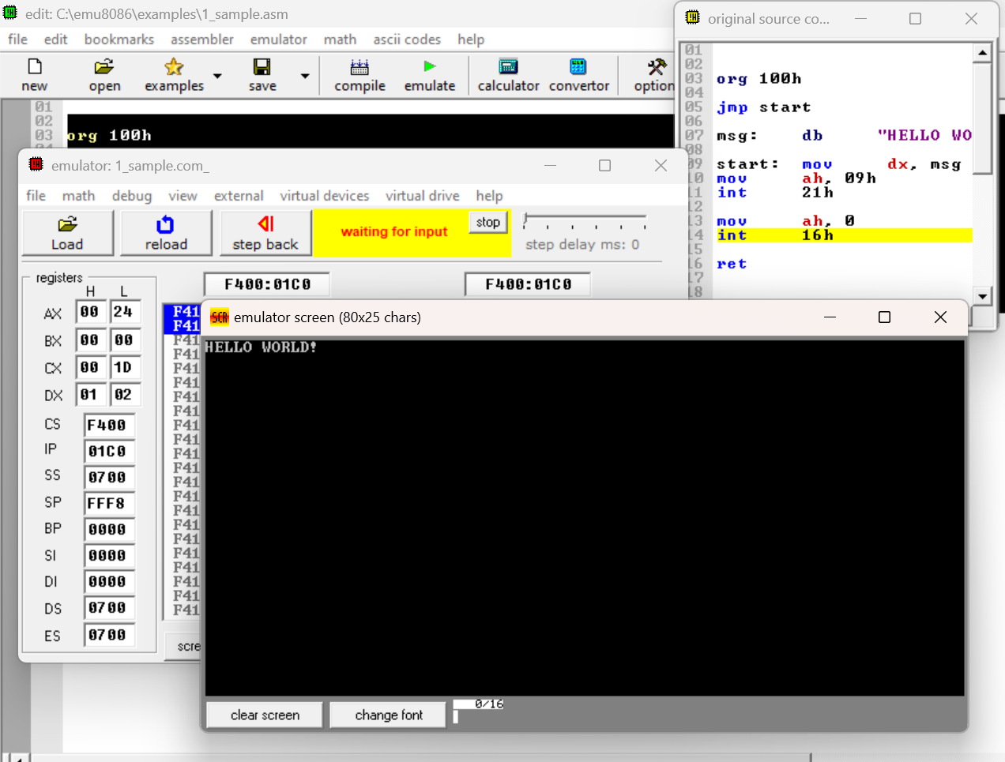

**CODE TO PRINT OUR NAME:**

org 100h

jmp start

msg: db "Meher Ekshita", 0Dh,0Ah, 24h

start: mov dx, msg

mov ah, 09h

int 21h

mov ah, 0

int 16h

ret

**OUTPUT:**

