BBA Semester – [SPECIFY SEMESTER]
Research Project – Interim Report

A study on "Analyzing Operational Efficiency and Predicting Breakdown Risk and Shipment Weight in the Warehouse Network of Supply Flow FMCG Solutions"

Research Project submitted to Jain Online (Deemed-to-be University)
In partial fulfillment of the requirements for the award of:
Bachelor of Business Administration

Submitted by:
Lakshmi M G
USN: 232VBBR00036

Under the guidance of:
[SPECIFY GUIDE NAME]
(Faculty-JAIN Online)

Jain Online (Deemed-to-be University)
Bangalore
[SPECIFY ACADEMIC YEAR]

DECLARATION

I, Lakshmi M G, hereby declare that the Research Project Report titled "Analyzing Operational Efficiency and Predicting Breakdown Risk and Shipment Weight in the Warehouse Network of Supply Flow FMCG Solutions" has been prepared by me under the guidance of [SPECIFY GUIDE NAME], Faculty of Jain Online (Deemed-to-be University). I declare that this project work is towards the partial fulfillment of the requirements for the award of the degree of Bachelor of Business Administration. I further declare that this report is based on secondary data supplied by Supply Flow FMCG Solutions, and that every figure reported has been produced by the analysis notebooks accompanying this submission. This work has not been submitted to any other university or institution for the award of any degree or diploma.

Place: ______________________
Date: Lakshmi M G
USN: 232VBBR00036

TABLE OF CONTENTS

Title | Page Nos.
Executive Summary
List of Tables
List of Figures
Chapter 1: Introduction and Background
1.1 Introduction and Background
1.2 Problem Statement
1.3 Objective of Study
1.4 Company and Industry Overview
1.5 Overview of Theoretical Concepts
Chapter 2: Research Methodology
2.1 Scope of the Study
2.2 Methodology
2.2.1 Research Design
2.2.2 Data Collection
2.2.3 Sampling Method
2.2.4 Data Analysis Tools
2.3 Period of Study
2.4 Utility of Research
2.5 Approach to EDA and Pre-processing
2.5.1 Network-wide data quality and pre-processing
2.5.2 Objective 1 — preparing to segment the network
2.5.3 Objective 2 — defining breakdown risk
2.5.4 Objective 3 — preparing to predict shipment weight
Chapter 3: Data Analysis and Interpretation
3.1 Deciding Models and Model Building
3.1.1 Choosing algorithms
3.1.2 Objective 1 — Warehouse performance segments
3.1.3 Objective 2 — Breakdown risk classification
3.1.4 Objective 3 — Shipment weight regression
3.2 Improving Model Performance
3.2.1 Objective 1 — improvements
3.2.2 Objective 2 — improvements
3.2.3 Objective 3 — improvements
3.2.4 The constraint shared by all three objectives
3.3 Findings and Interpretation
3.3.1 Results by objective
3.3.2 Headline results
3.3.3 Findings that span all three objectives
3.3.4 Answers to the three business questions
3.3.5 Limitation applying to all results
3.3.6 Summary of this milestone
Annexure
Annexure 1 — Where the evidence comes from

LIST OF TABLES

Table No. | Table Title | Page No.
Table 1 | Current tools used by the company and their limitations
Table 2 | Objectives, methods and target columns
Table 3 | Measures used in this report and how to read them
Table 4 | Software tools used for data analysis
Table 5 | Utility of the research by beneficiary
Table 6 | Stages of the exploratory analysis
Table 7 | Columns containing missing values
Table 8 | Missingness tested against the targets only versus against all columns
Table 9 | Strongest correlations across the network
Table 10 | Establishment year correlation before and after filling its gaps
Table 11 | Pre-processing decisions and the measurement justifying each
Table 12 | Numeric conditions against the performance measures
Table 13 | Candidate framings for the breakdown risk target
Table 14 | Eta-squared at each adjacent cut point in the breakdown count
Table 15 | Comparison of the two binary framings on balance and signal retained
Table 16 | Mean shipment weight by grouping
Table 17 | Algorithms compared for each objective
Table 18 | Evidence for selecting four segments
Table 19 | Profile of the five warehouse segments
Table 20 | Segment quality measured against randomised data
Table 21 | Conditions tested for difference across segments
Table 22 | Model screening results for breakdown risk classification
Table 23 | Classification test results, all features versus characteristics only
Table 24 | Per-class classification results on the held-back test set
Table 25 | Model screening results for shipment weight regression
Table 26 | Regression test results on the held-back test set
Table 27 | Recorded and recommended shipment weight by zone
Table 28 | Evidence on the source of the regression accuracy
Table 29 | Feature removal tests for the classification model
Table 30 | Derived features tested for the classification model
Table 31 | Resampling treatments tested for the classification model
Table 32 | Remaining improvements for Objective 2 in order of expected value
Table 33 | Headline results by objective
Table 34 | What carries the signal in each objective
Table 35 | Profile of the 908-warehouse subgroup against the rest of the network
Table 36 | Answers to the three business questions
Table 37 | Summary of this milestone
Table 38 | Report sections and the notebooks that produced them

LIST OF FIGURES

Figure No. | Figure Title | Page No.
Figure 1 | Missing value map
Figure 2 | Pearson correlation heatmap
Figure 3 | Subgroup overlap
Figure 4 | Numeric conditions against performance measures
Figure 5 | Breakdown counts and binary risk classes
Figure 6 | How the features that move with breakdowns change across the count
Figure 7 | Numeric features by breakdown-risk class
Figure 8 | Share of each risk class within each category level
Figure 9 | Shipment weight distribution
Figure 10 | Storage issues against shipment weight
Figure 11 | Choosing the number of segments
Figure 12 | Performance by segment
Figure 13 | Silhouette and Dunn index against randomised data
Figure 14 | Silhouette of every rated warehouse, sorted within its segment
Figure 15 | Rated warehouses in PCA space, coloured by segment
Figure 16 | Confusion matrix
Figure 17 | ROC and precision-recall curves
Figure 18 | Actual against predicted
Figure 19 | Prediction errors against predicted values
Figure 20 | Objective 2 permutation importance
Figure 21 | Objective 3 permutation importance

EXECUTIVE SUMMARY
Supply Flow FMCG Solutions distributes instant noodles through a network of 25,000 warehouses, and performance across that network varies widely. This project applies predictive machine learning to the records the company already maintains, so that breakdown risk and suitable shipment weight can be estimated before the event rather than reported after it.
The problem addressed
- Some warehouses meet demand on time; others face repeated storage, transport and staffing problems, and breakdowns stop work without warning.
- The company manages this today through descriptive dashboards and through heuristic rules such as fixed reorder points and threshold alerts.
- Both tools respond only after a problem has appeared, both weigh one measure at a time, and neither can be tested for accuracy.
What was built
- Objective 1 — clustering: segments the network into performance tiers.
- Objective 2 — classification: estimates whether a warehouse is likely to report four or more breakdowns.
- Objective 3 — regression: predicts a suitable shipment weight for each warehouse.
The data and its main constraint
- Secondary data supplied by the company: 25,000 rows and 24 columns, one row per warehouse.
- Coverage spans four zones, six regional zones, rural and urban sites, and both company-owned and rented premises.
- There are no duplicate records and no placeholder codes, and gaps appear in only three of the 24 columns.
- The file holds a single snapshot of each warehouse rather than a history. This rules out time-series forecasting and sensor-based predictive maintenance, and it means every result shows association rather than cause.
Two findings from the exploratory work that shaped everything after it
- A group of 908 warehouses is defined three times over. A missing government certificate, zero recorded storage issues and zero recorded breakdowns select an identical set of rows. Those warehouses were established on average in 2021 to 2022 and ship about a quarter of the typical volume, which is consistent with sites recently commissioned but not yet fully operating. They were kept and flagged rather than removed, because the company must still plan for them.
- Storage issues and shipment weight move together almost exactly, at a correlation of 0.987. This single relationship dominates the regression result.
The central finding, reached independently by all three objectives
- Reported storage issues and warehouse age explain the differences in performance across the network.
- Location, ownership, capacity size and zone explain almost none of it.
- In the clustering work only two of seventeen conditions differed meaningfully across segments; in both predictive models, storage issues carried the signal while most remaining features contributed nothing measurable.
Model results
- Clustering produced five segments, four discovered by K-Means and one assigned by rule. The separation measures show these are cuts through a continuous spread rather than naturally separated groups, so they are reported as descriptive tiers.
- Classification, using a tuned AdaBoost model, identifies 76.7 per cent of genuinely high-risk warehouses at a precision of 57 per cent. This suits a ranked inspection list rather than an automatic decision.
- Regression, using a tuned CatBoost model, predicts shipment weight to within 4 per cent, although that accuracy rests almost entirely on the single strong relationship noted above.
What the company can act on
- Prioritise maintenance inspections using the breakdown-risk ranking.
- Set dispatch quantities from the shipment-weight predictions.
- Stop using zone, capacity band and ownership as the basis for differentiated policy, because the data does not support it.
- Treat the 908 recently commissioned warehouses as a separate planning group until they have an operating history.
Improving the models further depends less on additional tuning than on obtaining data the file does not currently hold, in particular a maintenance history for each warehouse.

CHAPTER 1
INTRODUCTION AND BACKGROUND

INTRODUCTION AND BACKGROUND

1.1 Introduction and Background
Supply Flow FMCG Solutions distributes instant noodles through a network of 25,000 warehouses. Performance across that network varies widely:
- Some warehouses meet demand on time.
- Others face repeated storage, transport and staffing problems.
- Breakdowns stop work without warning.
The company currently manages this with two kinds of tools:
Table 1: Current tools used by the company and their limitations
Current tool | What it does | Limitation
Descriptive dashboards | Report refills, storage issues, breakdowns and shipment volumes | Report what has already happened
Heuristic rules | Fixed reorder points and threshold alerts set by judgement | Applied uniformly; accuracy cannot be tested

Both respond after a problem appears, both weigh one measure at a time, and neither can be checked for accuracy.
Two standard predictive approaches were considered and do not fit this data:
- Time series forecasting requires repeated observations of the same warehouse over time.
- Predictive maintenance requires sensor readings.
This file contains a single snapshot of each warehouse and holds neither. That constraint shapes every modelling choice in the project.

1.2 Problem Statement
The company cannot presently tell, in advance, which warehouses are likely to fail or what quantity each should receive. The specific gaps are:
- Performance differences across the network are visible in dashboards but have never been attributed to measurable conditions, so infrastructure spending cannot be directed on evidence.
- Breakdowns are recorded only after they occur, so maintenance is reactive rather than planned.
- Shipment quantities are set by judgement and applied through uniform rules, rather than fitted to the conditions of each warehouse.
- None of the current tools produce an estimate whose accuracy can be measured, so their reliability is unknown.
This study addresses those gaps by building models on the company's own records and testing them on data held back from training, so that the error of each estimate is known.

1.3 Objective of Study
Table 2: Objectives, methods and target columns
Objective | Business question | Method | Target column
1 | Which conditions separate strong warehouses from weak ones? | Clustering | None — unsupervised
2 | Which warehouses are likely to break down? | Classification | wh_breakdown_l3m
3 | What shipment weight suits each warehouse? | Regression | product_wg_ton

A fourth objective follows from the three above: to provide a single, evidence-based view of operational efficiency, breakdown risk and suitable shipment weight, in place of descriptive dashboards and judgement-based rules.

1.4 Company and Industry Overview
Supply Flow FMCG Solutions operates in fast-moving consumer goods distribution, where products move in high volume, at low margin, and on short replenishment cycles. In that setting, warehouse availability determines service level directly: a warehouse that halts disrupts supply to every retailer it serves, and the cost is borne immediately because there is little buffer stock in the channel.
The company's network is described in its own records as follows.
- Source: secondary data collected by Supply Flow FMCG Solutions.
- Size: 25,000 rows, 24 columns, one row per warehouse.
- Coverage: four zones, six regional zones, rural and urban sites, company-owned and rented.
- Duplicates: none. No two warehouses share an identical set of attributes.
- Gaps: present in 3 of the 24 columns only.
- Placeholder values: none. There are no negative numbers and no codes standing in for missing data.
The network is heavily rural, with 22,957 rural sites against 2,043 urban, and is split between company-owned and rented premises. Warehouse capacity is recorded in three bands, and government certification in five grades. These structural attributes are the levers the company has traditionally used to explain performance differences, and testing whether they in fact explain anything is a central question of this study.

1.5 Overview of Theoretical Concepts
Three families of technique are applied, each matched to the nature of its objective.
- Clustering is unsupervised: there is no target variable, and the algorithm groups warehouses by similarity across chosen measures. It is appropriate for Objective 1, where the aim is to discover performance tiers rather than to predict a known value. K-Means and Ward hierarchical clustering are the two methods used.
- Classification predicts which of a fixed set of categories an item belongs to. It is appropriate for Objective 2, where each warehouse is assigned to a risk class.
- Regression predicts a continuous numeric value. It is appropriate for Objective 3, where the output is a shipment weight in tons.
Two further concepts govern how the work was validated. Cross-validation repeatedly splits the training data and measures performance on each held-out part, which gives a more stable estimate than a single split. Hyperparameter tuning searches the settings of a chosen algorithm for the combination that performs best, and is applied here through the Optuna library.
Each objective is assessed with standard measures. These are defined once below and then used throughout the report without further explanation.
Each objective is assessed with standard measures. They are defined once here and then used without further explanation.
Table 3: Measures used in this report and how to read them
Measure | What it answers | Range and reading
Pearson / Spearman correlation | Do two columns move together? | −1 to +1. Values near 0 mean no relationship
η² (eta-squared) | How much of the difference in a measure is explained by splitting warehouses into groups? | 0 to 1. Higher means the groups are further apart
Cramér's V | How strongly are two categories associated? | 0 to 1. Below 0.10 is normally treated as negligible
Overlap score | Do two conditions select the same warehouses? | 0 to 1. A score of 1.00 means an identical set of rows
SMD | How far apart are two groups on a column? | Measured in standard deviations. Below 0.1 is treated as no practical difference
Silhouette | Does each warehouse sit closer to its own segment than to the next nearest? | −1 to +1. Higher is better
Calinski–Harabasz | How wide is the spread between segments against the spread within them? | Higher is better
Davies–Bouldin | How similar is each segment to its closest neighbour? | Lower is better
Dunn index | How large is the gap between the two closest segments? | Higher is better
Accuracy | What share of warehouses were classified correctly? | 0 to 1
Recall (High Risk) | Of the warehouses that really are high risk, what share did the model flag? | 0 to 1. This is the operational measure for maintenance planning
Precision (High Risk) | Of the warehouses the model flagged, what share really were high risk? | 0 to 1
Macro-F1 | Combined precision and recall, averaging the two classes equally regardless of size | 0 to 1
ROC-AUC | If one high-risk and one low-risk warehouse are picked at random, how often does the model rank them in the right order? | 0.5 is guessing, 1.0 is perfect
R² | What share of the variation in shipment weight does the model explain? | 0 to 1
MAE / RMSE | Average size of the prediction error, in tons | Lower is better
MAPE | Average error as a percentage of actual shipment weight | Lower is better
VIF | How much does one predictor duplicate the others? | Above 5 signals redundancy
Permutation importance | How far does the model's score fall when one column is shuffled at random? | 0 means the column contributes nothing
Mutual information | How much does knowing one column tell you about another? | Reported here as a share of the target's uncertainty. Higher means more informative
Leakage | Has the model been given information it would not have in real use? | Any leakage inflates results and must be prevented

CHAPTER 2
RESEARCH METHODOLOGY

RESEARCH METHODOLOGY

2.1 Scope of the Study
Within scope.
- All 25,000 warehouses recorded in the company file, across four zones and six regional zones, rural and urban, company-owned and rented.
- A descriptive summary of the network, followed by analysis of the conditions linked to differences in operational efficiency.
- Predictive models for breakdown risk and for suitable shipment weight, each reporting the factors that matter most.
Outside scope.
- Prescriptive recommendations and optimisation frameworks. The study explains and predicts; it does not compute optimal allocations, routes, costs or pricing.
- Any causal claim. Because the data is a single snapshot, results show association only.

2.2 Methodology

2.2.1 Research Design
The study is both exploratory and empirical.
- Exploratory: it identifies which recorded conditions are linked to differences in warehouse performance, without assuming in advance which of them matter.
- Empirical: every conclusion is tested against recorded data, and every model is evaluated on rows held back from training so that its error is measurable.
A rule was fixed before the analysis began: no number would be written into any document before a notebook had computed it, and no statement would be made about a chart without viewing that chart.

2.2.2 Data Collection
- Mode: secondary data collection. No primary survey or interview was conducted.
- Source: operational records maintained by Supply Flow FMCG Solutions, supplied as a single workbook.
- Unit of observation: one warehouse per row.
- Volume: 25,000 rows and 24 columns.
- Content: warehouse characteristics such as establishment year, capacity band, location type, ownership and certification; and operating measures such as refill requests, storage issues, transport issues, government checks, breakdowns and shipment weight.

2.2.3 Sampling Method
No sampling was applied at the data collection stage. The file contains the complete population of 25,000 warehouses, so the study works on the full network rather than on a sample drawn from it.
Sampling was applied only within the modelling process, in two forms:
- Train and test split. For Objectives 2 and 3 the data was divided into 20,000 training rows and 5,000 test rows, stratified so that the class balance matches across both parts. The test rows were held back and used once, at the end, and took no part in any decision.
- Cross-validation. Within the training rows, five-fold cross-validation was used for model screening and tuning.

2.2.4 Data Analysis Tools
Table 4: Software tools used for data analysis
Purpose | Tools used
Language and environment | Python 3.12, JupyterLab, Visual Studio Code
Data handling | pandas, NumPy
Statistical testing | SciPy, statsmodels
Modelling | scikit-learn, XGBoost, CatBoost, PyCaret
Hyperparameter tuning | Optuna
Visualisation | Matplotlib, Seaborn

PyCaret was used only to screen model families against one another. Optuna then tuned the single family selected at that stage.

2.3 Period of Study
The file records one observation per warehouse rather than a series over time. The operating measures it contains refer to defined recent windows: storage issues, government checks and breakdowns are recorded for the last three months, and transport issues for the last year. Establishment years range from 1996 to 2023.
Because there is no repeated observation of the same warehouse, the study cannot measure change over time, and cannot establish that any condition causes any outcome. This constraint is stated wherever a result might otherwise be read causally.

2.4 Utility of Research
Table 5: Utility of the research by beneficiary
Beneficiary | Use
Maintenance planning | A ranked list of warehouses by breakdown risk, allowing inspections to be scheduled before failure rather than after it
Dispatch planning | A recommended shipment weight for each warehouse, fitted to its recorded conditions rather than to a uniform rule
Infrastructure investment | Evidence on which conditions do and do not explain performance, so that spending is directed at conditions that matter
Network reporting | Five performance tiers that group warehouses by operating profile rather than by geography

2.5 Approach to EDA and Pre-processing
The exploratory work moved from simple to complex:
Table 6: Stages of the exploratory analysis
Stage | What was examined | Techniques
Univariate | The shape of each column on its own | Histograms, box plots, summary statistics
Bivariate | Relationships between pairs of columns | Pearson and Spearman correlation, group means
Multivariate | Structure across many columns at once | PCA, variance inflation factors, clustering-readiness checks
Hypothesis testing | Whether observed differences are real | Chi-square, ANOVA, Kruskal–Wallis, with effect sizes

Two working rules were applied throughout:
- No number was written into any document before a notebook computed it.
- No statement was made about a chart without viewing the chart, because summary statistics do not reveal shape.
The exploratory work is reported below in four parts: the network-wide analysis carried out once and shared by all three objectives, followed by the analysis specific to each objective.

2.5.1 Network-wide data quality and pre-processing
This work was carried out once on the full file and applies to all three objectives.
Missing values.
Only 3 of 24 columns have any gap.
Table 7: Columns containing missing values
Column | Missing | % of rows | What the cell actually contains
wh_est_year | 11,881 | 47.52% | An empty cell
workers_num | 990 | 3.96% | An empty cell
approved_wh_govt_certificate | 908 | 3.63% | The typed text `'NA'`

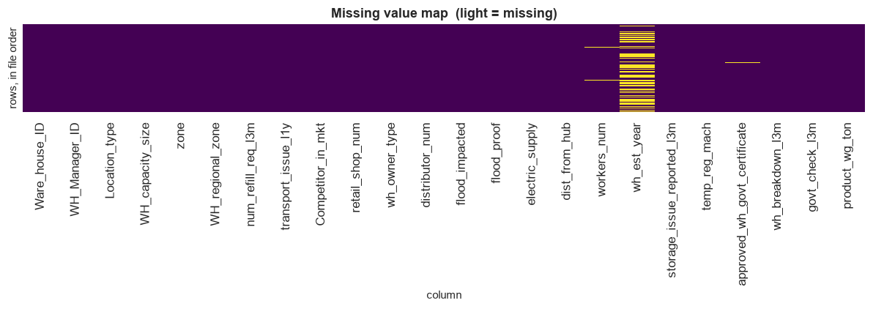
Figure 1: Missing value map
Reading the chart:
- Light bands mark missing cells, with rows shown in file order.
- Only three columns show any gaps at all.
- The establishment year band is striped evenly from top to bottom, which confirms the gaps are spread through the whole file rather than concentrated in one batch of records.
- Across ten consecutive blocks of 2,500 rows, the missing rate for establishment year stays within 45.48%–49.56%. No batch of records is responsible.
The certificate gaps are not blank cells.
- All 908 are cells where a person typed NA.
- Standard file reading converts that text to a null, which hides the distinction.
- A blank cell is an absent measurement. A typed NA is a recorded business state.
- Re-reading the file with automatic null conversion disabled separated the two.
The gaps are not random. Each gap was tested against every other column, not only against the two targets:
Table 8: Missingness tested against the targets only versus against all columns
Column with gaps | Tested against targets only | Tested against all columns
wh_est_year | Would look unrelated | Not random. Rows without a year request fewer than half as many refills (2.55 against 5.49, SMD −1.353). The year is missing for every warehouse with 0–2 refill requests
workers_num | Would look completely random | Not random. No difference on either target, but clear differences on flood-impacted (SMD +0.391), flood-proof (+0.368) and electric supply (+0.190)

This distinction matters. Testing only against the targets would have treated both gaps as random, and led to a simpler but wrong way of filling them.
Correlation across the network.
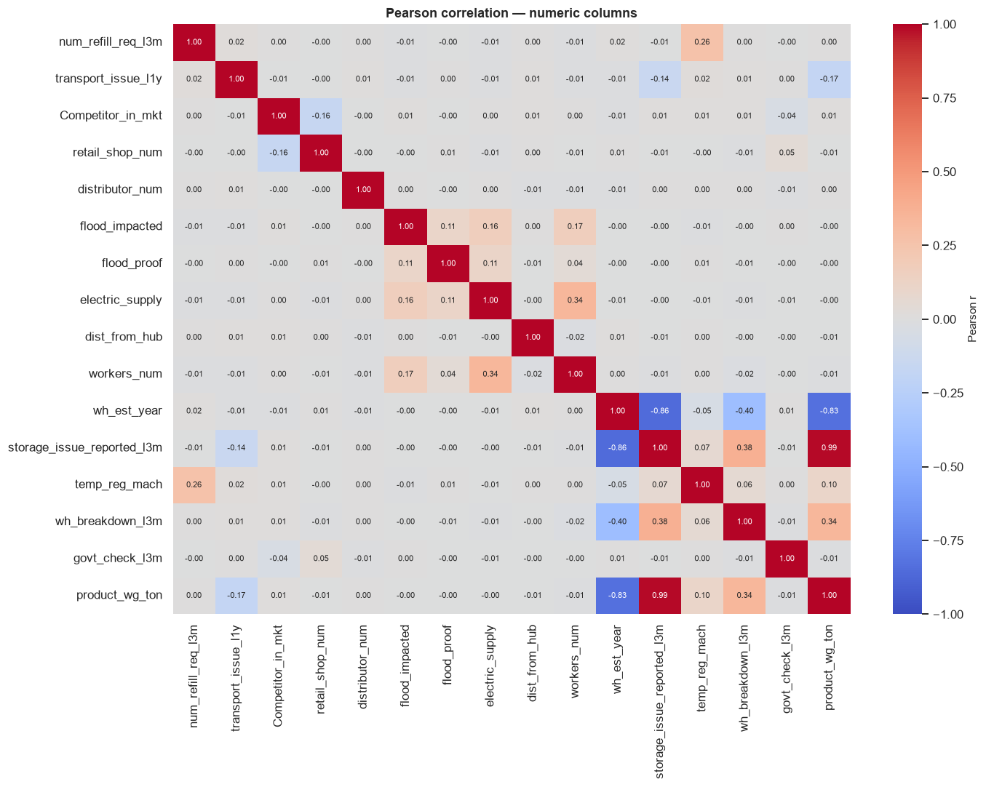
Figure 2: Pearson correlation heatmap
Reading the chart: one group of columns is closely related, and almost everything outside that group is close to zero.
Table 9: Strongest correlations across the network
Pair | Pearson r | Business meaning
Storage issues ↔ shipment weight | 0.99 | Warehouses that ship more report proportionally more storage issues
Establishment year ↔ storage issues | −0.86 | Older warehouses report more storage issues
Establishment year ↔ shipment weight | −0.83 | Older warehouses ship more
Establishment year ↔ breakdowns | −0.40 | Older warehouses break down somewhat more
Storage issues ↔ breakdowns | 0.38 | More storage issues, somewhat more breakdowns

- The strongest pair outside this group is electric supply ↔ worker count at 0.34.
- All remaining pairs sit below 0.18.
Does establishment year keep its strength after its gaps are filled? No — it loses about a quarter of its correlation:
Table 10: Establishment year correlation before and after filling its gaps
Measured on | Correlation with shipment weight
Recorded years only | −0.83
After the 47.52% gap is filled with 2009 | −0.61

This has a practical consequence. A meaningful part of the year's apparent strength came from which warehouses had a year recorded at all, not from the year value itself.
The 908-warehouse subgroup.
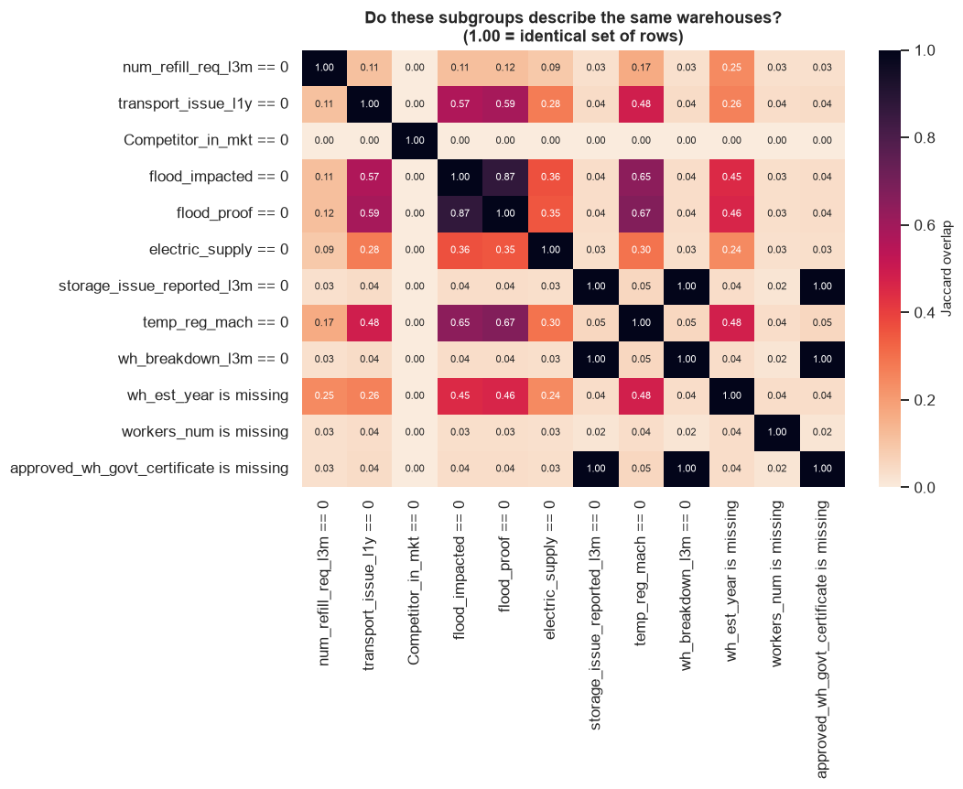
Figure 3: Subgroup overlap
Reading the chart:
- Each cell gives the overlap score between two conditions.
- A score of 1.00 means the two conditions select exactly the same warehouses.
- Three cells reach 1.00: a missing certificate, zero storage issues, and zero breakdowns all describe the same 908 warehouses.
Why this scan was run at all. A column that fixes a target to one constant value for a group of rows makes that target trivially predictable for those rows. That inflates model scores without the model having learned anything. The scan was designed to find such cases rather than to confirm an expectation.
One overlap that is not a problem. Flood-impacted and flood-proof overlap at 0.8708. This is not duplication — both are rarely positive, so their large zero-groups necessarily overlap.
Pre-processing decisions applied to all objectives.
Each treatment is paired with the measurement that justified it.
Table 11: Pre-processing decisions and the measurement justifying each
Decision | Justification
Drop both identifier columns | Each holds 25,000 distinct values, one per row, so neither describes how a warehouse operates
Keep the 908 unrated warehouses and add a flag column | They are part of the network the company plans for; removing them would narrow the project's stated scope
Fill establishment year and worker count before splitting | Each fill value was re-computed on 200 random 80% subsets and all 200 reproduced it exactly
Ordinal encoding for capacity size and certificate grade | Both have a natural order (Small < Mid < Large; C < B < B+ < A < A+) but arrive as unordered text
One-hot encoding for zone, regional zone, location type, ownership | No natural order exists
Scale features only for linear and SVM models | Tree-based models are unaffected by the scale of a feature
Keep all outliers | See the measurements below
Apply no resampling | Tested against alternatives and found to perform best

On outliers. An IQR rule flags 11.77% of transport issues and 9.82% of the flood-impacted indicator.
- Both result from applying a rule built for continuous measures to a count and to a yes/no indicator.
- When the median and the first quartile are both 0, the IQR fence has zero width, so every non-zero value is flagged.
- Removing these would delete genuine minority categories.
- Only retail shop count and worker count are genuine continuous candidates. For those, 81 and 5 rows sit below the lower fence, and 867 and 602 above the upper fence. No value at either end is impossible in practice.
- All rows were kept.
Preventing information from the test set reaching the model. This is known as leakage, and it inflates results.
- Scalers and encoders were fitted on the training split only, then applied to the test split.
- The two fills above are the single exception, and it is evidenced: each fill value was re-computed on 200 random 80% subsets, and all 200 produced the identical value. Filling before or after the split therefore yields identical data.
- The exception covers those two values and nothing else.
- Where a target is derived from a source column, the source column was removed immediately.

2.5.2 Objective 1 — preparing to segment the network
Before segmenting the network, the analysis needed to establish which conditions actually relate to performance.
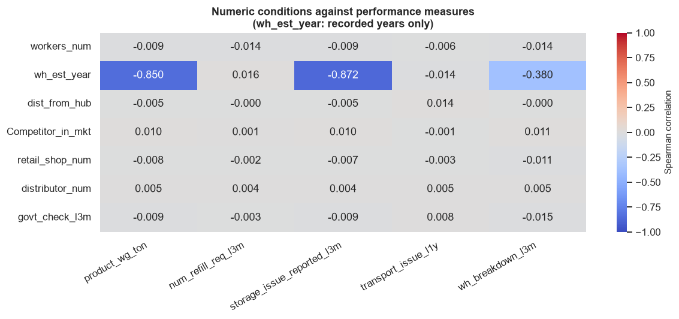
Figure 4: Numeric conditions against performance measures
Reading the chart: establishment year is the only numeric condition with any relationship to the performance measures.
Table 12: Numeric conditions against the performance measures
Condition | vs shipment weight | vs storage issues | vs breakdowns
Establishment year | −0.850 | −0.872 | −0.380
Worker count | −0.009 | −0.009 | −0.014
Distance from hub | −0.005 | −0.005 | 0.000
Competitors in market | 0.010 | 0.010 | 0.011
Retail shops | −0.008 | −0.007 | −0.011
Distributors | 0.005 | 0.004 | 0.005
Government checks | −0.009 | −0.009 | −0.015

Every condition other than establishment year sits between −0.015 and +0.014, which is no relationship.
What this means for the design. Segments are therefore defined by the performance measures themselves, with conditions used afterwards to profile and explain the resulting groups.

2.5.3 Objective 2 — defining breakdown risk
Objective 2 requires a class to predict. The obvious choice does not work.
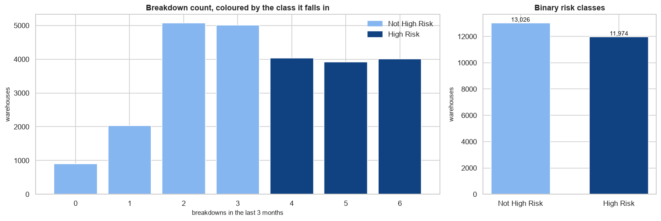
Figure 5: Breakdown counts and binary risk classes
Reading the chart: the left panel gives the number of warehouses at each breakdown count, coloured by the class assigned. The right panel gives the two resulting classes.
Table 13: Candidate framings for the breakdown risk target
Framing | Class balance | Decision
Any breakdown vs none | 96.37% / 3.63% | Rejected. Badly imbalanced, and reproducible from the single rule storage_issue == 0
Not High Risk (0–3) vs High Risk (4–6) | 52.10% / 47.90% | Adopted. Near balanced, ratio 1.09 : 1

How the 3 | 4 boundary was chosen. Every adjacent cut point in the 0–6 range was tested. The test measures η²: how far apart warehouses on either side of the cut are on shipment weight, storage issues and establishment year.
Table 14: Eta-squared at each adjacent cut point in the breakdown count
Cut point | Position in the banding | η² (shipment / storage / year)
0 vs 1 | Inside Not High Risk | 0.2051 / 0.5069 / 0.4027
1 vs 2 | Inside Not High Risk | 0.1597 / 0.1698 / 0.2176
2 vs 3 | Inside Not High Risk | 0.0003 / 0.0003 / 0.0002
3 vs 4 | The boundary | 0.0266 / 0.0282 / 0.0384
4 vs 5 | Inside High Risk | 0.0008 / 0.0008 / 0.0010
5 vs 6 | Inside High Risk | 0.0001 / 0.0001 / 0.0002

Two cut points score higher than 3 | 4, and both were rejected. The 0 | 1 and 1 | 2 cuts score highest for one specific reason. They separate the 908 warehouses that record zero storage issues and zero breakdowns from everyone else. Measured on rated warehouses only, a cut at 0 | 1 retains 0% of the signal:
Table 15: Comparison of the two binary framings on balance and signal retained
Framing | Classes | Smallest class | Imbalance ratio | Signal kept among rated warehouses
Not High Risk / High Risk | 2 | 47.90% | 1.09 : 1 | 48.5%
Any breakdown vs none | 2 | 3.63% | 26.53 : 1 | 0.0%

Business reading: a cut at 0 | 1 separates warehouses that have not started operating from those that have. That is a record of commissioning status, not a measure of breakdown risk. A model trained on it would reproduce the rule "this warehouse has logged no storage issues" and add nothing.
What can honestly be claimed is narrower. 3 | 4 is not the largest step overall. Among the cut points that separate warehouses that are actually operating, it is the strongest by a factor of roughly 33 to 38 (0.0266 / 0.0282 / 0.0384, against at most 0.0008 / 0.0008 / 0.0010).
How the features behave across the breakdown count.
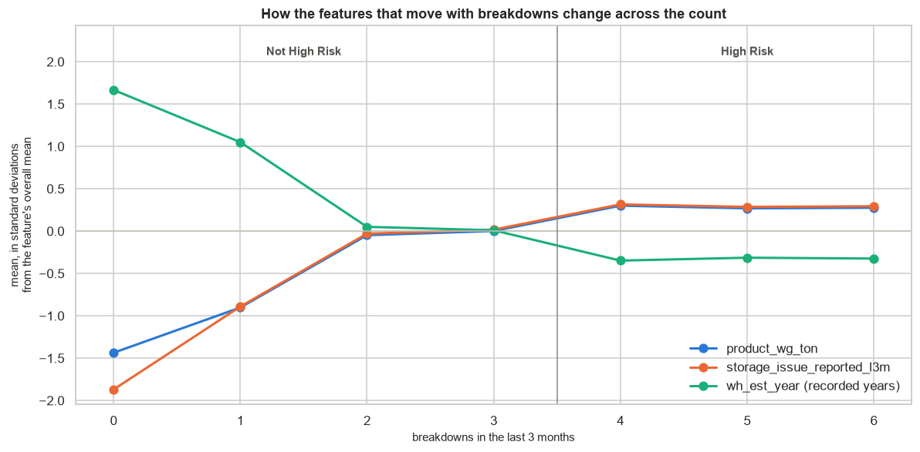
Figure 6: How the features that move with breakdowns change across the count
Reading the chart: each line is one feature, expressed in standard deviations from its own network mean, plotted against the breakdown count. The vertical line marks the 3 | 4 boundary.
- Shipment weight and storage issues rise together from 0 to 4 breakdowns, then flatten.
- Establishment year falls across the same range, so higher-risk warehouses are older.
- All three lines are almost flat from 4 to 6, which is why splitting anywhere inside the High Risk band would add nothing.
- The steep movement from 0 to 2 comes from the 908 warehouses with no recorded activity, not from a risk gradient.
Numeric features against the risk class.
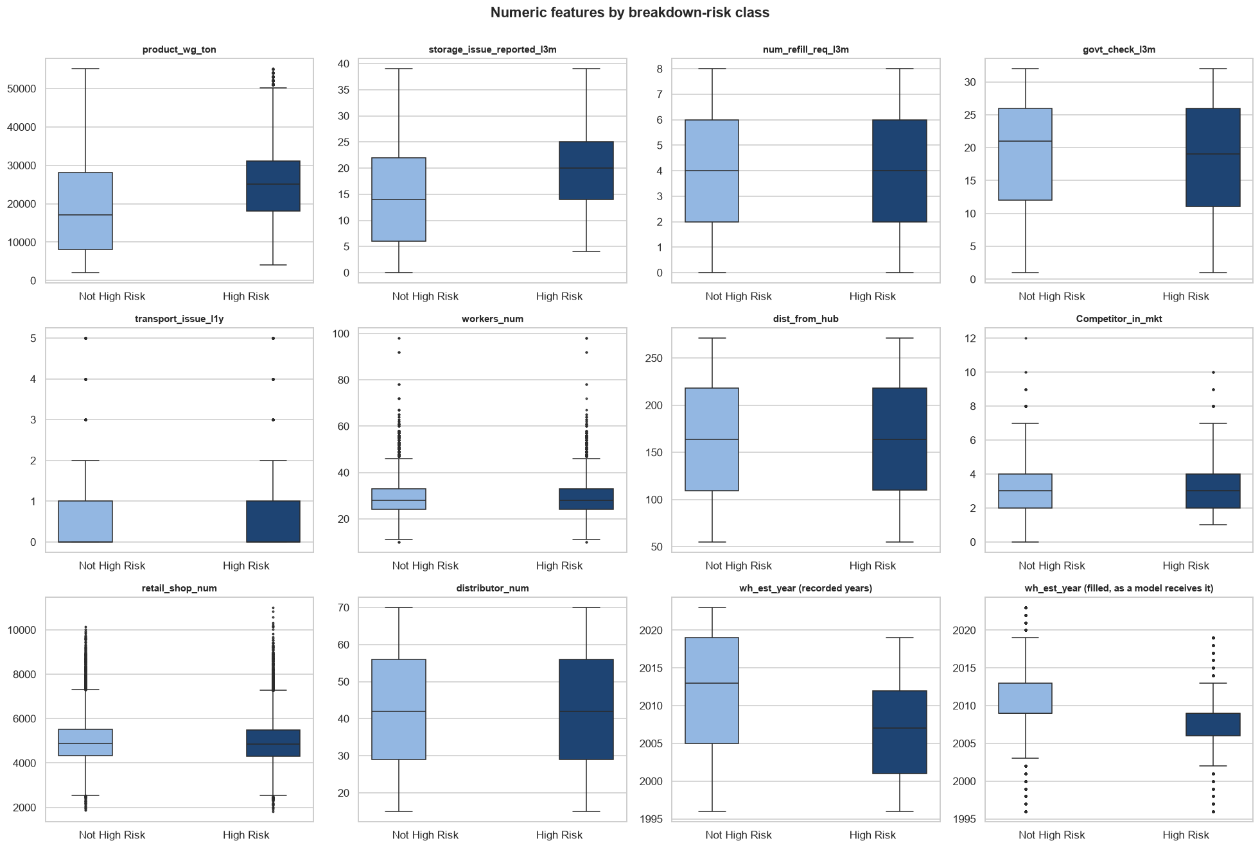
Figure 7: Numeric features by breakdown-risk class
Reading the chart: each panel compares the distribution of one feature between the two classes.
- Three features separate the classes. High Risk warehouses ship more (median 25,000 t against 17,000 t), report more storage issues (median 20 against 14), and are older (median recorded year 2007 against 2013).
- Nine features do not. Refill requests, government checks, transport issues, worker count, distance from hub, competitors, retail shops and distributor count have nearly identical boxes in both classes.
- This is the same conclusion the permutation importance later reaches on the fitted model, arrived at here before any model was built.
Categorical features against the risk class.
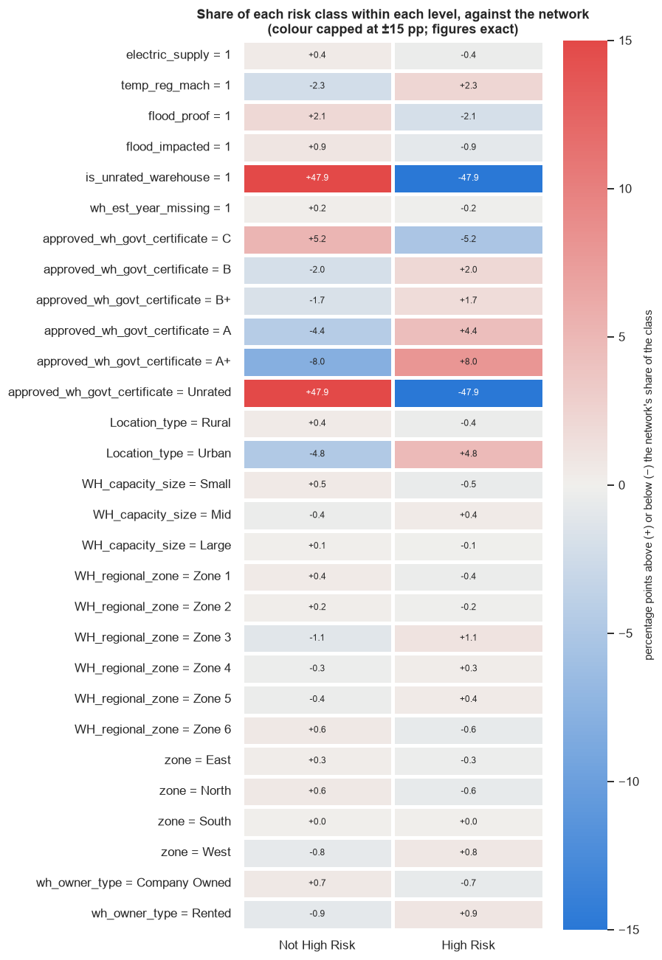
Figure 8: Share of each risk class within each category level
Reading the chart: each cell gives how far that level's share of a class sits above (red) or below (blue) the network's own share. A value near zero means the level carries no information about risk.
- The unrated flag is decisive but uninformative. Unrated warehouses sit +47.9 percentage points towards Not High Risk, simply because all 908 of them record zero breakdowns by definition.
- Certificate grade shows a consistent gradient. Grade C is +5.2 towards Not High Risk while grade A+ is −8.0, meaning better-certified warehouses are more likely to be High Risk. This follows from age: older warehouses have had longer to obtain a higher grade, and they also break down more.
- Urban sites lean High Risk by 4.8 percentage points.
- Zone, regional zone, capacity size, ownership and the flood indicators are all within ±1.1 points, which is no relationship.

2.5.4 Objective 3 — preparing to predict shipment weight
Regression needs a target whose shape is understood, and predictors that do not duplicate one another.
Shape of the shipment weight target.
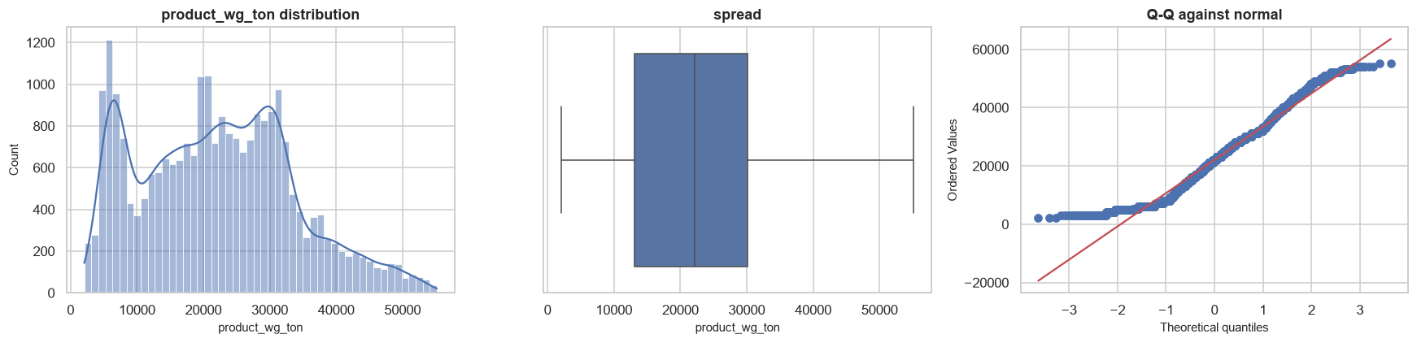
Figure 9: Shipment weight distribution
Summary statistics describe an even, symmetric column:
- Mean 22,103 t, median 22,101 t.
- Skew 0.332, kurtosis −0.502.
- Range 2,065 t to 55,151 t.
The charts show that reading is incomplete:
- The histogram has a sharp peak near 6,000 t.
- It dips around 10,000 t.
- It then has a broad body from about 12,000 to 32,000 t containing more than one peak.
- The Q-Q plot shows a flat step at the low end, and both tails shorter than a normal distribution.
Decision: no transformation was applied. The reasoning is specific:
- A log or square-root transform corrects right skew. Skew here is 0.332, which is mild.
- The actual departures are multiple peaks and short tails. Neither transform removes those.
- Linear regression requires well-behaved prediction errors, not a normally distributed target. Those errors were checked directly after the model was fitted.
Which conditions relate to shipment weight. Mean shipment weight by group:
Table 16: Mean shipment weight by grouping
Grouping | Lowest group | Highest group | Gap | Gap as % of network mean
Location type | Rural 21,844 t | Urban 25,004 t | 3,160 t | 14.3%
Regional zone | Zone 1 21,743 t | Zone 2 22,471 t | 728 t | 3.3%
Zone | South 21,933 t | East 22,721 t | 788 t | 3.6%
Capacity size | Small 21,900 t | Mid 22,202 t | 303 t | 1.4%

Location is the one category with a visible gap — urban warehouses ship about 14.5% more than rural ones. Two measurements keep that in proportion:
- Only 2,043 warehouses (8.17%) are urban, so the comparison rests on a small group.
- The gap is about 0.27 standard deviations, against a spread within each group of roughly 11,600 t.
Business reading: the urban–rural difference is real when averaged across the network, and too small to predict any individual warehouse. Capacity, zone and regional zone differ by under 4%, which is too small to justify treating those groups differently.
The single strongest predictor, seen directly.
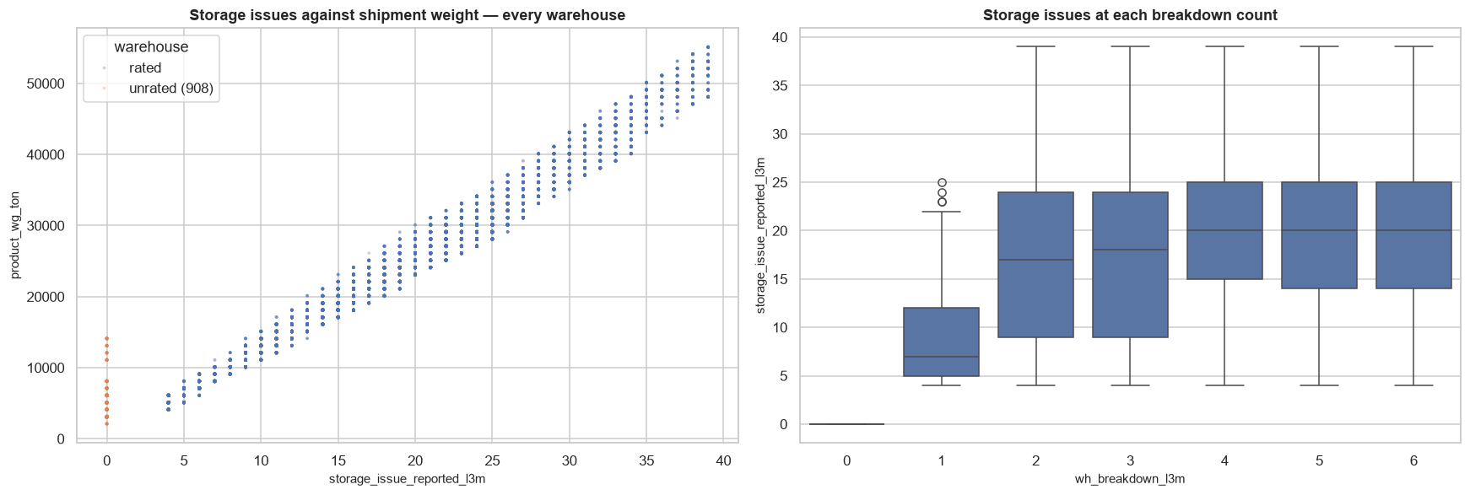
Figure 10: Storage issues against shipment weight
Reading the chart: the left panel plots every warehouse, with storage issues on the horizontal axis and shipment weight on the vertical. The right panel shows storage issues at each breakdown count.
- The left panel is almost a straight line. This is the 0.987 correlation in visual form, and it is the reason the regression model later reaches an R² of 0.9947.
- The 908 unrated warehouses sit apart, in orange, stacked at zero storage issues with shipment weights between roughly 2,000 t and 14,000 t. They are the only warehouses that break the line.
- The right panel shows the same gap from the other direction. Storage issues jump from 0 to a median of 7 at one breakdown, then rise gradually to a median of 20 at four or more.
- Read together, the panels show that one recorded quantity carries most of the information about shipment weight, and that the low end of the range belongs almost entirely to warehouses with no operating history.
Is the 0.99 correlation between storage issues and shipment weight a redundancy problem among predictors? No. Shipment weight is the Objective 3 target, not a competing predictor. VIF across the Objective 3 predictors tops out at 2.27 (capacity size) and 2.06 (storage issues), all well below the threshold of 5. No two predictors duplicate each other.

CHAPTER 3
DATA ANALYSIS AND INTERPRETATION

DATA ANALYSIS AND INTERPRETATION

3.1 Deciding Models and Model Building

3.1.1 Choosing algorithms
Table 17: Algorithms compared for each objective
Objective | Nature of the problem | Algorithms compared
1 | No target variable; groups must be discovered | K-Means, Ward hierarchical clustering
2 | Two-class prediction on a near-balanced target | Logistic regression (baseline), Naive Bayes, SVM, decision tree, random forest, XGBoost, AdaBoost, CatBoost
3 | Continuous prediction | Linear regression (baseline), ridge, lasso, SVR, decision tree, random forest, XGBoost, AdaBoost, CatBoost

Method applied to Objectives 2 and 3:
- Model families were screened with PyCaret on the training rows only, using 5-fold cross-validation.
- The top-ranked family was then tuned with Optuna.
- The test set was held back and used once, at the end.

3.1.2 Objective 1 — Warehouse performance segments
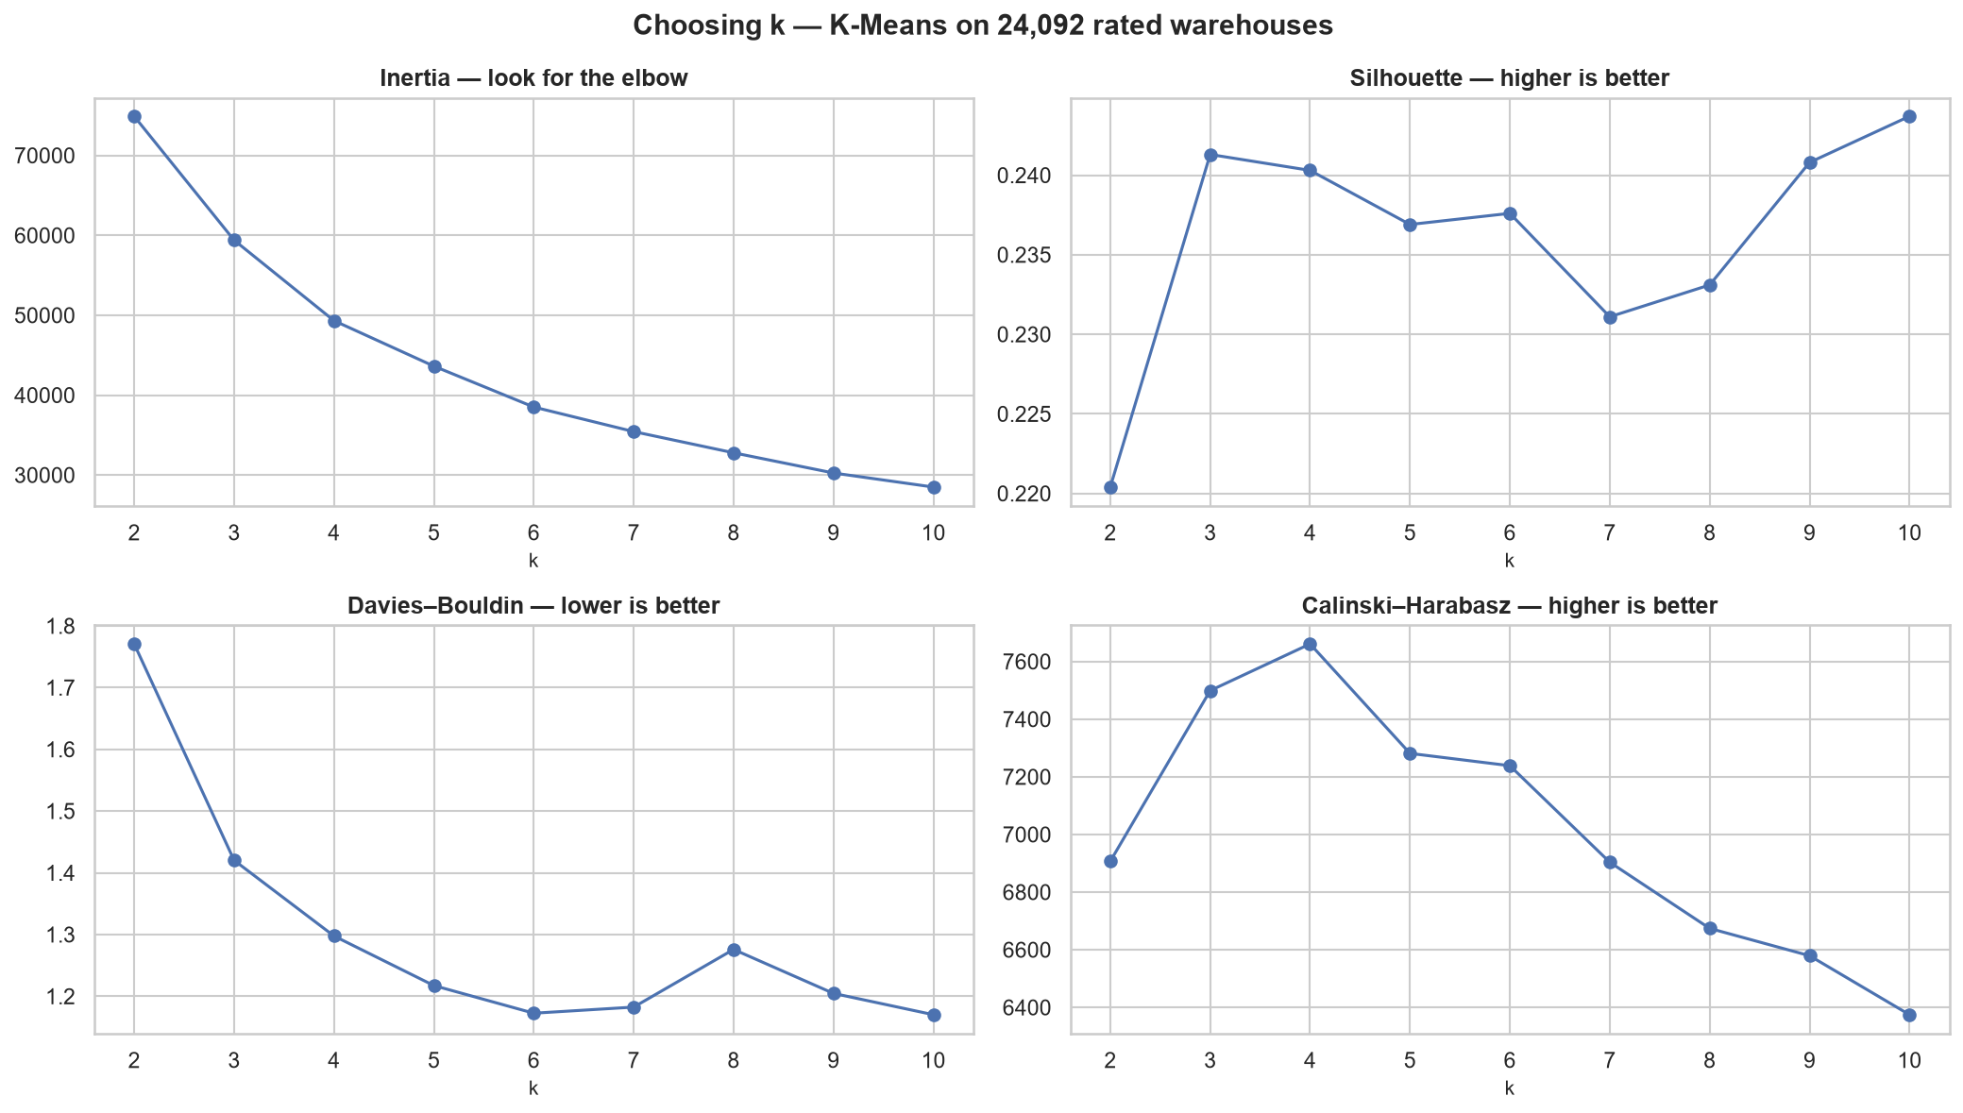
Figure 11: Choosing the number of segments
Reading the chart: the four panels do not agree on a single answer, so the choice was made by weighing them.
Table 18: Evidence for selecting four segments
Evidence | k = 4 | k = 6
Calinski–Harabasz | 7,661.0 — the maximum | 7,238.5
Stability across repeat runs | 0.9997 — the most stable | 0.9639
Inertia reduction from previous k | 16.96%, before reductions fall to 11.54% | 11.73%
Davies–Bouldin | 1.2976 | 1.1725
Silhouette | 0.2403 | 0.2376

- Calinski–Harabasz, stability and the inertia elbow all support k = 4.
- Silhouette is effectively flat across the whole tested range of k = 2 to 10.
- Only Davies–Bouldin supports k = 6.
- k = 4 was chosen for the 24,092 rated warehouses.
The 908 unrated warehouses were placed in their own segment by rule, not by K-Means, because they are defined by a data condition rather than discovered by distance. This gives five segments in total.
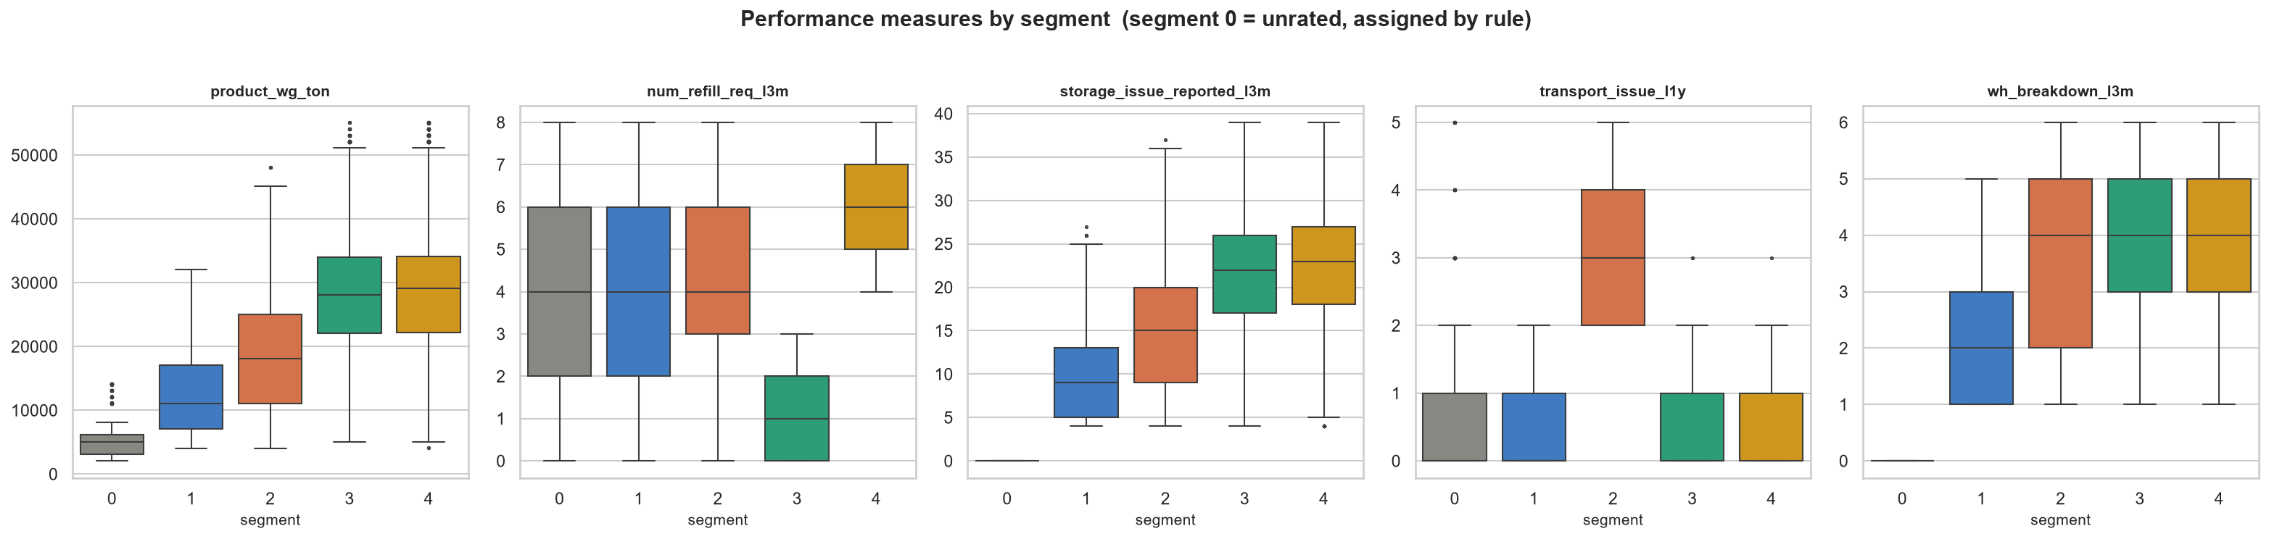
Figure 12: Performance by segment
Reading the chart: each panel gives one performance measure across the five segments.
- Segment 0 sits at zero on storage issues and breakdowns, by construction.
- Segment 2 is the only group with clearly higher transport issues (median 3, against 0 for every other segment).
- Segments 3 and 4 separate almost entirely on refill frequency, not on volume.
Table 19: Profile of the five warehouse segments
Segment | Warehouses | % | Description | Mean shipment | Mean refills | Mean transport issues | Mean breakdowns
0 | 908 | 3.63 | Newly commissioned, not yet rated | 5,430 t | 3.98 | 0.62 | 0.00
1 | 6,249 | 25.00 | Low volume, few breakdowns | 12,648 t | 4.15 | 0.36 | 2.07
2 | 4,018 | 16.07 | Transport problems | 18,093 t | 4.34 | 3.07 | 3.67
3 | 6,172 | 24.69 | High volume, rarely refilled | 28,354 t | 1.34 | 0.33 | 4.25
4 | 7,653 | 30.61 | High volume, frequently refilled | 28,864 t | 6.14 | 0.28 | 4.33

Segment quality, measured against randomised data. Cluster metrics cannot on their own confirm that structure is real, so each was re-computed on five randomised copies of the data:
Table 20: Segment quality measured against randomised data
Metric | Final segments | Randomised baseline | Reading
Silhouette | 0.2405 | 0.2194 | Marginally better
Calinski–Harabasz | 7,661.0 | 6,507.9 | Clearly better
Davies–Bouldin (lower is better) | 1.2976 | 1.3308 | Marginally better
Dunn index | 0.00043 | 0.0518 | Worse than randomised data

What the numbers say:
- Three of the four metrics beat the randomised baseline, but only Calinski–Harabasz beats it clearly.
- The Dunn index measures the gap between the two closest segments. At 0.00043 against 0.0518, the segments are adjacent rather than separated.
- The Hopkins statistic, which tests whether a dataset has any clustering tendency at all, exceeds its randomised baseline by only 0.040 when computed across all columns.
The two separation measures, side by side. The remaining discussion uses silhouette and the Dunn index, because between them they answer the two questions that matter: does each warehouse sit closer to its own segment than to the next, and is there a gap between the segments at all?
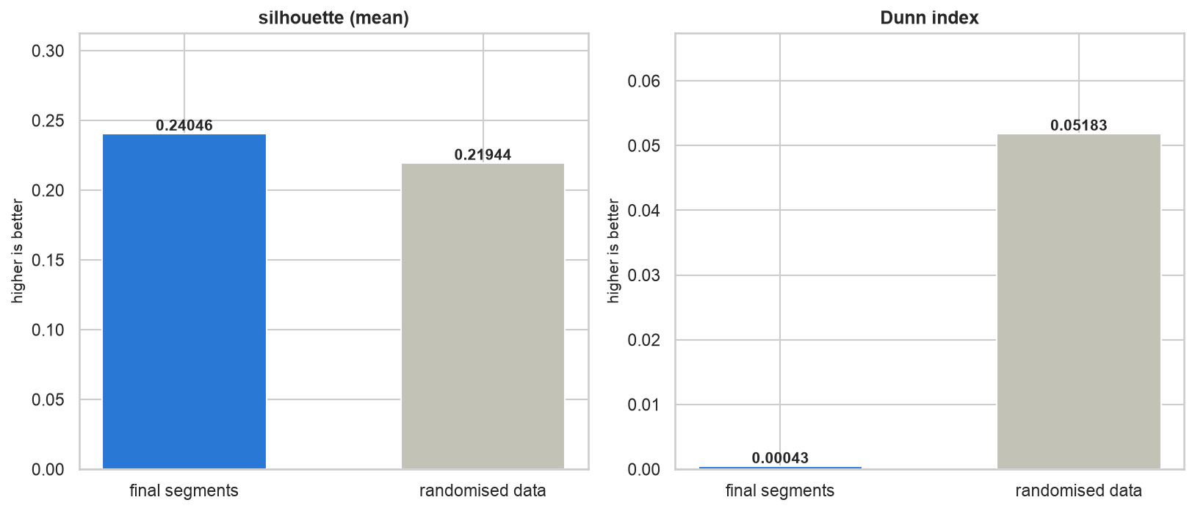
Figure 13: Silhouette and Dunn index against randomised data
Reading the chart: each panel compares the final segments against the same measure computed on randomised copies of the data.
- Silhouette is marginally ahead: 0.24046 against 0.21944, a gain of about 0.021. Randomising the data removes any real structure, so a genuine grouping should beat that baseline comfortably. This one does not.
- The Dunn index is far behind: 0.00043 against 0.05183. The final segments score roughly 120 times worse than randomly grouped data on the gap between the two closest segments.
- The two measures do not contradict each other. Silhouette asks whether each warehouse sits nearer its own centre than the next, which is what K-Means optimises directly. Dunn asks whether any empty space separates the groups, and there is none.
Silhouette of every individual warehouse.
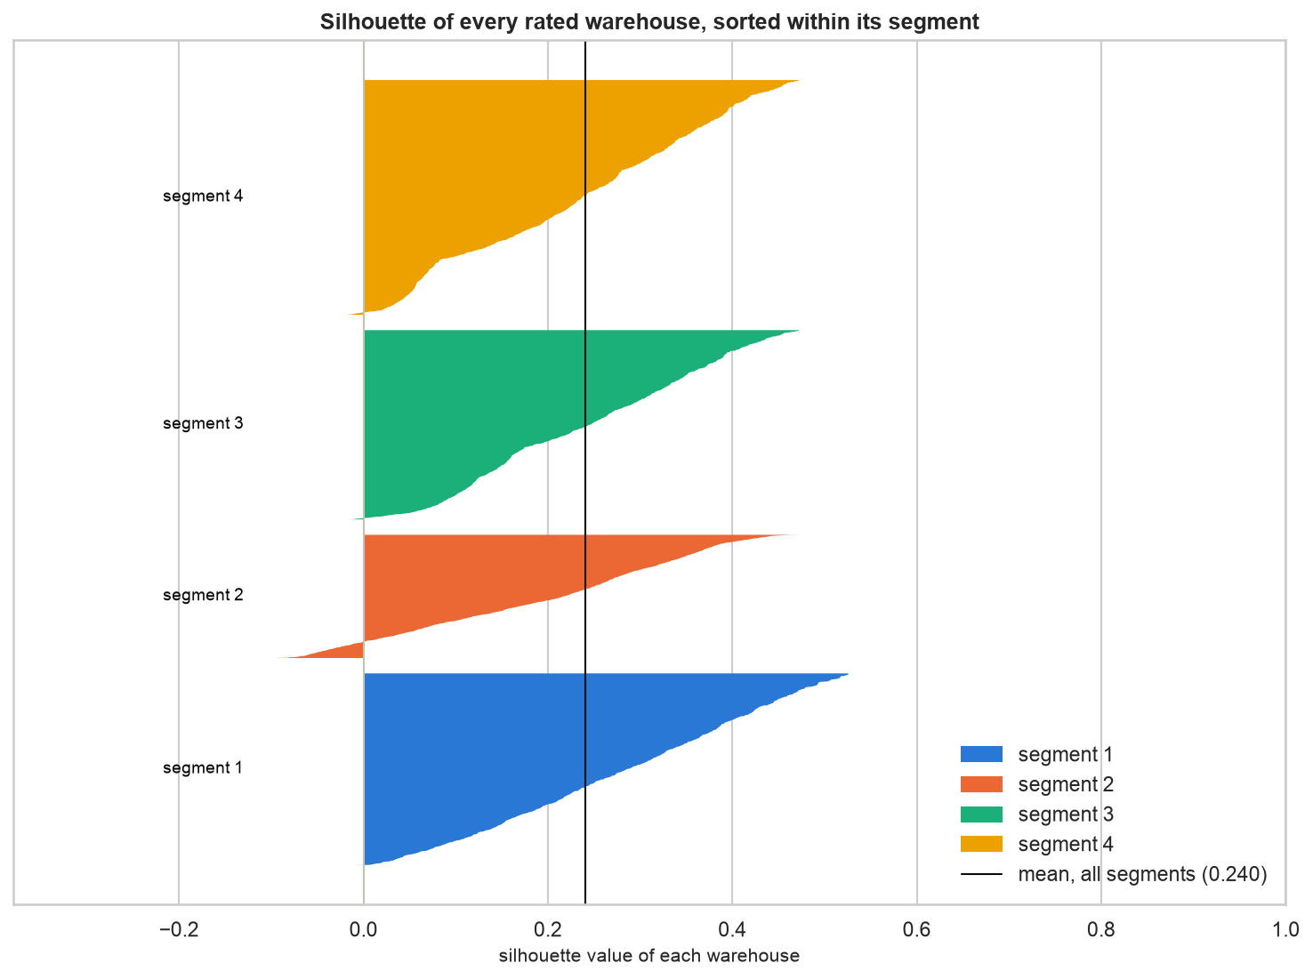
Figure 14: Silhouette of every rated warehouse, sorted within its segment
Reading the chart: each warehouse is one horizontal bar, sorted within its segment. The vertical line is the overall mean of 0.240.
- No segment reaches a mean above roughly 0.28, and the highest individual value in the network is about 0.53. A well-separated grouping would show most warehouses above 0.5.
- Segment 2 is the weakest. It has a visible negative tail, meaning 13.2% of its warehouses sit closer to a different segment than to their own.
- Segments 1 and 3 have almost no negative values, so their members are at least consistently assigned even though the segments are not far apart.
The segments seen in two dimensions.
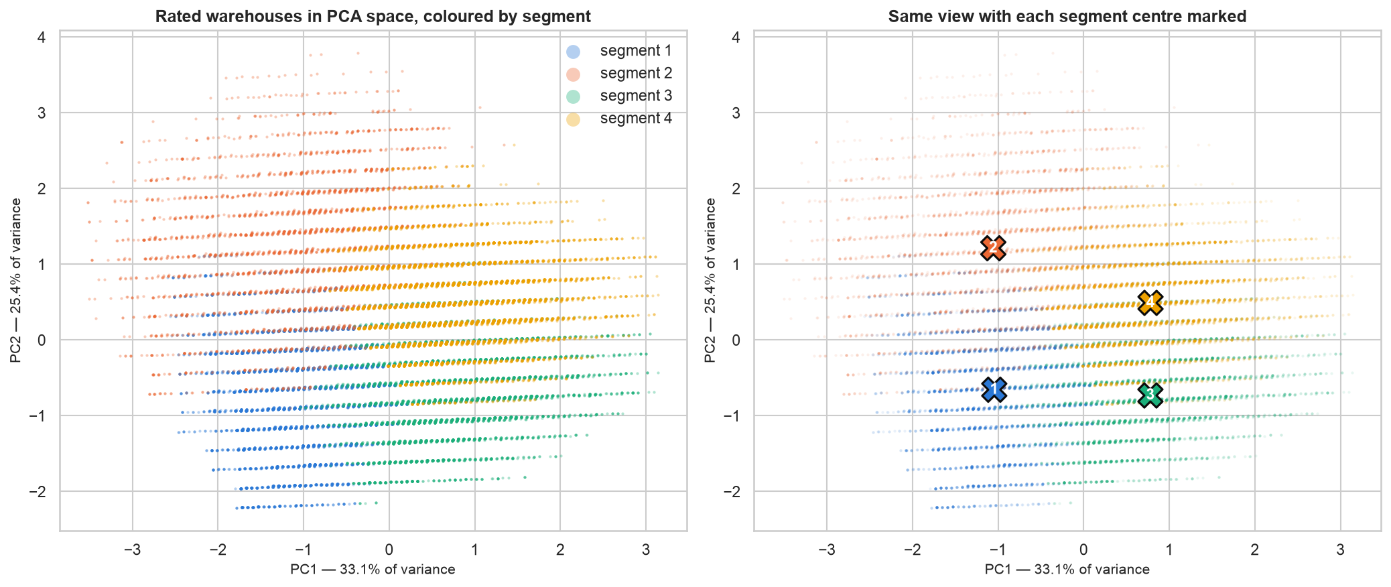
Figure 15: Rated warehouses in PCA space, coloured by segment
Reading the chart: the four scaled performance measures are projected onto their first two principal components, which together carry 58.5% of the variation. The left panel colours each warehouse by segment; the right marks each segment centre.
- The warehouses form one continuous cloud. There is no empty space anywhere between the coloured regions.
- The boundaries between colours are straight lines. That is what a partition drawn through a continuous spread looks like, rather than groups that were already separate before clustering began. It is the same finding the Dunn index reports numerically.
- The diagonal banding within the cloud comes from the underlying measures being whole-number counts.
- The four centres are genuinely distinct and sit well apart, which is why the segments remain useful for describing warehouses even though they are not naturally separated.
Conclusion for the business: these five segments are usable descriptive tiers for reporting and planning. They are not naturally separated categories, and should not be presented as though the network divides into five distinct kinds of warehouse.
Which conditions differ across segments. Of 17 conditions tested:
Table 21: Conditions tested for difference across segments
Condition | Test | Effect size | Verdict
Establishment year | ANOVA | η² 0.366 | Large
Temperature regulation | Chi-square | V 0.200 | Small
Certificate grade | Chi-square | V 0.082 | Negligible
Location type | Chi-square | V 0.051 | Negligible
Ownership type | Chi-square | V 0.016 (p = 0.122) | Negligible
Zone | Chi-square | V 0.011 (p = 0.396) | Negligible
Capacity size | Chi-square | V 0.010 (p = 0.539) | Negligible
Remaining 10 conditions | — | All negligible | Negligible

Only establishment year separates the segments to any meaningful degree.

3.1.3 Objective 2 — Breakdown risk classification
Model screening. All eight families were compared on the training rows using 5-fold cross-validation, ranked by macro-F1.
Table 22: Model screening results for breakdown risk classification
Model | Accuracy | ROC-AUC | Macro F1
AdaBoost | 0.6261 | 0.6582 | 0.6137
CatBoost | 0.6166 | 0.6639 | 0.6117
Random forest | 0.6147 | 0.6594 | 0.6103
Logistic regression | 0.6093 | 0.6656 | 0.6086
SVM, linear kernel | 0.6051 | — | 0.6043
XGBoost | 0.5979 | 0.6489 | 0.5975
Decision tree | 0.5751 | 0.5741 | 0.5741
Naive Bayes | 0.5145 | 0.6580 | 0.3957

Two observations from the leaderboard:
- The top four families sit within 0.005 macro-F1 of one another. No family is clearly best. This suggests the limit comes from the data itself, not from the algorithm chosen.
- Naive Bayes fails at 0.3957. Its recall is 0.068 against precision of 1.000, meaning it classifies almost every warehouse as Not High Risk, and is correct whenever it does predict High Risk. Its assumption that features are independent does not hold against this correlated feature set.
Tuning. AdaBoost was selected and tuned with Optuna over 40 trials, producing n_estimators = 298 and learning_rate = 1.935. Best cross-validated macro-F1: 0.6197.
Test results on the 5,000 held-back warehouses:
Table 23: Classification test results, all features versus characteristics only
Metric | All features | Characteristics only | Difference
Accuracy | 0.6122 | 0.5810 | +0.0312
Macro F1 | 0.6063 | 0.5807 | +0.0256
ROC-AUC | 0.6547 | 0.6349 | +0.0198
PR-AUC (High Risk) | 0.5769 | 0.5799 | −0.0030

The characteristics-only model uses warehouse attributes but no same-period operating measures.
- It scores lower on accuracy, macro-F1 and ROC-AUC. Current operating measures therefore add information beyond fixed warehouse attributes.
- On PR-AUC for the High Risk class the two are level (0.577 against 0.580). The operating measures improve overall ranking without improving precision on the class that matters most.
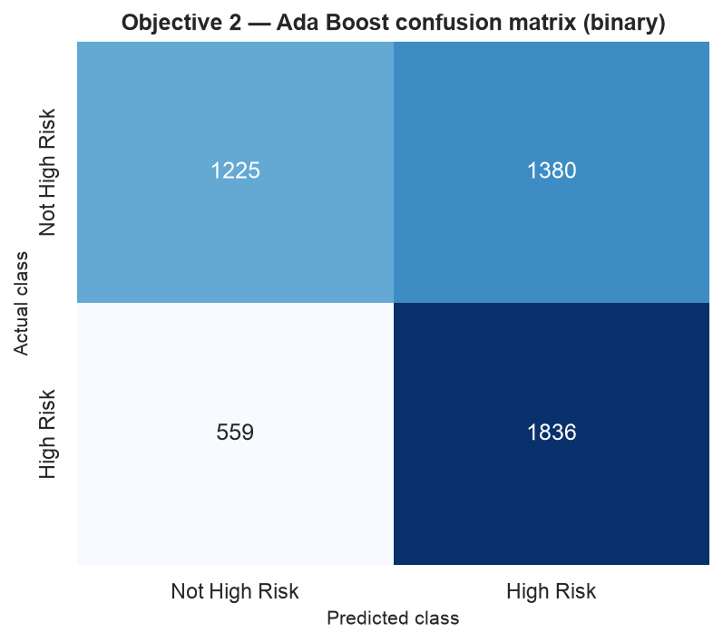
Figure 16: Confusion matrix
Per-class results:
Table 24: Per-class classification results on the held-back test set
Class | Precision | Recall | F1 | Warehouses
High Risk | 0.571 | 0.767 | 0.654 | 2,395
Not High Risk | 0.687 | 0.470 | 0.558 | 2,605

Translated into operational terms:
- Of 2,395 warehouses that genuinely are high risk, 1,836 were correctly flagged — just over three in four.
- This comes at the cost of 1,380 false alarms among 2,605 low-risk warehouses.
- A warehouse the model flags has a 57% chance of genuinely being high risk.
Business assessment: for maintenance planning this trade-off is reasonable, because missing a warehouse that then breaks down costs more than inspecting one that did not need it. The output should be used as a ranked worklist for prioritising inspections, not as an automatic yes/no decision.
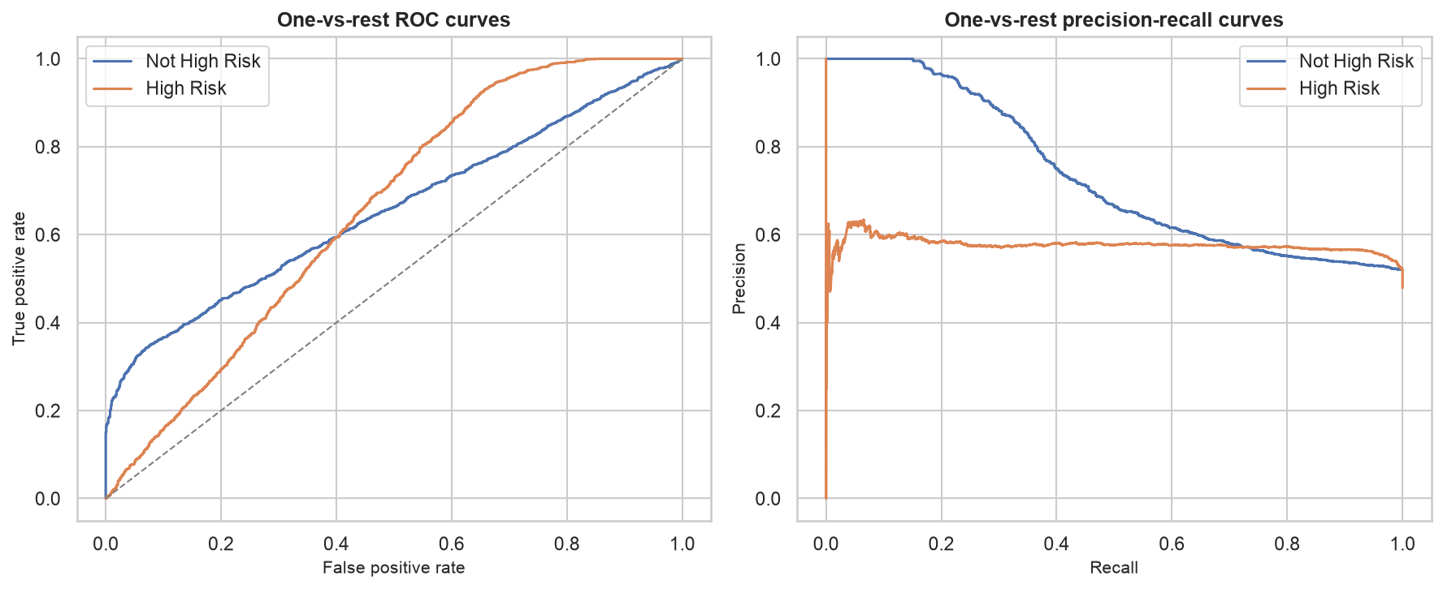
Figure 17: ROC and precision-recall curves
Reading the chart: a perfect model would reach the top-left corner of the ROC chart; a model with no skill would follow the diagonal line. Both curves sit above the diagonal but well short of the corner. A ROC-AUC of 0.655 means that given one high-risk and one low-risk warehouse chosen at random, the model ranks them in the correct order about 65% of the time.

3.1.4 Objective 3 — Shipment weight regression
Model screening, ranked by R²:
Table 25: Model screening results for shipment weight regression
Model | MAE | RMSE | R² | MAPE
CatBoost | 643.9 | 872.5 | 0.9943 | 4.07%
XGBoost | 668.8 | 912.1 | 0.9938 | 4.29%
Random forest | 680.2 | 925.1 | 0.9936 | 4.22%
Decision tree | 829.9 | 1,255.7 | 0.9883 | 5.11%
Linear regression | 1,113.2 | 1,446.9 | 0.9845 | 6.80%
Ridge | 1,113.1 | 1,446.9 | 0.9845 | 6.80%
Lasso | 1,112.7 | 1,446.6 | 0.9845 | 6.79%
AdaBoost | 1,419.0 | 1,769.8 | 0.9767 | 10.73%
Support vector regression | 9,442.4 | 11,437.8 | 0.0289 | 78.74%

CatBoost was selected and tuned with Optuna, producing 400 iterations, depth 6 and learning rate 0.041.
Test results:
Table 26: Regression test results on the held-back test set
Metric | Value | Business reading
R² | 0.9947 | The model explains 99.5% of the variation in shipment weight
Adjusted R² | 0.9947 | Unchanged after accounting for the number of predictors
MAE | 634 t | Typical error of 634 tons
RMSE | 842 t | Larger errors are not much larger than typical ones
MAPE | 4.00% | Typical error is 4% of the actual shipment weight

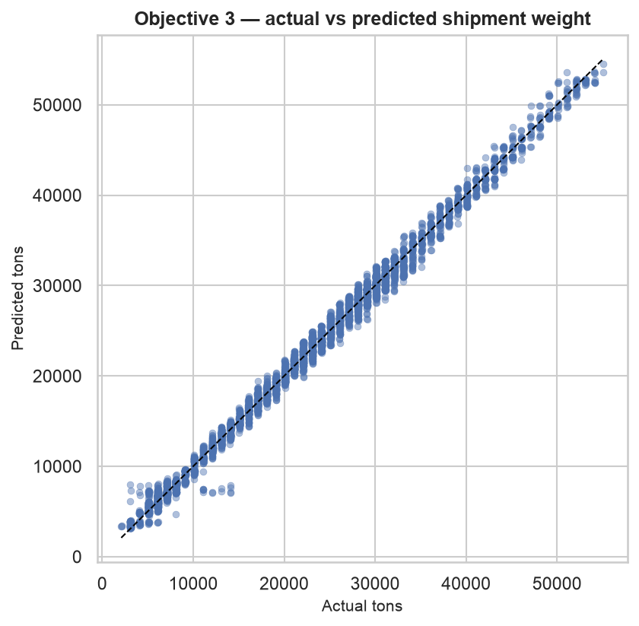
Figure 18: Actual against predicted
Reading the chart:
- Predictions track the diagonal closely across the whole range.
- One group departs from it: a band of warehouses with actual weights near 10,000–14,000 t is predicted at roughly 7,500 t.
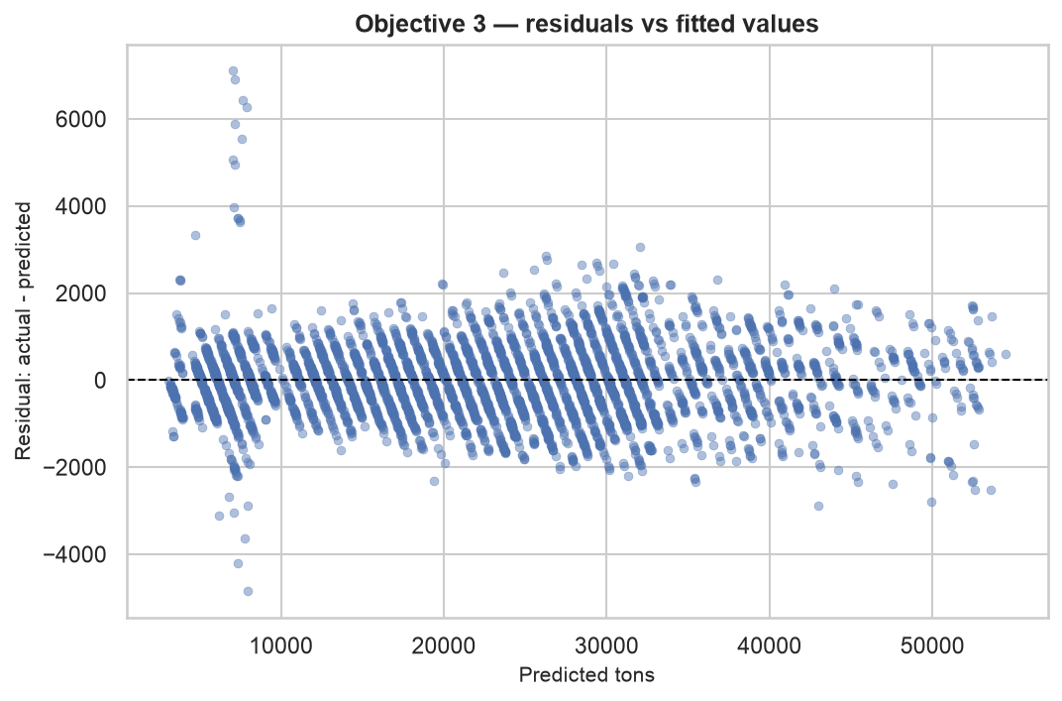
Figure 19: Prediction errors against predicted values
Reading the chart:
- Errors are centred on zero and mostly within ±2,000 t across the whole range, and do not widen as predicted values increase. The constant-variance assumption holds.
- The errors form vertical bands. This occurs because predictions cluster onto a small number of values, which is what happens when a model is driven by a whole-number count column.
- The largest errors, from −5,000 t to +7,000 t, all occur near a predicted value of about 7,500 t. These are the 908 low-volume warehouses that ship about a quarter of the typical volume.
Zone comparison, as Objective 3 requires:
Table 27: Recorded and recommended shipment weight by zone
Zone | Warehouses | Recorded mean | Recommended mean | Difference from network mean
East | 429 | 22,721 t | 22,689 t | +587 t
North | 10,278 | 22,199 t | 22,202 t | +100 t
West | 7,931 | 22,079 t | 22,072 t | −30 t
South | 6,362 | 21,933 t | 21,939 t | −163 t

- All four zones fall within about 790 t of one another, against a network mean of 22,103 t — a spread of under 4%.
- Recommended volumes track recorded volumes closely in every zone.
- Zone is not a usable basis for differentiating shipment volume.
Assessment of this result.
An R² of 0.9947 is unusually high, so it was examined closely before being accepted.
The evidence shows the model is largely repeating one relationship that was already present in the data:
Table 28: Evidence on the source of the regression accuracy
Evidence | Measurement | What it means
Correlation between storage issues and shipment weight | r = 0.987 | The two columns already move together almost exactly
Permutation importance, storage issues | 1.98 | Shuffling this one column removes almost all of the model's accuracy
Permutation importance, next-best feature | 0.016 | About 125 times smaller
VIF across all predictors | Maximum 2.27 | No two predictors duplicate each other
Prediction error pattern | Vertical bands | Predictions are driven by a whole-number count

Interpretation:
- The high R² is not caused by two predictors duplicating each other. None of them do.
- The strong relationship runs from a single predictor to the target.
- The model is accurate, but it is not combining many weak signals into a strong prediction. It is reproducing a near-fixed relationship between two recorded columns.
Business reading: the company can predict shipment weight accurately, and that result is usable. The claim is narrower than the R² alone suggests, and should be reported as such. The model's value is in confirming and applying an existing relationship rather than in discovering a new one.

3.2 Improving Model Performance
The three objectives require different kinds of improvement. For two of them, the improvement is not a higher score.

3.2.1 Objective 1 — improvements
Objective 1's improvement is not a higher score. It is establishing whether the segments are real groupings at all.
The Dunn index of 0.00043 against a randomised baseline of 0.0518 indicates the segments are adjacent rather than separated. Before accepting them as groupings, two options are worth testing:
- Clustering on a reduced feature set.
- A density-based method such as DBSCAN, which does not assume round clusters and can leave warehouses unassigned.

3.2.2 Objective 2 — improvements
Objective 2 has the most room to improve of the three, and also the clearest limit. The changes below are ordered by what the measurements support.
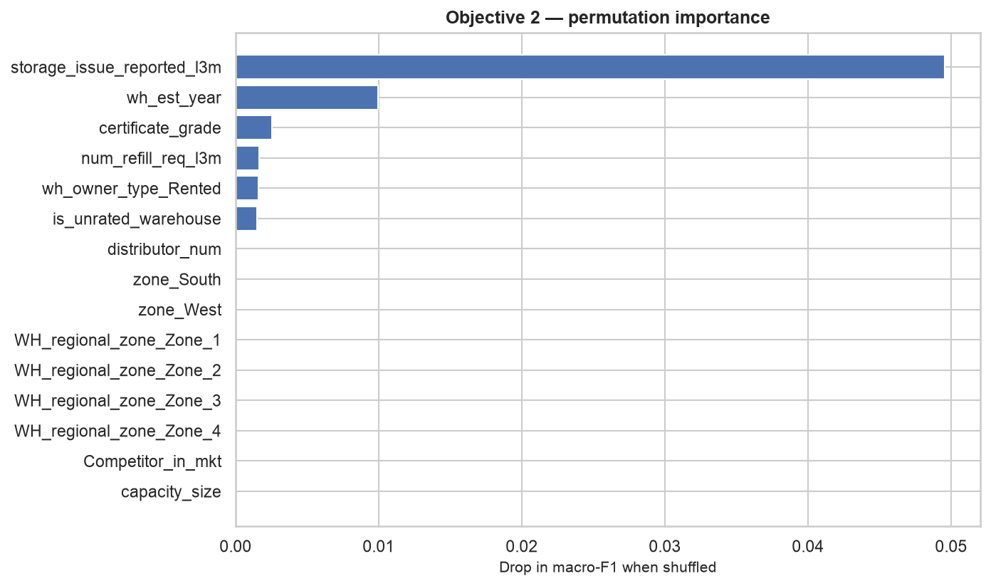
Figure 20: Objective 2 permutation importance
Reading the chart: one feature dominates and most contribute nothing measurable. Storage issues score 0.0496 and establishment year 0.0100; 21 of the 28 features score zero or below. A negative score means that shuffling the column slightly improved the model, which is the expected behaviour of a column carrying no information.
The obvious response is to remove the features scoring zero. This was tested, and it does not work:
Table 29: Feature removal tests for the classification model
Change tested | Logistic regression | Random forest
Remove shipment weight | No meaningful change | No meaningful change
Remove storage issues | No meaningful change | No meaningful change
Remove the 18 low-information features | No meaningful change | Worse — 0 of 20 folds improved
Shuffle the 18 low-information features | No meaningful change | No meaningful change

Two results here matter:
- Removing either storage issues or shipment weight on its own changes nothing. At a correlation of 0.987 they carry the same information, so whichever remains does the same work. The choice between them is a modelling convenience, not a substantive decision.
- Removing the 18 weak features together made random forest worse. Individually they appear useless. Collectively they still contribute. Permutation importance measures each column while the others are present, so it understates columns that are individually weak but complementary.
Derived features were tested and mostly rejected. Each candidate was added to the model and the change measured against a threshold agreed before the run:
Table 30: Derived features tested for the classification model
Candidate added | Result
Storage issues per 1,000 t | No meaningful change
Shops per distributor | No meaningful change
Flood-unprotected indicator | No meaningful change

Some derived features score well in isolation — warehouse age at 7.18% and tons per worker at 8.48% mutual information — but each is built from columns already present in the model, so they add no new information.
Resampling was tested and rejected. With the two classes at 52% and 48%, there is little imbalance to correct, and the measurements confirm that correcting it reduces performance:
Table 31: Resampling treatments tested for the classification model
Treatment | Macro F1
No resampling | 0.6127
Random oversampling | 0.6013
Random undersampling | 0.6013

Class balance is instead handled through stratified splitting, macro-F1 as the selection metric, and per-class reporting.
Remaining improvements, in order of expected value:
Table 32: Remaining improvements for Objective 2 in order of expected value
Priority | Change | Reasoning | Expected effect
1 | Tune the decision threshold | The model currently flags a warehouse when predicted probability passes 0.5. Nothing establishes 0.5 as the correct operating point. For maintenance planning, recall on High Risk matters more than balanced accuracy | Lets the company choose its own trade-off between missed warehouses and false alarms. Cheapest change available and the clearest in business terms
2 | Tune CatBoost or random forest properly | Both finished within 0.005 macro-F1 of AdaBoost in screening, and both have far larger tuning spaces — depth, subsampling, column sampling and regularisation, against AdaBoost's two parameters | Could overtake the current model
3 | Raise the Optuna trial count | 40 trials over two parameters locates the right region but not the best point within it | 80 to 100 trials would tighten the search

The realistic limit.
Objective 2 is unlikely to improve substantially. The reasons are worth stating, rather than continuing to tune the model without benefit:
- Seven of the eight model families landed within 0.04 macro-F1 of one another, and the top four within 0.005. These span linear, kernel, tree and boosted approaches. Naive Bayes is the only exception, and it fails because its core assumption does not hold here. When very different algorithms agree this closely, the constraint is the information available, not the method.
- Breakdowns are partly random events. A warehouse's recorded conditions constrain the risk but cannot determine it.
- There is no breakdown history to learn from. The file records each warehouse once, so the model cannot see whether a warehouse has broken down repeatedly in the past, which is normally the strongest predictor of future failure.
The realistic improvement for Objective 2 is better use of the model rather than a higher score:
- Set the threshold to match the company's tolerance for false alarms.
- Present the output as a ranked inspection worklist rather than a yes/no verdict.
- Report recall on High Risk as the headline measure, since that is what maintenance planning acts on.

3.2.3 Objective 3 — improvements
Objective 3's accuracy requires no improvement. What it requires is evidence about how much the model contributes beyond a relationship that already existed in the data.
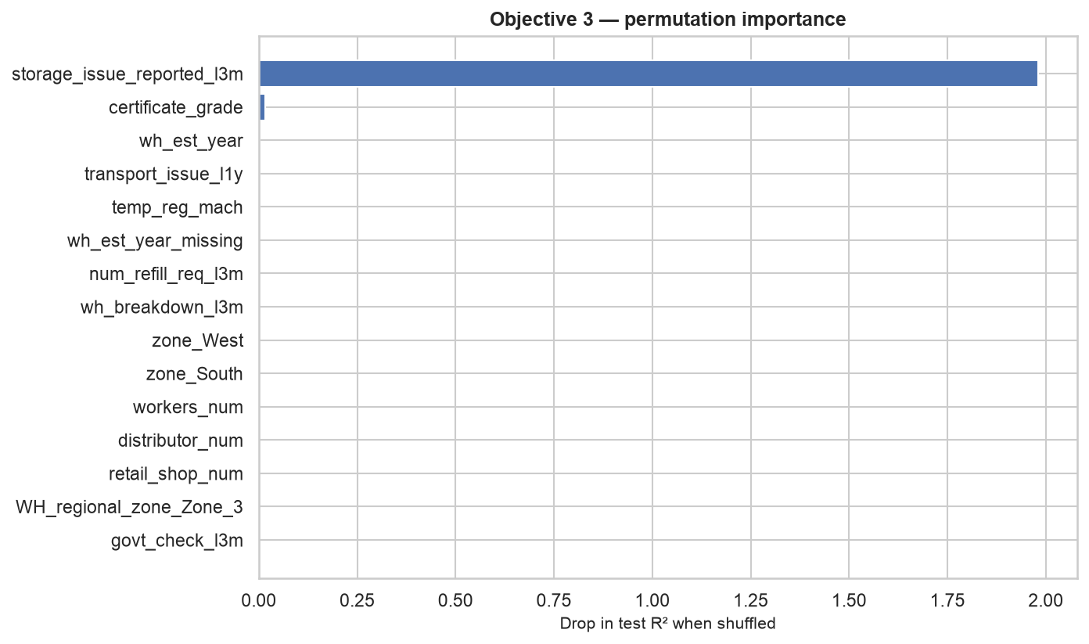
Figure 21: Objective 3 permutation importance
Reading the chart: storage issues score 1.98 against 0.016 for the next feature — about 125 times smaller. The model rests almost entirely on one column.
The most informative remaining experiment. Build a variant of the model without storage issues and measure how far R² falls. That single number would quantify how much the model contributes beyond the 0.987 relationship it currently reproduces.
A targeted fix for the largest errors. The 908 low-volume warehouses carry the largest regression errors, ranging from −5,000 t to +7,000 t. Fitting a separate model for that group, or adding an explicit indicator for it, addresses a specific identified weakness rather than applying a general-purpose change.

3.2.4 The constraint shared by all three objectives
- The dataset is a single snapshot. There is no maintenance history, no sensor reading and no repeated observation of the same warehouse. Those are the inputs that make breakdown prediction effective in other settings.
- No model here should be used as an automatic decision rule without validation against outcomes recorded over a period of time.
- Every result shows association, not cause.

3.3 Findings and Interpretation

3.3.1 Results by objective
Objective 1 — warehouse performance segments.
The network was segmented into performance tiers using clustering.
- Five segments were produced: four discovered by K-Means across the 24,092 rated warehouses, plus one assigned by rule for the 908 unrated warehouses.
- The segments separate on volume and refill frequency, not on location, ownership or capacity.
- They are reporting tiers rather than natural groups. Three of four quality measures beat a randomised baseline, but only one beats it clearly, and the Dunn index falls below the baseline (0.00043 against 0.0518). The warehouses form one continuous spread rather than distinct clusters.
- Business use: a reasonable way to organise the network for reporting and planning. Not evidence that the network divides into five distinct kinds of warehouse.
Objective 2 — breakdown risk.
Breakdown risk was framed as a two-class problem: Not High Risk (0–3 breakdowns) against High Risk (4–6).
- AdaBoost was selected from eight model families and tuned with Optuna.
- It flags 76.7% of genuinely high-risk warehouses — 1,836 of 2,395 in the held-back test set.
- A flag is 57% reliable, producing 1,380 false alarms among 2,605 low-risk warehouses.
- The top four model families finished within 0.005 macro-F1 of one another, which suggests the limit comes from the data itself, not from the algorithm chosen.
- Business use: a ranked worklist for prioritising inspections. Not an automatic yes/no decision.
Objective 3 — shipment weight.
Shipment weight was predicted for every warehouse using regression.
- CatBoost was selected from nine model families and tuned with Optuna.
- It predicts shipment weight to within 4% (R² 0.9947, MAE 634 t).
- The accuracy rests on one relationship. Storage issues correlate with shipment weight at 0.987 and carry about 125 times the importance of the next feature. The model reproduces an existing relationship rather than combining many weak signals.
- Zone does not differentiate volume. All four zones fall within 790 t of one another, a spread of under 4%.
- Business use: suitable for setting dispatch quantity, provided the point above is reported alongside it.

3.3.2 Headline results
Table 33: Headline results by objective
Objective | Model selected | Result | Business reading
1 — Clustering | K-Means (k = 4) plus one rule-based segment | Five segments. Silhouette 0.2405 against 0.2194 for randomised data | Useful reporting tiers; not sharply separated groups
2 — Classification | AdaBoost, tuned with Optuna | Accuracy 61.2%, macro-F1 0.606, ROC-AUC 0.655 | Flags 76.7% of high-risk warehouses; a flag is 57% reliable
3 — Regression | CatBoost, tuned with Optuna | R² 0.9947, MAE 634 t, MAPE 4.0% | Predicts shipment weight to within 4%

3.3.3 Findings that span all three objectives
The project synopsis recorded an expectation before any analysis was run:
"Initial checks suggest shipment weight is driven mainly by reported storage issues and warehouse age, while location and ownership appear weak."
The evidence confirms this expectation. All three objectives reached the same conclusion independently, using different methods:
Table 34: What carries the signal in each objective
Objective | Method used | What carries the signal | What does not
1 — Clustering | ANOVA and chi-square across 17 conditions | Establishment year (η² 0.366, large); temperature regulation (V 0.200, small) | Zone (p = 0.396), ownership (p = 0.122), capacity (p = 0.539), flood indicators (p = 0.577 and 0.607)
2 — Classification | Permutation importance across 28 features | Storage issues (0.0496), establishment year (0.0100) | 21 of 28 features score zero or below
3 — Regression | Permutation importance across 29 features | Storage issues (1.98) | Next feature scores 0.016 — about 125 times smaller

Stated for the business:
- What a warehouse records about its own operations predicts its performance.
- Where it sits, who owns it and how large it is do not.
- Infrastructure spending decisions based on zone, capacity band or ownership are therefore unlikely to be supported by this data.
A second finding that was not expected.
A consistency scan tested whether any group of columns describes the same warehouses. Three separate conditions select an identical set of 908 warehouses, with an overlap score of 1.0000:
certificate is missing == storage_issue_reported_l3m == 0 == wh_breakdown_l3m == 0

Those 908 warehouses were profiled against the other 24,092:
Table 35: Profile of the 908-warehouse subgroup against the rest of the network
Attribute | The 908 | All others | SMD
Establishment year | 2,021.94 | 2,008.91 | +2.522
Shipment weight | 5,430 t | 22,731 t | −2.099
Temperature regulation fitted | 0.01 | 0.31 | −0.890
Every other column | — | — | ≤ 0.096

- They are of ordinary size, staffing and market position.
- They were established on average in 2021–2022.
- They hold no certificate, and have logged no storage issue and no breakdown.
- They ship about a quarter of the typical volume.
Most likely explanation: recently commissioned warehouses that are not yet fully operating. The file records no commissioning date, so this remains an interpretation rather than a confirmed fact.
Decision taken: these warehouses were kept and flagged rather than removed, because they are part of the network the company must plan for.

3.3.4 Answers to the three business questions
The project set out to answer three questions. Each now has an evidence-based answer.
Table 36: Answers to the three business questions
Question asked at the outset | Answer from the analysis | Confidence
Which conditions separate strong warehouses from weak ones? | Reported storage issues and warehouse age. Location, ownership, capacity and zone do not separate them. The network divides into five usable reporting tiers, but these are cuts through a continuous spread rather than naturally distinct groups | High on the conditions; moderate on the tiers, because the Dunn index falls below its randomised baseline
Which warehouses are likely to break down? | Warehouses with 4 or more breakdowns can be identified with 76.7% recall, at 57% precision. The output works as a ranked inspection list, not as a yes/no decision | Moderate. Eight model families agreed closely, which indicates the limit is the data rather than the method
What shipment weight suits each warehouse? | Shipment weight can be predicted to within 4%. Zone makes no useful difference, with all four zones inside a 790 t range | High on accuracy, with the qualification that the accuracy rests on one strong relationship already present in the data

What the company can act on now
- Prioritise inspections using the breakdown-risk ranking, with the alert threshold set to the company's own tolerance for false alarms.
- Set dispatch quantities from the shipment-weight predictions.
- Stop using zone, capacity band and ownership as the basis for differentiated policy, because the data does not support it.
- Treat the 908 recently commissioned warehouses as a separate planning group until they have an operating history.
What cannot be concluded. The data is a single snapshot, so every result above shows association rather than cause. None of these models should replace a human decision until they have been validated against outcomes recorded over time.

3.3.5 Limitation applying to all results
The data is a single snapshot with no time dimension. Every result in this report shows association, not cause.

3.3.6 Summary of this milestone
Table 37: Summary of this milestone
Area | Finding
Data quality | 25,000 warehouses, no duplicates, gaps in only three columns. Each gap was explained rather than filled by default. The certificate "gap" is a typed NA, which is a recorded business state
Central finding | All three objectives independently confirm that operating measures and warehouse age explain performance, while location, ownership, capacity and zone do not
Discovery | 908 warehouses selected identically by three separate conditions. Profile indicates recently commissioned sites not yet fully operating
Objective 1 | Five usable descriptive tiers. Reported as reporting groups, not as naturally separated categories, because the Dunn index falls below its randomised baseline
Objective 2 | Flags 76.7% of high-risk warehouses at 57% precision. Usable as a ranked inspection worklist
Objective 3 | Predicts shipment weight to within 4%. Accuracy rests on one dominant relationship, which is stated openly
Limitation | The data is a single snapshot, so every result shows association, not cause

ANNEXURE

Annexure 1 — Where the evidence comes from
Every figure and number in this report was produced by one of the project notebooks and written to a saved output file. Nothing was calculated outside them.
Table 38: Report sections and the notebooks that produced them
Report section | Produced by | Saved outputs
1.4, 2.5.1 — data quality, missing values, the 908-warehouse group | notebooks/00_preliminary_analysis.ipynb | docs/02_data_quality_report.md
2.5.1 — pre-processing applied to all objectives | notebooks/01_global_preprocessing.ipynb | data/preprocessed/warehouse_preprocessed.csv
2.5.2 — conditions against performance | Obj_1_Clustering/notebooks/11_eda_clustering.ipynb | —
3.1.2 — segments, segment quality, condition tests | 13_feature_engineering, 14_model_building, 15_evaluation_and_profiling | Obj_1_Clustering/training_and_evaluation/
2.5.3 — the binary risk target and the 3 | 4 boundary | 21_eda_classification.ipynb, 22_data_transformation.ipynb | Obj_2_Classification/data/processed/
3.1.3, 3.2.2 — model screening, tuning, test results, feature probes | 23_feature_engineering, 24_data_split_and_model_building, 25_model_evaluation | Obj_2_Classification/training_and_evaluation/, model/
2.5.4 — shipment weight distribution, group means, VIF | Obj_3_Regression/notebooks/31_eda_regression.ipynb | Obj_3_Regression/training_and_evaluation/
3.1.4, 3.2.3 — model screening, tuning, test results, zone comparison | 34_data_split_and_model_building, 35_model_evaluation | Obj_3_Regression/training_and_evaluation/, model/

Decisions taken during the analysis, and the evidence behind each, are recorded in docs/03_decision_log.md.

