1. **Home**

Since 2010, Vidya Sanskaar International Public School (VSIPS) has been committed to providing a holistic and high-quality educational experience to students from Nursery to Grade 10. Our affiliation with the Central Board of Secondary Education (CBSE) ensures a curriculum that meets national standards and prepares students for academic success.  
  
Our campus is designed to provide an exceptional learning environment, incorporating modern facilities and lush green surroundings that inspire creativity and curiosity. Students have access to state-of-the-art infrastructure, including well-equipped classrooms, a library, labs, sports facilities, and spaces for performing arts, ensuring a well-rounded educational experience.

Photos: CEO, Principal and Sr Academic Coordinator

**Vision**

To empower students to reach their full potential through the values of ‘Vidya’ and ‘Sanskaar’, fostering socially responsible, globally aware, and academically strong leadership.

**Mission**

To provide a stimulating and inclusive learning environment that fosters academic excellence, character development, and cultural awareness.

To nurture the unique potential of each student, equipping them with essential skills, knowledge, and values to thrive in a rapidly evolving world.

Events

NEWS

1. **Academics**
   1. **Curricular Structure**

The school is affiliated with the Central Board of Secondary Education (CBSE). CBSE's curriculum emphasizes conceptual understanding, critical thinking, and practical application, preparing students for higher education and future challenges.

The school embraces the National Education Policy 2020, which aims to revolutionize the Indian education system. By focusing on holistic development, multidisciplinary learning, and skill enhancement, the NEP promotes a learner-centric approach.

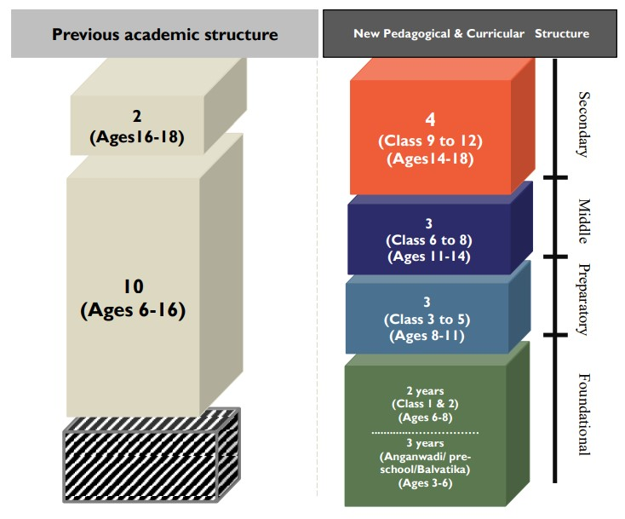

At each stage, the curriculum is thoughtfully designed to meet the developmental needs of the students, fostering a strong academic foundation while promoting holistic growth.

* **Foundation stage: (3-8 Years)**
  + **Pre-School:** Nursery, Junior KG, Senior KG
  + **Primary School:** Grade 1 and 2

The Foundational Stage will consist of five years of flexible, multilevel, play/activity-based learning with a focus on developing cognitive, affective, and psychomotor abilities and early literacy and numeracy.

* **Preparatory stage: (8-11 Years) Grade 3 to 5**

The Preparatory Stage, spanning three years, advances from the play, discovery, and activity-based approach of the Foundational Stage. It introduces light textbooks and aspects of formal yet interactive classroom learning. This aims to establish a robust foundation across various subjects such as reading, writing, speaking, physical education, art, languages, science, and mathematics.

* **Middle stage: (11-14 years) Grade 6 to 8**

It incorporates subject teachers to facilitate the exploration of abstract concepts in sciences, mathematics, arts, social sciences, and humanities. While introducing specialized subjects and teachers, experiential learning within each subject and interdisciplinary explorations will remain a focal point.

* **Secondary stage: (14-16 years) Grade 9 and 10**

The Secondary Stage will comprise of two years of study, building on the subject-oriented pedagogical and curricular style of the Middle Stage, but with greater depth, greater critical thinking, greater attention to life aspirations, and greater flexibility.

* 1. **Student:**

Diary:

|  |  |  |
| --- | --- | --- |
| No | Particular | Details |
|  |  |  |

Feedback*: link of next element*

Books list:

Question Bank:

NTSE:

* 1. **Assessment:**

Implementing a comprehensive assessment system, the school focuses not only on evaluating students' progress but also on providing feedback and fostering their continuous growth.

* 1. **Staff**
* **Dedicated Educators:** Our team of passionate and dedicated educators are committed to providing quality education and creating a conducive learning environment.
* **Guidance and Support:** The school's faculty members serve as mentors, providing guidance and support to help students reach their full potential academically and personally.
* **Subject Expertise:** The faculty members bring a wealth of subject expertise, fostering curiosity, and facilitating hands-on learning experiences in various disciplines.

|  |  |  |  |  |
| --- | --- | --- | --- | --- |
| Sl No | Teacher Name | Qualification | Designation/Subject | Teaching Experience (Yrs) |
|  |  |  |  |  |
|  |  |  |  |  |

* 1. **Parents:**

Our school believes in the importance of parental involvement in a child's education. We encourage parents to participate in various school events and provide opportunities for them to communicate with teachers and staff members. Together, we can help our students achieve their full potential.

We believe that a strong partnership between parents and teachers is essential for the holistic development of students. Regular communication, parent-teacher meetings, and workshops create a supportive network for addressing each child's unique needs and fostering their growth.

Parents may schedule a prior appointment to meet with the principal.

* **Visiting hours: 3.30 pm to 4.30 pm (Mon to Sat)**
* **Appointment link:** vsips google calendar link
* **School office Nos:** 080- 3561 2861 to 3561 2879 (19 lines)
* **Feedback link**: *next element link*

1. **Admissions**

Admissions for the new academic year commences from the November of existing academic year. Online process is setup for admission process for transparency and inclusiveness. Admission will be given on merit basis.

* **Age criteria:**

For admission in class 1, students should have completed six years by June 01 of the academic year.

|  |  |
| --- | --- |
| **Class** | **Age (years)** |
| Nursery | 3 |
| Jr KG | 4 |
| Sr KG | 5 |
| 1 | 6 |

* **Admission Process:**

|  |  |
| --- | --- |
| **Step-1:** **Application (Online)**   * Link: *next element* | Submit the completed application form along with the required documents, including academic records and identification proof. |
| **Step 2: Entrance Assessment**   * Saturday at 9 am – 12.30pm * Syllabus Link: *nextelement* | Participate in the entrance assessment to evaluate the student's aptitude and academic readiness for our programs. |
| **Step 3: Interaction**   * Saturday at 9am -12.30pm * (Communicated through e-mail) | Engage in a personal interaction with the school's admission team to understand the student's interests, aspirations, and suitability for our educational environment |

1. **Campus**

Our campus provides a safe and conducive learning environment, equipped with modern infrastructure and technology to support student learning.

|  |  |
| --- | --- |
| **State-of-the-Art Infrastructure** | Our campus is equipped with modern facilities, spacious classrooms, well-equipped laboratories, and dedicated spaces for sports, arts, and extracurricular activities. |
| **Sports and Fitness Facilities** | variety of sports and fitness facilities to promote physical well-being and an active lifestyle. |
| **Library and Resource Center** | well-stocked library that encourages a love for reading and access to a wide range of learning resources. |
| **Classrooms:** | An integrated curriculum that blends academic learning with co-curricular activities, ensuring a holistic development for students. |
| **Artificial Intelligent interactive Board:** | Cutting-edge educational technologies to enhance teaching and learning experiences. |
| **Laboratory:** | Students are encouraged to explore their interests through practical experiences and real-world applications. |
| **Auditorium:** |  |
| **Transportation** |  |

1. **Sports & Cultural**

Our state-of-the-art sports facilities offer students the chance to engage in various sports and activities, promoting a healthy and active lifestyle.

|  |  |
| --- | --- |
| Games | Swimming |
| Yoga | Fine arts & Craft |
| Taekwondo | Dance & Music |

PPT: Shared

1. **NCC**

Vidya Sanskaar International Public School raised NCC unit in the year 2023 with …… students with the unit no…. affiliated to 3KAR BN.

**Aim:**

The ‘Aims’ of the NCC laid out in 1988 have stood the test of time and continue to meet the requirements expected of it in the current socio–economic scenario of the country. The NCC aims at developing character, comradeship, discipline, a secular outlook, the spirit.

**Pledge:**

We the cadets of the National Cadet Corps,

do solemnly pledge that we shall always uphold the unity of India.

We resolve to be disciplined and responsible citizens of our nation.

We shall undertake positive community service in the spirit of selflessness

and concern for our fellow beings

Link: <https://indiancc.nic.in/>

NCC Cadets List: 2023-24

|  |  |  |  |  |
| --- | --- | --- | --- | --- |
| Sl No | Cadets Name | Class | Year of Joining | Reg No |
|  |  |  |  |  |
|  |  |  |  |  |

**NCC Facilities:**

**Obstacle Course:**

**Firing Range:**

**NCC Camp @ Vidya Sanskaar**

1. **Events**
   1. Community engagement: Community service is an integral part of our extracurricular activities that promote social responsibility and empathy in students.
   2. Alumni network: Our school boasts a robust network of successful alumni in various fields who continue to give back to the school and inspire current students.
2. **Contact Us**

Contact information

|  |  |  |  |
| --- | --- | --- | --- |
| **Sl No** | **Office** | **Phone No** | **E-mail** |
| 1 | Principal | 080-3561 2863  (Ext no. 205) | principalvsips@vidyasanskaar.edu.in |
| 2 | School Office | 080- 3561 2861 to 3561 2879 (19 lines) | vsips@vidyasanskaar.edu.in |
| 3 | Executive Officer | 080- 3561 2842  (Ext no. 105) | eo@vidyasanskaar.edu.in |
| 4 | Admission enquiry | 080- 3561 2840 to 3561 2855 (16 lines) | admissions@vidyasanskaar.edu.in |
| 5 | General enquiry | 080- 3561 2843 | support@vidyasanskaar.edu.in |
| 6 | Transport | 080- 3561 2844 | transport@vidyasanskaar.edu.in |

Location and directions