**Task-1:**

**Step-1**: Connecting to the server

* creating two groups: **devops** and **testing**

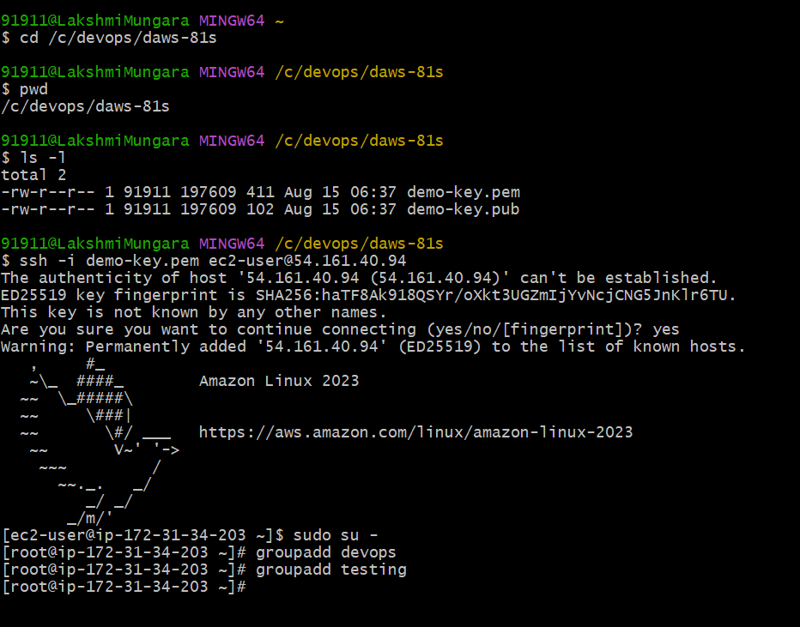

**Step-2**: **User Creation and Group Assignment**

* Creating four users: ram, raheem, suresh, philip
* Assigning ram and raheem to the devops group
* Assigning suresh and Philip to the testing group

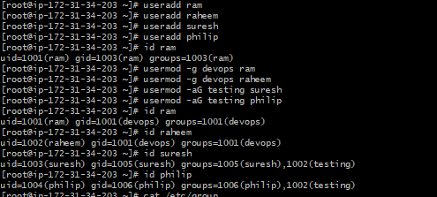

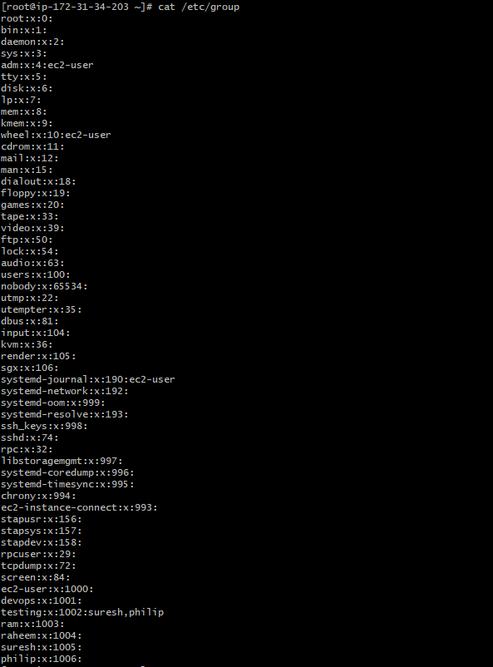

**Step-3: Key-based Authentication**

* For each user(ram, raheem, suresh and philip)
* Generating SSH Key pair
* Configure key-based authentication by adding the public key to the user’s authorized_keys file
* Ensure correct permissions are set on the .ssh directory and the authorized_keys file

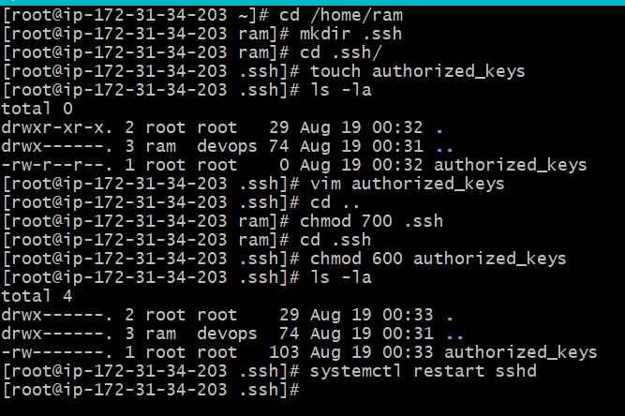

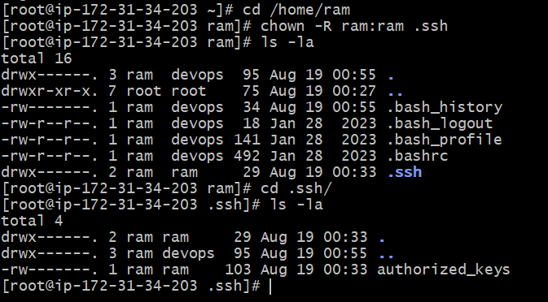

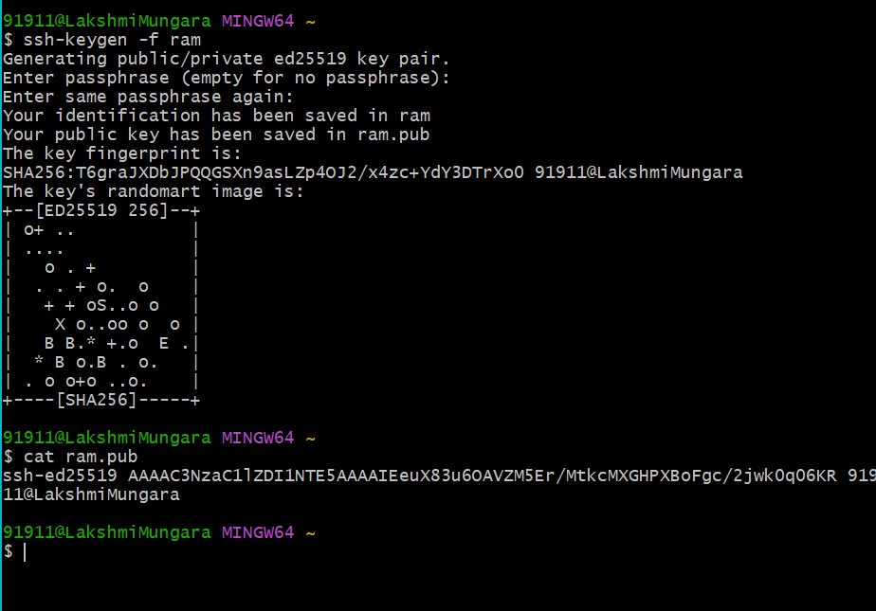

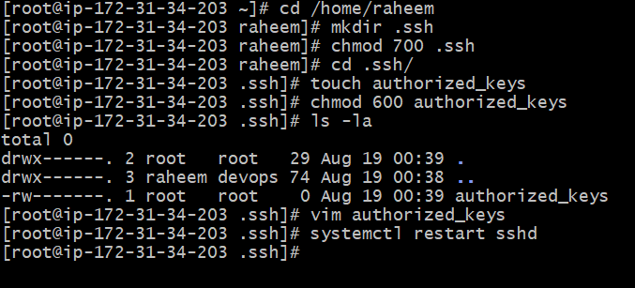

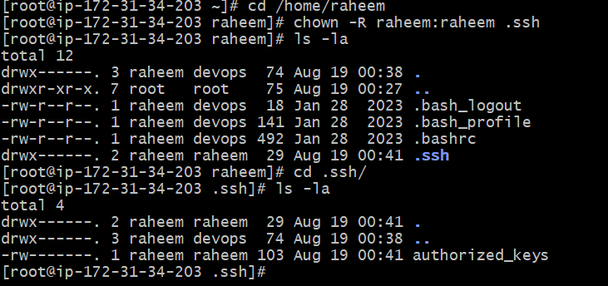

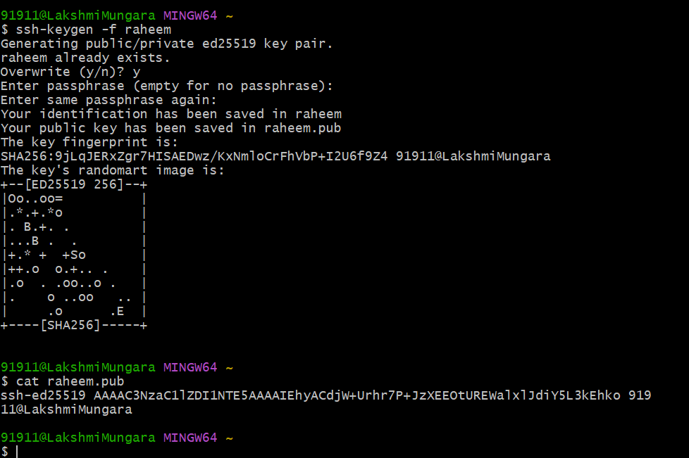

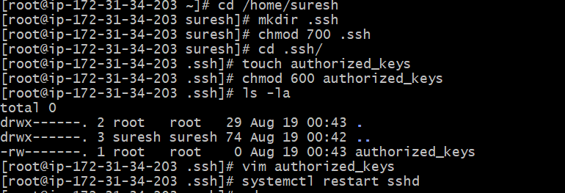

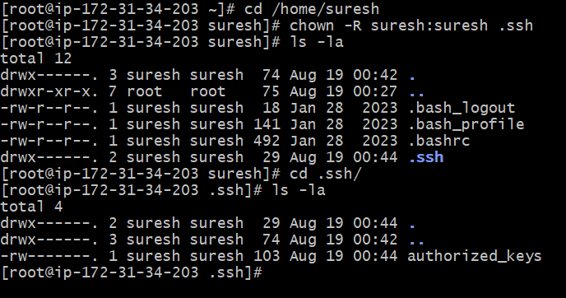

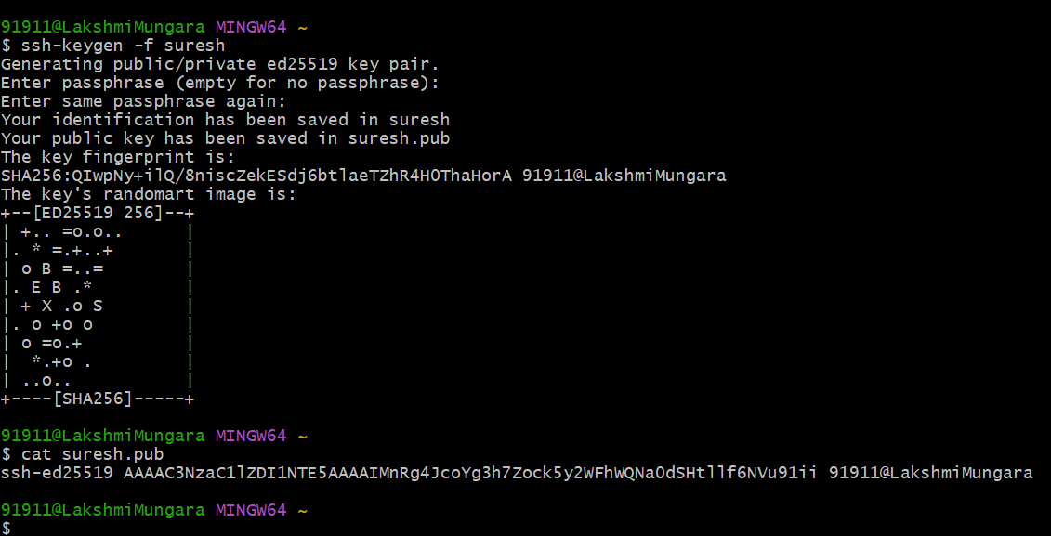

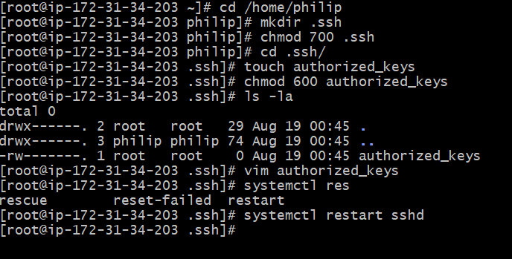

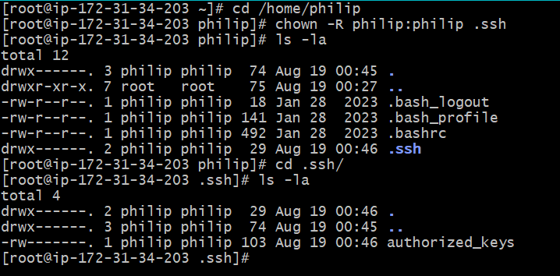

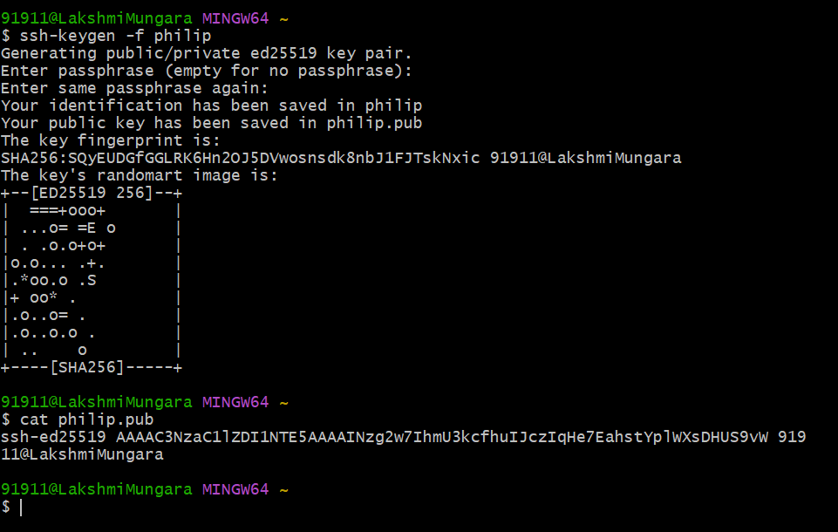

**Step-4: Disable Password-Based Authentication**

* Modify the SSH configuration file to disable password-based authentication, allowing only key-based authentication

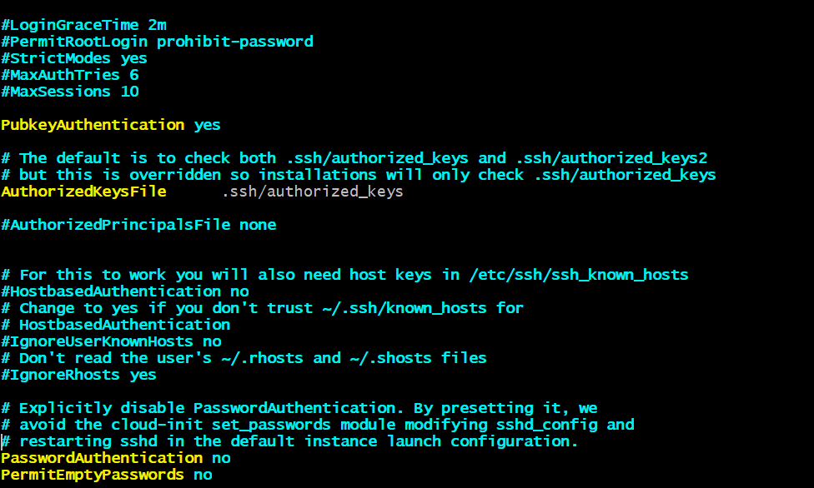

**Step-5: Testing and Verification**

* Verify that each user can log in to the server using their private key
* Confirm that password-based login attempts are denied

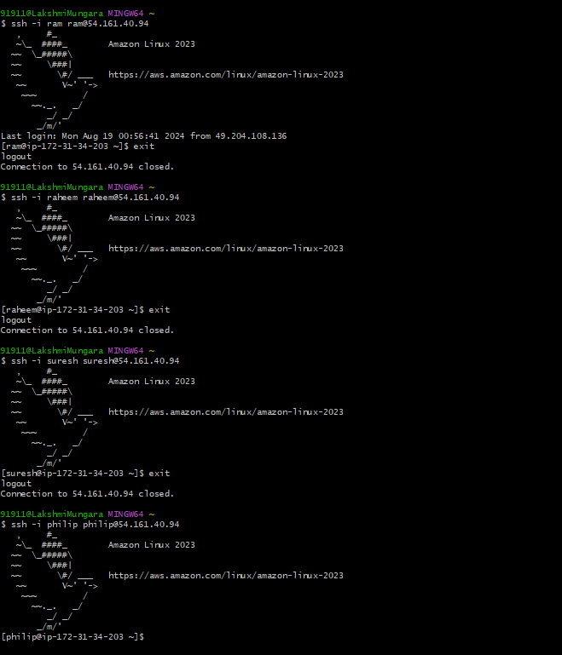

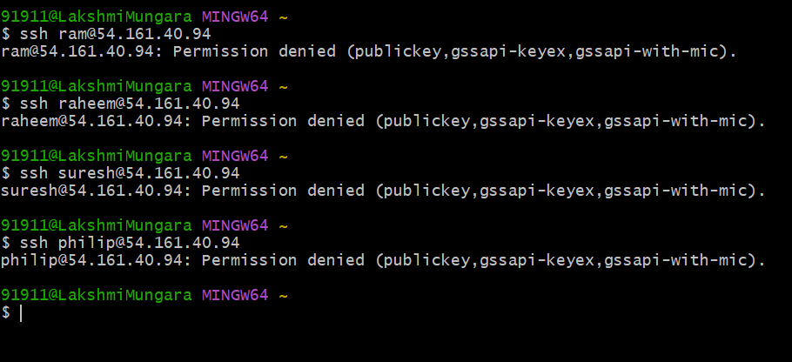

-------------------------------------------------**Task Completed**------------------------------------------------------