**Task-2:**

**Step-1: Connecting to the server**

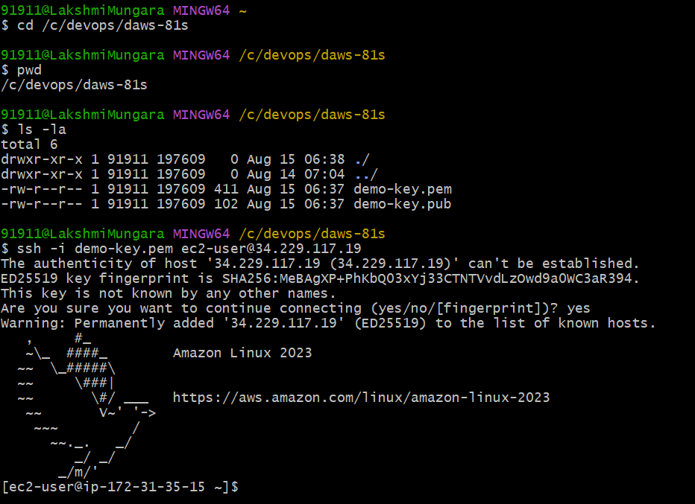

* Creating two groups **devops** and **testing**

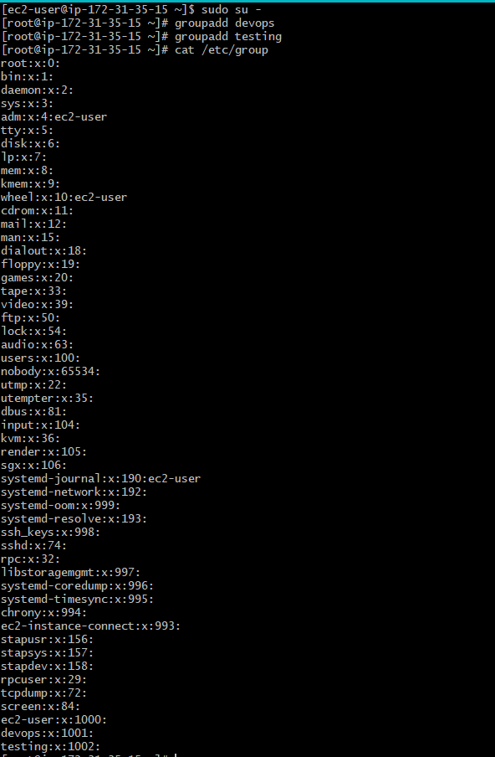

* Creating four users: **ram, raheem, suresh**, and **philip**
* Assigning **ram** and **raheem** to the **devops** group
* Assigning **suresh** and **philip** to the **testing** group

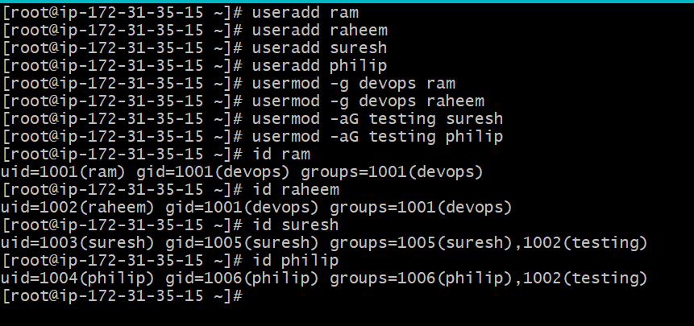

### Step-2: Directory and File Setup

* Creating a directory structure under **/home/devops_projects** for the **devops** group and **/home/testing_projects** for the **testing** group
* Inside **/home/devops_projects**, creating a subdirectory **project1** with a file **devops_task.txt**
* Inside **/home/testing_projects**, creating a subdirectory **project2** with a file **testing_task.txt**

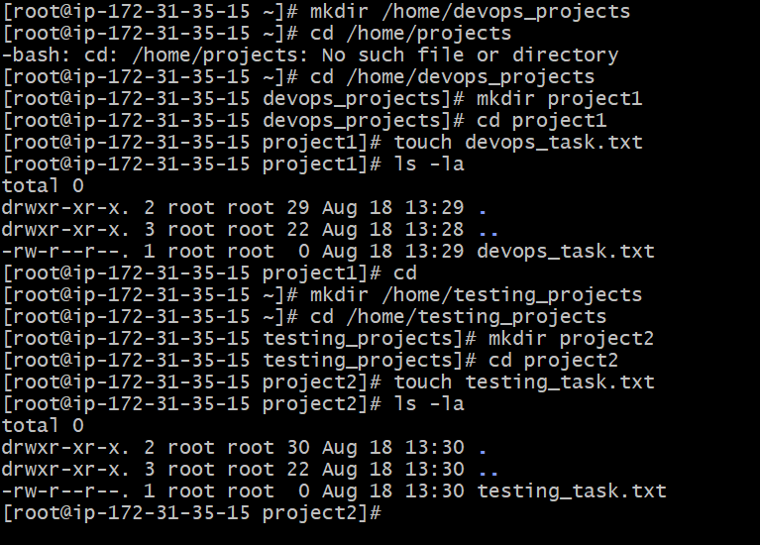

**Step-3**: **Set Permissions**

* Assign ownership of the **devops_projects**directory and its contents to the **devops** group.
  + Ensure that only members of the **devops** group have read, write, and execute permissions.
* Assign ownership of the **testing_projects** directory and its contents to the **testing** group.
  + Ensure that only members of the **testing** group have read, write, and execute permissions.

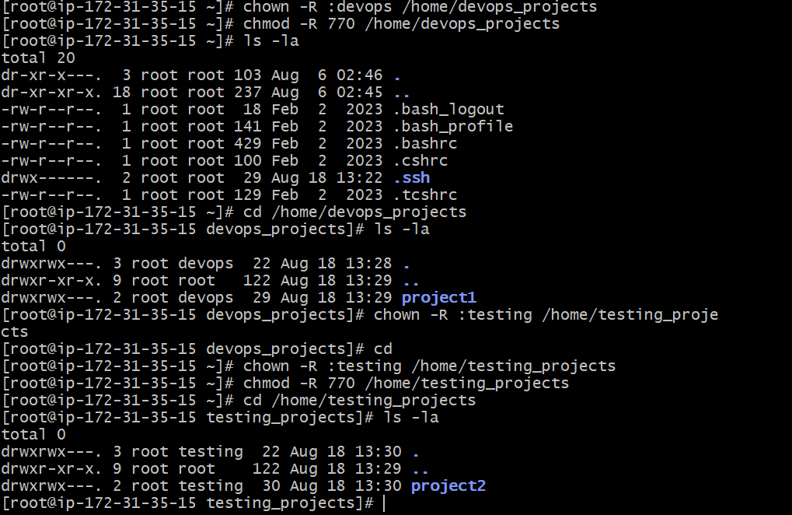

* Ensure that the files **devops_task.txt** and **testing_task.txt** are writable only by their respective owners and readable by their respective groups.

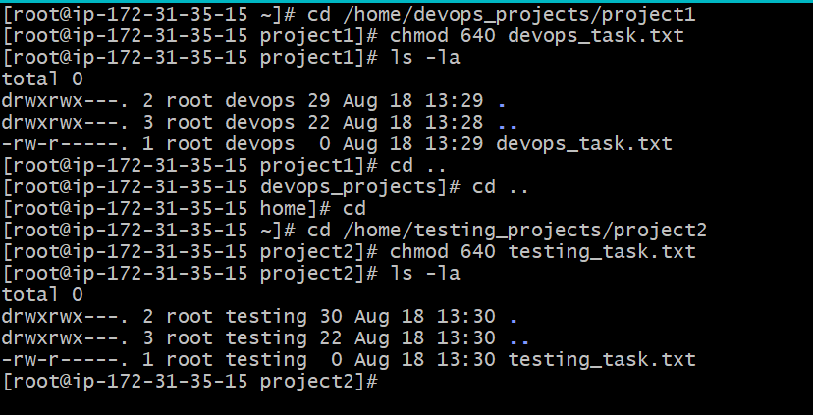

**Step-4: Testing and Verification**

Test access by having each user:

* Verify that **ram** and **raheem** can access and modify files in the **devops_projects/project1** directory.
* Verify that **suresh** and **philip** can access and modify files in the **testing_projects/project2** directory.

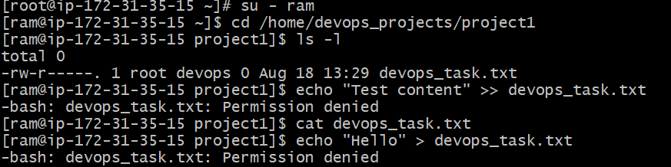

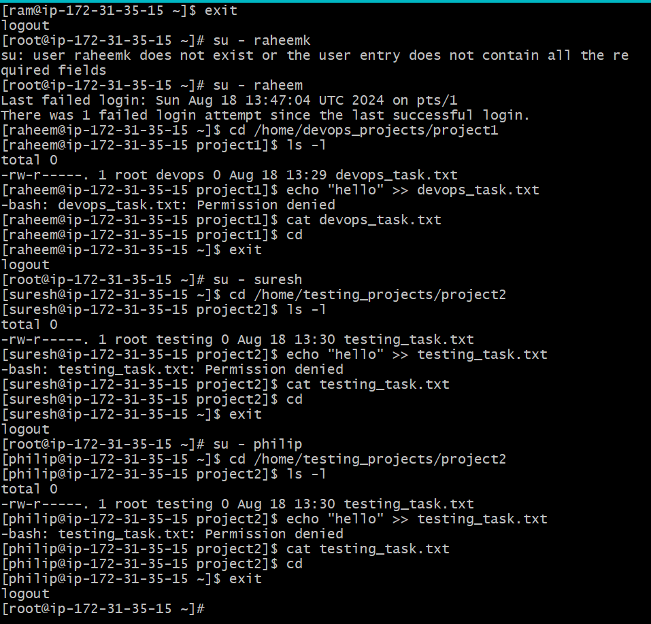

* Confirm that users in the **devops** group cannot access files in the **testing_projects** directory and vice versa

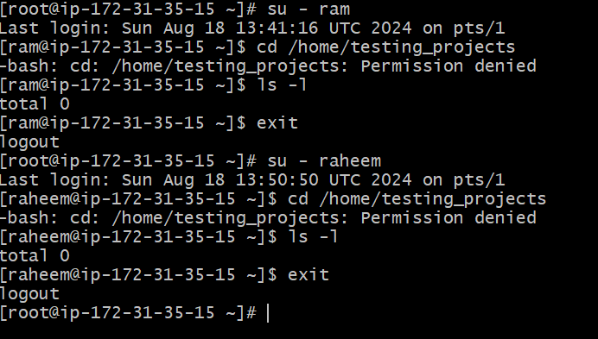

**Step-5: Change Modifications**

* Modify the permissions of the **project1** and **project2** directories
* Change permissions so that the **devops_task.txt** file is only readable(not writable) by members of the **devops** group
* Change permissions so that the **testing_task.txt** file is only writable(not readable) by members of the testing group

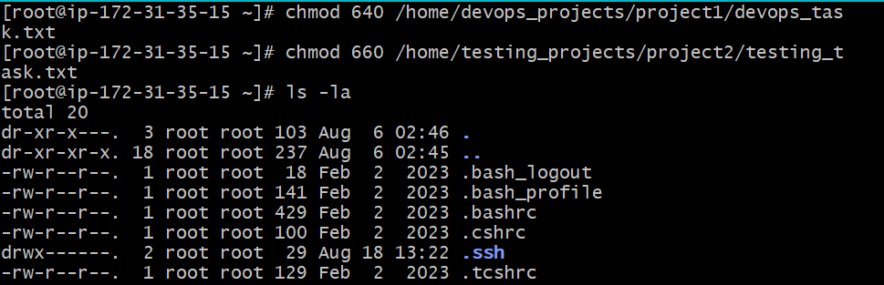

* Test these changes by having each user attempts to read and write to the modified files and directories

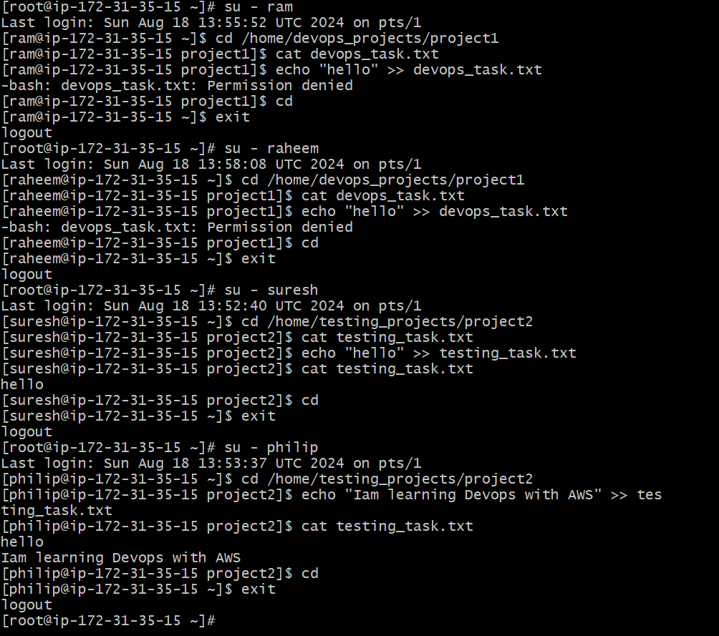

-----------------------------------------------------------**Task Completed**-------------------------------------------------------------