**Day – 2 Session-2(13/04/2024)**

**Step – 1**: changing the working directory and generating the key-pair by using the command

**ssh-keygen –f linux-key**

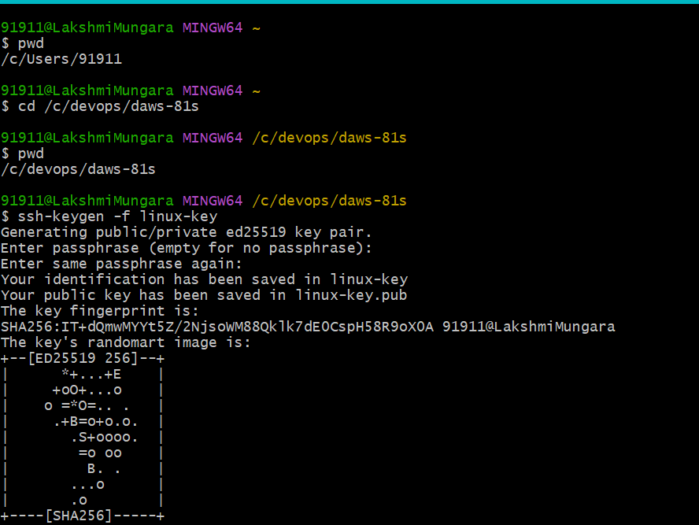

**Step – 2**: Connecting to the AWS instances with IP address: 54.198.7.27

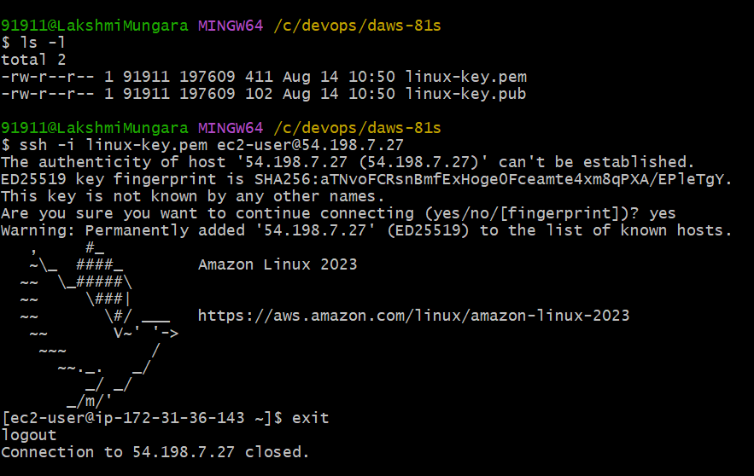

**Step-3**: Displaying the Current working directory and changing the directory

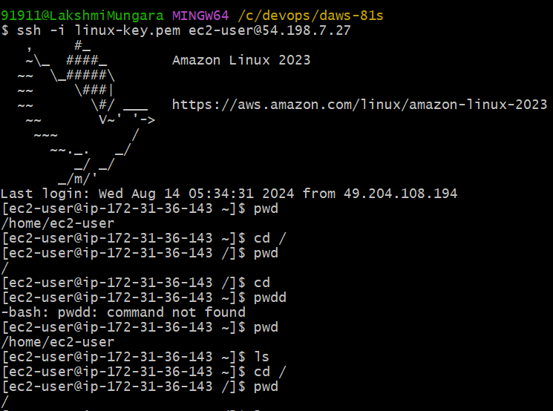

**Step – 4**: List out the files in alphabetical order and reverse order

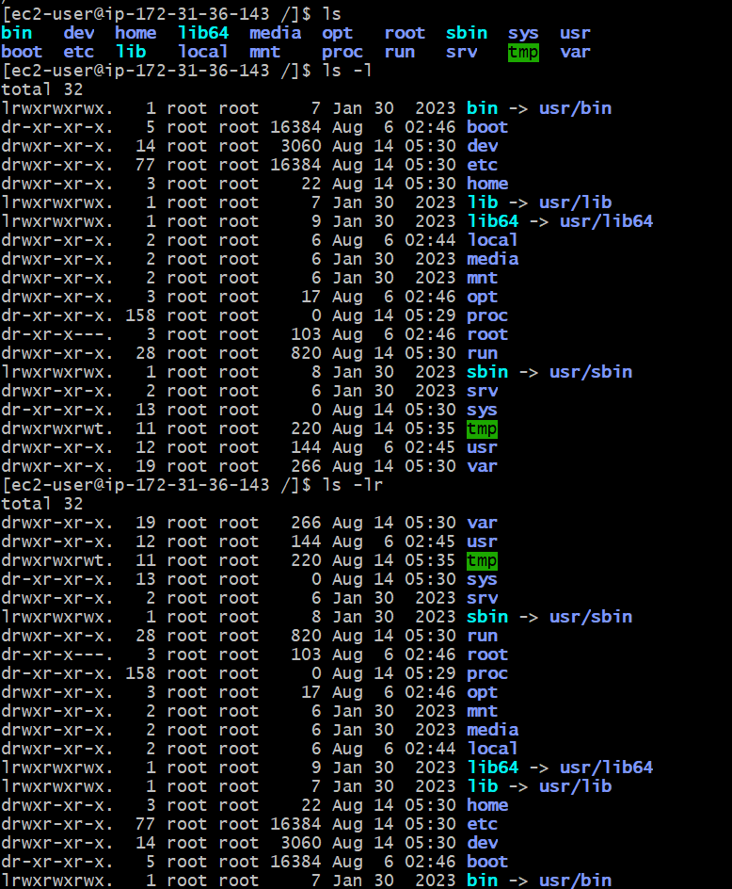

List out the files and details with respect to time based

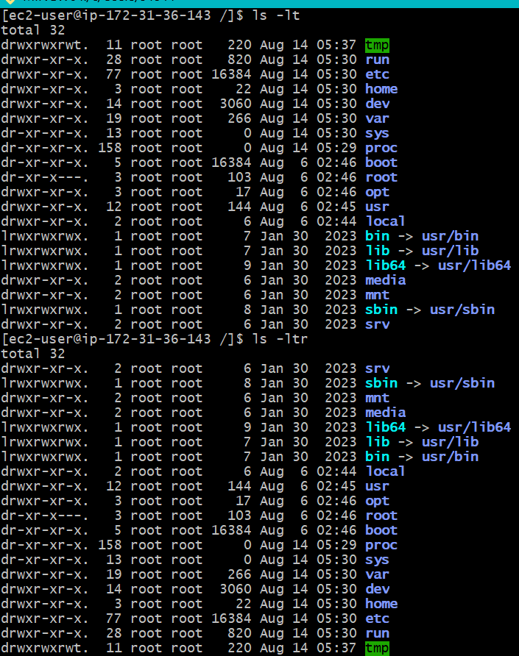

**Step – 5**: List out all the hidden files (ls -la = shows all the hidden files)

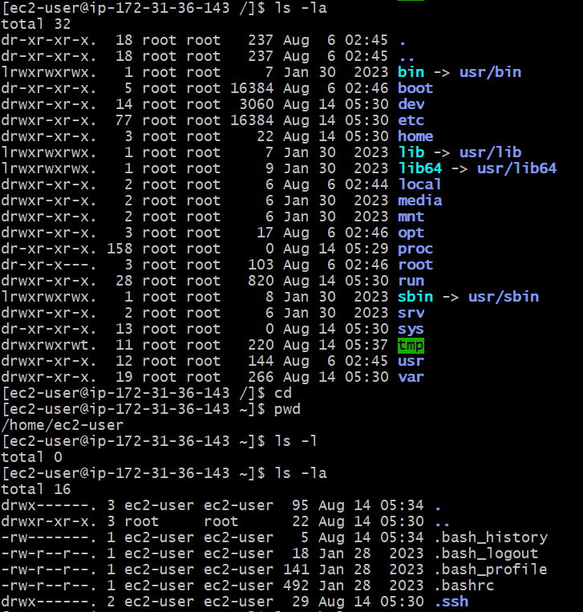

**Step-6**: Help command (ls --help)

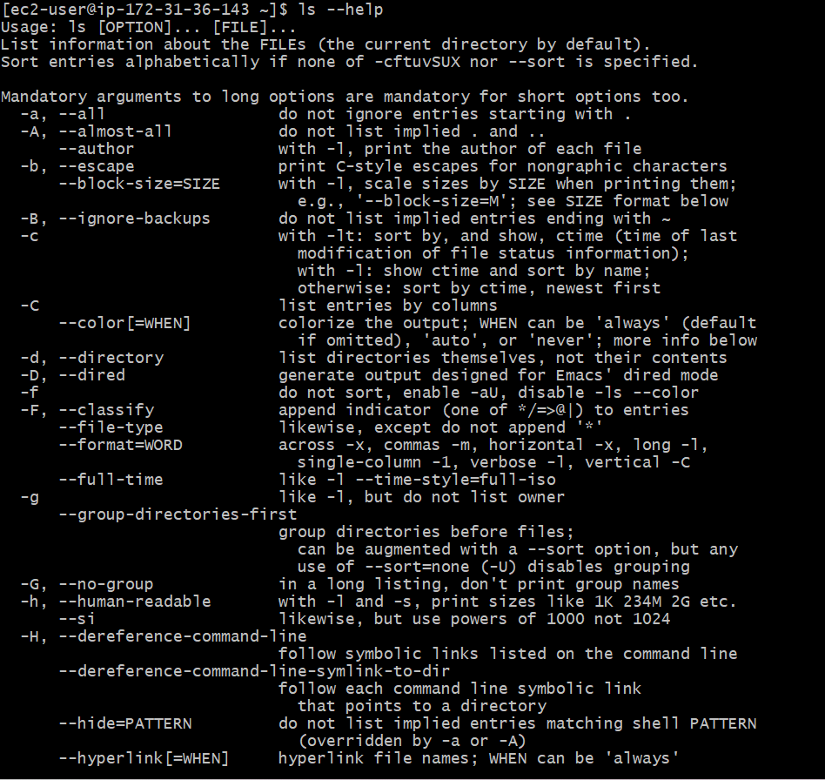

**Step-7**: creating file and adding contents to the file

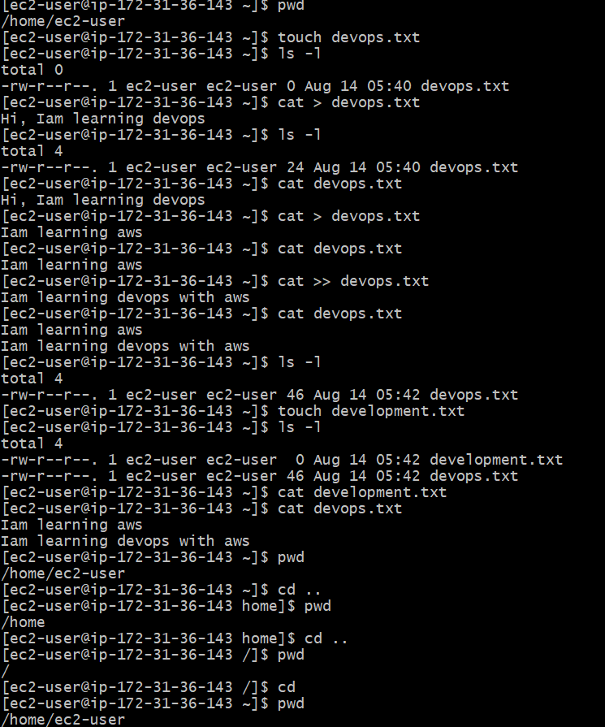

**Step-8**: creating directories

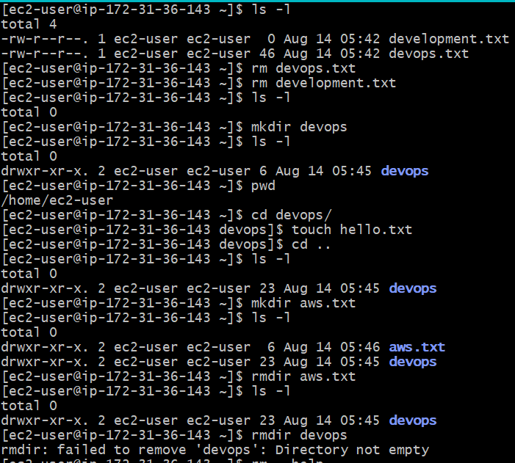

**Step-9:** Removing directories

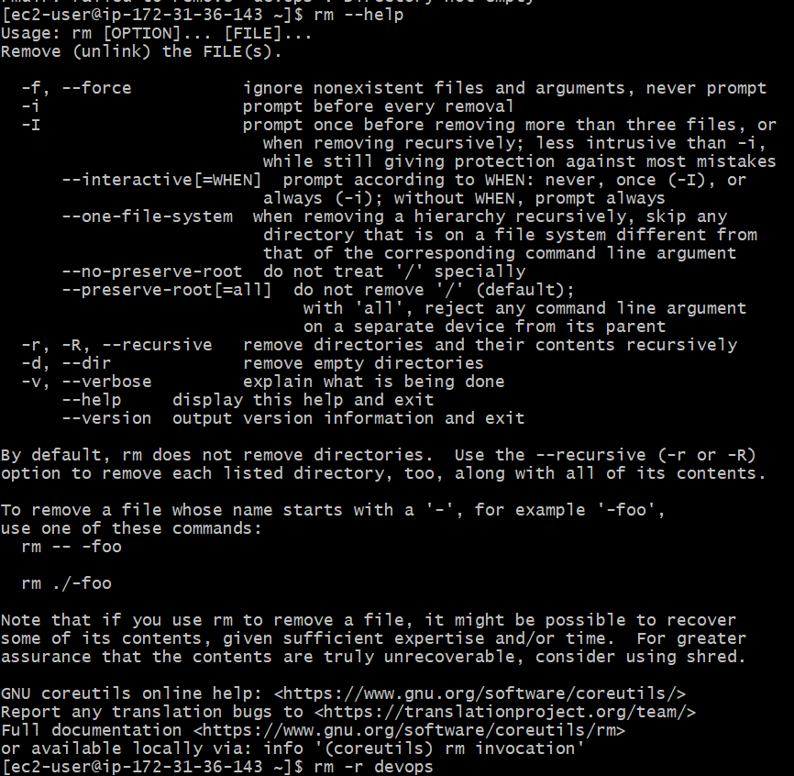

**Step-10**: Renaming the files or directories and connection closed

