EX.NO: 1.B WINDOWS FUNDAMENTALS ROLL NO : 231901027

DATE : 05.02.2025

AIM:

WINDOWS FUNDAMENTALS ,DISCOVER MORE ABOUT SYSTEM CONFIGURATION,UAC SETTINGS,RESOURCE MONITORING,THE WINDOWA REGISTRY AND MORE.

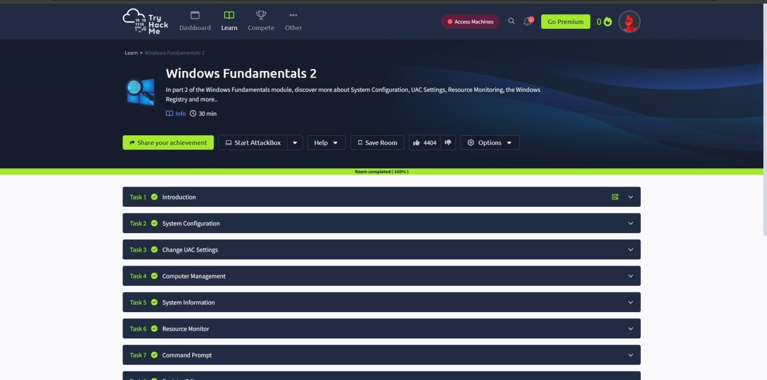

TASK 2 : SYSTEM CONFIGURATION

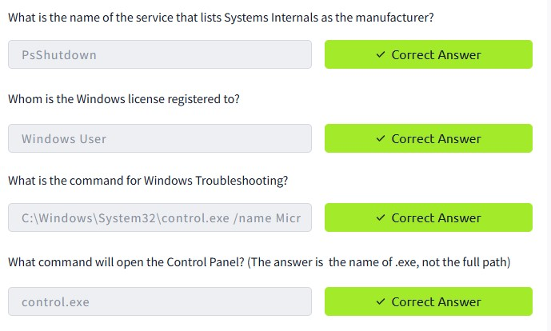

TASK 3 : CHANGE UAC SETTINGS

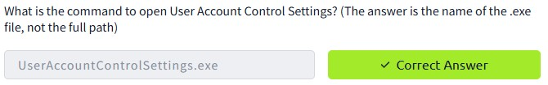

TASK 4 : COMPUTER MANAGEMENT

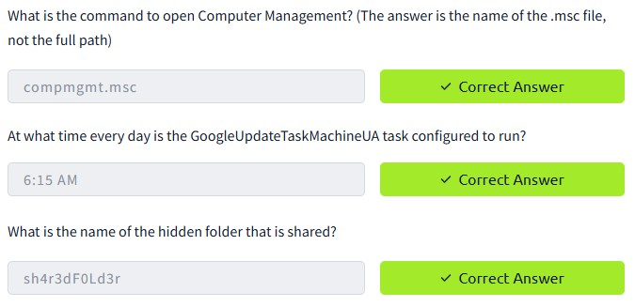

TASK 5 : SYSTEM INFORMATION

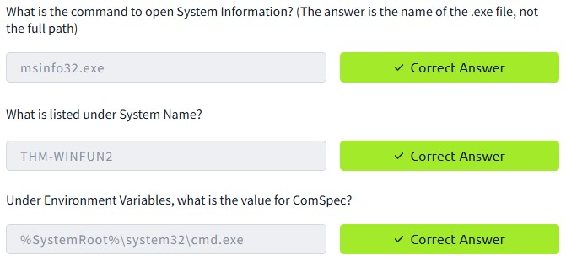

TASK 6 : RESOURCE MONITOR

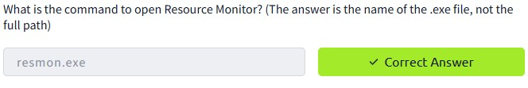

TASK 7 : COMMAND PROMPT

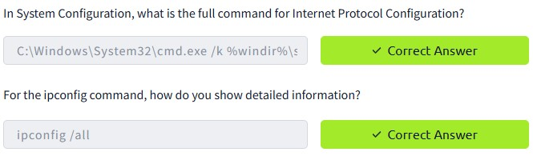

TASK 8 : REGISTRY EDITOR

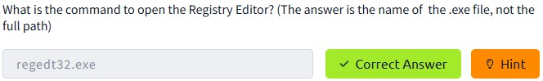

Conclusion:

Tryhackme platform windows fundamentals 2 task is successfully completed.