EX.NO: 1.a WINDOWS FUNDAMENTALS ROLL NO : 231901027

DATE : 05.02.2025

AIM:

Windows fundamentals module. Learning abount the windows desktop,the NTFS file system,UAC,the control panel and more in tryhackme platform.

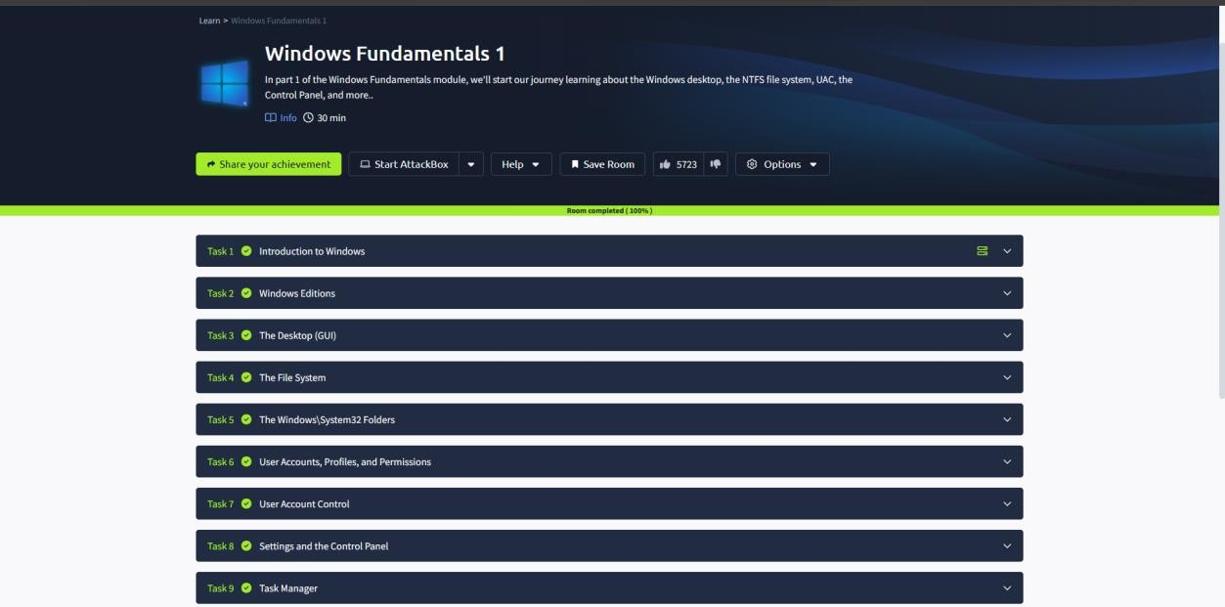

TASK 02 : WINDOWS EDITIONS

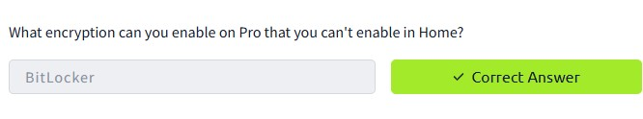

TASK 03 : THE DESKTOP(GUI)

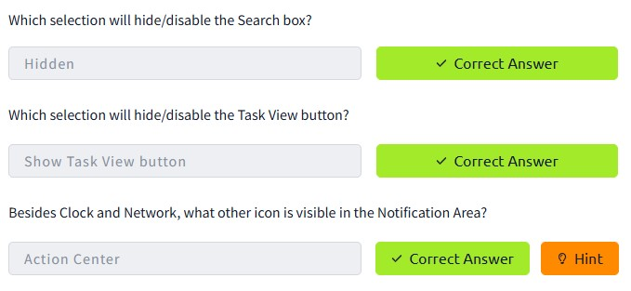

TASK 4 : THE FILE SYSTEM

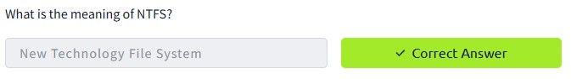

TASK 5 : THE WINDOWS/SYSTEM32FOLDERS

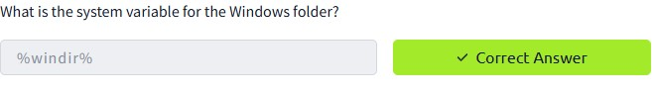

TASK 6 : USER ACCOUNTS,PROFILES, AND PERMISSIONS

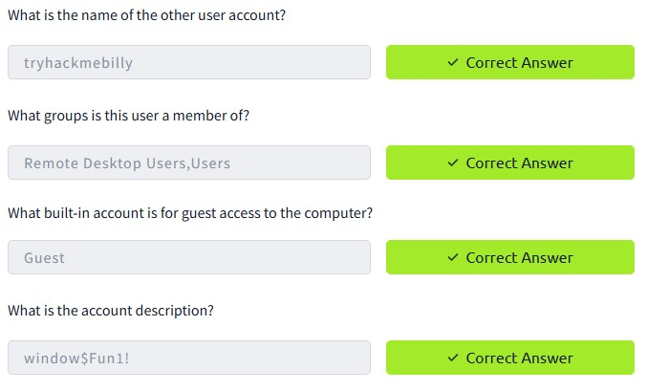

TASK 7 : USER ACCOUNT CONTROL

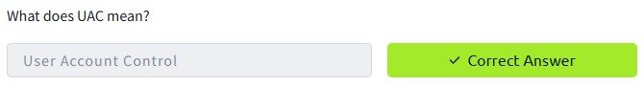

TASK 8 : SETTINGS AND THE CONTROL PANEL

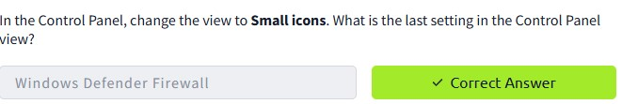

TASK 9 : TASK MANAGER

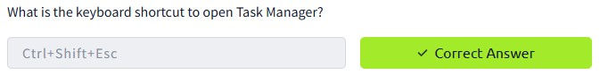

Conclusion:

Tryhackme platform windows fundamentals 1 task is successfully completed.