EX.NO: 2 Security Models and Principles ROLL NO : 231901027

DATE : 12.02.2025

AIM:

Study about the security triad and common security models and principles.

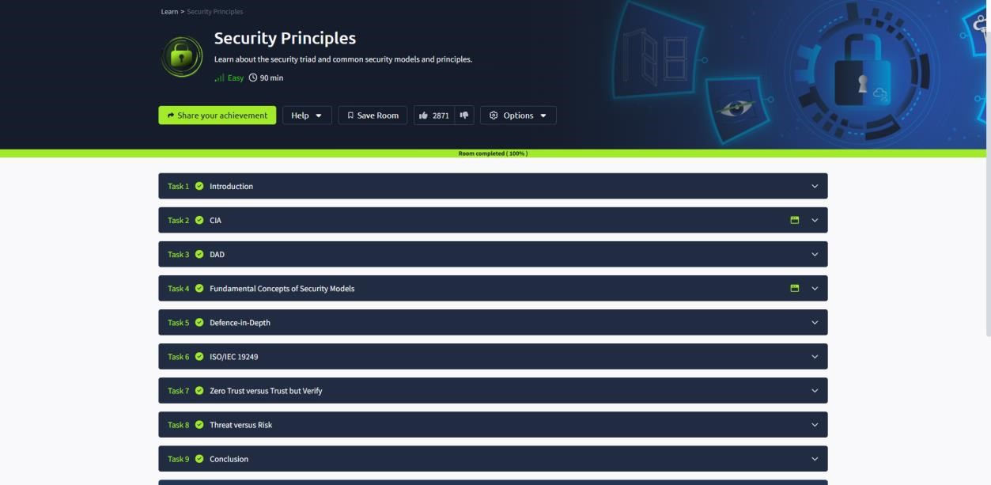

TASK 2 : CIA:

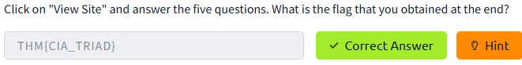

TASK 3 : DAD:

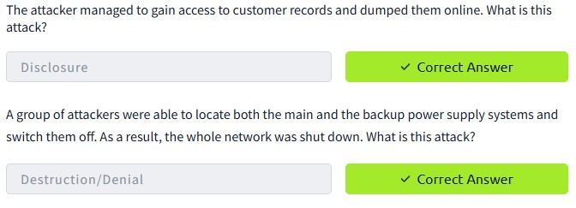

TASK 4 : FUNDAMENTAL CONCEPTS OF SECURITY MODELS

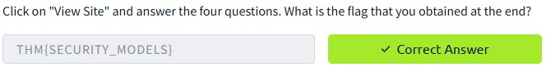

TASK 5 : DEFENCE-IN-DEPTH

TASK 6 : ISO/IEC 19249

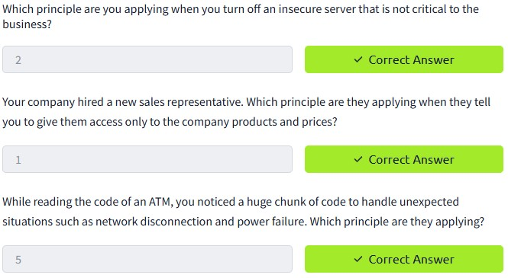

TASK 7 : ZERO TRUST VERSUS TRUST BUT VERIFY

TASK 8 : THREAT VERSUS RISK

Conclusion:

Tryhackme platform security principle task is successfully completed.