EX.NO: 3 Explore Identity and Access Management ROLL NO : 231901027

DATE : 19.02.2025

AIM :

Study about identification, authentication, authorisation, accounting and identity management.

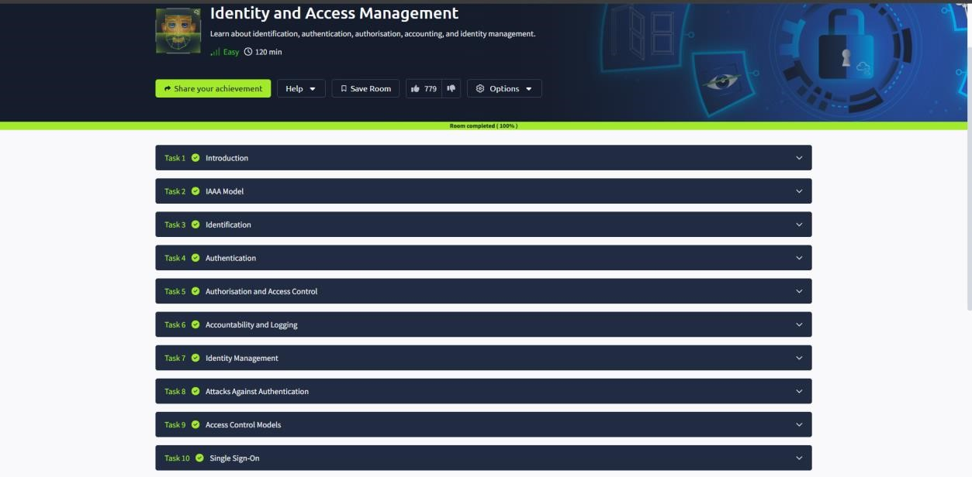

TASK 2 : IAAA MODEL

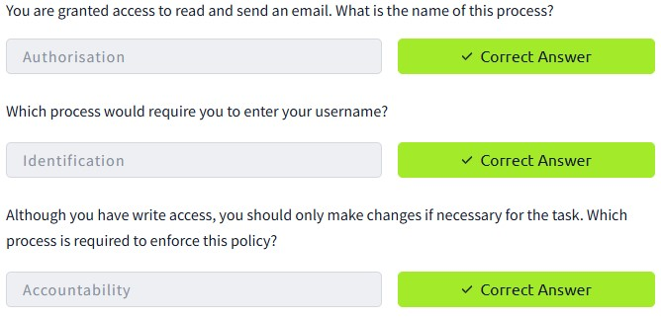

TASK 3 : IDENTIFICATION

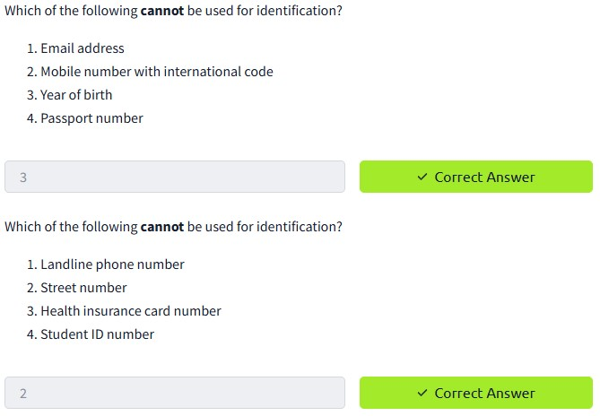

TASK 4 : AUTHENTICATION

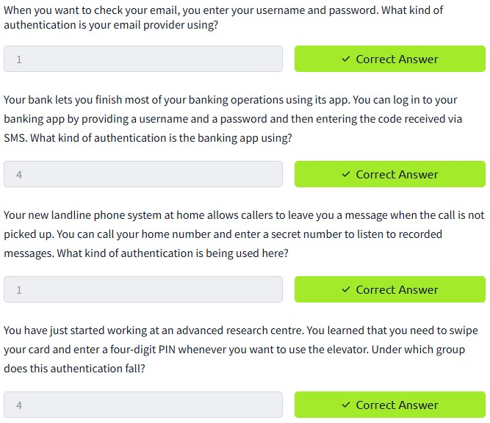

TASK 5 : AUTHORISATION AND ACCESS CONTROL

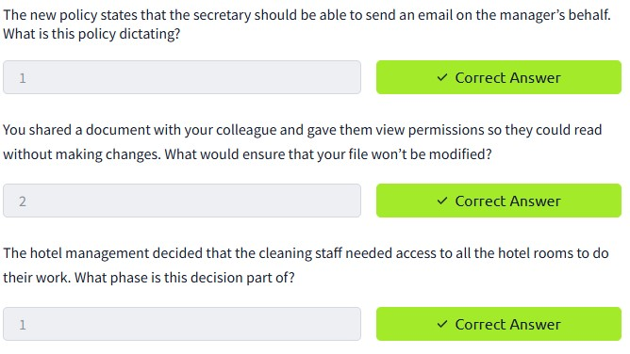

TASK 6 : ACCOUNTABILITY AND LOGGING

TASK 7 : IDENTITY MANAGEMENT

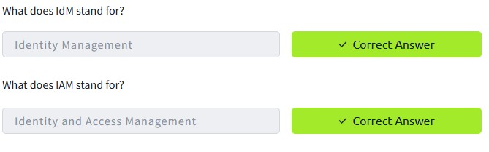

TASK 8 : ATTACKS AGAINST AUTHENTICATION

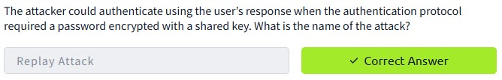

TASK 9 : ACCESS CONTROL MODELS

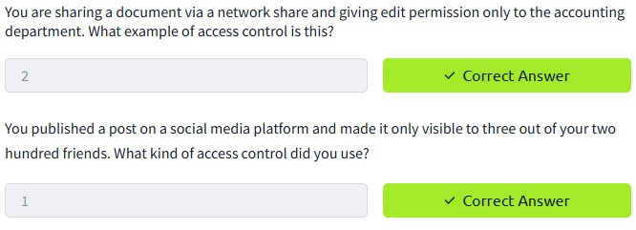

TASK 10 : SINGLE SIGN-ON

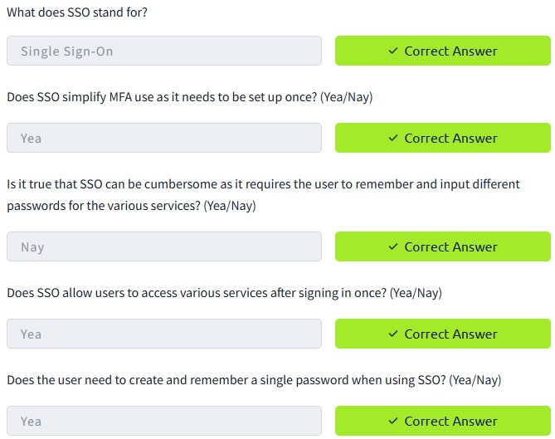

TASK 11 : SCENARIOS



CONCLUSION:

Tryhackme platform Explore Identity and Access Management task is successfully completed