EX.NO: 4 Analyze the Malicious Network Traffic using Wireshark ROLL NO : 231901027

DATE : 05.03.2025

AIM:

Applying analytical skill to analyze the malicious network traffic using wireshark.

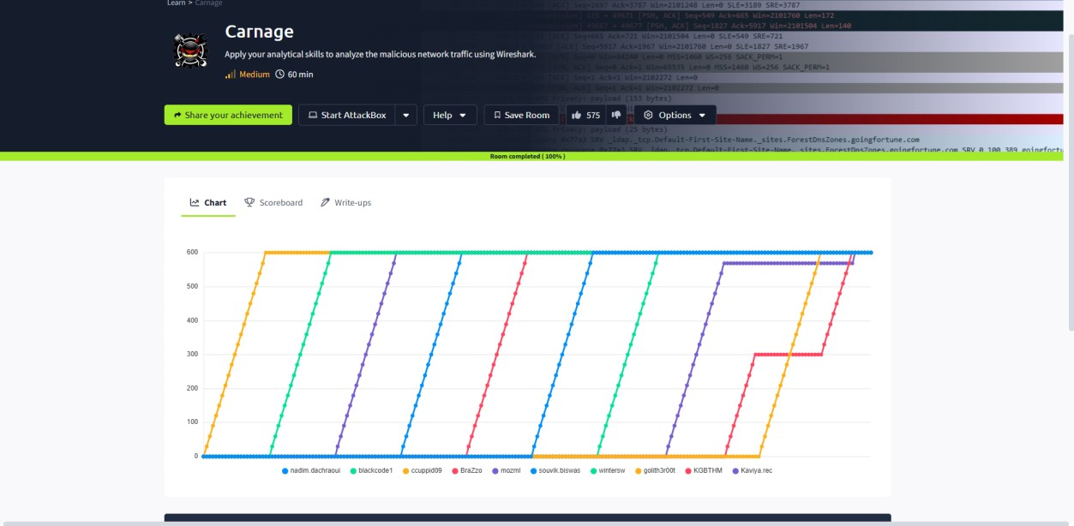

TASK 2 : TRAFFIC ANALYSIS

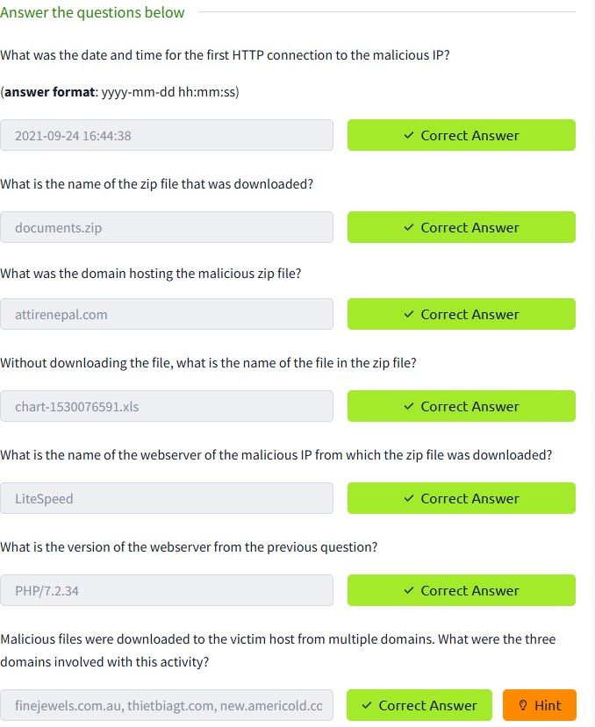

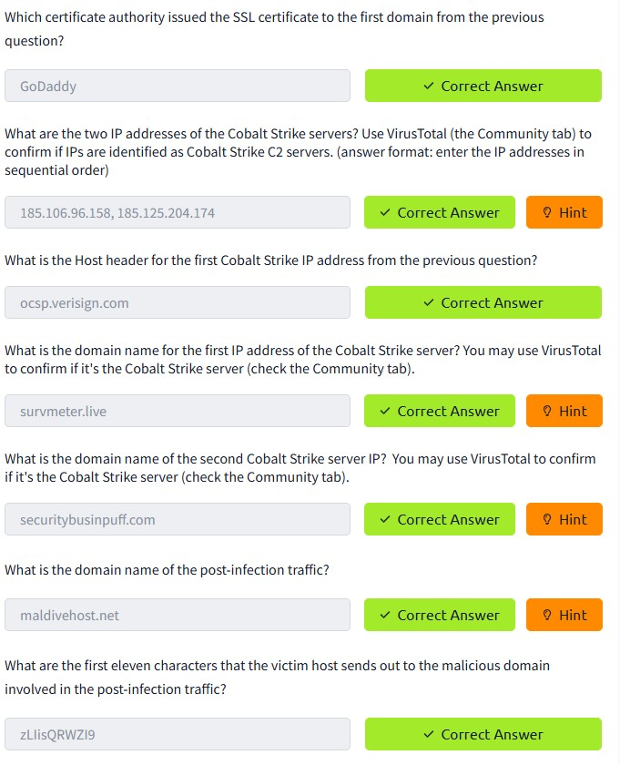

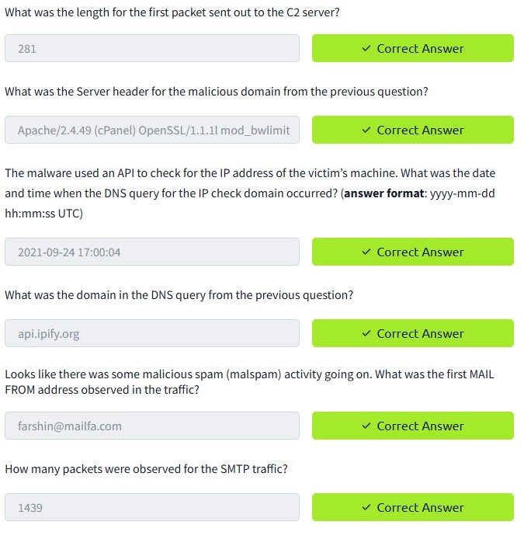

CONCLUSION:

Tryhackme platform Analyze the Malicious Network Traffic using Wireshark task is successfully completed.