**Anagram:**

**CODE :**

import java.util.*;public class anagram{ public static void main(String[] args) { anagra("geeks","kseeg"); anagra("allergy","allergic"); anagra("g","g"); } public static void anagra(String s1 ,String s2){ Map<Character,Integer> hm = new HashMap<>(); for(char c: s1.toCharArray()){ hm.put(c,hm.getOrDefault(c,0)+1); } Map<Character,Integer> hm1 = new HashMap<>(); for(char c:s2.toCharArray()){ hm1.put(c,hm1.getOrDefault(c,0)+1); } System.out.println(hm.equals(hm1)); }}

**OUTPUT :**

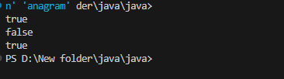

TIME COMPLEXITY : O(n)

SPACE COMPLEXITY : O(n)

**Row with maximum 1s'**

**CODE :**

public class maxoneinrow { public static void main(String[] args) { System.out.println(find(new int[][]{{0, 1, 1, 1}, {0, 0, 1, 1}, {1, 1, 1, 1}, {0, 0, 0, 0}})); } public static int find(int arr[][]) { int key = -1 , value = 0; for(int i = 0 ; i<arr.length; i++){ int one = 0; for(int j =0 ; j<arr[i].length ; j++){ if(arr[i][j]==1) one++; } if(value<one){ key = i; value = one; } } return key; }}

**OUTPUT :**

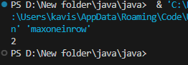

TIME COMPLEXITY : O(m*n)

SPACE COMPLEXITY : O(1)

**Longest consecutive subsequence**

**CODE :**

import java.util.HashSet;public class longestsequence { public static void main(String[] args) { System.out.println(find(new int[]{2, 6, 1, 9, 4, 5, 3})); } public static int find(int[] arr) { HashSet<Integer> set = new HashSet<>(); for (int num : arr) { set.add(num); } int ans = 0; for (int num : arr) { if (!set.contains(num - 1)) { int cur = num; int c = 1; while (set.contains(cur + 1)) { cur += 1; c += 1; } ans = Math.max(ans, c); } } return ans; }}

**OUTPUT:**

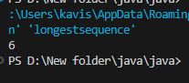

TIME COMPLEXITY : O(n)

SPACE COMPLEXITY : O(n)

**Longest palindrome in a string**

**CODE :**

public class longestpalinsubstring { public static void main(String[] args) { palin("forgeeksskeegfor"); palin("Geeks"); palin("abc"); } public static void palin(String s){ System.out.print(s + " : "); int start = 0; int end = 0; for (int i = 0; i < s.length(); i++) { int o = find(s, i, i); int e = find(s, i, i + 1); int max = Math.max(o, e); if (max > end - start) { start = i - (max - 1) / 2; end = i + max / 2; } } String ans = s.substring(start, end + 1); System.out.println(ans.length() > 1 ? ans : s.charAt(0)); } public static int find(String s , int l , int r){ while (l >= 0 && r < s.length() && s.charAt(l) == s.charAt(r)) { l--; r++; } return r - l - 1; }}

**OUTPUT:**

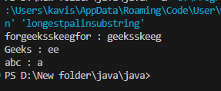

TIME COMPLEXITY : O(n^2)

SPACE COMPLEXITY : O(n)

**Rat in a maze problem**

**CODE :**

import java.util.ArrayList;public class ratmaze { public static void main(String[] args) { System.out.println(findPath(new int[][]{{1, 0, 0, 0}, {1, 1, 0, 1}, {1, 1, 0, 0}, {0, 1, 1, 1}})); } public static ArrayList<String> findPath(int[][] mat) { ArrayList<String> ans = new ArrayList<>(); int n = mat.length; boolean[][] vis = new boolean[n][n]; find(ans, 0, 0, mat, n, "", vis); return ans; } public static void find(ArrayList<String> ans, int r, int c, int[][] m, int n, String p, boolean[][] vis) { if (r == n - 1 && c == n - 1 && m[r][c] != 0) { ans.add(p); return; } if (r >= 0 && r < n && c >= 0 && c < n) { if (vis[r][c] || m[r][c] == 0) { return; } vis[r][c] = true; find(ans, r + 1, c, m, n, p + 'D', vis); find(ans, r, c - 1, m, n, p +'L', vis); find(ans, r, c + 1, m, n, p + 'R', vis); find(ans, r - 1, c, m, n, p +'U', vis); vis[r][c] = false; } }}

**OUTPUT :**

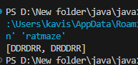

TIME COMPLEXITY : O(4^(n^2))

SPACE COMPLEXITY : O(n^2)