**Kth Smallest element**

**CODE :**

class Solution {

public static int kthSmallest(int[] arr, int k) {

Arrays.sort(arr);

return arr[k-1];

}

}

OUTPUT :

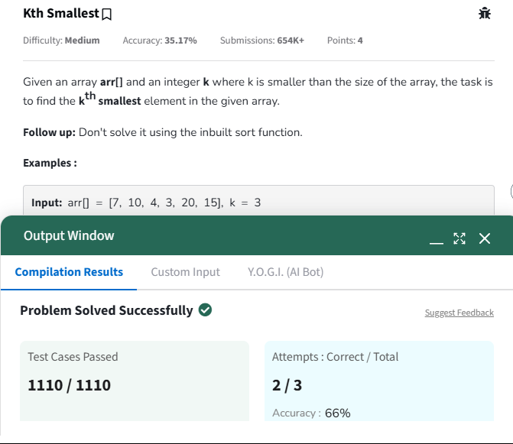

TIME COMPLEXITY : O(nlogn)

SPACE COMPLEXITY : O(1)

**MINIMIZE THE HEIGHTS II**

**CODE :**

class Solution {

int getMinDiff(int[] arr, int k){

int n =arr.length;

if( n == 1){

return 0;

}

Arrays.sort(arr);

int ans = arr[n-1] - arr[0];

int min = arr[0] + k;

int max = arr[n-1] - k;

for(int i=0; i<n-1; i++){

int min_ele = Math.min(min, arr[i+1]-k);

int max_ele = Math.max(max, arr[i]+k);

if(min_ele < 0)

continue;

ans = Math.min(ans, max_ele - min_ele);

}

return ans;

}

}

TIME COMPLEXITY : O(n)

SPACE COMPLEXITY : O(n)

**PARENTHESIS CHECKER :**

**CODE :**

class Solution {

static boolean isParenthesisBalanced(String s) {

Stack<Character> st = new Stack<>();

for(char ch : s.toCharArray()) {

if(ch == '(') {

st.push(')');

} else if(ch == '{') {

st.push('}');

} else if(ch == '[') {

st.push(']');

} else {

if(st.isEmpty() || st.pop() != ch) {

return false;

}

}

}

return st.isEmpty();

}

}

OUTPUT :

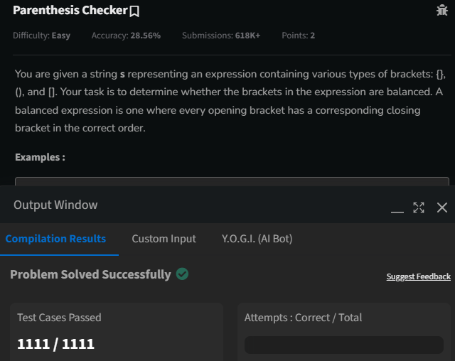

TIME COMPLEXITY : O(N)

SPACE COMEPLEXITY : O(N)

**EQUILLIBRIUM POINT :**

**CODE :**

public class equilibrium { public static void main(String[] args) { System.out.println(find(new int[]{1, 3, 5, 2, 2})); System.out.println(find(new int[]{1, 2, 3})); } public static int find(int arr[]) { int lsum = 0 , rsum = 0 ; int i = 0 , j = arr.length - 1; lsum += arr[i]; rsum += arr[j]; while(i+1<j-1){ if(lsum<rsum){ i++; lsum += arr[i]; } if(rsum<lsum){ j--; rsum += arr[j]; } if(rsum==lsum){ i++; lsum += arr[i]; j--; rsum += arr[j]; } } return lsum==rsum ? i+1 : -1; }}

**OUTPUT :**

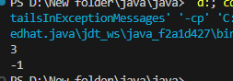

TIME COMPLEXITY : O(N)

SPACE COMPLEXITY : O(N)

**BINARY SEARCH :**

**CODE :**

public class binarysearch { public static void main(String[] args) { System.out.println(bs(new int[]{ 2, 3, 4, 10, 40 },10)); } static int bs(int arr[], int x) { int l = 0, r = arr.length - 1; while (l <= r) { int mid = l + (r - l) / 2; if (arr[mid] == x) return mid; if (arr[mid] < x) l = mid + 1; else r = mid - 1; } return -1; }}

**OUTPUT :**

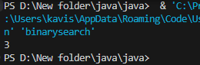

TIME COMPLEXITY : O(N)

SPACE COMPLEXITY : O(N)

**NEXT GREATER ELEMENT :**

**CODE :**

class Solution {

// Function to find the next greater element for each element of the array.

public ArrayList<Integer> nextLargerElement(int[] arr) {

int n = arr.length;

ArrayList<Integer> res = new ArrayList<>();

Stack<Integer> stack = new Stack<>();

for(int i=0;i<n;i++){

res.add(-1);

}

for(int i=0;i<n;i++){

while(!stack.isEmpty() && arr[stack.peek()]<arr[i]){

int ind=stack.pop();

res.set(ind,arr[i]);

}

stack.push(i);

}

return res;

}

}

OUTPUT :

Input = [12,15,17,9]

Output=[15,17,-1,-1]

TIME COMPLEXITY : O(N)

SPACE COMPLEXITY : O(N)

**UINON OF TWO ARRAYS WITH DUPLICATE ELELMENTS :**

**CODE :**

import java.util.HashSet;import java.util.Set;public class unionarrays { public static void main(String[] args) { System.out.println(findUnion(new int[]{1, 2, 3}, new int[]{2, 3, 4})); } public static int findUnion(int a[], int b[]) { Set<Integer> s = new HashSet<>(); for(int i : a){ s.add(i); } for(int j : b){ s.add(j); } return s.size(); }}

**OUTPUT :**

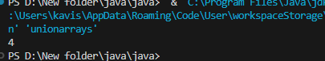

TIME COMPLEXTY :O(n)

SPACE COMPLEXITY :O(N)