**3SUM CLOSEST**

**CODE :**

class Solution { public int threeSumClosest(int[] nums, int target) { Arrays.sort(nums); int ans = nums[0] + nums[1] + nums[2]; int dif = Integer.MAX_VALUE; for(int i = 0 ; i<nums.length-2 ; i++){ int j = i +1; int k = nums.length - 1; while(j<k){ int s = nums[i] + nums[j] + nums[k]; if(s==target){ return s; } if(s<target){ j++; }else{ k--; } int d = Math.abs(s-target); if(dif>d){ dif = d; ans = s; } } } return ans; }}

OUTPUT :

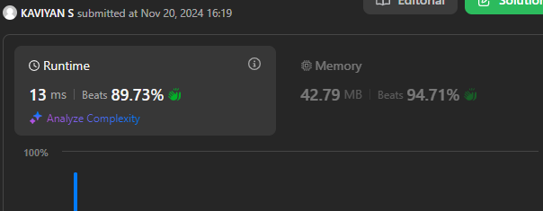

**JUMP GAME II**

CODE :

class Solution { public int jump(int[] nums) { int j = 0 , l = 0 , r = 0; while(r<nums.length - 1){ int f = Integer.MIN_VALUE; for(int i = l ; i<=r ; i++){ f = Math.max(i+nums[i] , f); } l= r+1; r = f; j++; } return j; }}

**OUTPUT :**

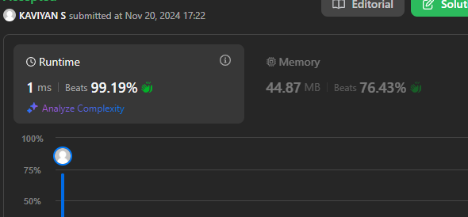

GROUP ANAGARAM’S

CODE :

class Solution { public List<List<String>> groupAnagrams(String[] strs) { HashMap<String , List<String>> hm = new HashMap<>(); for(int i = 0 ; i<strs.length ; i++){ char c[] = strs[i].toCharArray(); Arrays.sort(c); String s= new String(c); if(hm.containsKey(s)){ List<String> l = hm.get(s); l.add(strs[i]); hm.put(s,l); }else{ List<String> l = new ArrayList<>(); l.add(strs[i]); hm.put(s,l); } } List<List<String>> ans = new ArrayList<>(); for(Map.Entry<String,List<String>> e : hm.entrySet()){ ans.add(e.getValue()); } return ans; }}

OUTPUT :

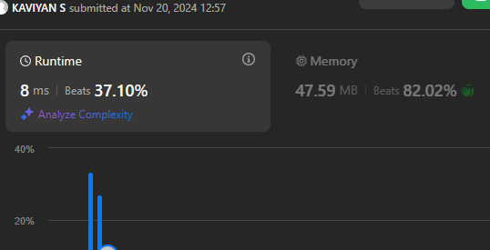

**DECODE WAYS**

**CODE :**

class Solution { public int numDecodings(String s) { int strLen = s.length(); int[] dp = new int[strLen + 1]; dp[0] = 1; if (s.charAt(0) != '0') { dp[1] = 1; } else { return 0; } for (int i = 2; i <= strLen; ++i) { if (s.charAt(i - 1) != '0') { dp[i] += dp[i - 1]; } if (s.charAt(i - 2) == '1' || (s.charAt(i - 2) == '2' && s.charAt(i - 1) <= '6')) { dp[i] += dp[i - 2]; } } return dp[strLen]; }}

OUTPUT :

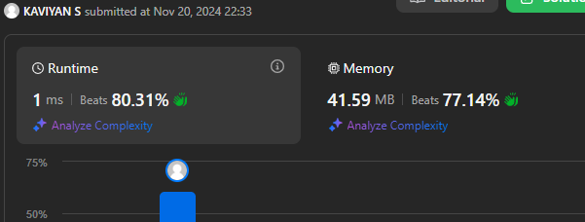

**BEST TIME TO BUY AND SELL STOCKS II**

**CODE :**

class Solution { public int maxProfit(int[] a) { int curr=a[0]; int profit=0; for(int i=1;i<a.length;i++){ if(a[i]<curr) curr=a[i]; else if(a[i]>curr) { profit+=a[i]-curr; curr=a[i]; } } return profit; }}

OUTPUT :

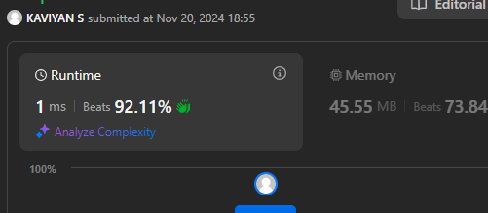

**NUMBER OF ISLANDS**

**CODE :**

class Solution { public void dfs(char[][]grid,int i,int j){ int m=grid.length,n=grid[0].length; if(i<0||j<0||i>=m||j>=n||grid[i][j]=='0')return; grid[i][j]='0'; dfs(grid,i+1,j); dfs(grid,i-1,j); dfs(grid,i,j+1); dfs(grid,i,j-1); } public int numIslands(char[][] grid) { int m=grid.length,n=grid[0].length,count=0; for(int i=0;i<m;i++){ for(int j=0;j<n;j++){ if(grid[i][j]=='1'){ count++; dfs(grid,i,j); } } } return count; }}

OUTPUT :

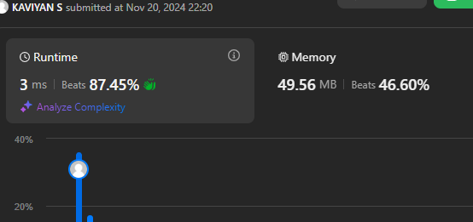

**MERGE SORT**

**CODE :**

class Solution {

void mergeSort(int arr[], int l, int r) {

if (l < r) {

int m = l + (r - l) / 2;

mergeSort(arr, l, m);

mergeSort(arr, m + 1, r);

merge(arr, l, m, r);

}

}

static void merge(int arr[], int l, int m, int r){

int n1 = m - l + 1;

int n2 = r - m;

int L[] = new int[n1];

int R[] = new int[n2];

for (int i = 0; i < n1; ++i)

L[i] = arr[l + i];

for (int j = 0; j < n2; ++j)

R[j] = arr[m + 1 + j];

int i = 0, j = 0;

int k = l;

while (i < n1 && j < n2) {

if (L[i] <= R[j]) {

arr[k] = L[i];

i++;

}

else {

arr[k] = R[j];

j++;

}

k++;

}

while (i < n1) {

arr[k] = L[i];

i++;

k++;

}

while (j < n2) {

arr[k] = R[j];

j++;

k++;

}

}

}

OUTPUT :

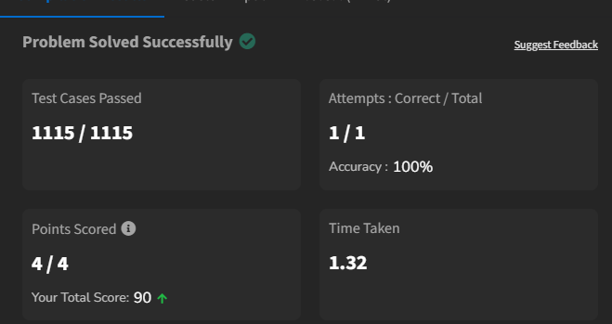

**QUICK SORT**

**CODE :**

class Solution {

static void quickSort(int arr[], int low, int high) {

if(low<high){

int pi = partition(arr,low,high);

quickSort(arr,low,pi-1);

quickSort(arr,pi+1,high);

}

}

static int partition(int arr[], int low, int high) {

int pivot = arr[high];

int i = low - 1;

for (int j = low; j <= high - 1; j++) {

if (arr[j] < pivot) {

i++;

swap(arr, i, j);

}

}

swap(arr, i + 1, high);

return i + 1;

}

static void swap(int[] arr, int i, int j) {

int temp = arr[i];

arr[i] = arr[j];

arr[j] = temp;

}

}

OUTPUT :

