./

CUSTOMER DATA MANAGEMENT SYSTEM DURING COVID-19

* CANDIDATE ID: 105082

Course Code: <CODE>



Version Number:

Team Members :

Team No:

Module: Model Based System Engineering

|  |  |  |  |  |  |
| --- | --- | --- | --- | --- | --- |
| **Ver. Rel. No.** | **Release Date** | **Prepared. By** | **Reviewed By** | **Approved By** | **Remarks/Revision Details** |
| 1.0 | 21/09/2020 | Lakshmi N |  |  |  |
| 1.1 | 23/09/2020 | Lakshmi N |  |  |  |
| 1.2 | 25/09/2020 | Lakshmi N |  |  |  |
|  |  |  |  |  |  |
|  |  |  |  |  |  |

**Document History**

# 

Table of Contents

1 INTRODUCTION 3

1.1 Problem Statement: 4

1.2 ProjectDescription**:** 4

2 REQUIREMENTS: 4

2.1 Software requirements: 4

2.2 Hardware requirements: 4

2.3 High Level requirements: 5

2.4 Low Level requirements: 5

3 DESIGN: 6

4 TEST PLAN: 8

4.1 Purpose: 8

4.2 Unit Testing: 8

4.3 Features to be tested: 8

4.4 Entry Criteria: 8

4.5 Exit Criteria: 8

5 TEST CASES: 9

6 CONCLUSION: 10

**Table of figures**

Figure 1: UML diagram of the system 7

# ****INTRODUCTION****

## **Problem Statement:**

An efficient data management system during the present covid-19 pandemic to ensure the proper keeping of customer data records in a shop.

## Project Description**:**

During the current Covid-19 situation, it has become a necessity to keep a record of the customers who visit a shop in order to ensure their safety. There is a high level of negligence from the customers’ side even after repeated requests from the Health Department authorities. The customer data management system ensures to keep the customer’s record in a more efficient manner when compared to the usual pen and paper method.

The proposed system records the details of the customers visiting a shop including their name, phone number and address. It includes a system to check the body temperature and proper sanitization. Due to unavailability of hardware components this can be achieved using functions in C programming language. This method could reduce the reporting of fake identities by people. The system also helps in monitoring the number of people entering the shop at a particular time thereby maintaining the social distancing norms.

# REQUIREMENTS:

## Software requirements:

The software requirements for this project are:

1. Code Blocks IDE
2. Microsoft word
3. Notepad

## Hardware requirements:

1. Operating System: Windows XP or above
2. Processor: Intel Core - 32 bit or above
3. RAM: 4GB or above

## High Level requirements:

|  |  |
| --- | --- |
| **ID** | **Description** |
| HL_01 | The system has an employee login. |
| HL_02 | Temperature check system |
| HL_03 | Sanitization check system |
| HL_04 | Restricted number of persons at a time |
| HL_05 | Customer details |

## Low Level requirements:

|  |  |
| --- | --- |
| **ID** | **Description** |
| LL_01 | The employees need to use the username and password provided which is stored in an employee. |
| LL_02 | Temperature check function ensures that the temperature of the customer is below a preset threshold. |
| LL_03 | Sanitization check functions ensures proper sanitization of the customers. |
| LL_04 | The system checks for the total number of persons inside the shop at a time to maintain the social distancing norms. |
| LL_05 | The customer details are stored in a document which can be used as a database. |
| LL_06 | The database should be accessible. |

# DESIGN:

The proposed system works with an employee login. If the employee logs-in successfully then he is redirected to select three options.

1. Enter new customer details
2. View customer details
3. Exit

The first option is used for adding new customer’s details onto the existing data document. In order to ensure the safety of both the employees and customers, Covid-19 protocol need to be obeyed. To make sure this, temperature check and sanitization is enabled.

The temperature can be checked using IR gun. But due to hardware constraints, a function is used with a threshold value. If the temperature of the person is above the threshold he/she is denied the entry to the shop. Sanitization is ensured using another function which returns a True value if the person is sanitized. The social distancing is ensured by permitting only a fixed number of persons inside the shop at a time. A variable is kept to maintain this count of people.

The second option enables the employee to view the already existing document containing the customer’s details.

The third option is the exit option to exit out of the program. The entire system is build using C programming language.

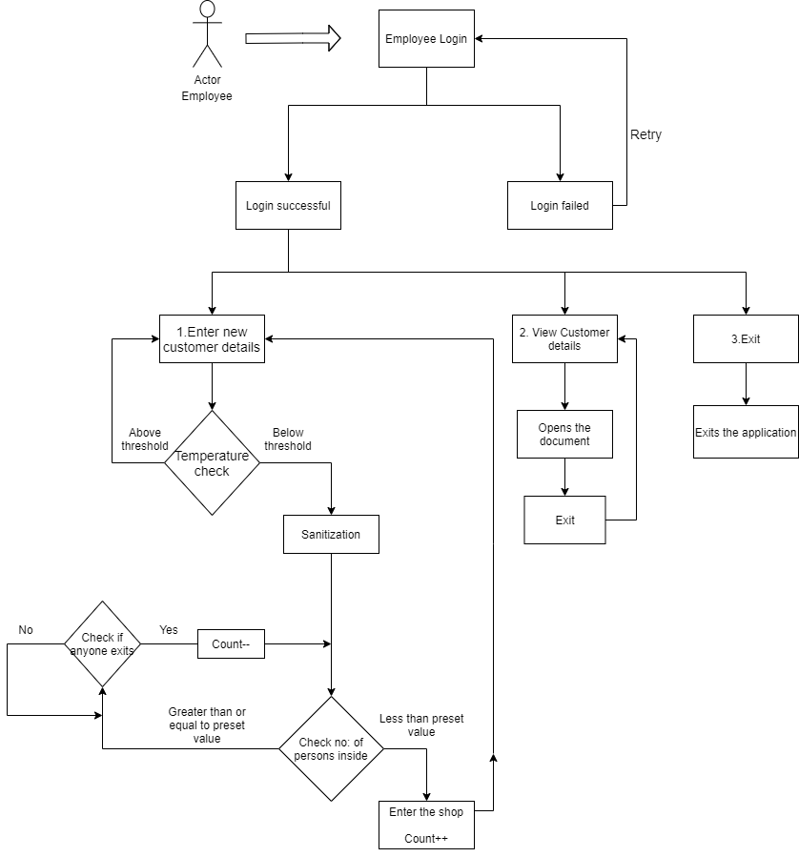

Figure 1: UML diagram of the system

# TEST PLAN:

## Purpose:

A test plan is a detailed document that describes the test strategy, objectives, schedule, estimation, deliverables, and resources required to perform testing for a software product. It serves as a blueprint to conduct software testing activities as a defined process.

## Unit Testing:

A unit test is a way of testing the smallest piece of code that can be logically isolated in a system. The purpose is to validate that each unit performs as expected.

## Features to be tested:

1. A valid login by the employee.
2. Checking the body temperature of the customer and proper sanitization.
3. Proper social distance monitoring.
4. Ensure the proper addition access of the document containing data.

## Entry Criteria:

1. Tasks are defined.
2. Procedures are defined.
3. Test cases are documented.

## Exit Criteria:

1. The test plan strategies have to be achieved.
2. All test cases need to be executed.
3. Tests cases should be passed or failed according to the condition.

# TEST CASES:

|  |  |  |  |  |  |
| --- | --- | --- | --- | --- | --- |
| TEST CASE ID | ACTION | INPUTS | ACTUAL OUTPUT | EXPECTED OUTPUT | STATUS |
| TC_01 | Employee Login | User-name=’mec’  Password=’123’ | “Login successful” | “Login successful” | PASS |
| TC_02 | Employee Login | User-name=’mac’  Password=’456’ | “Invalid Login, Please try again” | “Invalid Login, Please try again” | PASS |
| TC_03 | In login page | User enters 1 | Moves to enter new customer details page. | Moves to enter new customer details page. | PASS |
| TC_04 | In login page | User enters 2 | Moves to view customer details page. | Moves to view customer details page. | PASS |
| TC_05 | In login page | User enters 3 | Exits out of the application | Exits out of the application | PASS |
| TC_06 | Enter new customer details page:- phone no: check function | User enters- ‘0123456789’ | Valid Number | Valid Number | PASS |
| TC_07 | Enter new customer details page:- phone no: check function | User enters- ‘012345678’ | Invalid Number | Valid Number | FAIL |

|  |  |  |  |  |  |
| --- | --- | --- | --- | --- | --- |
| TC_08 | Enter new customer details page:- temperature check function | The value of temperature=38 (0C) | Below 41 0C:- function returns value 1 | Below 41 0C:- function returns value 1 | PASS |
| TC_09 | Enter new customer details page:- sanitization check function | Yes | Returns True | Returns True | PASS |
| TC_10 | Checking of no: of persons inside the shop | Count >=5 | Returns False | Returns False | PASS |
| TC_11 | Checking of no: of persons inside the shop | Count=3 | Returns True | Returns True | PASS |
| TC_12 | A persons leaves the shop | Nil | Count is reduced | Count is reduced | PASS |

# CONCLUSION:

The customer data management system is an efficient way to collect the data of the customers visiting the shops during this pandemic. This system reduces the need of people using the same pen and paper for writing their details while visiting the shops. This can be implemented in other places like temples, malls, etc.