1. What is Route 53?

Whenever user hits the url [www.jhooq.org](http://www.jhooq.org) it wil goes to DNS server i.e R53 it will try to resolve the request based on the name server setting. Once it resolved the request will forward to resource which is configured in EC2 instance , this request forwarding happening with the A-Record type.so we need to configure the below 2 components :

1.) Name server Record - For resolving the domain

2.) A-Record type – forwarding that particular req to the particular resource.

Note : we can server the request to any of the below shown resource like Ec2 , fargate,ECS,K8s , here we are using EC2.

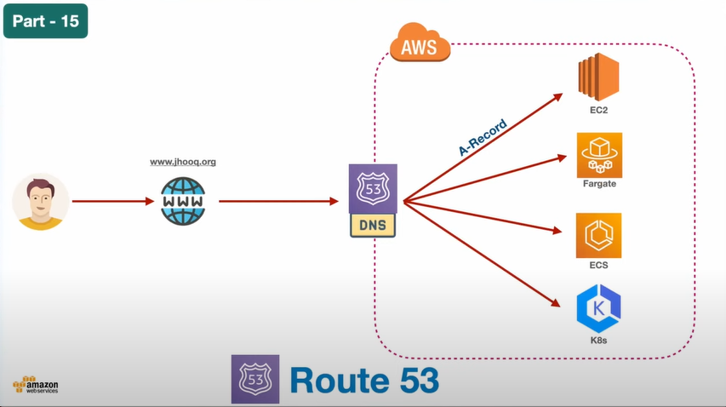

1. How to set up Hosted Zones inside Route 53

Lets assume we have a test.xyz website purchased from Godaddy or google doamins and for this we need to create a Hosted Zone for this website

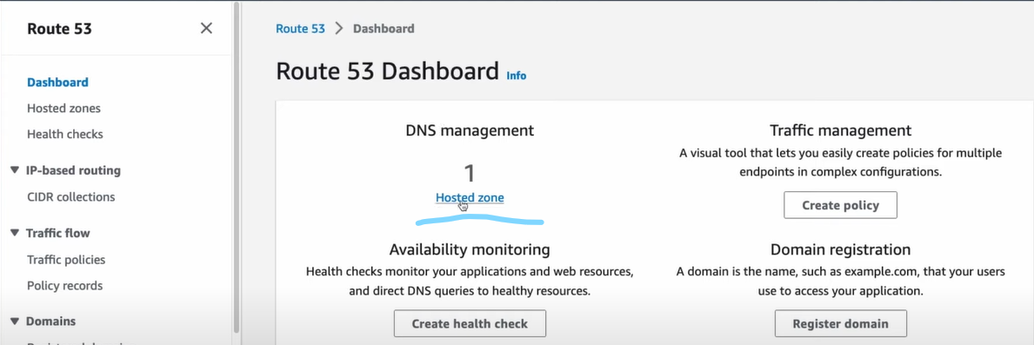

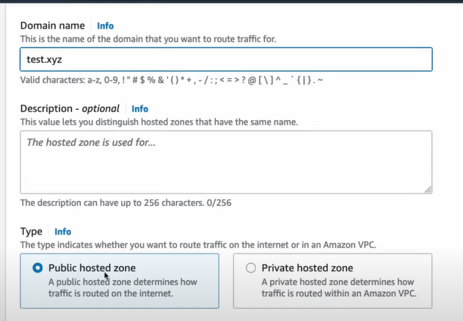

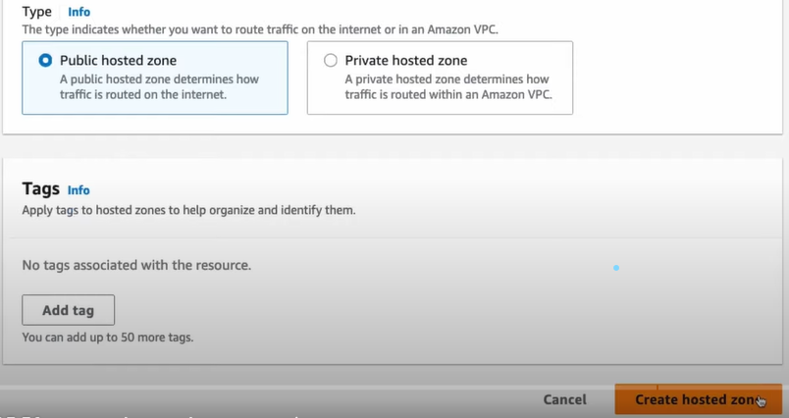

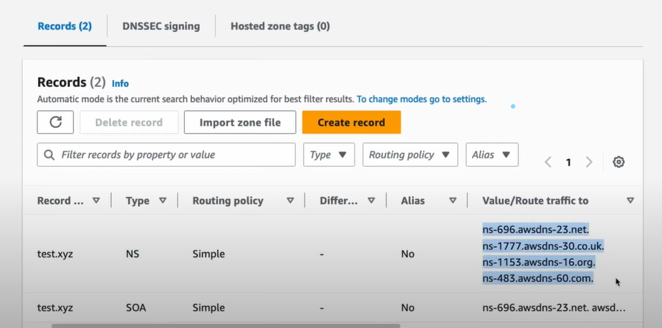

1. How to create custom Domain and how to integrate with AWS Route 53

Already we have a website i.e custom domain called [www.jhooq.org](http://www.jhooq.org) purchased form google domains for this we have already created hosted zones and the NS record values present in AWS R53 should be copied to google domains custom name servers.

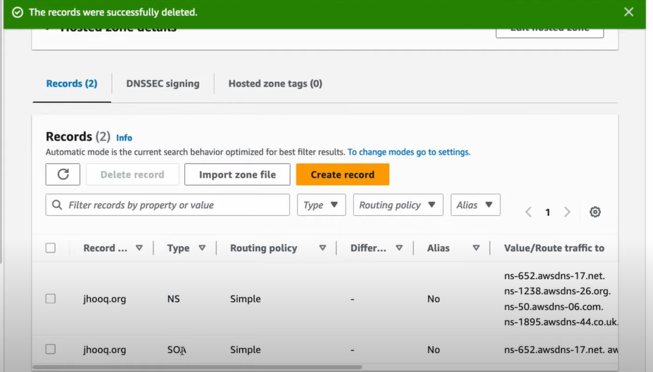

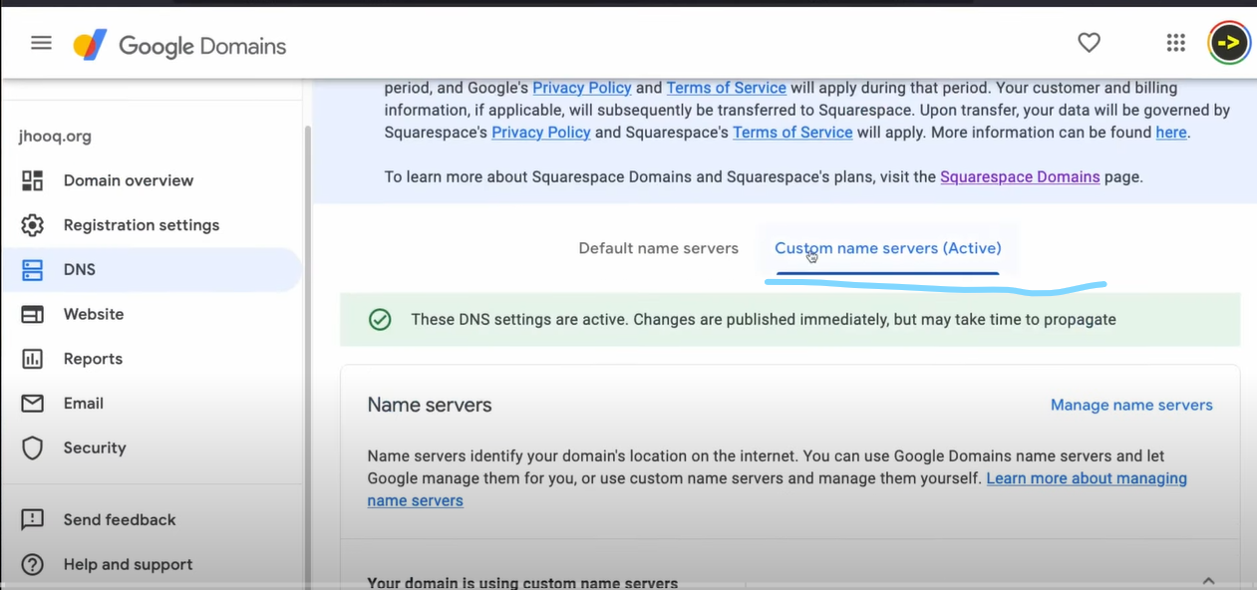

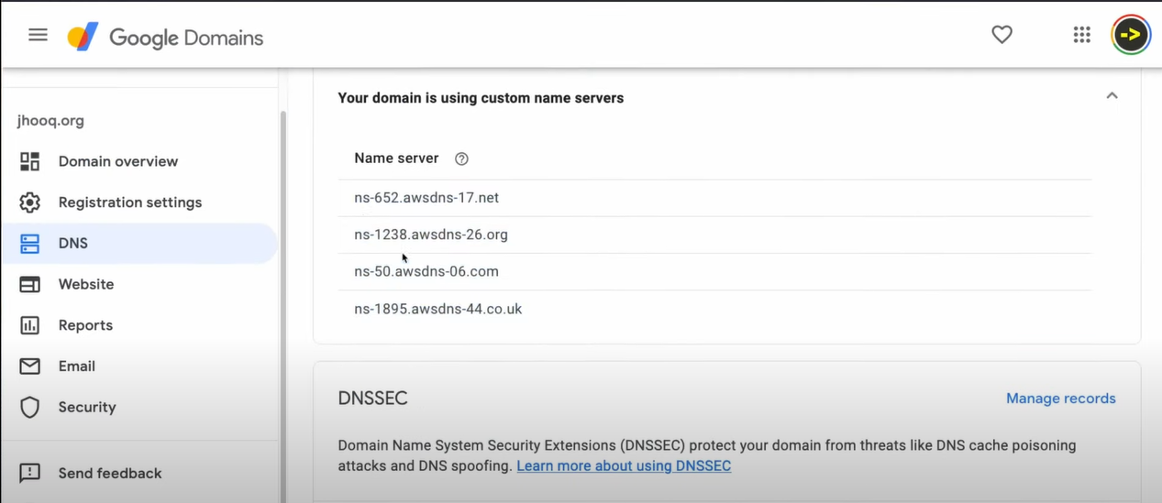

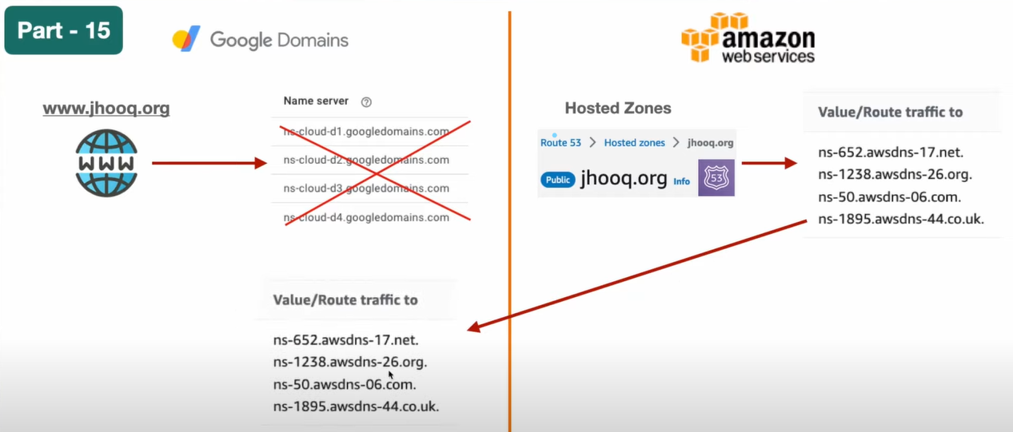

1. What is Name Server, A Name record, CNAME record and ALIAS record.

Create any EC2 instance and allow ssh 22 and http 80 ports for connecting to that server and access to the webserver(apache httpd server) that got installled into this server .

Auto enable public ip .

Now access this server with public ip

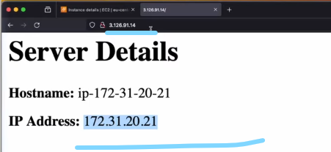

Here we are accessing the server (apache server home page)with public ip but we shouldn’t do like this instead we need to access the apache server home page with [www.jhooq.org](http://www.jhooq.org) , for this we need to crate a A record type in R53 hosted zone to point out to this particular Ec2 instance.

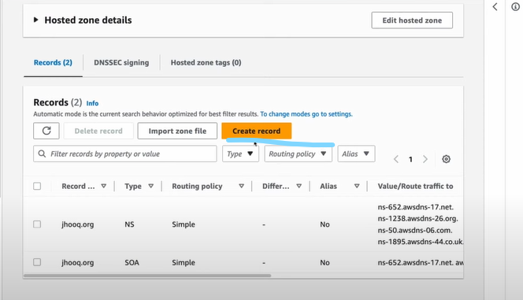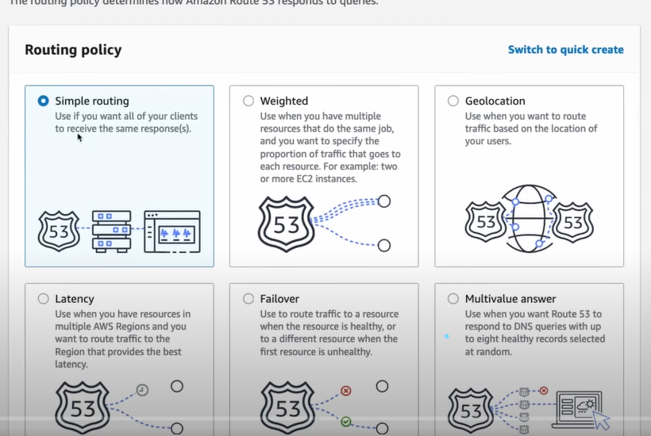

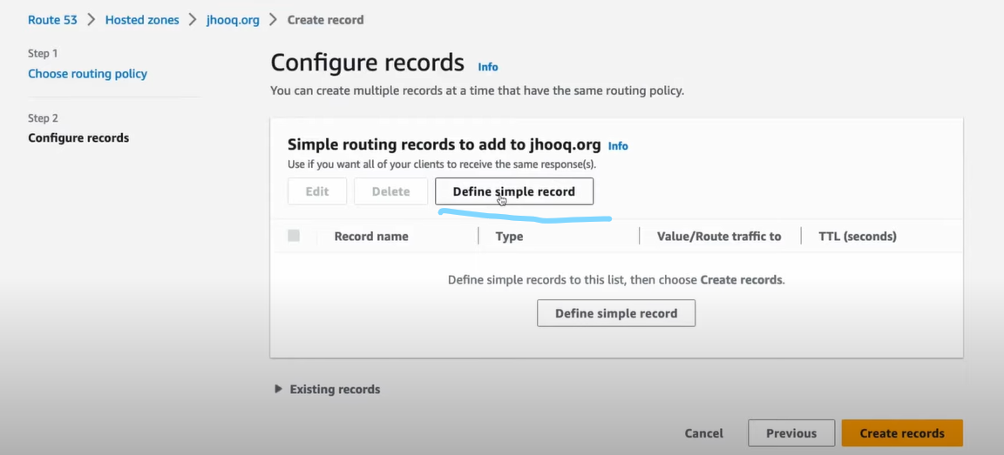

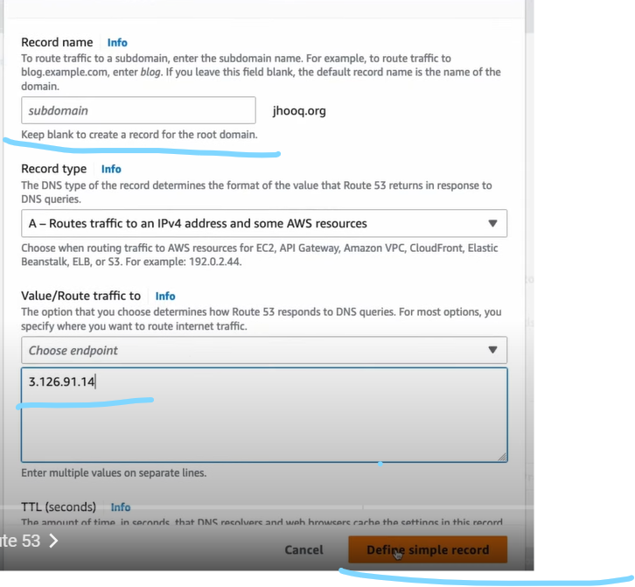

In the above keep the sub domain empty since we are not having sub domain.

Provide the Ec2 instance public ip address in the endpoint

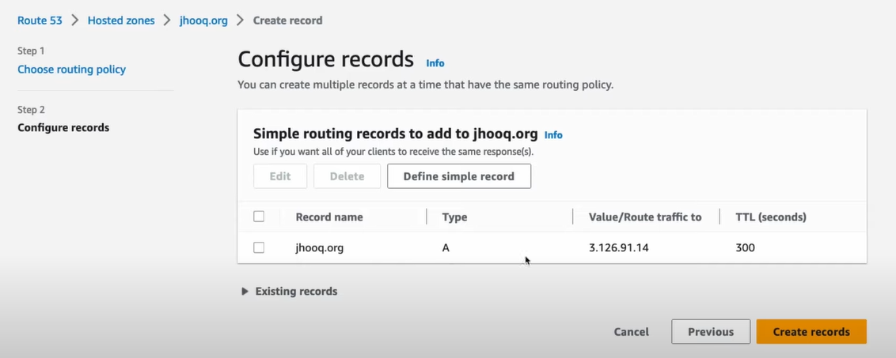

Edit the record and change the TTL to 10seconds for testing purpose.

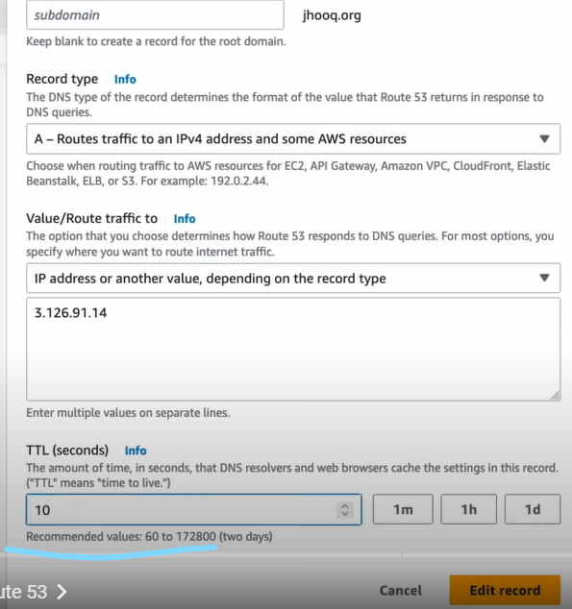

Now select the record and click on create record.

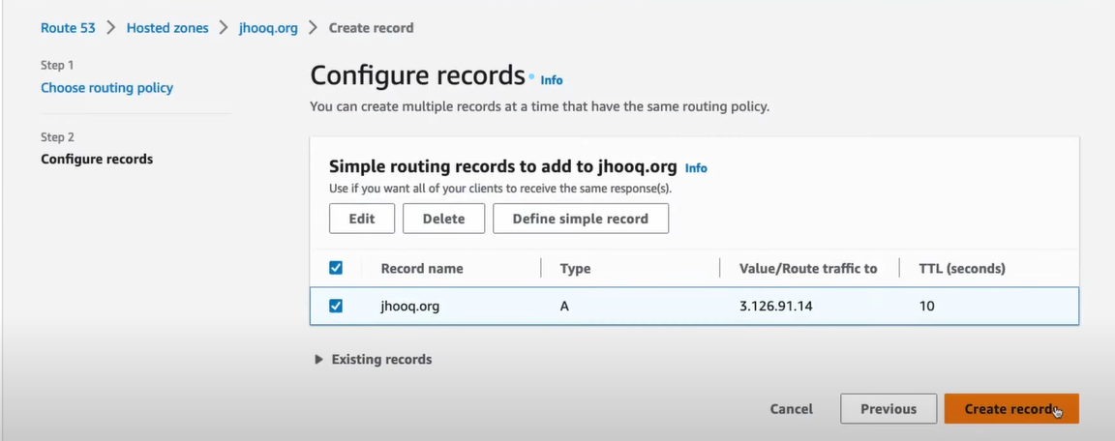

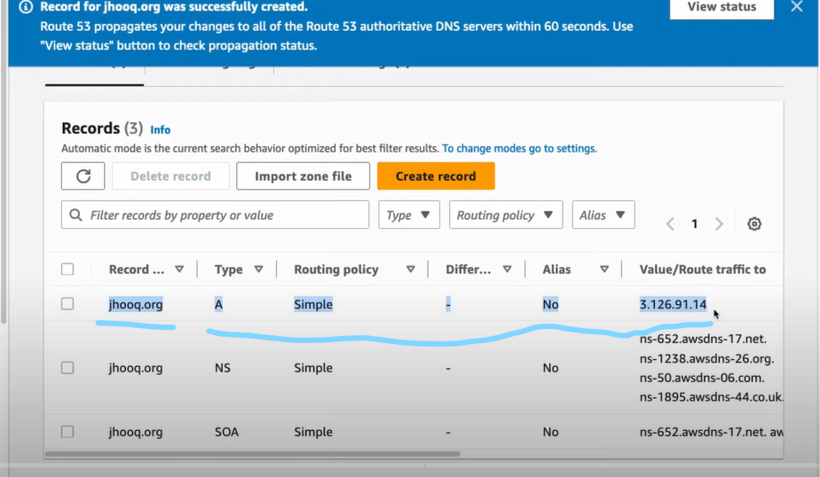

Now access the Ec2 instance with the custom Domain [www.jhooq.org](http://www.jhooq.org)

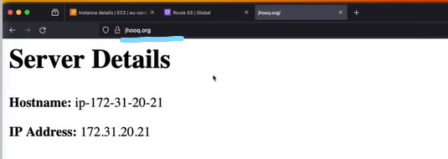

Routing Types?

1. Simple Routing

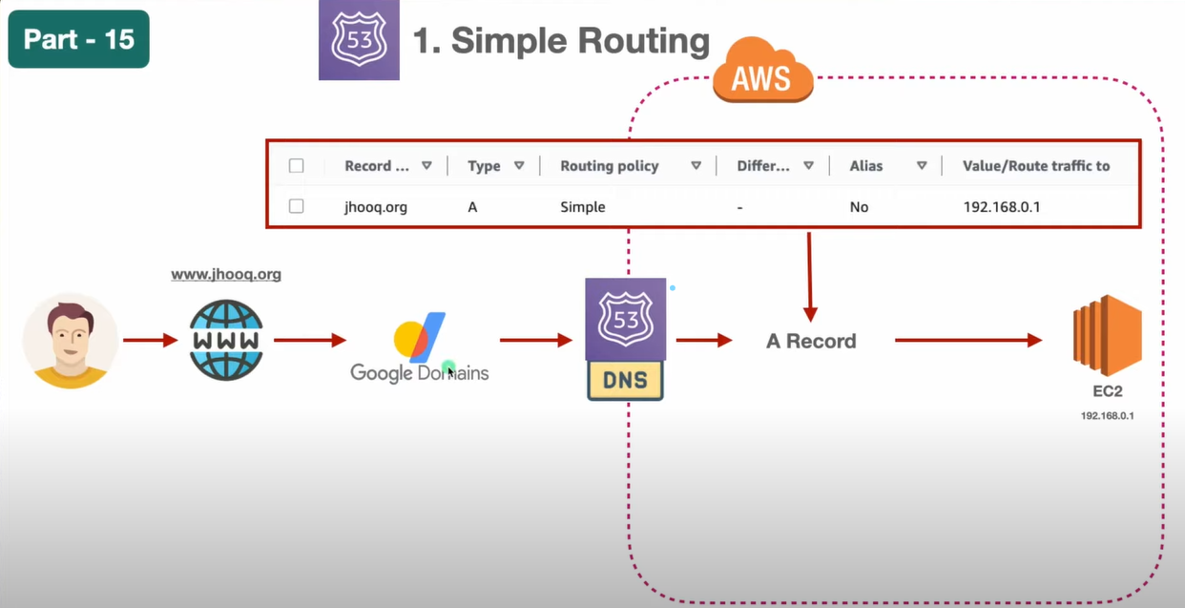

1. Weighted Routing: Depend on the no of requests coming.
2. Geolocation: depends on from which location the requests coming
3. Failover