2D FLAPPY BIRD

Project submitted to the
SRM University – AP, Andhra Pradesh
for the partial fulfillment of the requirements to award the degree of
Bachelor of Technology
In
Computer Science and Engineering
School of Engineering and Sciences
Submitted by
Varshini Gurram (AP23110011567)
Gopika Duggempudi(AP23110011571)
Lakshmi Poojitha Bonthu(AP23110011560)

Under the Guidance of
Ms. V. Veda Sri
Lecturer, Department of CSE
SRM University–AP
Neerukonda, Mangalagiri, Guntur
Andhra Pradesh – 522 240
[April, 2025]
Certificate

Date: 23-04-2024

This is to certify that the work present in this Project entitled “2D FLAPPY BIRD” has been carried out by our team under my/our supervision. The work is genuine, original, and suitable for submission to the SRM University – AP for the award of Bachelor of Technology/Master of Technology in School of Engineering and Sciences.

Supervisor

(Signature)
Prof. / Dr. [Name]
Designation,
Affiliation.

Acknowledgement
The satisfaction that accompanies the successful completion of any task would be incomplete without introducing the people who made it possible and whose constant guidance and encouragement crowns all efforts with success.
I am extremely grateful and express my profound gratitude and indebtedness to my project guide, Mrs. Kavitha Rani Karnena, Department of Computer Science & Engineering, SRM University, Andhra pradesh, for her kind help and for giving me the necessary guidance and valuable suggestions in completing this project work.

Varshini Gurram (AP23110011567)
Gopika Duggempudi(AP23110011571)
Lakshmi Poojitha Bonthu(AP23110011560)

Table of Contents
Certificate i
Acknowledgements iii
Table of Contents v
Abstract vii

1. Introduction 1
1.1 Heading 2 1
1.1.1 Heading 3 1
2. Methodology 3
2.1 Heading 2 3
2.1.1 Heading 3 3
3. Implementation 5
4. Result and Analysis 7
5. Discussion and Conclusion 9
6. Future Work 10
References 11

Abstract
This project involves the development of a classic arcade-style game, Flappy Bird, using Python. The game features a bird navigating a series of obstacles, with the player controlling its flight. This report details the game's design, implementation, and core mechanics. Key aspects of the development include:
- Game Mechanics: Implementing the bird's movement, obstacle generation, and collision detection.
- Library Usage: Leveraging the Pygame library for graphics rendering, event handling, and sound effects.
- Scoring System: Designing a system to track and display the player's score.
- User Interface: Creating a simple and intuitive interface for gameplay.
The project demonstrates the use of Python in developing interactive and engaging games.

Introduction
This project involves the development of a classic arcade-style game, Flappy Bird, using Python. The game features a bird navigating a series of obstacles, with the player controlling its flight.
Background and Significance:
The Flappy Bird game, originally created by Vietnamese developer Dong Nguyen, quickly gained immense popularity in 2013 and early 2014. Its simple yet challenging gameplay captivated millions of players worldwide. This project serves as an exercise in game development, providing hands-on experience in creating interactive software using Python. Game development provides a practical way to learn fundamental programming concepts, including event handling, game logic, and user interface design. The popularity of Flappy Bird also highlights the appeal of simple, addictive games and the impact a single developer can have in the gaming world.
Context:
This project is undertaken as part of a software development learning process. It allows us to apply theoretical knowledge of programming to a real-world application. In a broader context, this project demonstrates how a seemingly simple game can involve complex programming challenges and serve as a valuable tool for understanding software development principles.
Scope and Purpose:
The scope of this project is to create a functional Flappy Bird game using Python. This includes:
- Implementing the core game mechanics, such as bird movement, obstacle generation, and collision detection.
- Utilizing the Pygame library for graphics rendering, event handling, and sound effects.
- Designing a scoring system to track and display the player's score.
- Creating a simple and intuitive user interface for gameplay.
The purpose of this project is to demonstrate the use of Python in developing interactive and engaging games. It also aims to solidify our understanding of game development principles and the application of programming concepts in a practical context. Furthermore, the project aims to provide a foundation for more advanced game development projects and explore the capabilities of Python and the Pygame library.

Methodology
The development of this Flappy Bird game followed an iterative and event-driven programming methodology.
Event-Driven Architecture: The core of the game's logic is structured around an event-driven model. The game continuously listens for and processes events, primarily user input (key presses) and system events (like window closing). The game's behavior and state transitions are directly triggered by these events. This approach allows for a responsive and interactive gameplay experience where actions occur based on player input.
Modular Design: The code base is organized into logical modules and functions, each responsible for specific aspects of the game. This includes separate sections for initialization, handling game states, updating game elements (bird, pipes), collision detection, scoring, managing the high score, handling visual themes, rendering the game, and managing audio. This modularity enhances code readability, maintainability, and allows for easier expansion or modification of individual game features.
Iterative Development: While not explicitly documented in the code, the development likely involved an iterative process. Core functionalities like bird movement, pipe generation, and basic collision detection would have been implemented first, followed by enhancements such as scoring, game states, visual themes, audio, and the dashboard. This iterative approach allows for testing and refinement of core mechanics before adding more complex features.
State Management: The game employs a state machine using the game state variable to manage different phases of the game (waiting for start, playing, and game over, paused). This state management is crucial for controlling which parts of the game logic are active and what the player sees and can do at any given time.
Resource Management: The game includes mechanisms for loading and managing game resources such as images and sound files, with error handling to gracefully manage situations where these resources might be missing. It also handles the saving and loading of the high score to ensure data persistence.

Software Requirements Specification: Flappy Bird Game
The Flappy Bird game is a 2D side-scrolling arcade game where the player controls a bird, navigating it through a series of pipes. The game's objective is to achieve the highest possible score by successfully passing through the most pipes.

Functional Requirements
- FR1: Game Initialization: The game shall initialize the game window with a specified resolution. The game shall load and display the necessary game assets, including bird, pipe images, and background. The game shall initialize the game state, including bird position, pipe positions, and score.
- FR2: Bird Control: The player shall be able to control the bird's upward movement using a specified input method (e.g., spacebar, mouse click). The bird shall move upwards in response to the player's input. The bird shall be affected by gravity, causing it to descend over time.
- FR3: Obstacle Generation: The game shall generate a series of pipes (obstacles) with varying heights. The pipes shall move horizontally across the screen towards the player. The game shall ensure that there is a gap between the pipes for the bird to pass through.
- FR4: Collision Detection: The game shall detect collisions between the bird and the pipes. The game shall detect collisions between the bird and the top or bottom boundaries of the game window. Upon collision, the game shall transition to the "game over" state.
- FR5: Scoring: The game shall award points to the player for each successfully passed pipe. The game shall display the player's current score on the screen. The game shall update the score in real-time as the player progresses.
- FR6: Game Over: When a collision occurs, the game shall display a "game over" screen. The "game over" screen shall display the player's final score. The game shall provide an option for the player to restart the game.
- FR7: Sound Effects the game shall play sound effects for specific actions. The game shall play a sound when the bird flaps. The game shall play a sound when the bird collides with a pipe. The game shall play a sound when the player scores a point.

Non-Functional Requirements
The system should also adhere to the following non-functional requirements:
- NF1: Performance: The game shall maintain a consistent frame rate to ensure smooth gameplay. The game shall respond to user input with minimal delay.
- NF2: Usability: The game shall have a simple and intuitive user interface. The game controls shall be easy to learn and use.
- NF3: Portability: The game shall be playable on any system with the required Python environment and Pygame library.
- NF4: Maintainability: The game code shall be well-structured and documented to facilitate future modifications and updates.
- NF5: Reliability: The game shall function without errors and crashes during normal gameplay.

Implementation
The Flappy Bird game is implemented using the Pygame library, a free and open-source Python module designed for making multimedia applications like games.
Pygame Initialization: The implementation begins by initializing Pygame modules, including the core Pygame functionalities (pygame.init()) and the audio mixer (pygame.mixer.init()).
Screen Setup: The game window is created with defined dimensions (WIDTH, HEIGHT), and the display caption is set. A Pygame Clock object is used to control the game's frame rate (FPS), ensuring smooth animation.
Game Variables: Various game parameters are initialized, including the bird's position and properties, pipe properties (width, gap, horizontal position, and height), game state, score, level, and velocity.
Resource Loading: The implementation includes functions to load images (pygame.image.load ()) for the bird and pipes, and sound files (pygame.mixer.Sound()) for jump, hit, and pass actions. Error handling is included to manage cases where these files might not be found.
Theme Management: Two dictionaries (LIGHT_THEME, DARK_THEME) store colour palettes for different visual themes. A current theme variable tracks the active theme, and a toggle_theme () function allows switching between them.
Event Handling Loop: The main game logic resides within a while running: loop. Inside this loop, pygame.event.get () retrieves all events that have occurred. Key press events (pygame.KEYDOWN) are specifically handled to trigger actions based on the pressed key and the current game state.
Game State Logic: Conditional statements based on the game_state variable control the execution of different game logic:
- WAITING_FOR_START: Displays instructions and waits for the start key (TAB).
- PLAYING: Updates bird and pipe positions, checks for collisions, handles scoring and leveling, and plays sound effects.
- GAME_OVER: Displays the game over message and allows restarting with the spacebar. It also handles saving new high scores.
- PAUSED: Freezes game movement and displays a pause message.
Bird Movement: The bird's vertical movement is simulated using gravity and an upward velocity applied on jumping. Its position is updated in each frame.
Pipe Generation and Movement: Pipes are generated with random heights and move horizontally across the screen. When a pipe goes off-screen, it is reset with a new random height.
Collision Detection: The code checks for collisions between the bird and the screen boundaries (top and bottom) and with the upper and lower pipes.
Scoring and Levelling: The score is incremented when the bird passes a pipe. The game level increases at score milestones, reducing the gap between pipes to increase difficulty.
Rendering: In each frame, the screen is cleared and redrawn with the background, bird, pipes, ground, and any relevant text messages (score, game over, pause, level up, tutorial) using Pygame's drawing functions (pygame.draw.rect(), screen.blit(), font rendering).
Dashboard Implementation: A dedicated section of the screen is used to display real-time game information. This involves drawing a background rectangle and rendering text for various game parameters.
Audio Implementation: Pygame's mixer is used to load and play sound effects for jumping, hitting, and passing pipes, triggered by corresponding game events.
High Score Management: The game reads the high score from a text file at the start and writes to it whenever a new high score is achieved or when the reset function is called.

Additional Features beyond the Original Flappy Bird
This Pygame implementation of Flappy Bird incorporates several enhancements and additional features that extend beyond the core mechanics of the original game:
- Visual Themes (Light and Dark): The game offers players the ability to switch between a light and a dark color theme. This allows for customization of the visual experience based on preference or viewing conditions, adding a layer of personalization not present in the original.
- Dashboard with Real-time Information: A dedicated dashboard is implemented on the side of the game screen. This panel provides a continuous display of various game parameters, including the current score, the high score, the current game level, the active theme, the current game state (waiting, playing, game over, paused), and even internal variables like gravity, bird velocity, and pipe positions. This feature offers players and observers a deeper insight into the game's dynamics and can be particularly useful for understanding gameplay mechanics or for debugging purposes.
- Level Progression with Dynamic Difficulty: While the original game's difficulty steadily increases with speed, this implementation introduces distinct game levels tied to the player's score. Upon reaching score milestones (multiples of 10), the game level increases, and the gap between the pipes dynamically decreases, providing a more structured and noticeable increase in difficulty as the player progresses. A visual "Level Up!" message briefly appears to indicate this change.
- Tutorial Screen: The game includes a tutorial screen that appears in the initial "waiting for start" state. This screen provides clear instructions to new players on how to start the game, control the bird (jump), pause/resume, toggle the theme, and the basic objective of avoiding obstacles. This improves the initial user experience by providing guidance.
- Pause Functionality: The addition of a pause state allows players to temporarily halt the gameplay by pressing the 'P' key and resume it later. This provides a convenience not available in the original, allowing for breaks without losing progress.
- High Score Reset: The game includes a feature to reset the recorded high score by pressing the 'R' key. This offers players a way to clear the high score and start fresh, perhaps after significant gameplay or if a new player wants to set their own record.
- Total Jumps Counter: The dashboard tracks and displays the total number of jumps the player has made during the current game session. This is a simple statistic that adds a bit more information about the player's interaction with the game.
These additional functionalities enhance the user experience, provide more information about the game state, and introduce a more structured difficulty progression compared to the original Flappy Bird game.

Design (DFD Diagram):

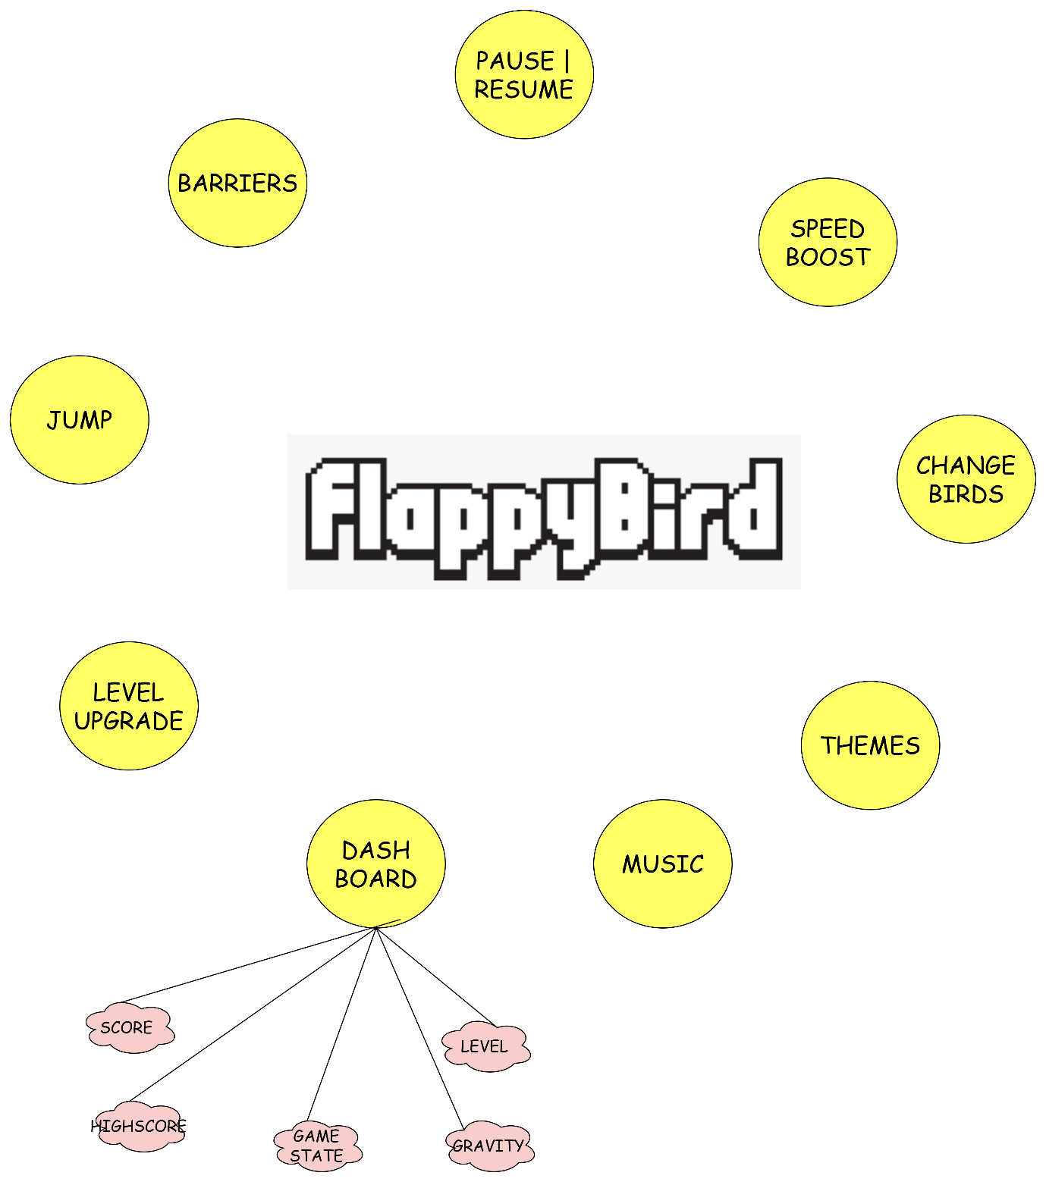

Result and Analysis
The implemented Flappy Bird game successfully recreates the core gameplay loop of the original while incorporating several additional features. The game effectively responds to player input, simulates bird physics and pipe movement, detects collisions accurately, and maintains a functioning scoring and levelling system. The inclusion of a dashboard provides real-time feedback on various game parameters, offering insights into the game's state and mechanics.
Core Gameplay: The fundamental mechanics of flapping, navigating through pipes, and scoring points are implemented as intended. The bird responds promptly to spacebar presses, and the scrolling pipes present a consistent challenge. The collision detection accurately identifies impacts with pipes and the ground, triggering the game over state.
Scoring and Level Progression: The scoring system correctly increments the player's score upon successfully passing pipes. The level progression, tied to score milestones, introduces a dynamic increase in difficulty by reducing the pipe gap. The "Level Up!" message provides clear feedback to the player about their progress.
Additional Features: The implemented enhancements significantly enrich the gameplay experience:
- Visual Themes: The light and dark theme toggle provides a degree of personalization and caters to different viewing preferences. The transition between themes is seamless and affects all relevant game elements.
- Dashboard Information: The real-time display of game parameters in the dashboard offers valuable information. For players, it provides immediate feedback on their score, level, and other statistics. For analysis and debugging, it offers a live view of the game's internal state, including velocities, positions, and game state transitions.
- Tutorial Screen: The initial tutorial effectively guides new players on how to interact with the game, improving the initial user experience and reducing the learning curve.
- Pause Functionality: The pause and resume functionality provides a convenient way for players to temporarily interrupt and later continue their game without losing progress.
- High Score Management: The game successfully saves and loads the high score, providing a persistent record of the player's best performance. The reset high score functionality offers an option to clear this record.
- Total Jumps Counter: While a minor addition, the total jumps counter provides an interesting statistic about player interaction.
Performance: The game runs smoothly at the targeted frame rate (60 FPS) on the testing environment. The use of Pygame's blitting for drawing and the relatively simple game logic contribute to this performance. However, more complex additions or a larger number of game elements could potentially impact performance, requiring optimization.
Code Structure and Maintainability: The modular design of the code, with separate sections for different functionalities, enhances readability and maintainability. The use of descriptive variable names and comments further contributes to code understanding. This structure would facilitate future modifications or additions to the game.
OUTPUT SCREENSHOTS:

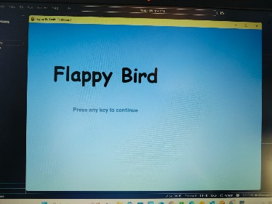

Themes:

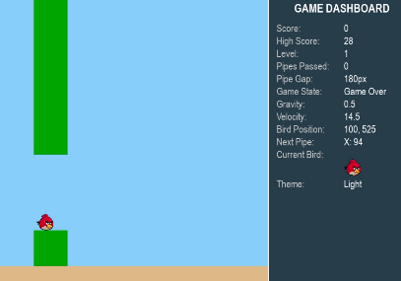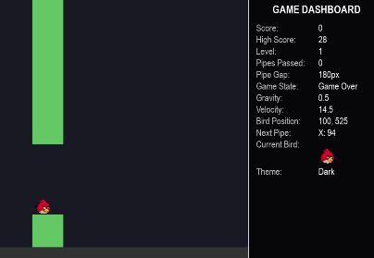

Birds:

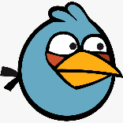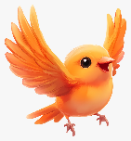

Discussion and Conclusion:
Potential Areas for Improvement:

- Visual Enhancements: While functional, the visuals could be further enhanced with more detailed sprites for the bird and pipes, background animations, or particle effects.
- Sound Design: Expanding the soundscape with additional sound effects for level up or other events could improve immersion.
- User Interface: The font used for text elements could be refined for better visual appeal. The layout of the tutorial and game over screens could also be further polished.
- Difficulty Scaling: While the level system introduces dynamic difficulty, further refinement of the difficulty curve could be explored, potentially adjusting pipe speed or the frequency of pipe generation.
- Platform Independence: While Pygame is cross-platform, considerations for different screen resolutions and aspect ratios could be implemented for wider compatibility.
Conclusion:
The implemented Flappy Bird game is a successful project that not only recreates the classic gameplay but also introduces valuable enhancements like visual themes, a comprehensive dashboard, level progression, pause functionality, and high score management. The event-driven architecture and modular code structure contribute to a functional and maintainable codebase. The additional features significantly enrich the user experience and provide deeper insights into the game's mechanics. While there are areas for potential future improvement, the current implementation provides a solid and engaging Flappy Bird experience.

Future Scope
The current implementation of the Flappy Bird game provides a solid foundation with several enhancements. However, there are numerous avenues for future development and expansion:
Gameplay Enhancements:
- Power-ups: Introduce power-ups that the player can collect to gain temporary advantages, such as invincibility, speed boosts, or the ability to temporarily widen the pipe gap.
- Varied Obstacles: Implement different types of obstacles beyond simple pipes, such as moving pipes, pipes with varying widths, or even temporary hazards like flying enemies.
- Special Game Modes: Introduce alternative game modes with different challenges, such as a time trial mode, an endless mode with increasing difficulty, or a "reverse" mode where the bird flies downwards.
- Multiplayer Mode: Explore the possibility of a local or online multiplayer mode where players compete to achieve the highest score simultaneously or race through a set course.
- Cosmetic Customization: Allow players to unlock or purchase different skins for the bird or visual styles for the pipes and background, adding a layer of personalization and progression.
- Environmental Variety: Implement different background environments that change as the player progresses through levels or achieve certain scores, adding visual interest.
Technical and Design Improvements:
- Improved Visuals and Animations: Enhance the visual appeal with smoother animations for the bird and pipes, parallax scrolling for the background, and more detailed sprites.
- Enhanced Sound Design: Expand the soundscape with more varied and immersive sound effects and potentially background music.
- User Interface (UI) Overhaul: Redesign the UI elements (menus, tutorial, game over screen, dashboard) for better aesthetics and user-friendliness.
- Adaptive Difficulty: Implement a more dynamic difficulty adjustment system that adapts to the player's skill level in real-time.
- AI Opponent (for potential multiplayer): Develop a basic AI opponent for practice or a single-player competitive mode.
- Platform Porting: Explore porting the game to other platforms, such as mobile (Android, iOS) or web browsers (using PyScript or similar technologies).
- Integration with Leaderboards and Achievements: Implement online leaderboards to allow players to compare their scores globally and integrate an achievement system to provide long-term goals.
- Analytics Tracking: Integrate basic analytics to track player behavior, identify areas of difficulty, and inform future design decisions.
By exploring these future scope possibilities, the current Flappy Bird implementation can evolve into a more engaging, feature-rich, and potentially competitive gaming experience. The modular design of the existing codebase provides a solid framework for incorporating these expansions.

References
https://flappybird.io/
https://www.pygame.org/docs/
https://realpython.com/pygame-a-primer/
https://freesound.org/
https://itch.io/game-assets/free

