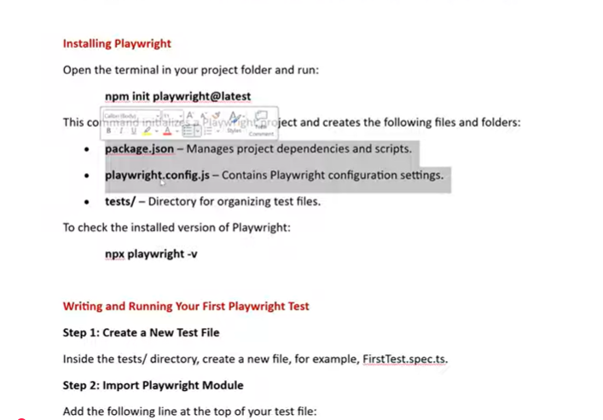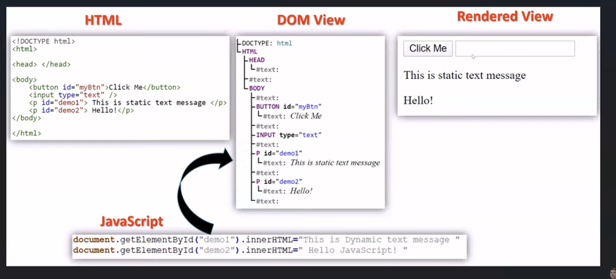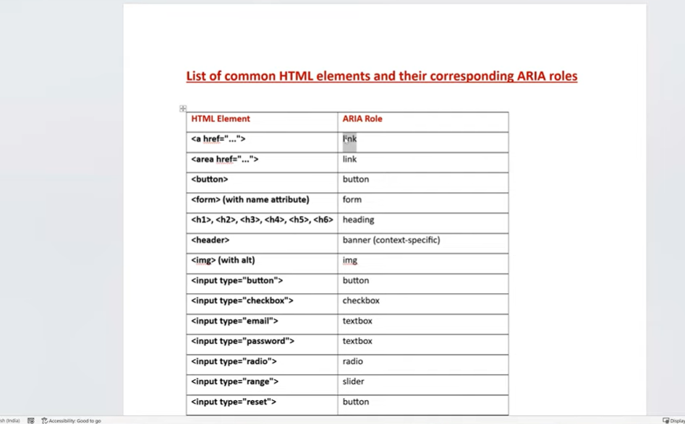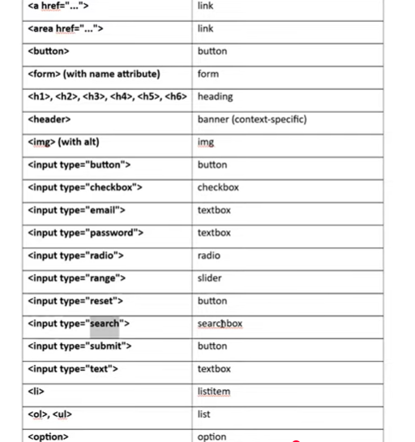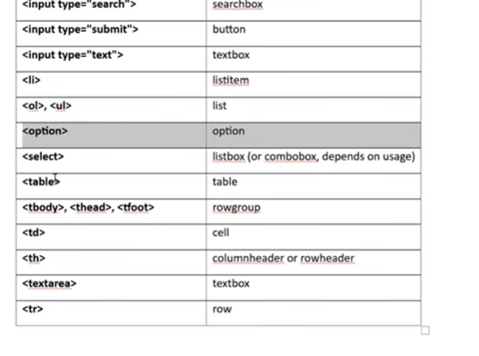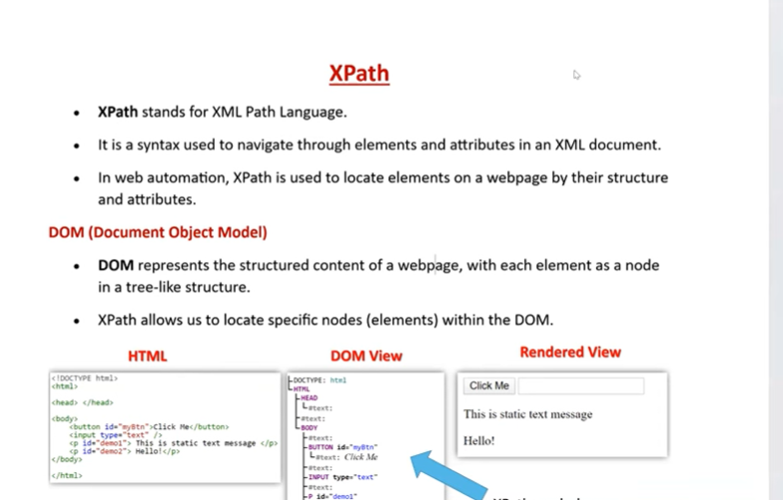
textContent() and innerText() both read text from an element, but they behave differently.
textContent():
- returns the raw text from the DOM
- includes hidden text
- does not care about CSS visibility
- faster and more direct
innerText():
- returns the visible, rendered text
- ignores hidden elements
- respects layout and styling
- closer to what a user actually sees

