Project Documentation
Crime Incident Analysis Dashboard
1. Project Overview
The Crime Incident Analysis Dashboard – 2025 is a data visualization project developed to analyze crime incidents recorded during the year 2025. The main objective of this project is to transform raw crime data into meaningful and easy-to-understand insights using data cleaning, transformation, modelling, and interactive dashboard design techniques.
The project focuses on identifying crime patterns, high-incident locations, time-based trends, and offense distribution across districts and neighborhoods. The final outcome is an interactive Power BI dashboard that supports data-driven understanding through filters, drillthrough pages, hierarchies, and dynamic measures.

2. Tools Used
- Microsoft Excel – Data cleaning and preprocessing
- Power Query – Data transformation
- Power BI Desktop – Data modeling and dashboard development
- DAX (Data Analysis Expressions) – Creating calculated measures

3. Dataset Information
- Source: Crime_Incidents_in_2025.csv (2025 crime incidents dataset)
- The dataset contains the following key fields:
  - Case Control Number (Unique ID)
  - Offense Type
  - Crime Method
  - District
  - Ward Number
  - Neighborhood Cluster
  - Report Date
  - Time Shift (Day / Evening / Night)
  - Latitude and Longitude (for map visualization)
The dataset includes location-based, time-based, and category-based information required for comprehensive analysis.

4. Data Cleaning and Preparation
4.1 Data Cleaning in Excel
The raw dataset was first imported into Microsoft Excel for preprocessing. The following steps were performed:
- Removed duplicate records to ensure accuracy, removed null values.
- Deleted unwanted or irrelevant columns that were not required for analysis.
- Handled missing values by verifying and correcting incomplete entries.
- Standardized column names for consistency.
- Formatted date columns properly for time-based analysis.
- Checked data consistency across categorical fields such as District and Offense Type.
After cleaning, the dataset was structured properly and saved for further transformation.

4.2 Data Transformation Using Power Query
The cleaned Excel dataset was then imported into Power BI. Power Query was used for additional transformation and structuring:
- Cleaned and simplified column headers.
- Changed data types (Date, Text, Decimal) correctly.
- Removed unnecessary columns that were not useful for reporting.
- Ensured proper formatting of date and location fields.
- Verified relationships and prepared the dataset for modeling.
These steps ensured that the data was ready for accurate calculations and visualization.

5. Data Modeling and DAX Measures
After transformation, data modeling was performed in Power BI. Several DAX measures were created to support dynamic analysis:
- Total Crimes – Total number of reported crime incidents.
- Distinct Crime Categories – Count of unique offense types.
- District Crime Count – Crime count per district.
- Crime Percentage Contribution – Percentage share of each district.
- Monthly Crime Trend – Crimes grouped by month.
- Time Shift Distribution – Crimes by Day, Evening, and Night shifts.
A hierarchical structure was created for location-based exploration:
District → Ward Number → Neighborhood Cluster
This hierarchy allows users to drill down into detailed levels of data.
6. Dashboard Development
The Power BI dashboard was designed to be clear, interactive, and visually appealing. The following components were included:
- KPI Cards displaying total crimes and key metrics.
- Bar Charts showing crime distribution by offense type.
- Line Chart for monthly crime trend analysis.
- Map Visualization using latitude and longitude to identify high-crime areas.
- Time Shift Analysis comparing crime occurrences across different time periods.
- Slicers for filtering by District, Offense Type, and Time Shift.
- Drillthrough Page for detailed district-level exploration.
- Navigation Buttons for moving between summary and detailed pages.
The dashboard layout was designed to be user-friendly and suitable for reporting purposes.

7. Key Insights
- Certain districts reported significantly higher crime incidents compared to others.
- Property-related offenses contribute a large portion of total crime cases.
- Crime incidents vary across time shifts, with noticeable differences between day and night.
- A Donut Chart was used to represent the distribution of crime incidents across different time shifts (Day, Evening, Midnight).
- The donut chart clearly highlights that the Evening shift has the highest percentage of crimes.
- Monthly analysis shows fluctuations in crime patterns throughout the year.
- Map visualization highlights specific neighborhoods with higher crime concentration.

8. Screenshorts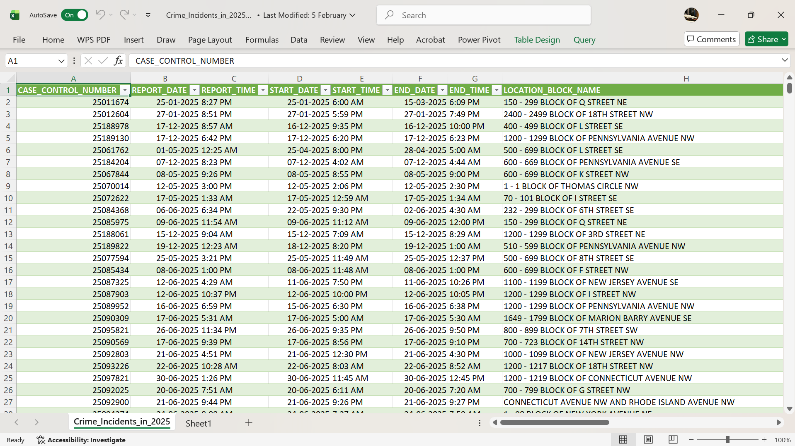
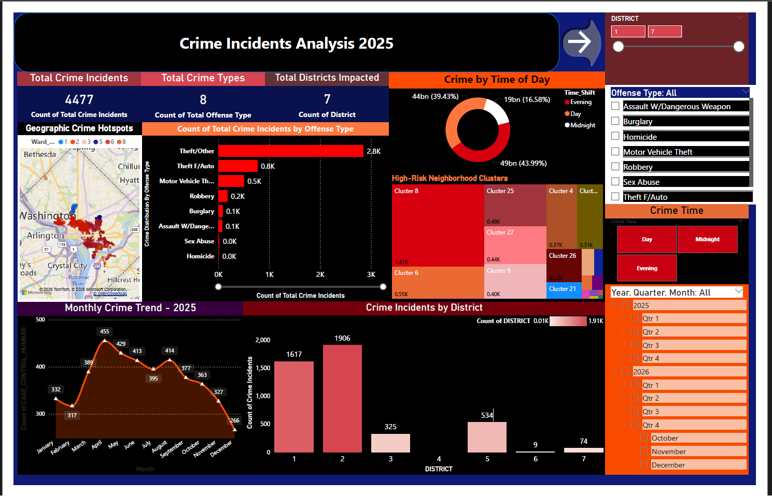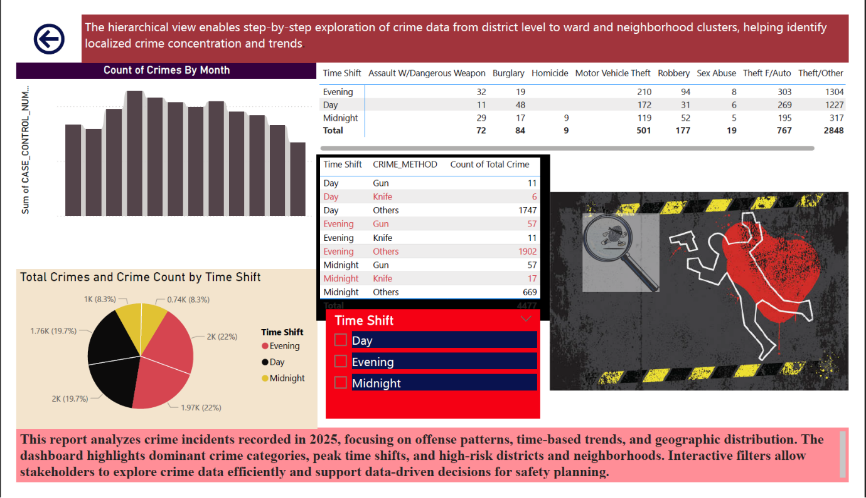

9. Files Included
- Crime_Incidents_2025.xlsx – Cleaned and structured dataset prepared using Excel and Power Query.
- MiniProject_Data Analysis with Excel n PowerBi.pbix – Power BI dashboard file containing all visualizations and measures.
- MiniProject_Documentation_LakshmiPrabhakar.docx – Detailed project documentation report.
- README.md – Project summary and basic usage instructions.

10. How to Use
- Open the Excel file to review the cleaned dataset.
- Open the Power BI (.pbix) file in Power BI Desktop.
- Use slicers to filter by district, offense type, or time shift.
- Use drillthrough functionality to explore detailed analysis.
- Navigate between pages using the dashboard navigation buttons.

11. Conclusion
The Crime Incident Analysis Dashboard – 2025 demonstrates practical skills in data cleaning, transformation, modeling, and interactive visualization. By using Excel for preprocessing and Power BI for advanced analysis and dashboard design, the project successfully converts raw crime data into structured, meaningful insights.
The project highlights the importance of proper data preparation and effective visualization in supporting analytical decision-making.

